# Step 1: Setup for the first time

* Go to **activity_Welcome.XML** at layout
* Change the layout to relative layout

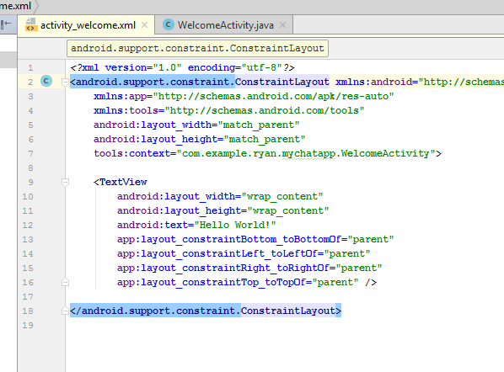

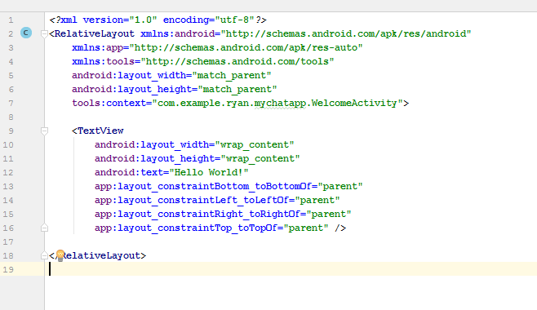

* Delete this text field, hello world
* Go to style, remove the action Bar
* 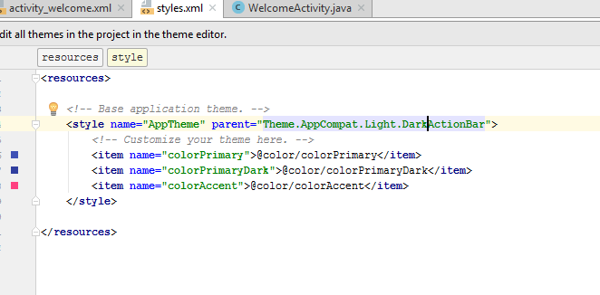
* Change to No action bar
* 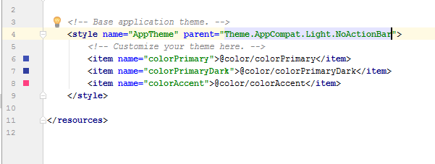
* 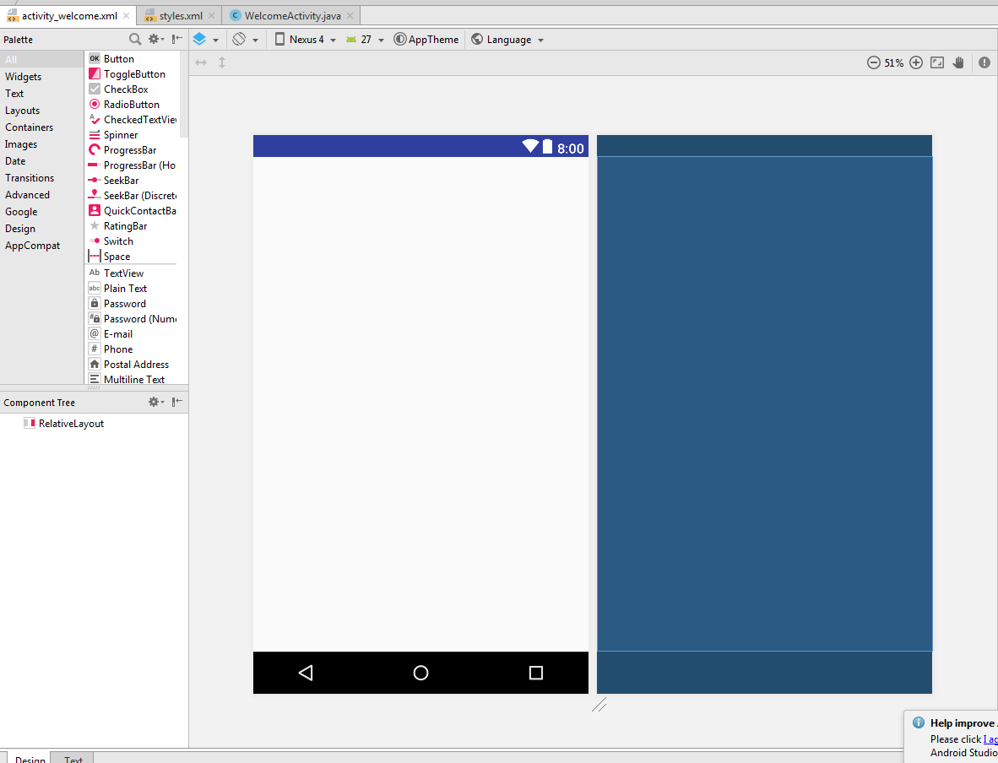
* It became like this
* Go to color.xml
* Remove color primary colourcode
* 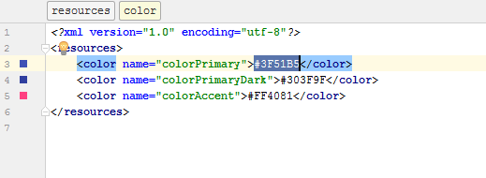
* Change to #A60707
* 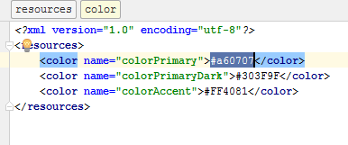
* Remove color primary dark colourcode
* 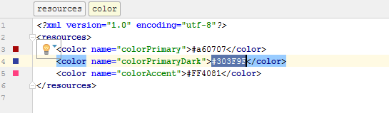
* Change to #9b0502
* 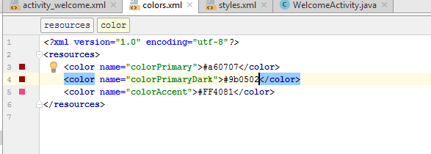
* It become this
* 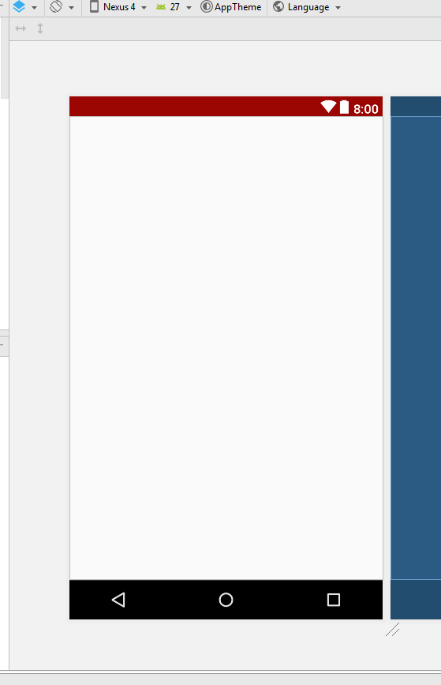

# Step 2: Connect mychat app to Firebase database

* You need to have Gmail account, sign in to your GMAIL account
* 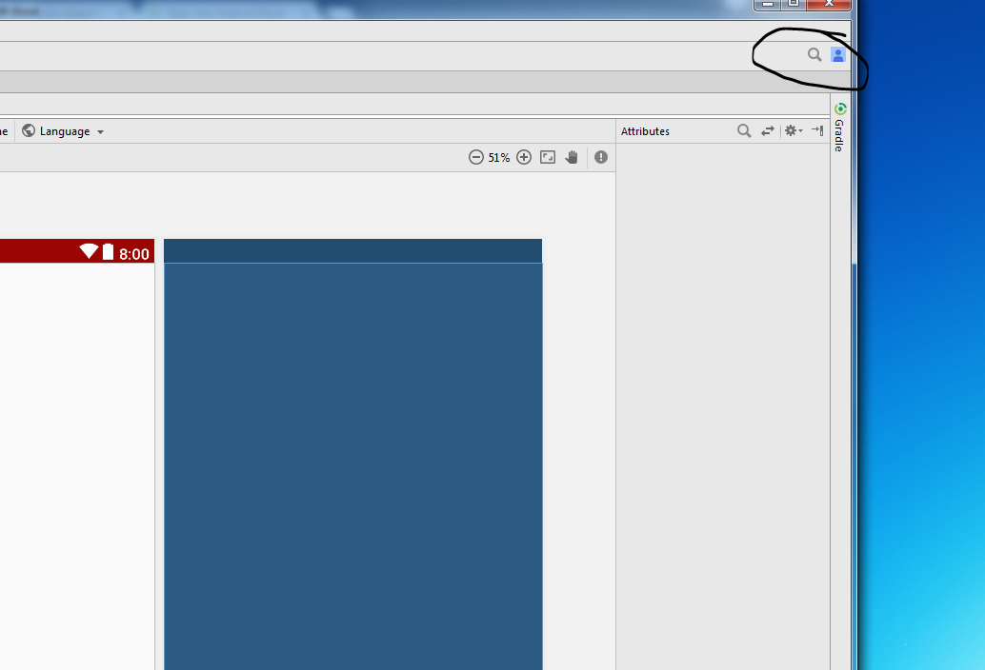
* Click on this
* 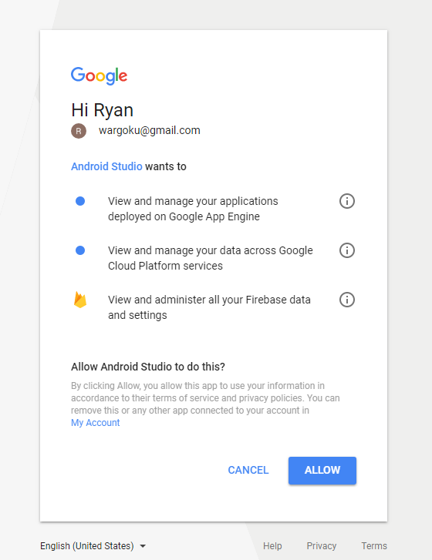
* Click allow
* 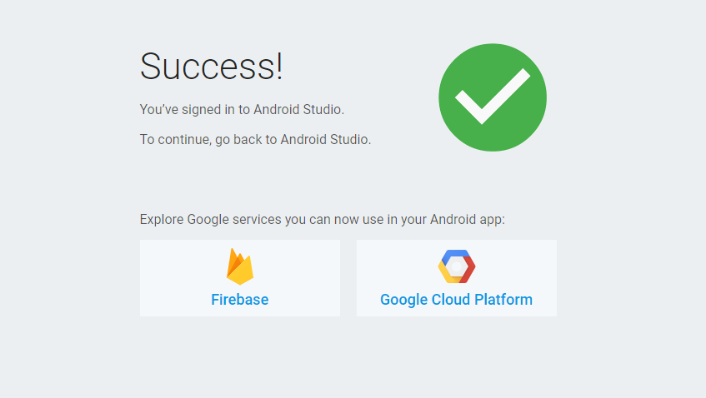
* You will see this
* 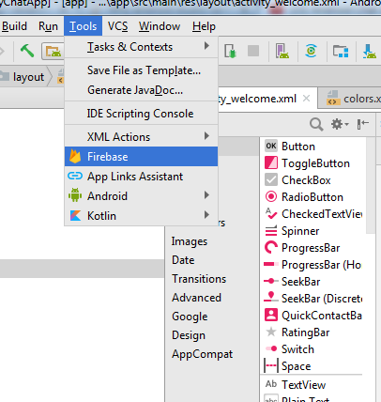
* Click on tool->firebase
* Click on email and password authentication
* 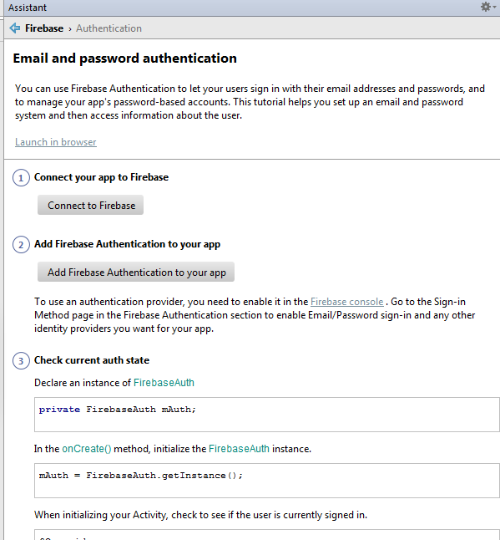
* Click on connect to firefox
* You will see this
* 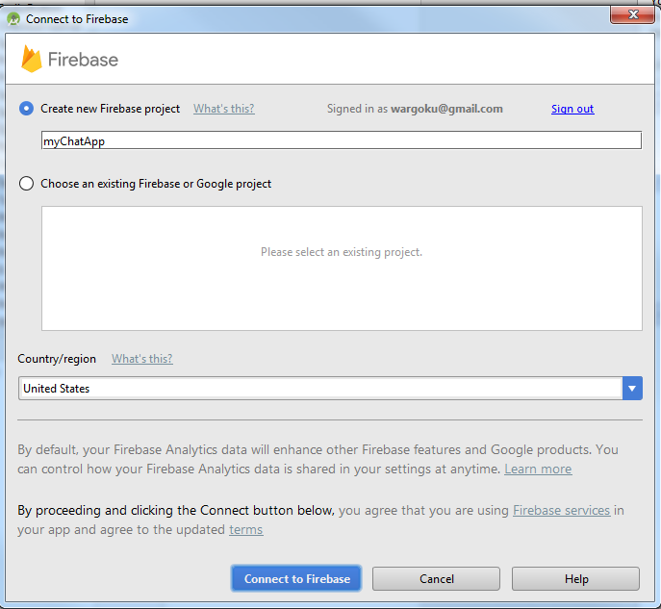
* Select your country and connect to Firebase
* 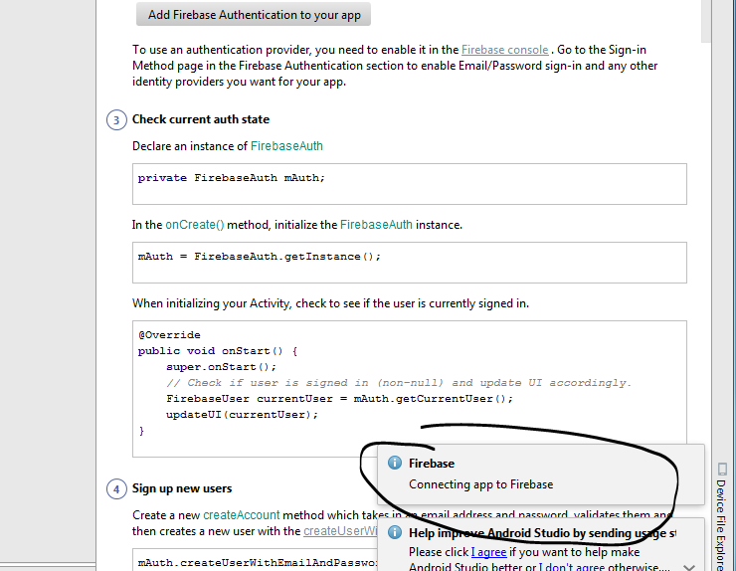
* Connecting notification will appear
* 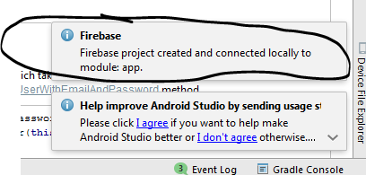
* When it is done, it will say Firebase project created.
* 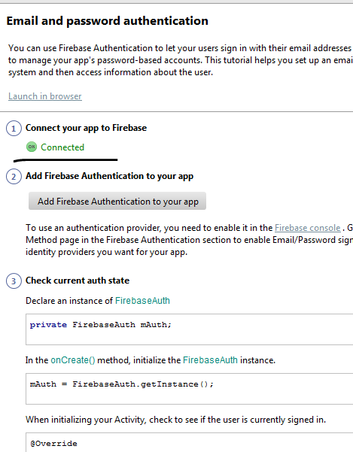\
* Click on **add Firebase Authentication to your app**, then click on accept change
* 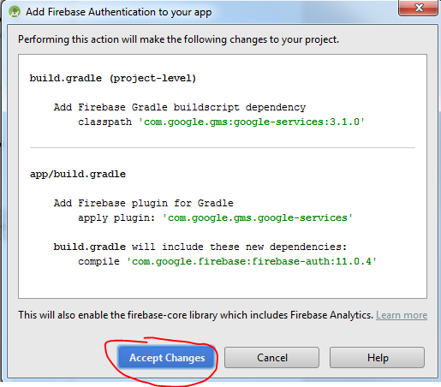
* Click on Real time database
* 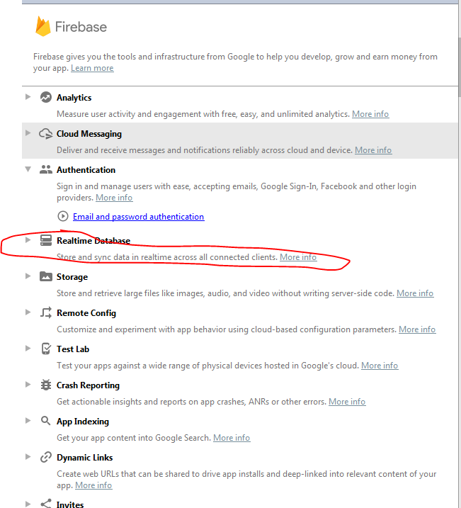
* 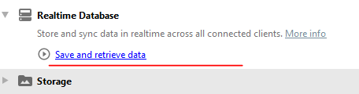
* Click on **save and retrieve data**
* 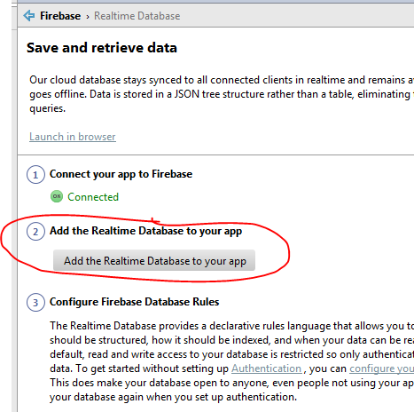
* Click on “**Add the Realtime Database to your app**”
* 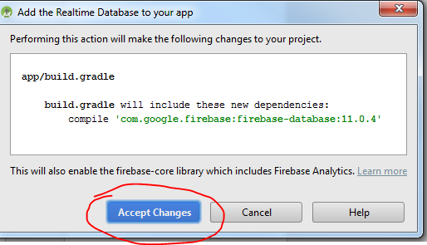
* Click on accept Changes
* Next step, go back and set up cloud messaging
* 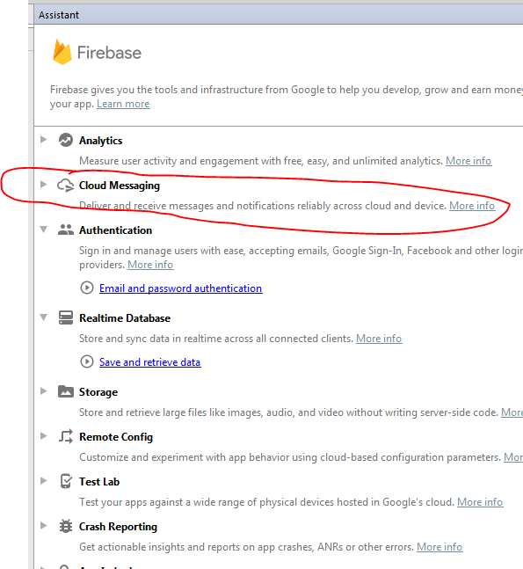
* Click on this
* 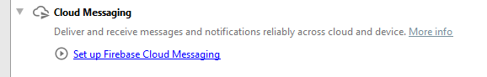
* Click on add FCM to your app
* 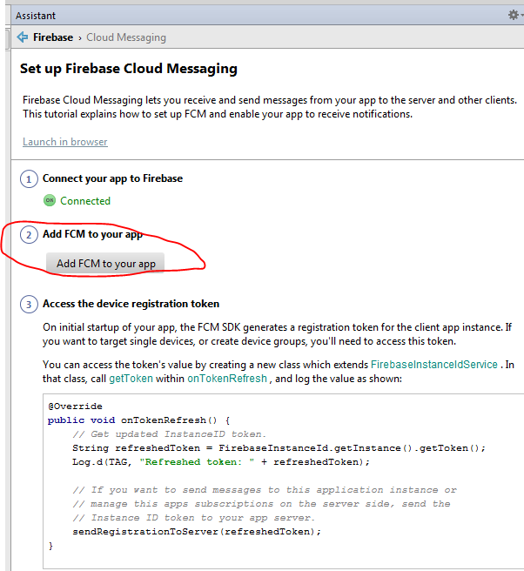
* 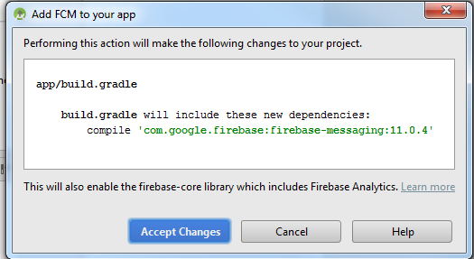
* Click on accept changes
* After that go to firebase website then click on **go to console**
* 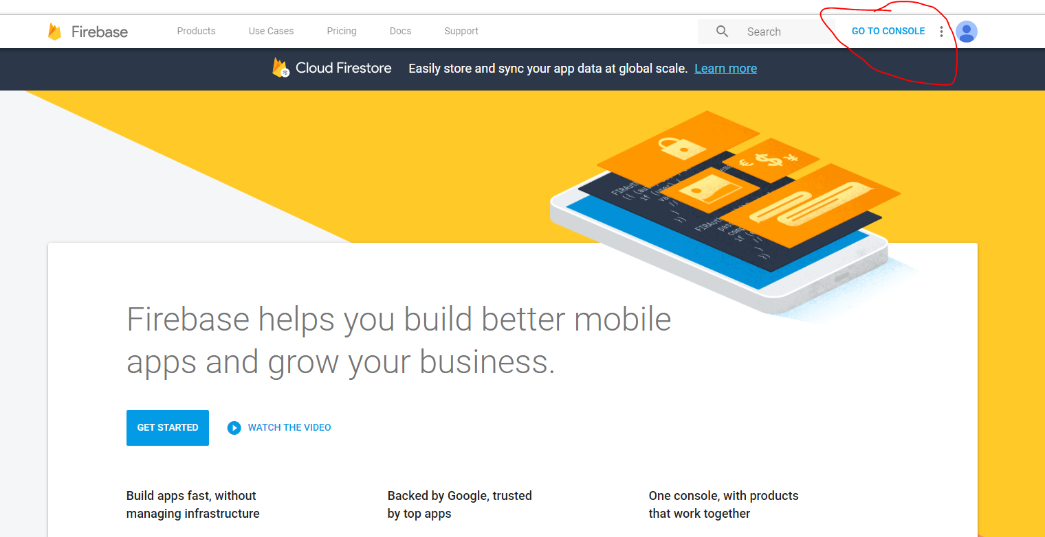
* You will see this
* 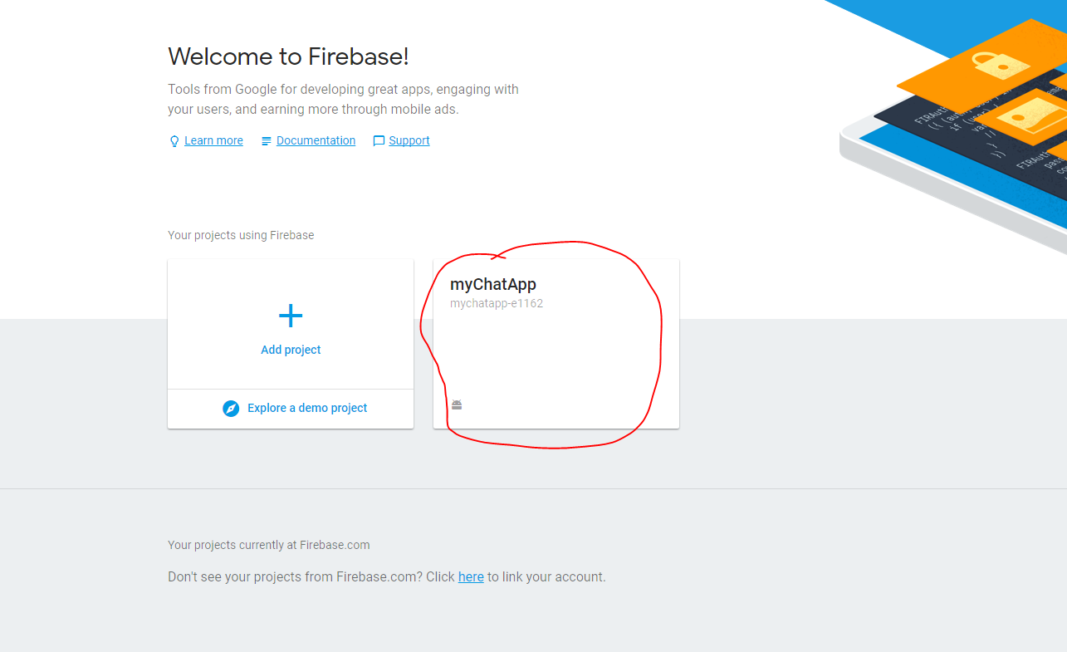
* Click on myChatApp, you should able to see this if u do it correctly
* 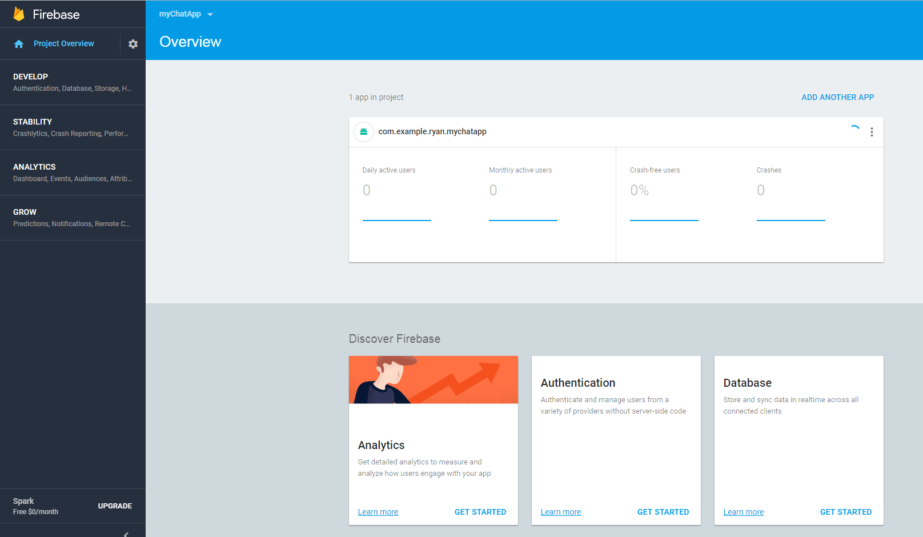
* Click on Authentication
* 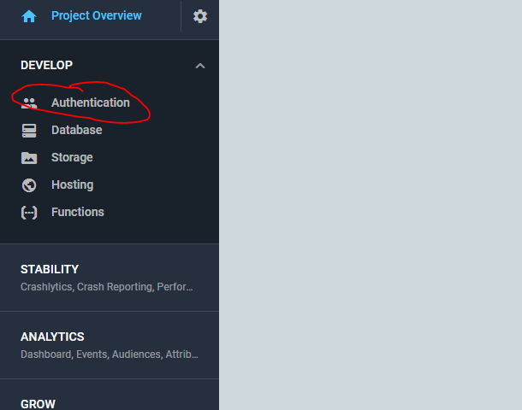
* Click on the sign in method
* 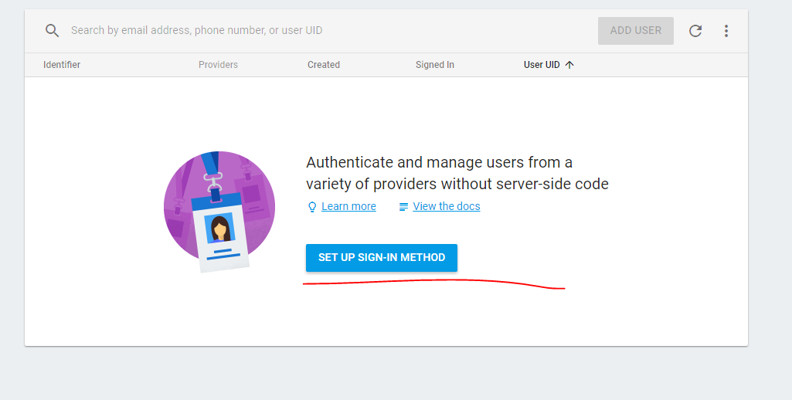
* Enable email sign in and google sign in
* 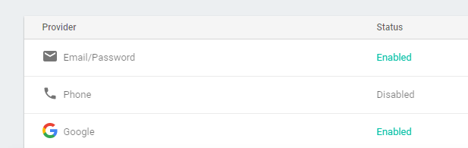

# Step 3: Welcome Page

* Go to welcome activity
* Find a Jpg or PNG fie, save it as “welcome_page”, must be small letter
* Copy the image to the drawable folder

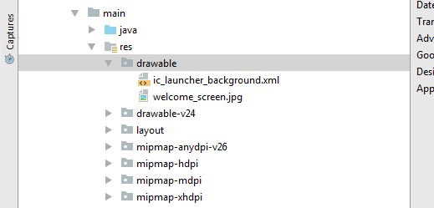

* Go to activity_welcome.xml
* 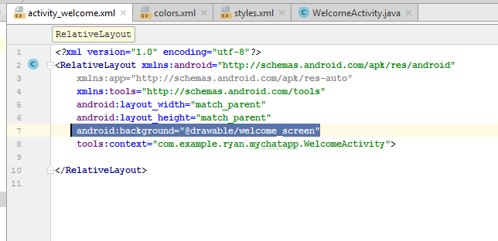
* Add in “**android:background="@drawable/welcome_screen"**”
* Then go to welcomeActivity.java file
* 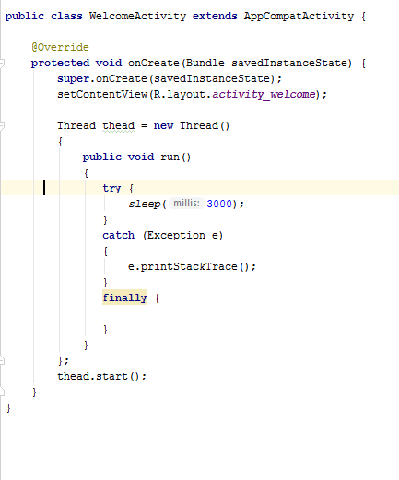
* Add in the following code in WelcomeActivity.java
* Create another **mainactivity** page to put in FINALLY
* Create a blank activity in the same folder
* 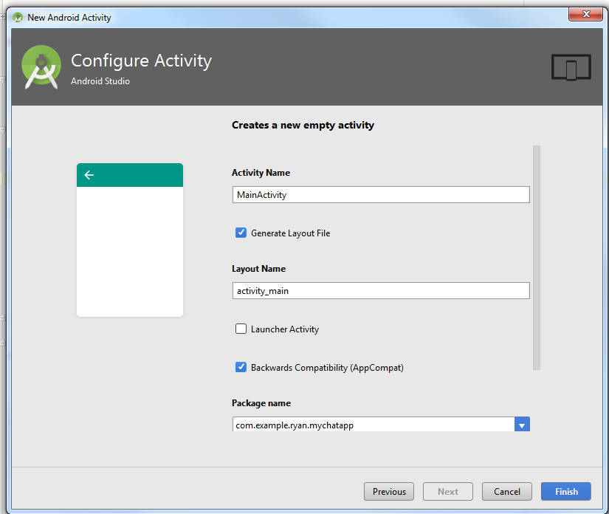
* Go to **activity_main.xml** file
* Change constraint layout to relative

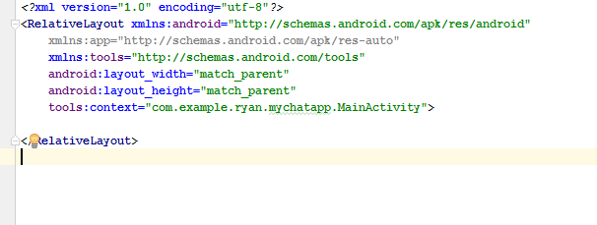

* Put a Text View in the activity_main.xml
* 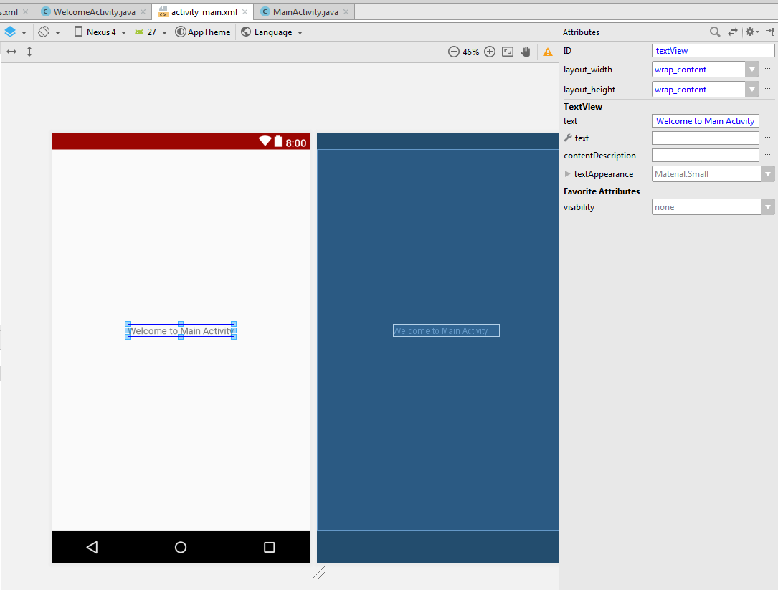
* Welcome to main activity
* 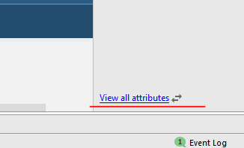
* Click on **View all attributes**
* On the search box, write TEXT
* 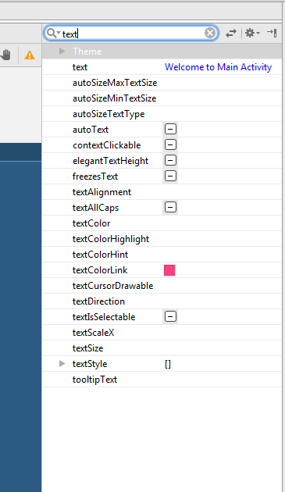
* Then go to fewer properties
* 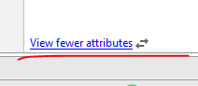
* You will brought to this screen
* 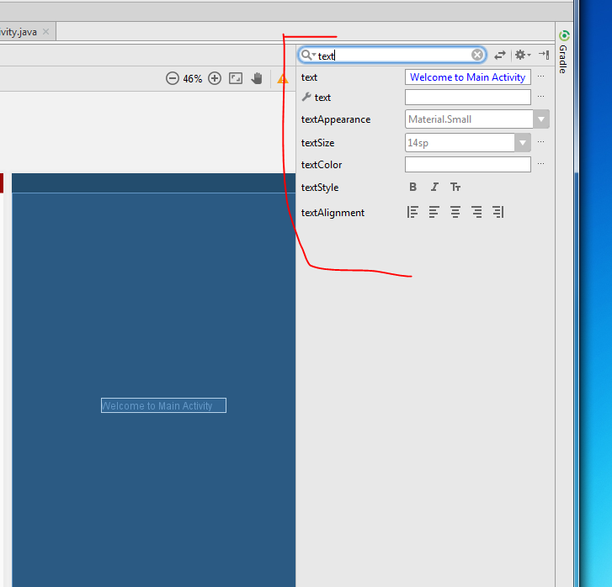
* Bold it and set the textsize to 20 SP
* 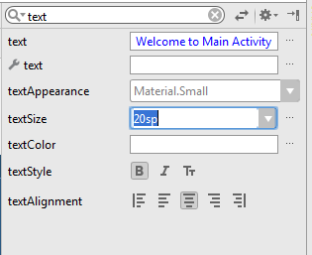
* 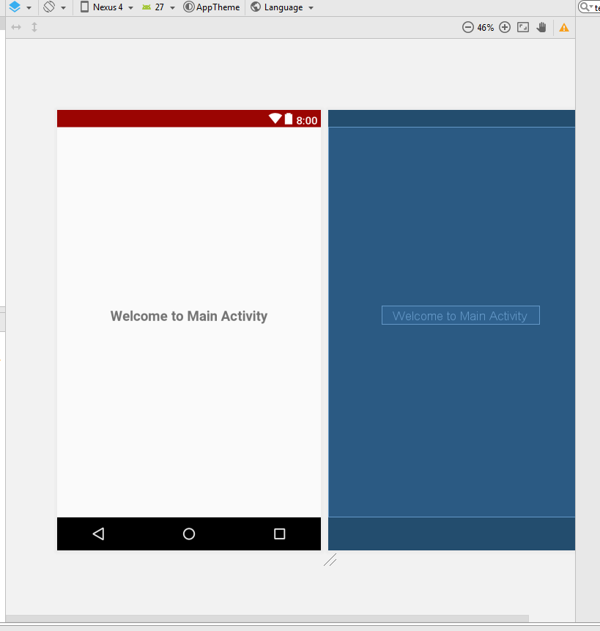
* Then now go back to finally part
* Enter the intent to go the mainactivity, add in this two lines
* 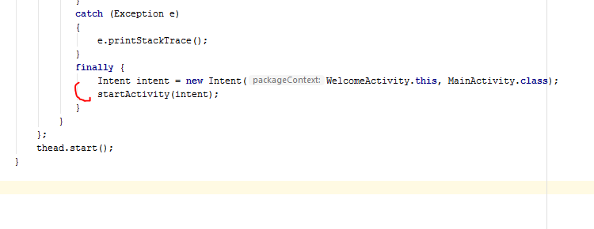
* Build and Run to check

# Step 3: Allow login user to main activity, else go to another page

* Create new activity, startpageActivity.java
* Go to activity_start_page, then u change the layout to relative
* 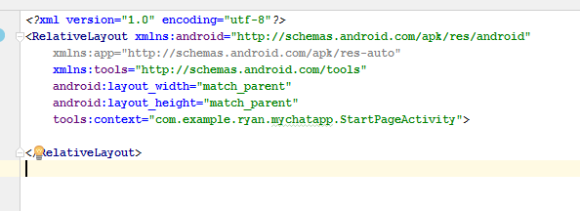
* Add a Textview Change to start page activity
* Go to mainactivity.java, add in FirebaseAuth object
* Then add in mAuth = FirebaseAuth.*getInstance*(); in the onCreate method of MainActivity
* Type onStart to run this method
* 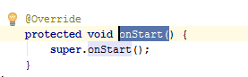
* 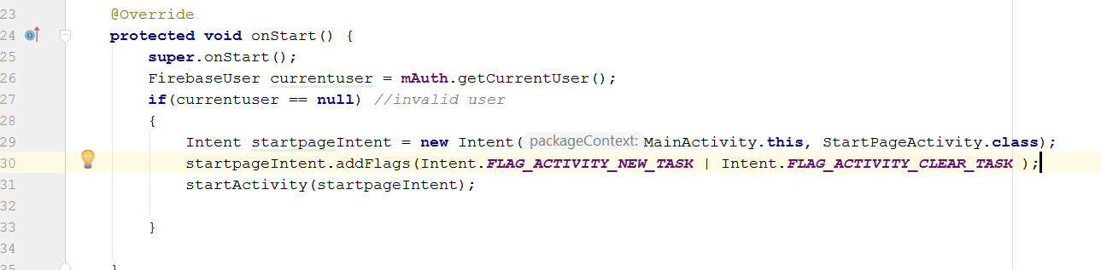
* Then go to welcomeActivity.java, create a new method call onpaused()
* 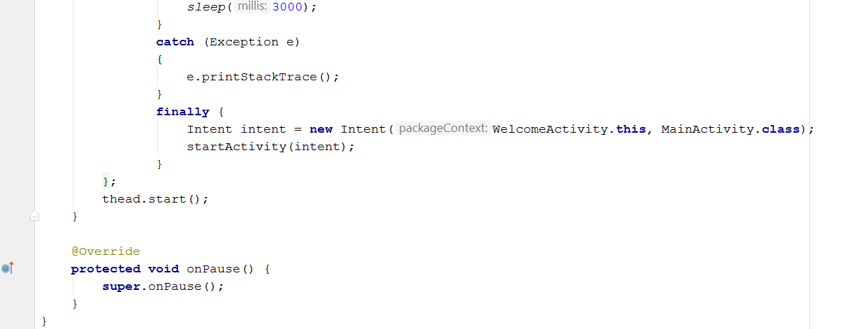
* **Rebuild and Run**
* Go to activity_startpage, remove the textview
* 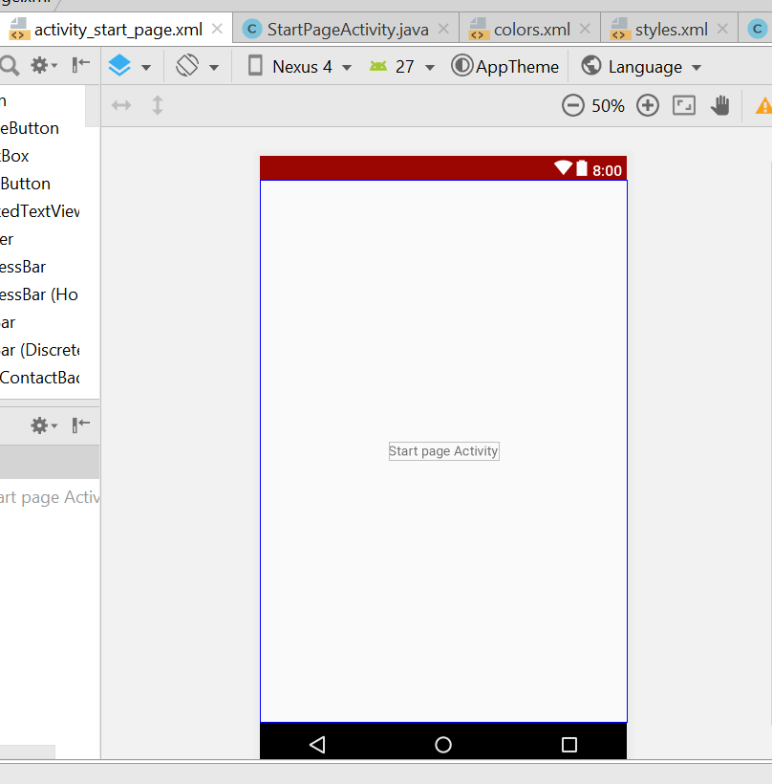
* Download a startpage png or jpg file, copy and paste into the drawable folder, name must be small letter
* 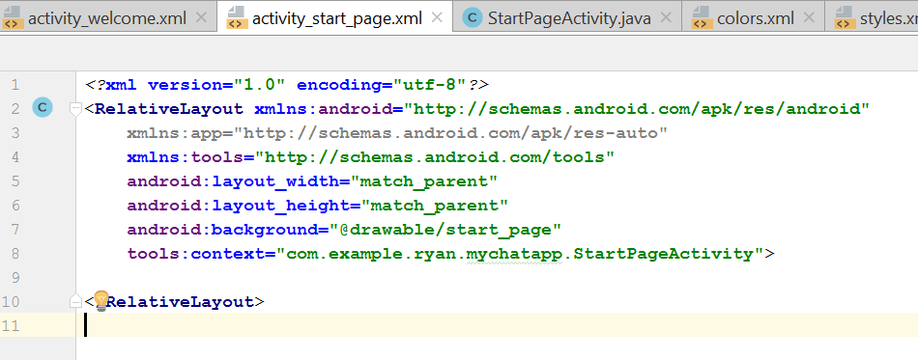
* Go the activity_star_tpage.xml, android:background="@drawable/start_page"
* Drag and drop a button the activity_start_page.xml
* Then click on this to make the width, match_parent
* 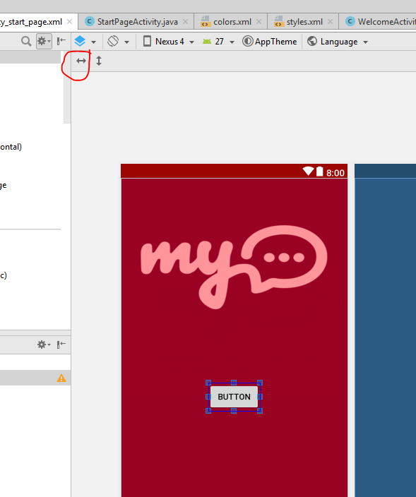
* 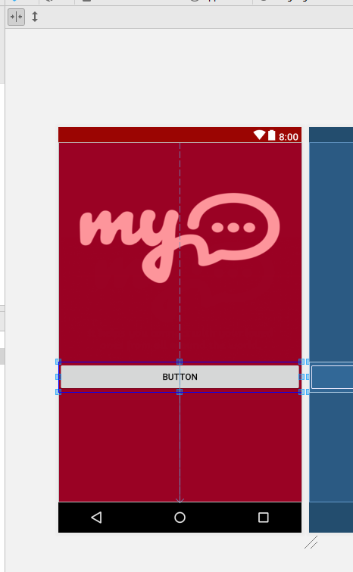
* The height of the button will be wrap_content
* Now go to view all attributes, and click, then go background
* 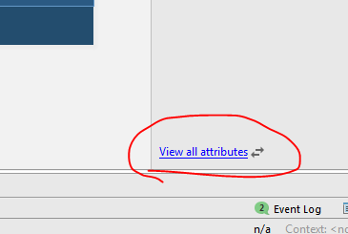
* 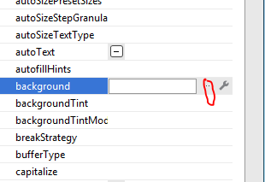
* Click on this … button
* The select, colour and background light
* 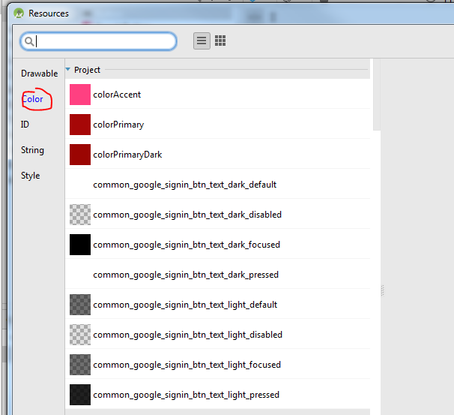
* 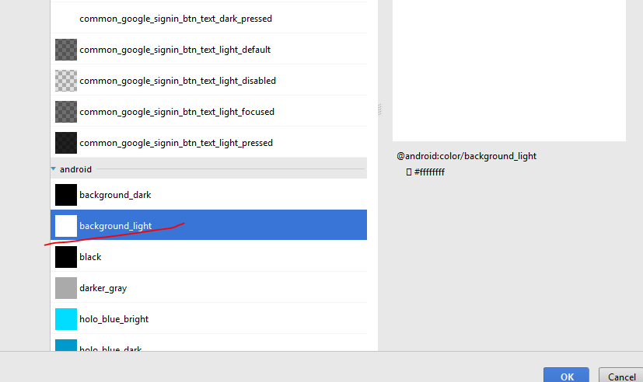
* Click okay
* Edit the text
* 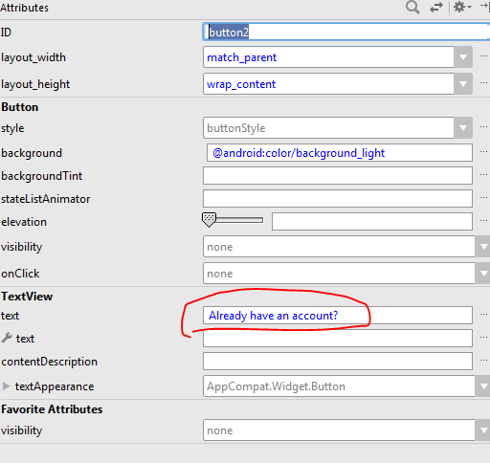
* Then search for the word “text”, you will see thing like this
* 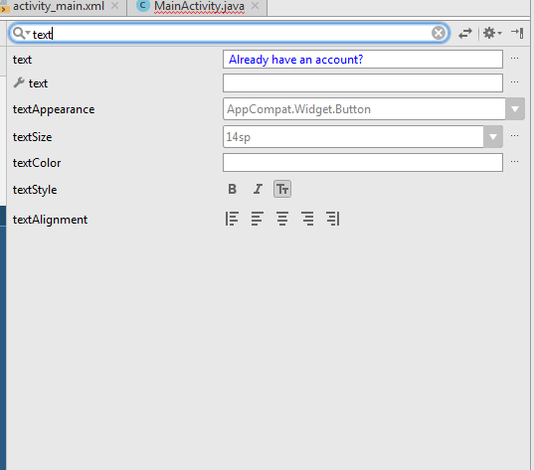
* Change the text colour and the size
* 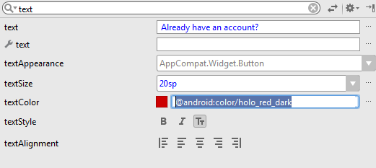
* Change the padding to 10dp and layout width to 320dp. Height 50dp
* 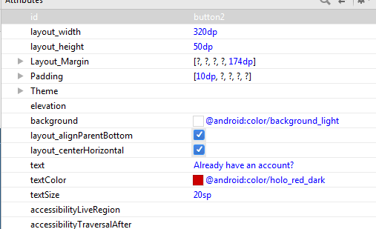
* The current screen look like this
* 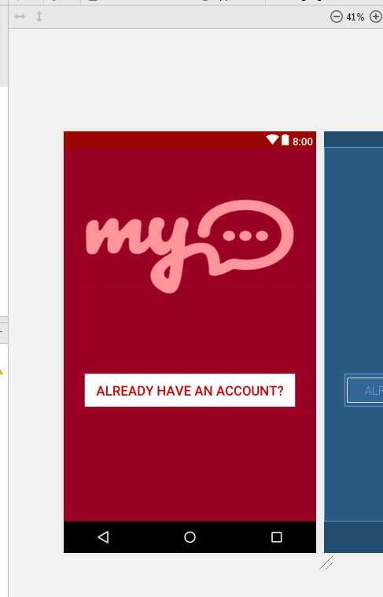
* Now drag another button, with same width and height to the XML
* 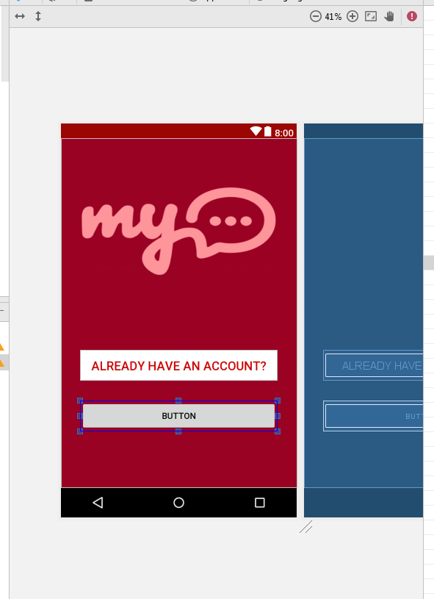
* Set the same background colour for it
* Set the size and textcolour same as just the previous one
* 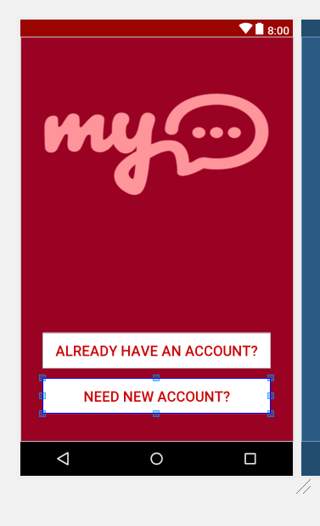
* Now set the id of both button.
* After that go to the startpageactivity.xml
* Create two button object
* 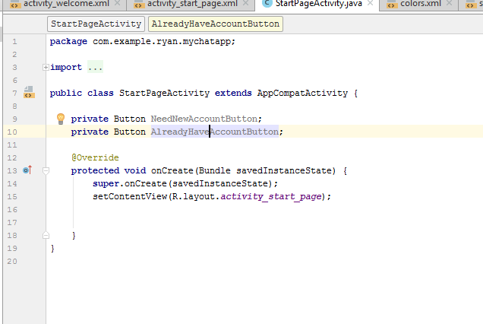
* Now to the onCreate method and add in the following
* **NeedNewAccountButton** = (Button) findViewById(R.id.***need_new_account_btn***);  
  **AlreadyHaveAccountButton** = (Button) findViewById(R.id.***already_have_account_btn***);
* 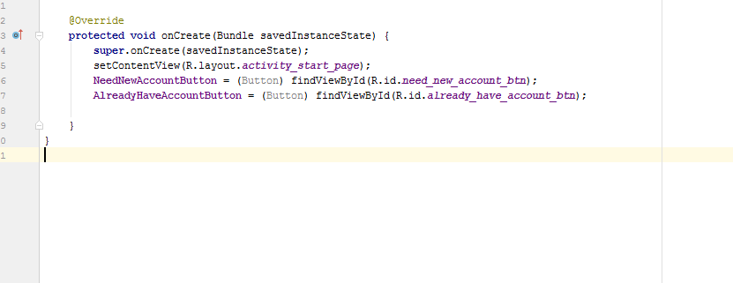
* Set onclick listener for it
* **NeedNewAccountButton**.setOnClickListener(**new** View.OnClickListener() {  
   @Override  
   **public void** onClick(View v) {  
     
   }  
  });
* **AlreadyHaveAccountButton**.setOnClickListener(**new** View.OnClickListener() {  
   @Override  
   **public void** onClick(View v) {  
     
   }  
  });
* We need two more activity, login activity and Register activity
* 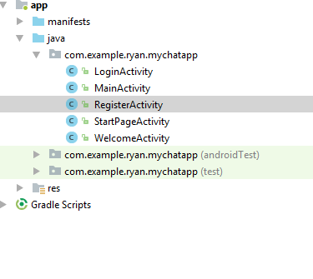
* The edit the layout, from constrant to relative layout of both
* Add in a textview in each of the activity xml to something like this
* 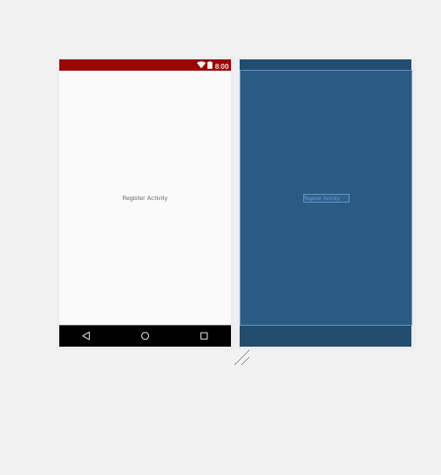
* Now go to the startpageActivity to add in the Intent for the two button to bring the user to this two new activity pages.
* 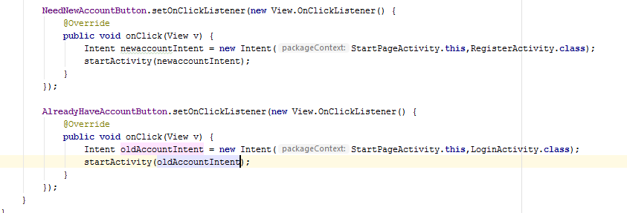
* Rebuild and run

# Step 4 : Design UI For Login And Register Activity

* Download register account image background and put it in the drawable folder
* Add in the “android:background="@drawable/sign_up"” in the activity_register.xml
* 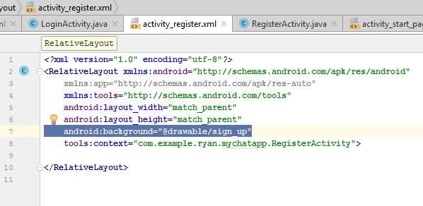
* 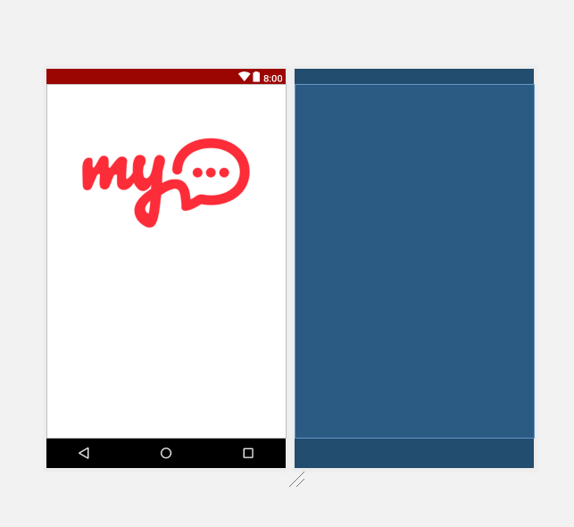
* 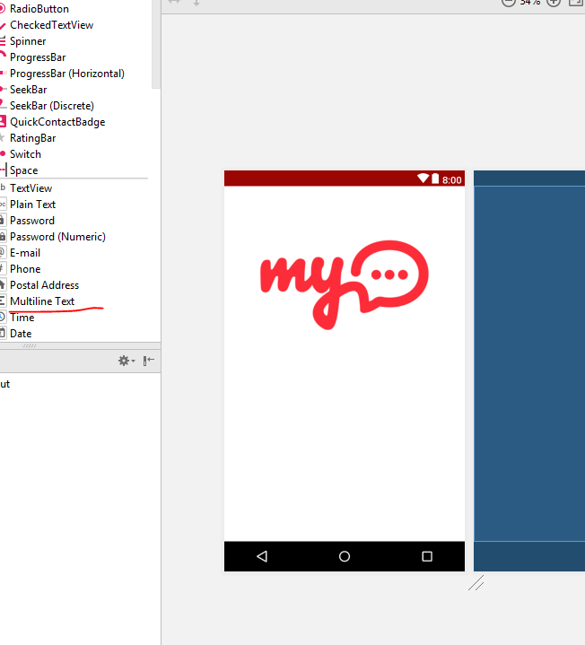
* Drag 3 multiline text from the left side bar into the activity, add in the hint for 3 multiline
* 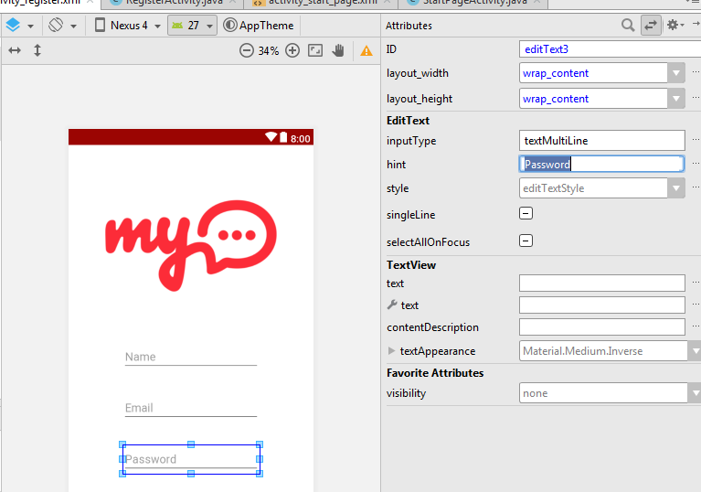
* Click on this button to expand the field length
* 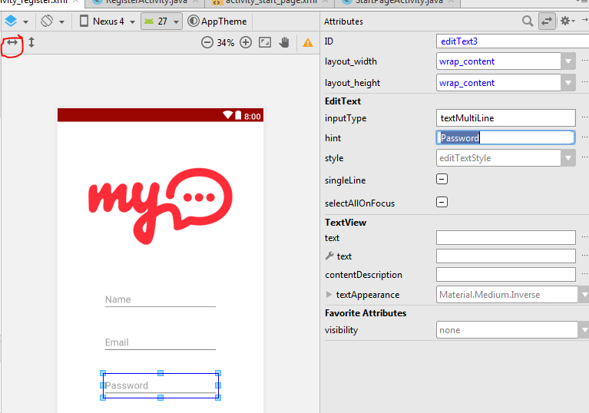
* Padding change to 15dp for each
* Drag and drop a button to here
* 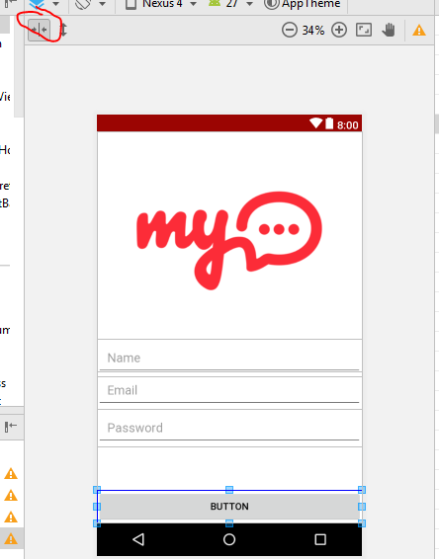
* Click this button to expand the Button
* Change the text to CREATE ACCOUNT
* Go the “Background” to change the Button colour
* 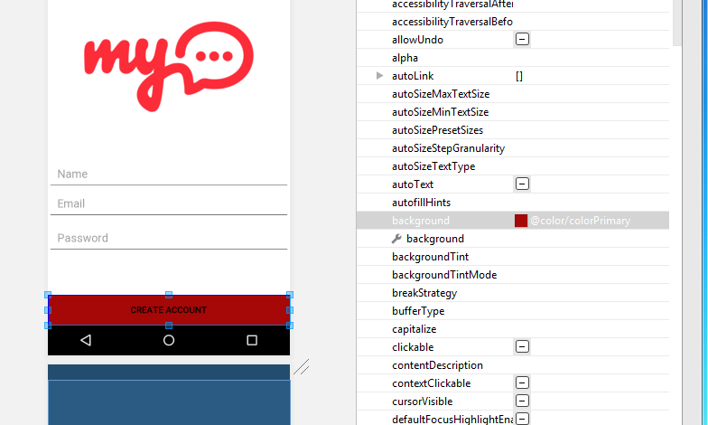
* Change the TextSize and TextColour, BOLD IT
* 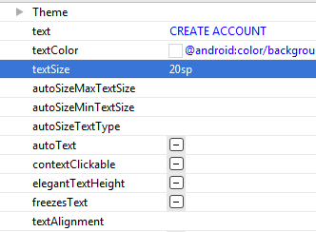
* Go to LoginActivity.XML now
* Delete the textview from LoginActivity
* Change the background of the Login Activity
* 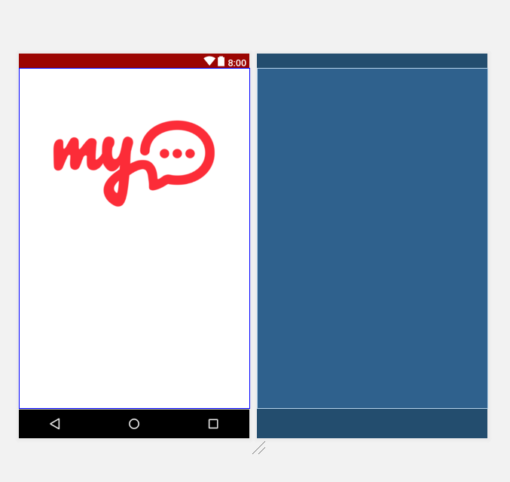
* 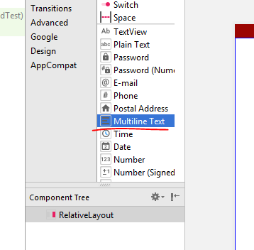
* Drag two Multiline Text into the activity.xml
* For hint, email email and password separately, padding is 20 dp
* Drag and drop a button, then change the button to 20dp and also make the width same as parent
* Change the Button text to **Sign In**
* 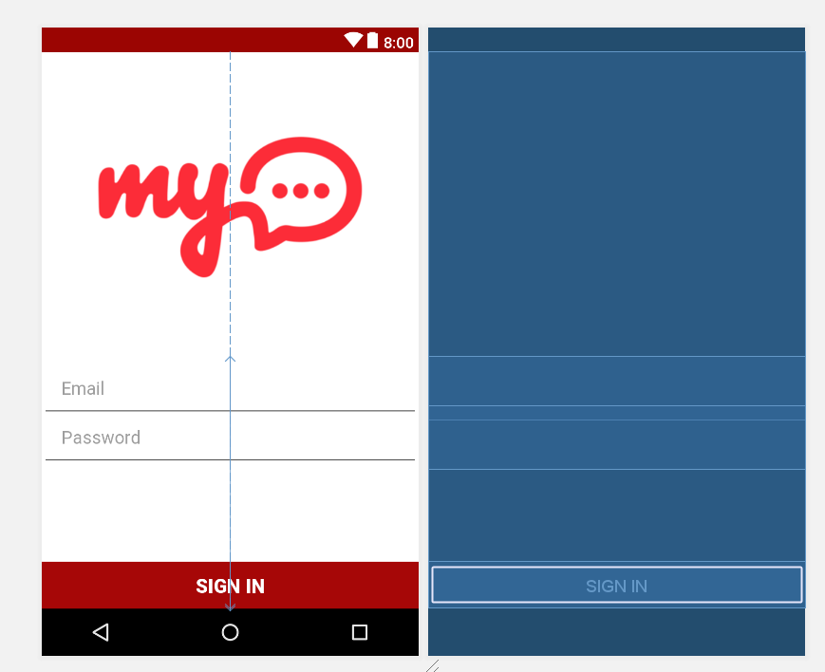

# Step 5: Toolbar setting for Login + Register

* Go to build.gradle (Module.app)
* 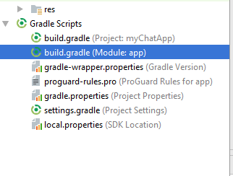
* Double click it
* Add in this line
* implementation **'com.android.support:design:26.1.0'**
* 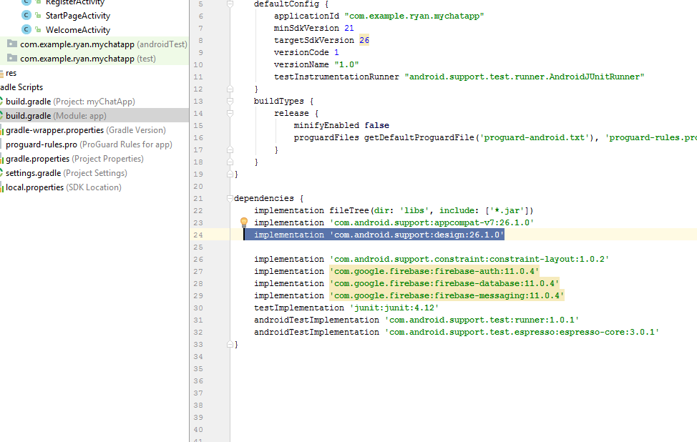
* Create new Layout Resource file
* Name it as app_bar_layout,
* 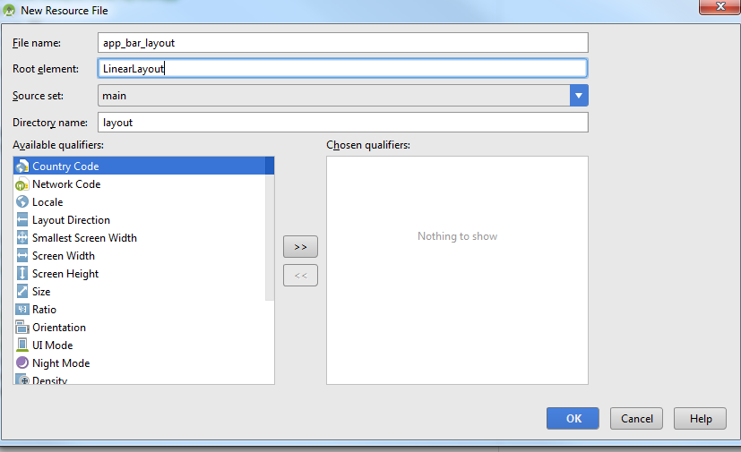
* Layout should be **android.support.v7.widget.Toolbar**
* 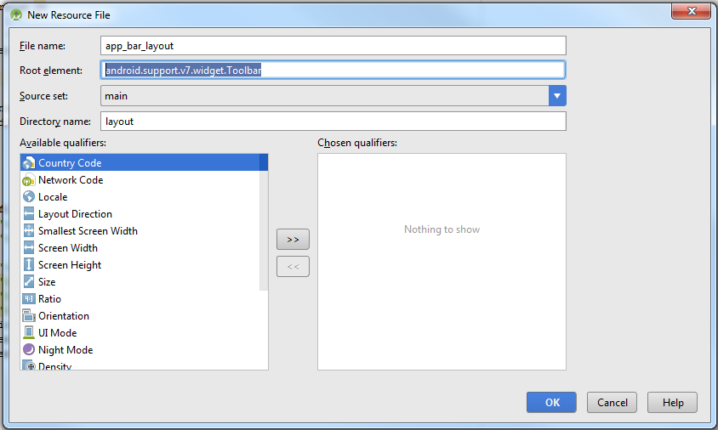
* Click okay, and this will appear
* 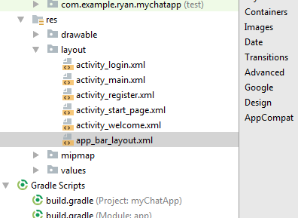
* Go to the layout, change the height to “wrap content”, and add the background to colorprimary
* 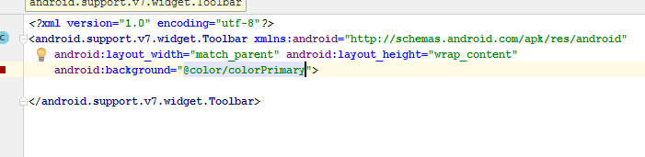
* You will get something like this
* 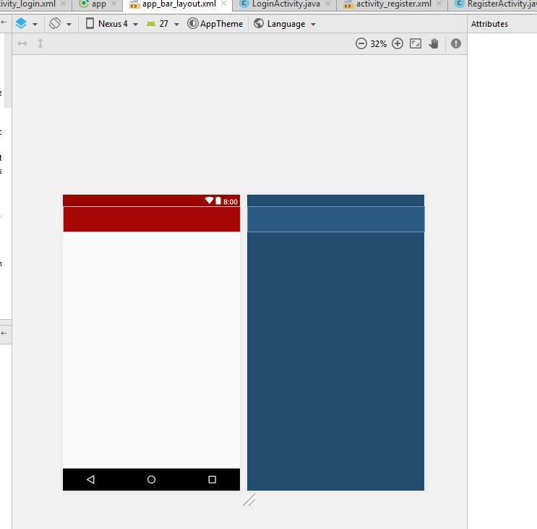
* The id for this toolbar is “main app bar”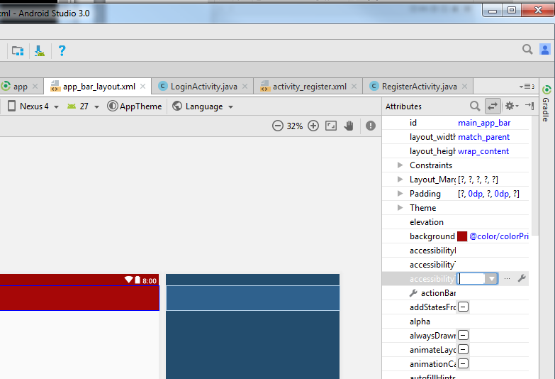
* Select the Theme, dark action bar
* 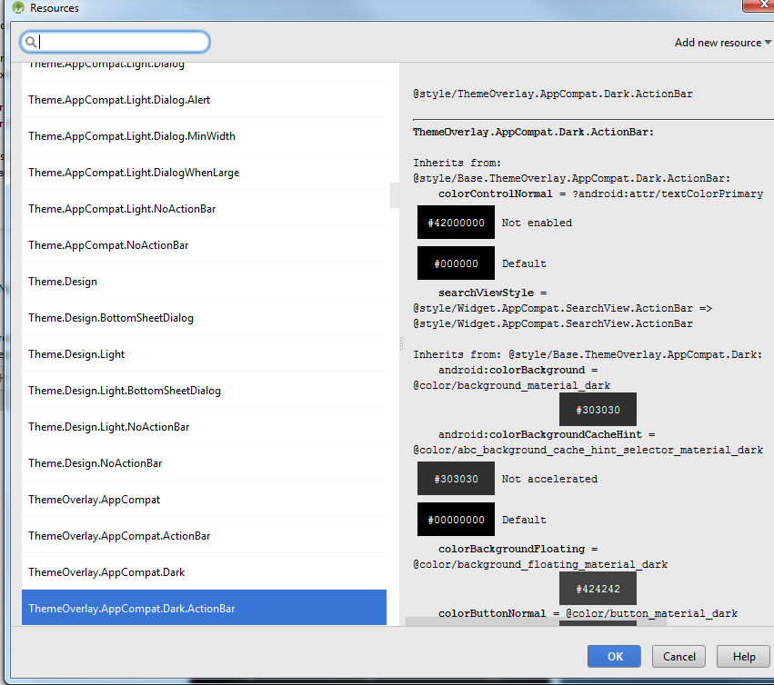
* Go to activity_main.XML file now
* Include the following line
* <**include layout="@layout/app_bar_layout"  
   android:id="@+id/main_page_toolbar"**>  
     
  </**include**>
* 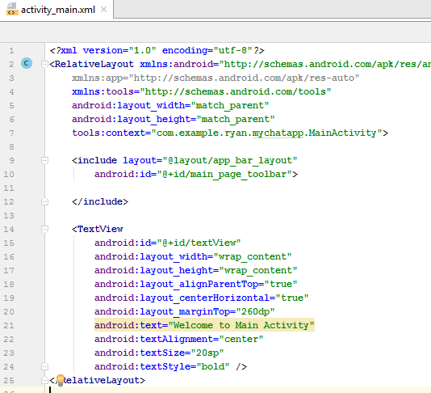
* Now go to MainActivity. Java
* 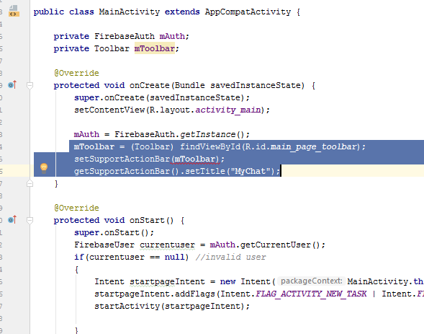
* Add in the following code in the mainactivity.java
* Now go to activity_login. Xml, add in the following code
* 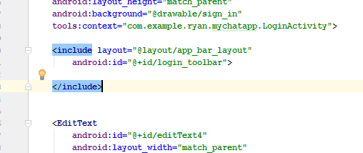
* Similarly declare toolbar in the loginactivity too
* 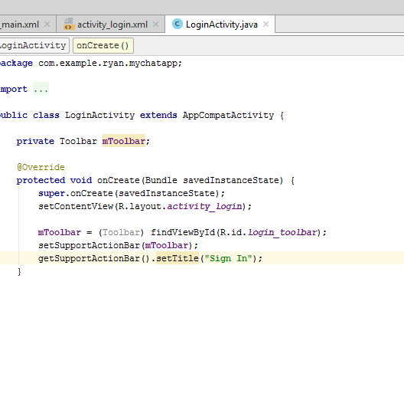
* Ok, now click on Android Manifest like shown below
* 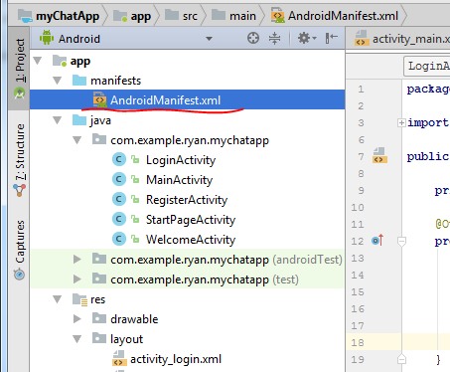
* You should see this when u double click
* 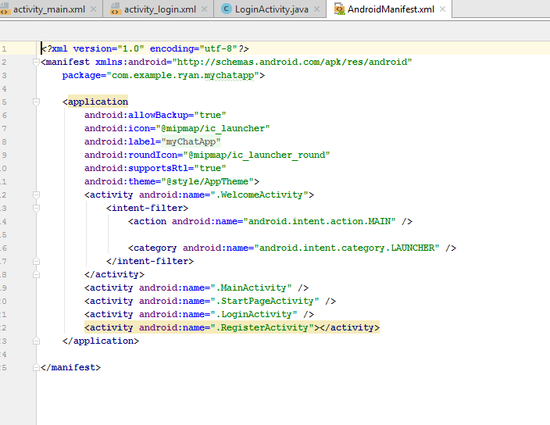
* Add in the startpage for the LoginActivity parent page
* 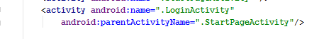
* Now go the LoginActivity.java, and add in the following line
* 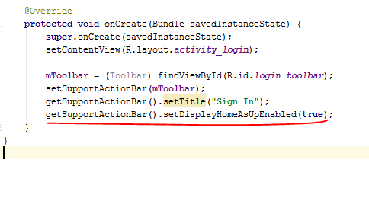
* Now go activity_register.xml
* Add in the following line

<**include layout="@layout/app_bar_layout"  
 android:id="@+id/register_toolbar"**>  
  
</**include**>

* It became like this

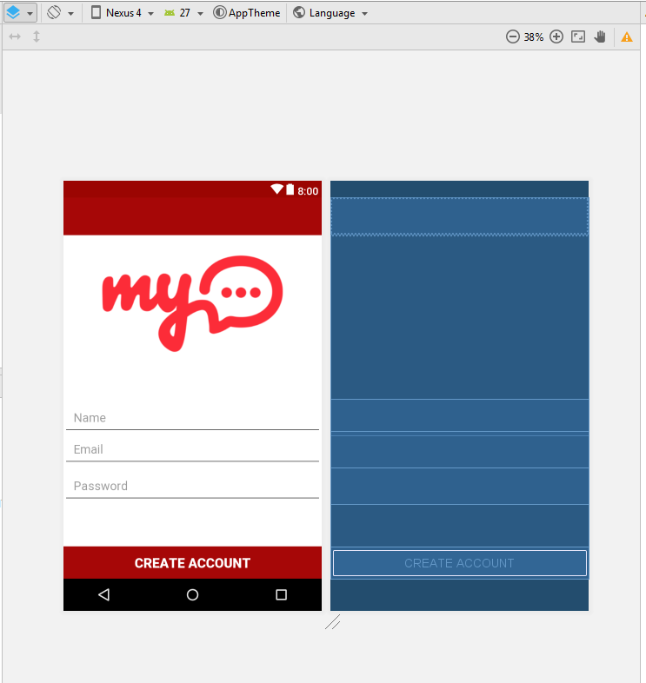

* Now go to register activity
* Add in the following code on toolbar
* 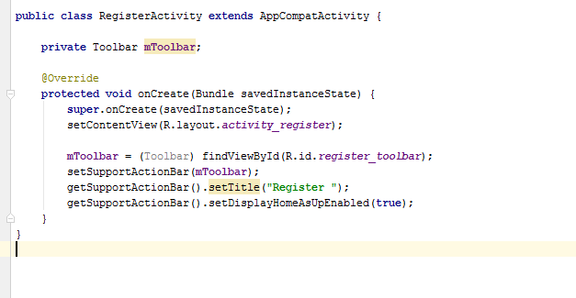After that go to Android Manifest again, add in the startpage as parent to RegisterActivity.java
* Rebuild and Run
* 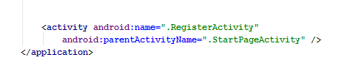
* Rebuild and Run

# Step 6: Register user and store in Database

* Add id for the name field of Register activity
* Register_name, register_email, Register_passsword
* The button, will be create_account_btn
* Now go to register_activity.java file
* Add in this lines
* 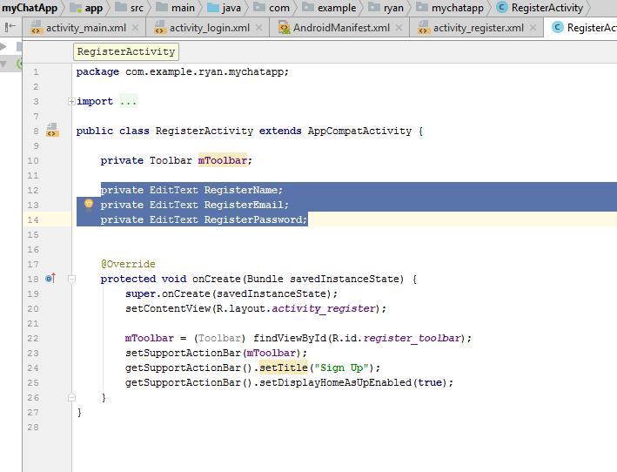
* Go back to the XML, Search for “input”, go to the email then go to INPUTTYPE, then select TEXTEMAILADDRESS
* 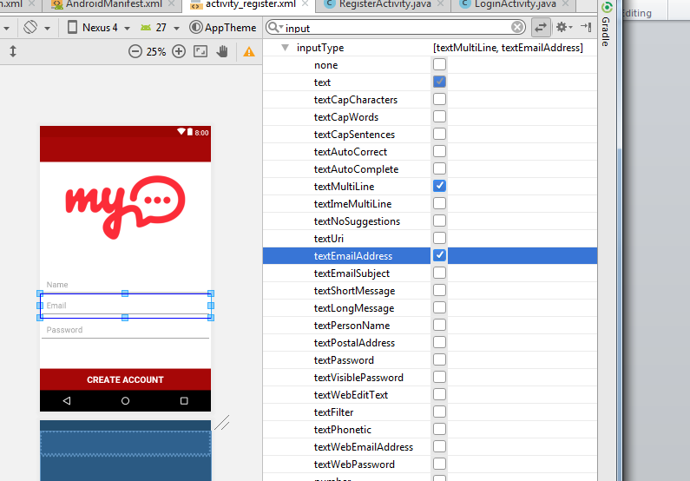
* Go to the password, INPUTTYPE, tick the TEXTPASSWORD.
* 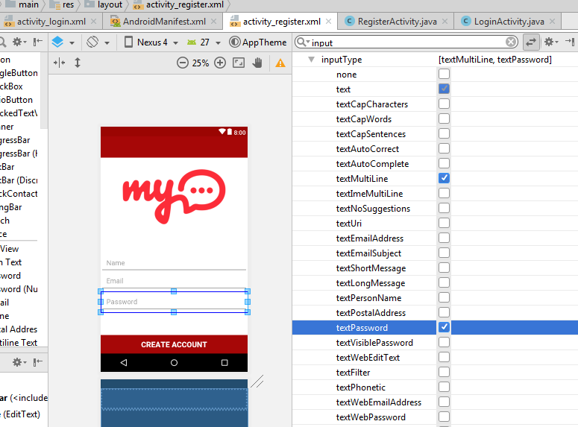
* Go back to registerActivity .java, then add in this few lines
* 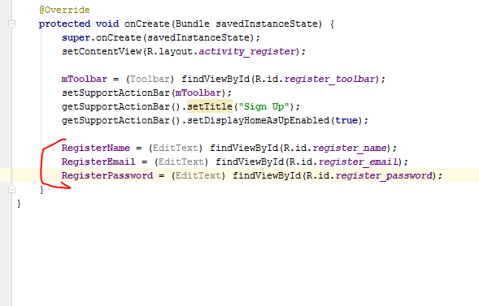
* Then u add in “CREATEACCOUNTBUTTON” Button object in the RegisterActivity.java, then set up the onClicklistener
* Inside the onclick method, get the name, email and password, create a **registerAccount** Method
* 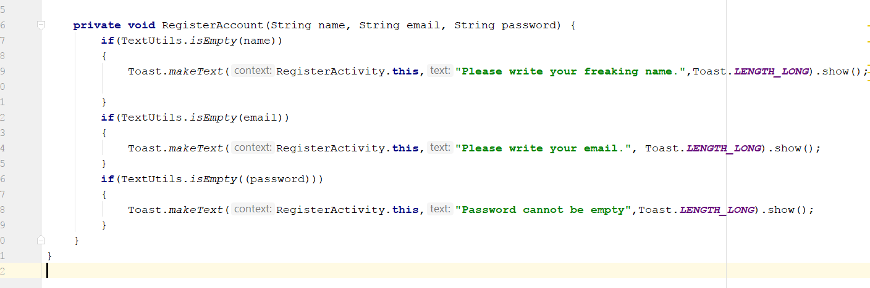
* The add in the following code on the top, **firebaseAuth mAuth**
* 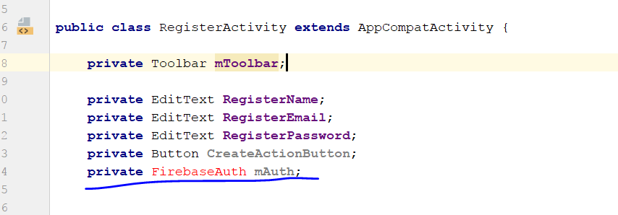
* Next step, in the onCreate method.
* Add this line
* 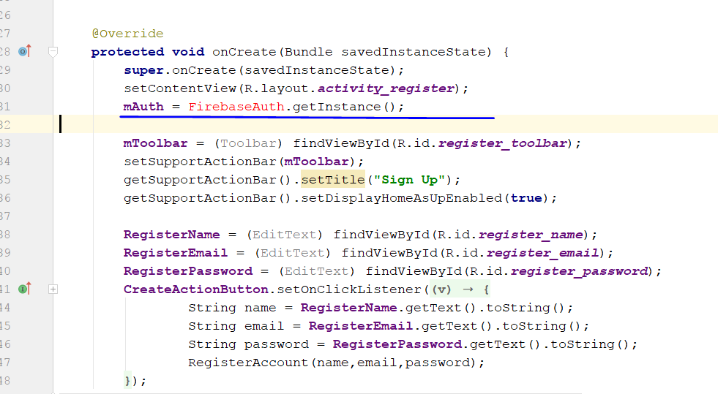
* Error detected
* 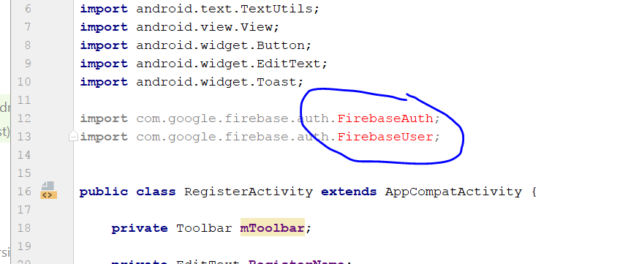
* Error: FirebaseAuth turn red, how to solve?
* Write this on the build/gradle of the app
* 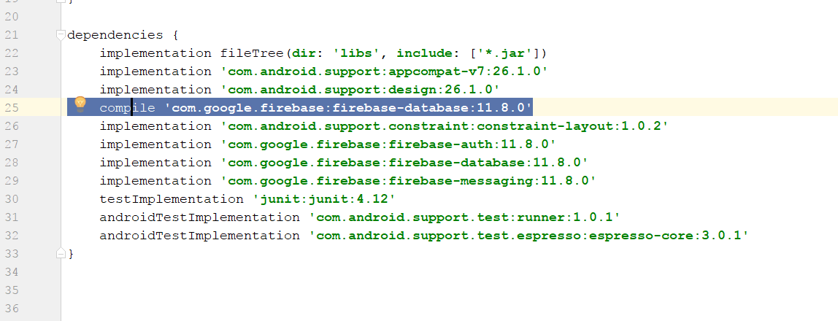
* In the RegisterAccount Method, in the else statement, add in the following code
* 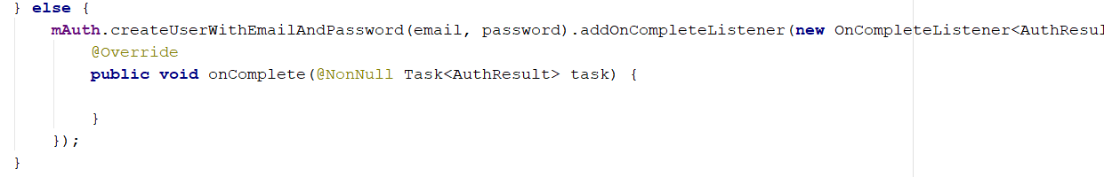
* So overall, it look something like this
* 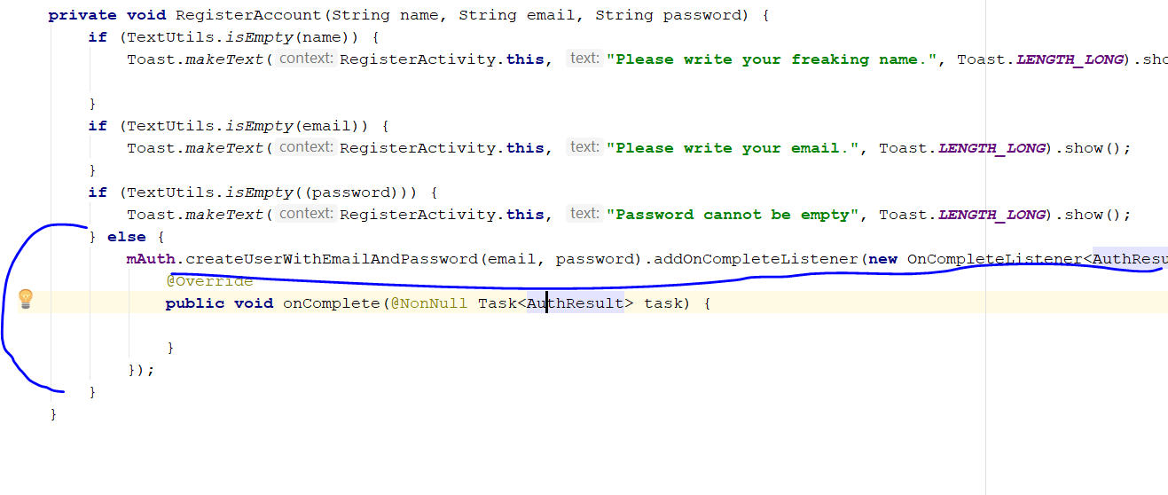
* public void onComplete(@NonNull Task<AuthResult> task) {
* Inside the the Oncomplete method, we will add if(task.isSuccessful){}
* This is to indicate if the user is registered successful to the firebase
* 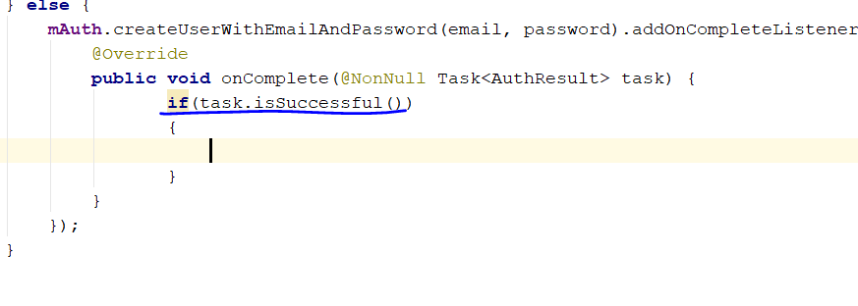
* Then end in the following codes inside
* Intent mainIntent = **new** Intent(RegisterActivity.**this**,MainActivity.**class**);  
  mainIntent.addFlags(Intent.***FLAG_ACTIVITY_NEW_TASK***|Intent.***FLAG_ACTIVITY_CLEAR_TASK***);  
  startActivity(mainIntent);
* 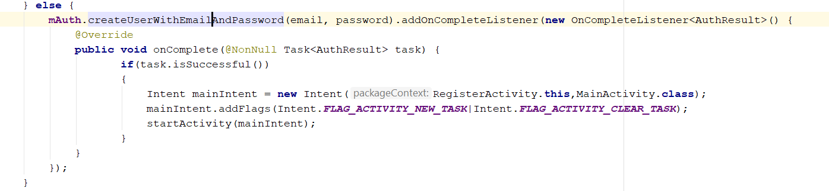
* Then u add in finish();
* And add in else statement if error occur
* It now look like this
* 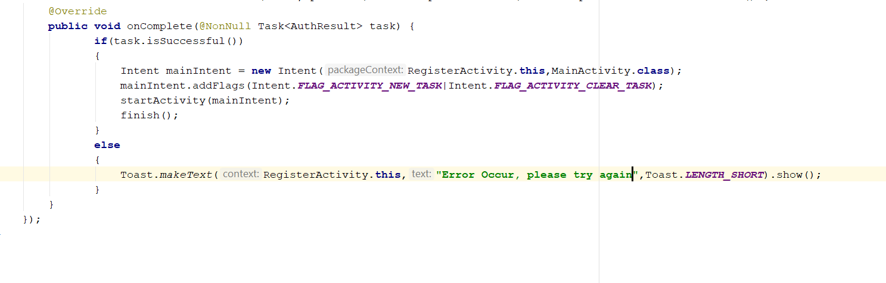
* Now cast the createAccountButton in the onCreate method
* **CreateAccountButton** = (Button) findViewById(R.id.***create_account_btn***);
* 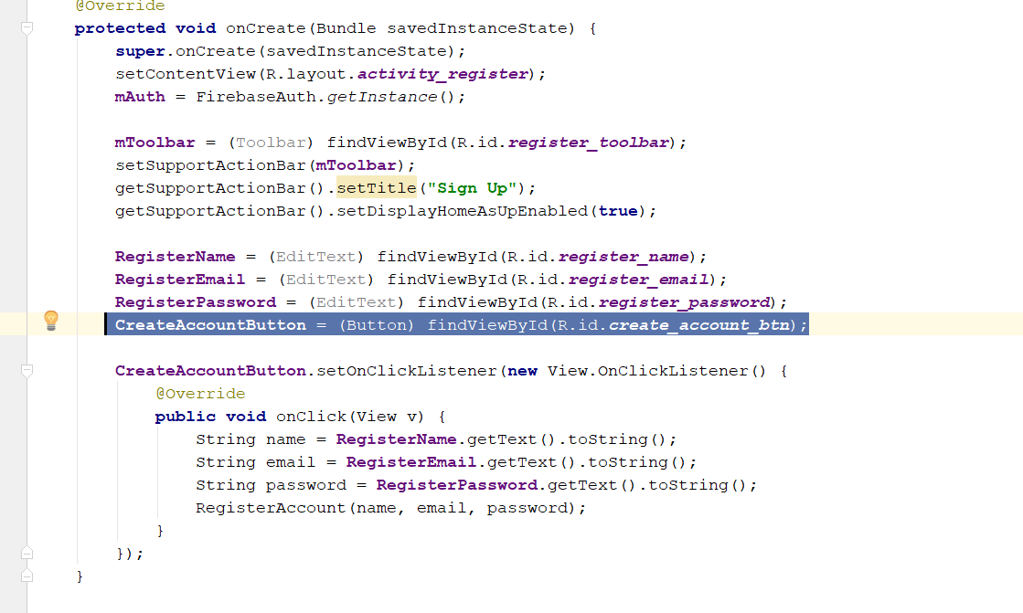
* Now we add a loading bar to display whenever someone press the button
* Declare this one top, private ProgressDialog loadingbar;
* Then in the onCreate method, instantise it, loadingbar = new ProgressDialog(this);

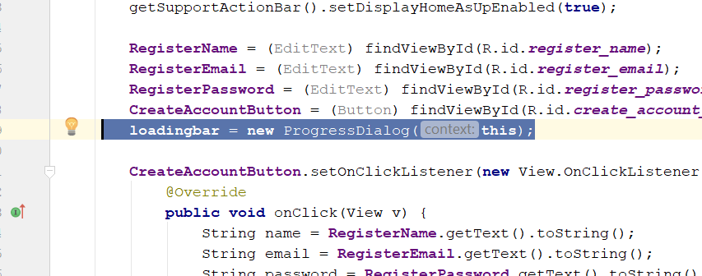

* Now at the Else statement there, add in the loadingbar message, setTitle(), and setMessage();
* After the last else, you must add in loadingbar.dismss
* 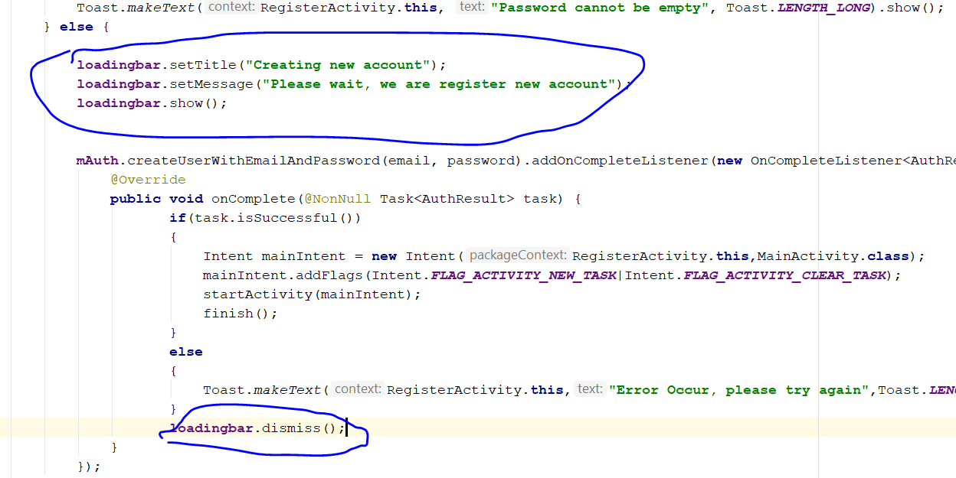
* Rebuild and Run
* Error occur
* 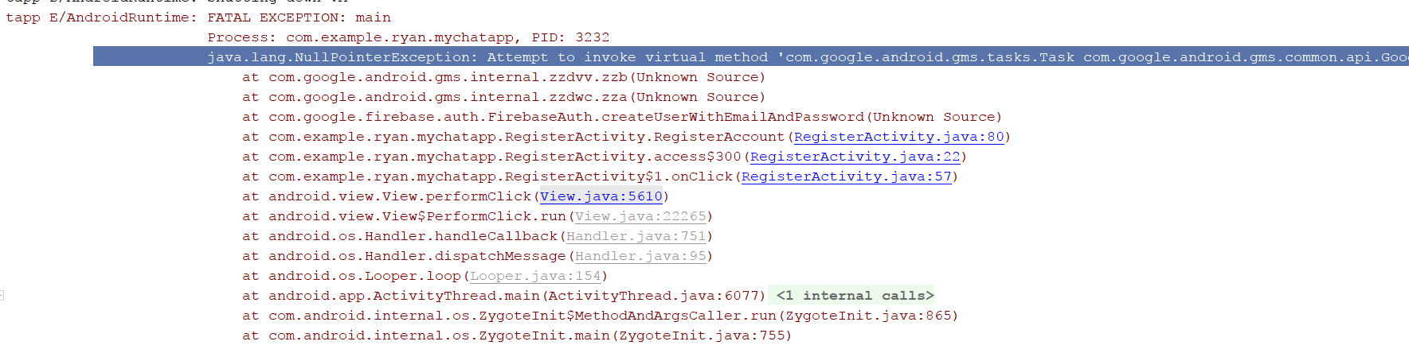
* Resolution: change to 11.2.0 in the build/gradle
* 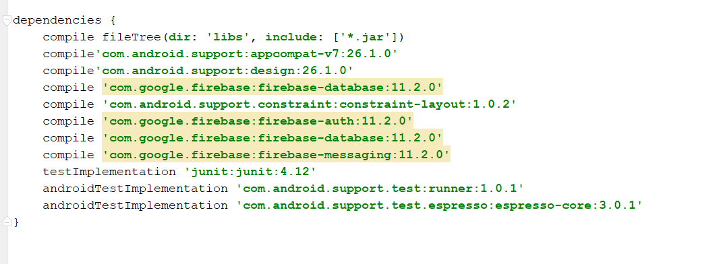
* They will prompt u to ipdate the Google Play services
* 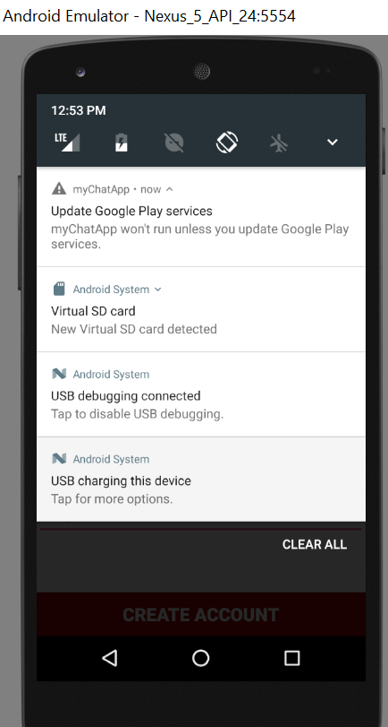
* Build/Gradle – app code

apply plugin: 'com.android.application'

android {

compileSdkVersion 26

defaultConfig {

applicationId "com.example.ryan.mychatapp"

minSdkVersion 21

targetSdkVersion 26

versionCode 1

versionName "1.0"

testInstrumentationRunner "android.support.test.runner.AndroidJUnitRunner"

}

buildTypes {

release {

minifyEnabled false

proguardFiles getDefaultProguardFile('proguard-android.txt'), 'proguard-rules.pro'

}

}

}

dependencies {

implementation fileTree(dir: 'libs', include: ['*.jar'])

implementation 'com.android.support:appcompat-v7:26.1.0'

implementation 'com.android.support:design:26.1.0'

implementation 'com.android.support.constraint:constraint-layout:1.0.2'

implementation 'com.google.firebase:firebase-auth:11.0.4'

implementation 'com.google.firebase:firebase-database:11.0.4'

implementation 'com.google.firebase:firebase-messaging:11.0.4'

testImplementation 'junit:junit:4.12'

androidTestImplementation 'com.android.support.test:runner:1.0.1'

androidTestImplementation 'com.android.support.test.espresso:espresso-core:3.0.1'

# Step 7: Create logout button

* At RES, create **Android Resource directory**
* Resource type will be menu, click okay
* Then you will see a menu directory
* 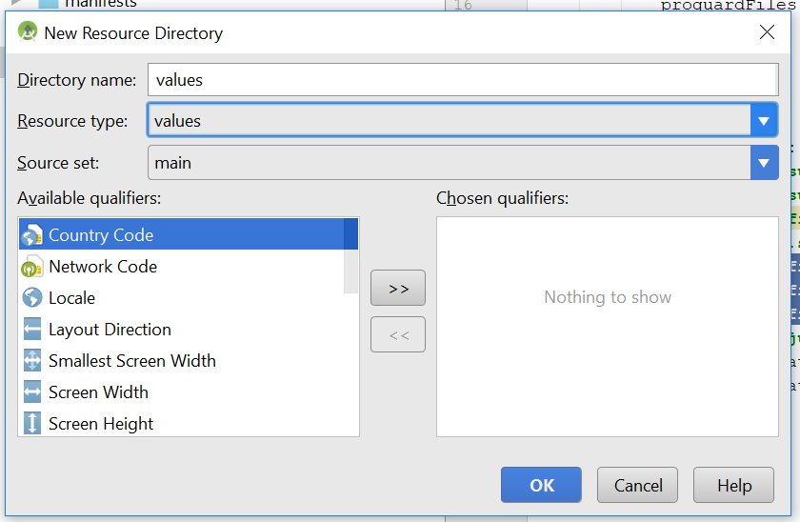
* 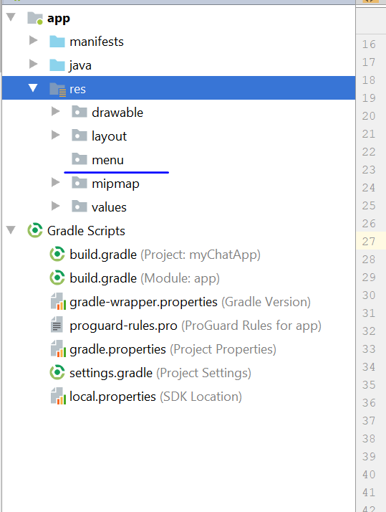
* Click menu, right click -> menu resource file
* The name will main_menu
* A main_menu.xml file will be created
* 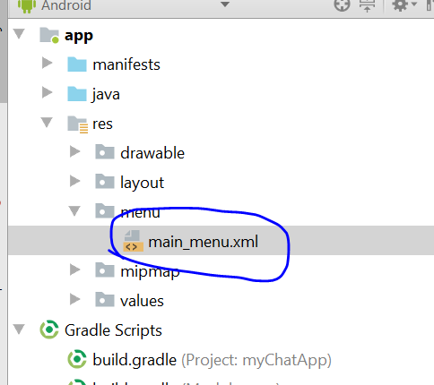
* Now we add the item inside the main_menu.xml
* 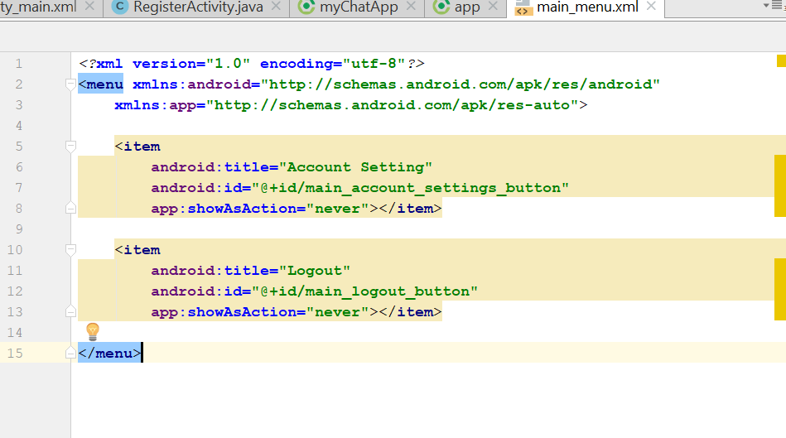
* Now go to mainActivity.java, go to the onStart() method to check if user is login
* Create a new method, call “LogoutUser()”
* Copy and paste the content from inside the onStart method, to the LogoutUser, and paste the logoutUser() in the onStart() method, if currentuser == null
* 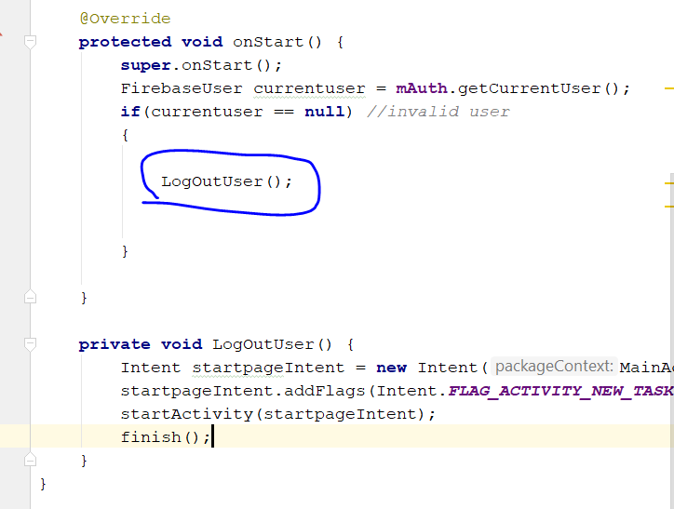
* Then add in onCreateoptionMenu(Menu menu)
* Add this line

‘**public boolean** onCreateOptionsMenu(Menu menu) {  
 **super**.onCreateOptionsMenu(menu);  
 getMenuInflater().inflate(R.menu.***main_menu***,menu);  
 **return true**;  
}

* Then add a new method onOptionItemselected()

**public boolean** onOptionsItemSelected(MenuItem item) {  
 **super**.onOptionsItemSelected(item);  
 **if**(item.getItemId() == R.id.***main_logout_button***)*//logoout user* {  
 **mAuth**.signOut();  
 }  
   
}

* 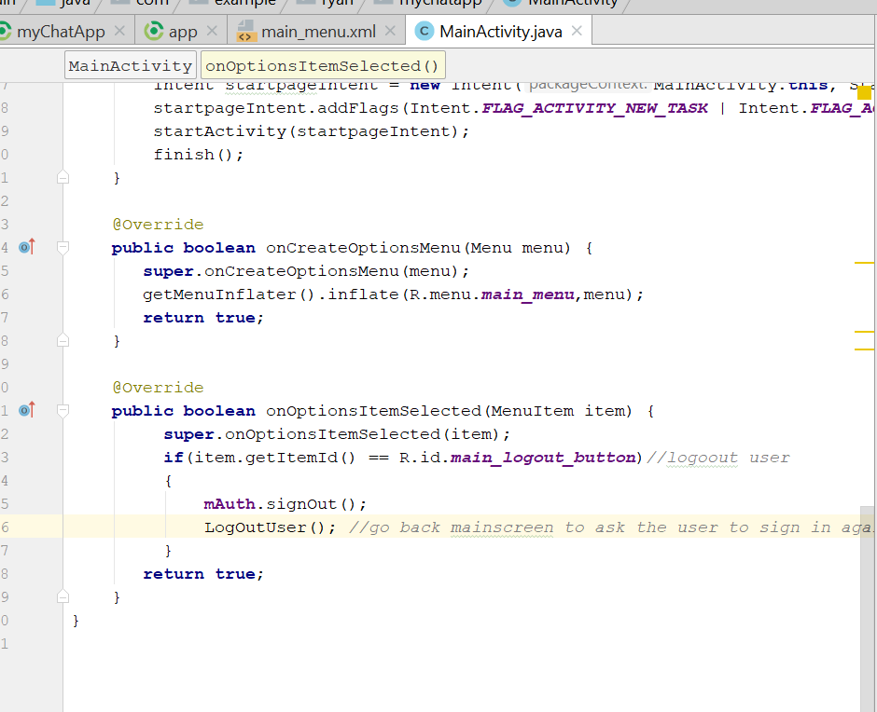
* Rebuild and Run

# Step 8: add tab on Main activity

* Delete the textview on activity_main.xml
* Add this line
* <**android.support.design.widget.AppBarLayout  
   android:layout_width="match_parent"  
   android:layout_height="wrap_content"**></**android.support.design.widget.AppBarLayout**>
* Then you will see this
* 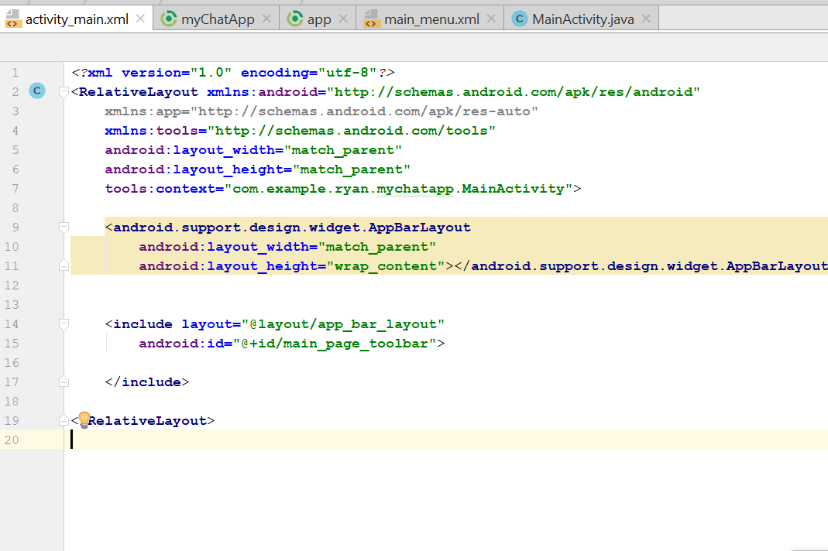
* Cut the app_bar_layout and paste into the AppbarLayout
* It will look like this now
* 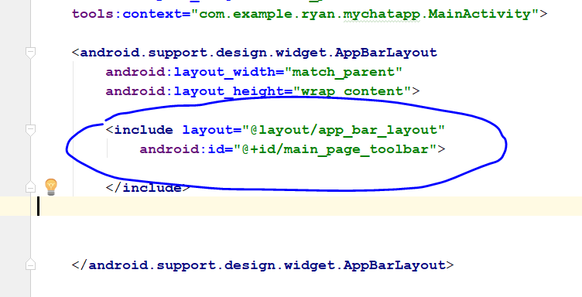
* Add this
* <**android.support.design.widget.TabLayout  
   android:id="@+id/main_tabs"  
  android:layout_width="match_parent"  
  android:layout_height="wrap_content"**>  
    
  </**android.support.design.widget.TabLayout**>
* 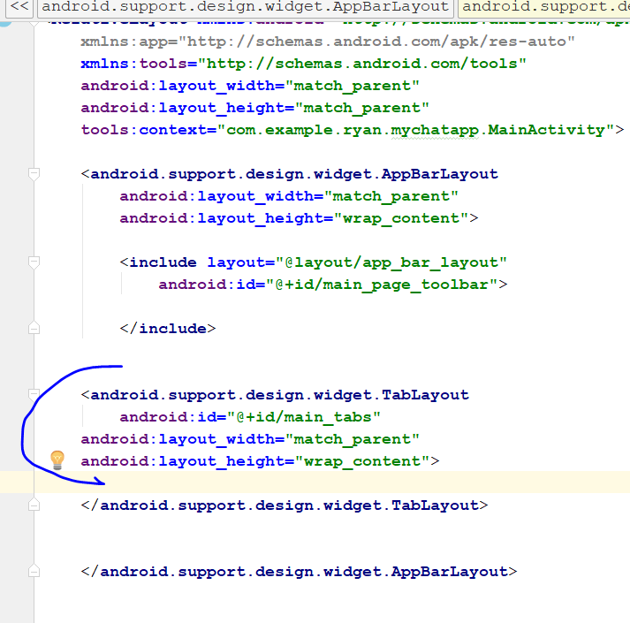
* Now look like this
* 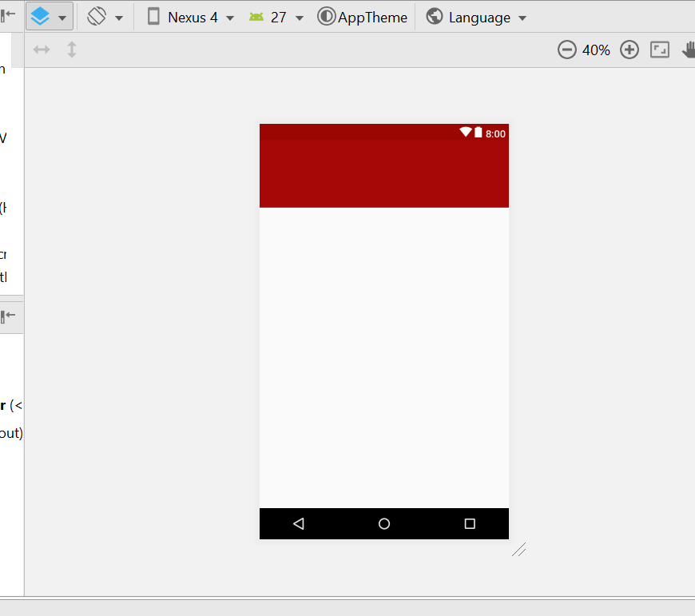
* Click on this
* 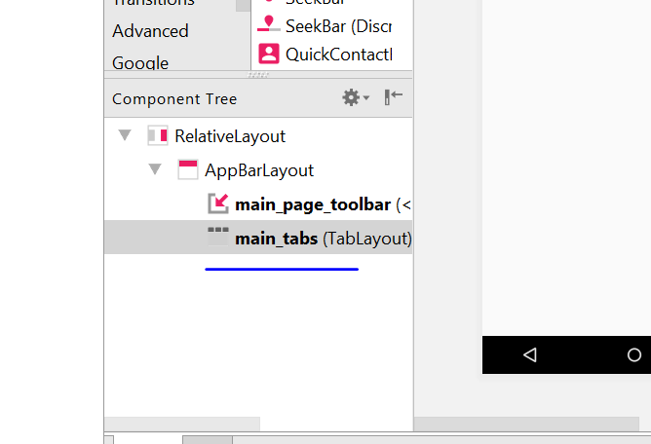
* Go to theme
* 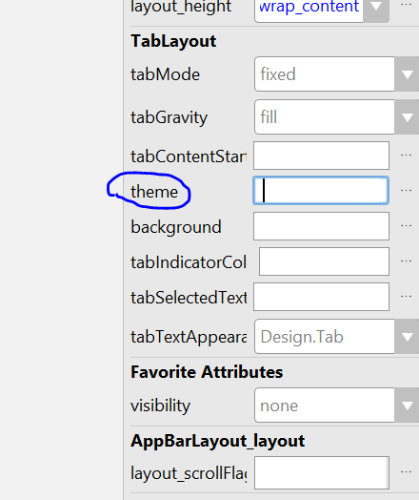
* Click on the 3 dot, search of AppCompat.Dark
* 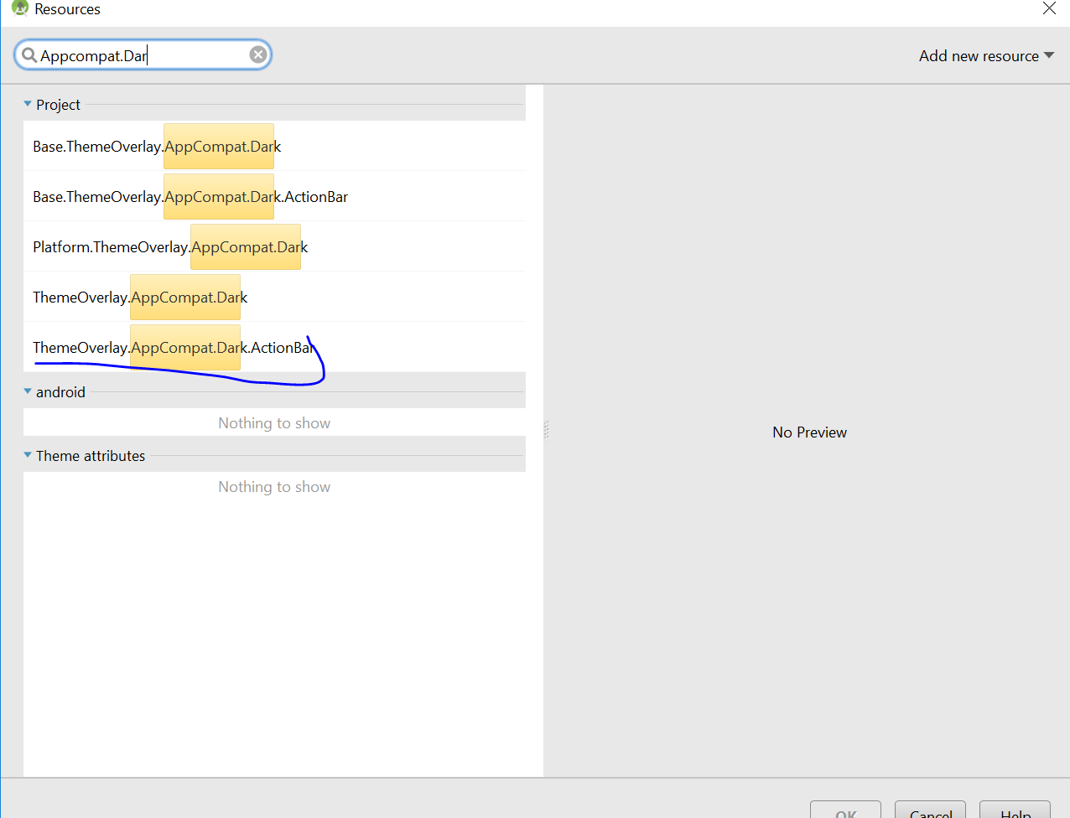
* Select this one
* Add in this line in the Text part
* 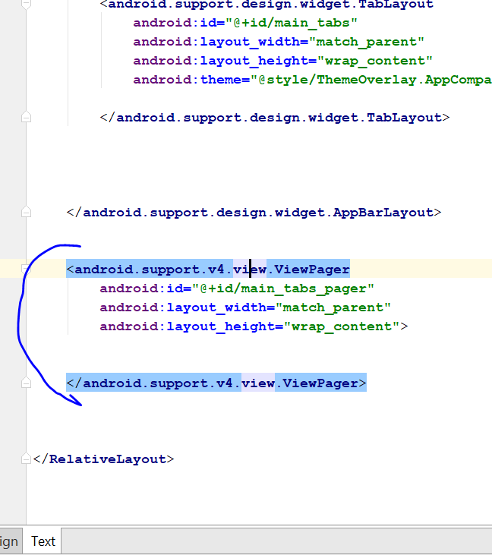
* <**android.support.v4.view.ViewPager  
   android:id="@+id/main_tabs_pager"  
   android:layout_width="match_parent"  
   android:layout_height="wrap_content"**>  
    
    
  </**android.support.v4.view.ViewPager**>
* Go to Design
* 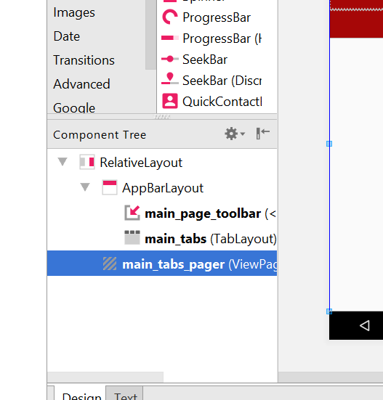
* Select pager
* Create fragment, right click , new -> new Fragment (Blank)
* 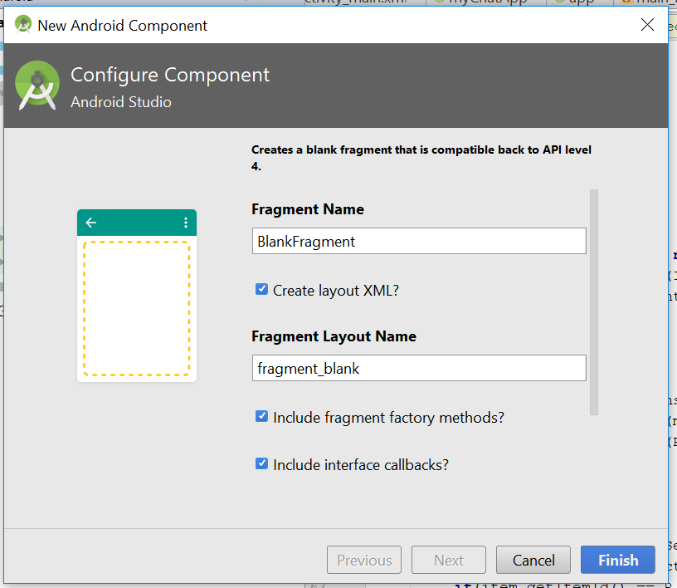
* In the same java location as main activity
* Uncheck this two checkbox
* 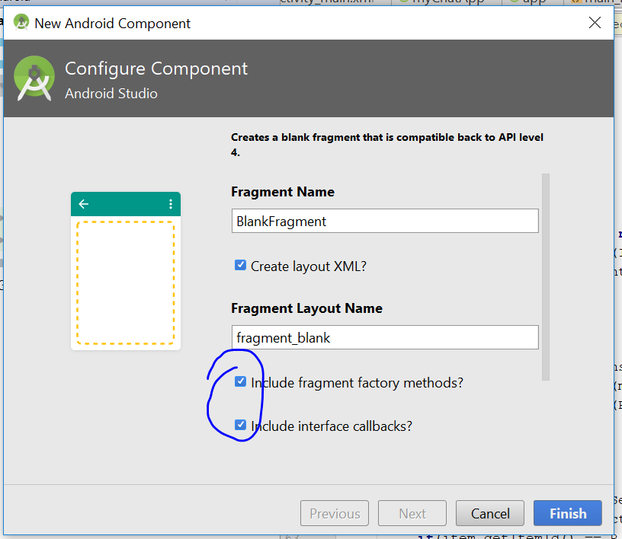
* 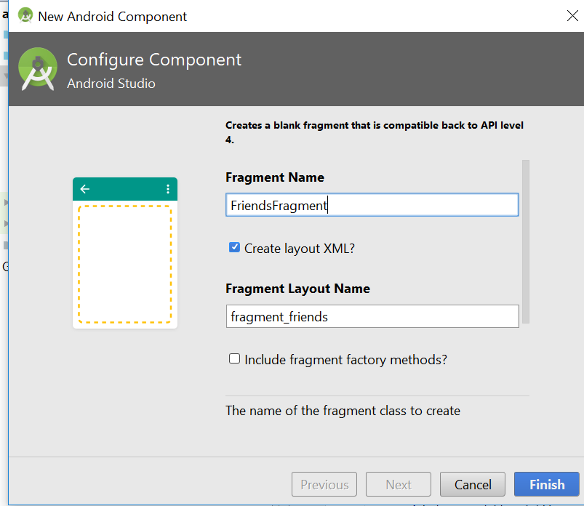
* Create new Fragment again -> this time call it chat fragments
* 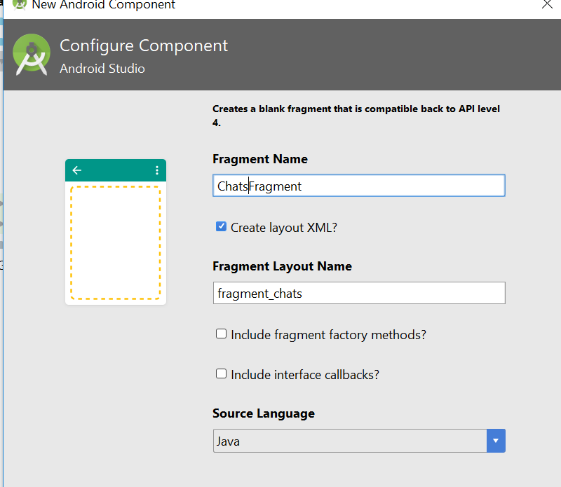
* Now create Request fragment -> click finish
* Now it should look like this
* 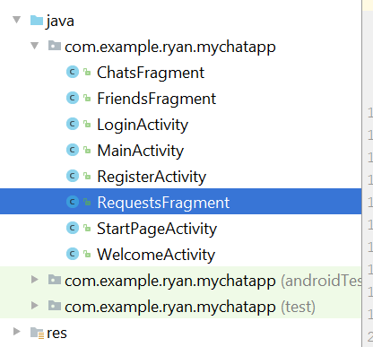
* Go to fragment_chat.xml, change the textview
* 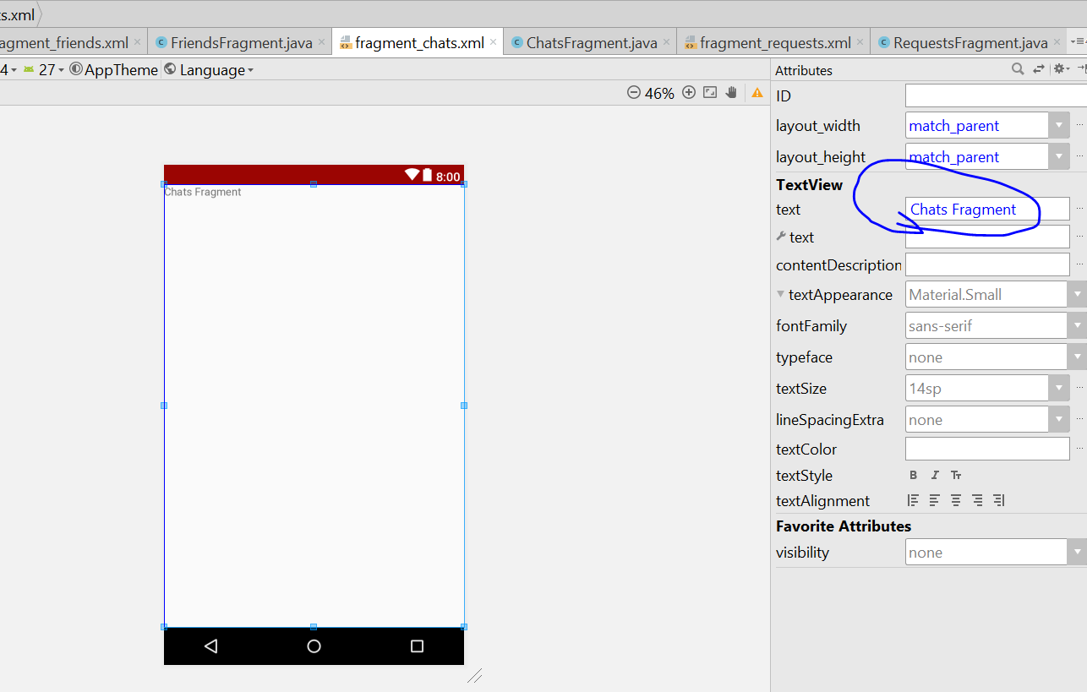
* Same applied to fragment_request.xml, fragment_friend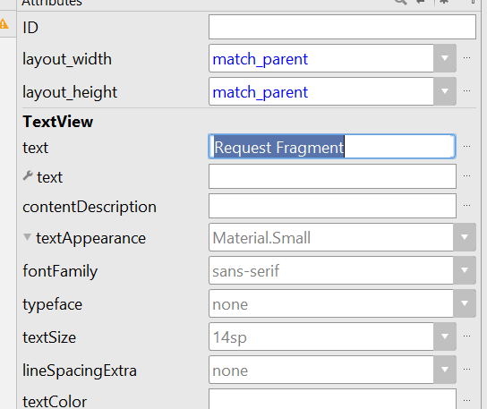
* Now go to Mainactivity.java
* Add in the following code
* 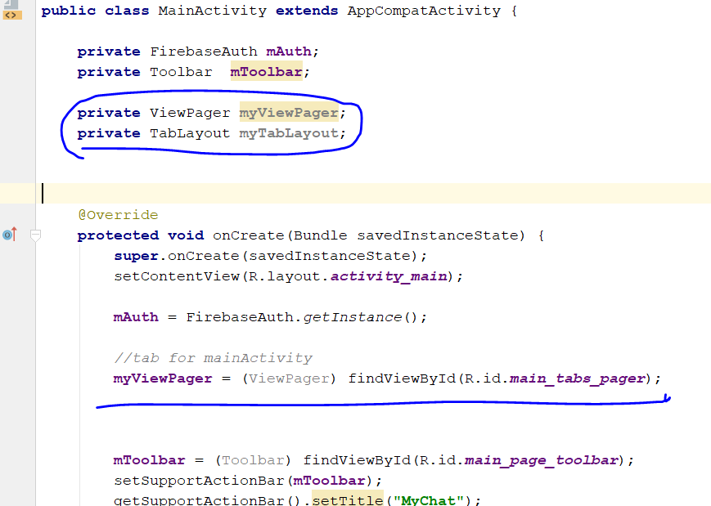
* Now create a new Pager Adapter in the MainActivity Java
* private TabsPagerAdapter myTabsPagerAdapter; it will appear Red red, it is okay, create the class, a new class call TabsPagerAdapter will be created
* 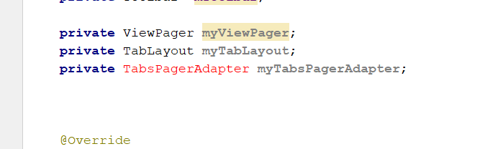
* In the “TabspagerAdapter.java”, u will need to import some library
* **import** android.support.v4.app.Fragment;  
  **import** android.support.v4.app.FragmentManager;  
  **import** android.support.v4.app.FragmentPagerAdapter;
* 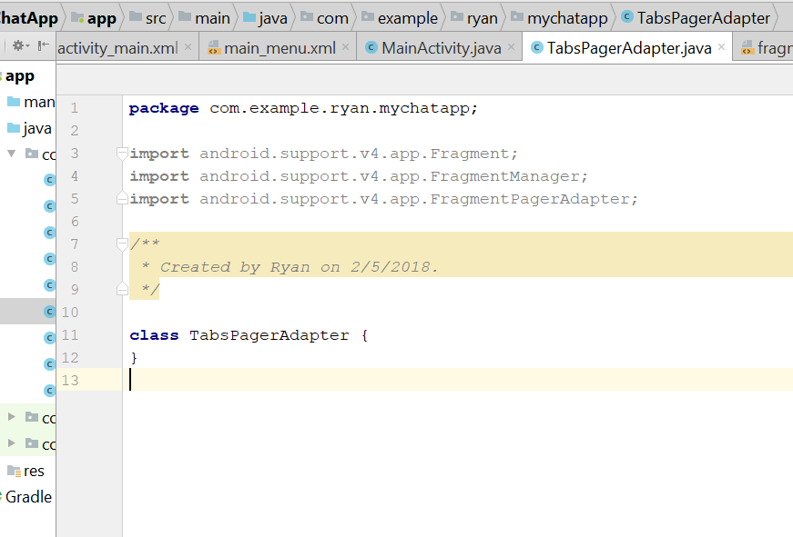
* Now add this line in the class, implement the method automatically
* 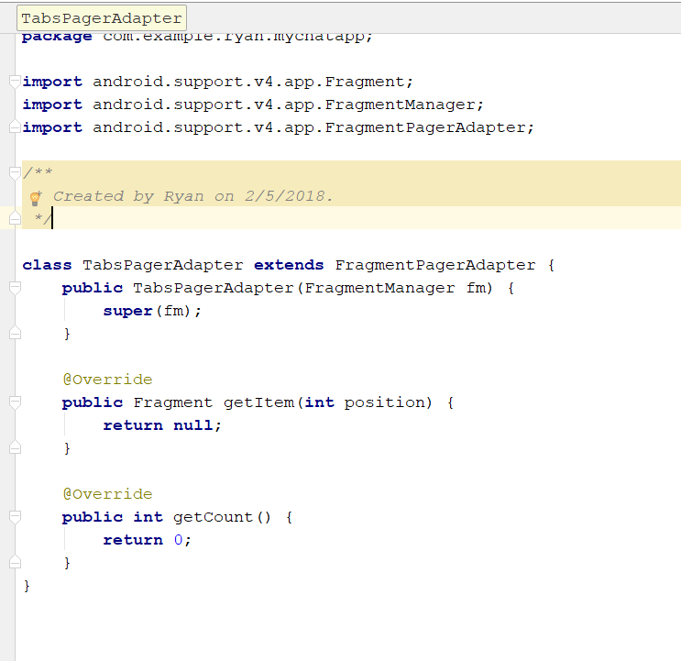
* Change the method accordingly to this
* 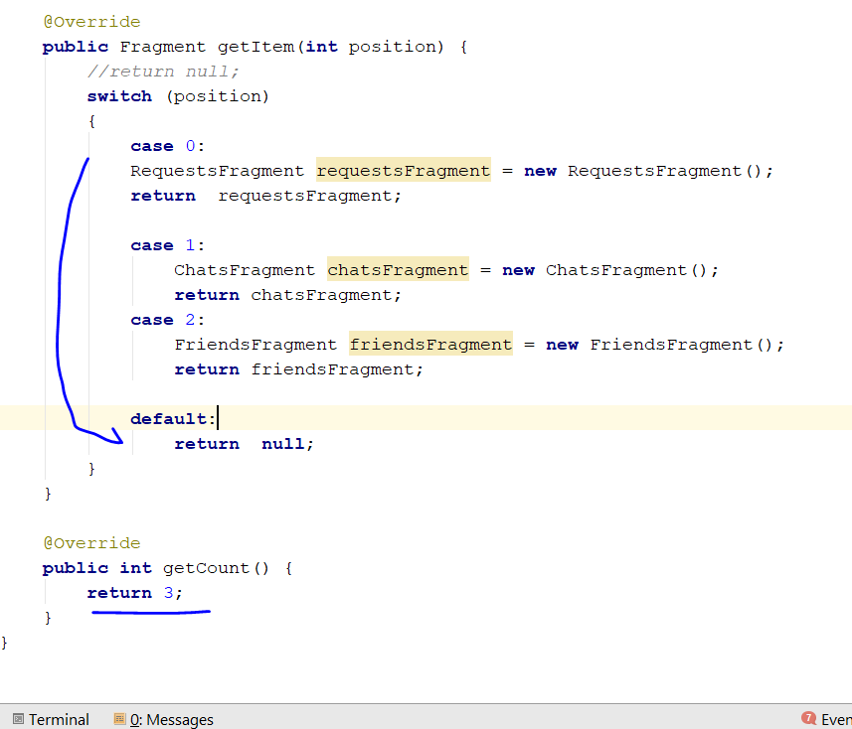
* Add in the new method call getPageTitle(), like below
* 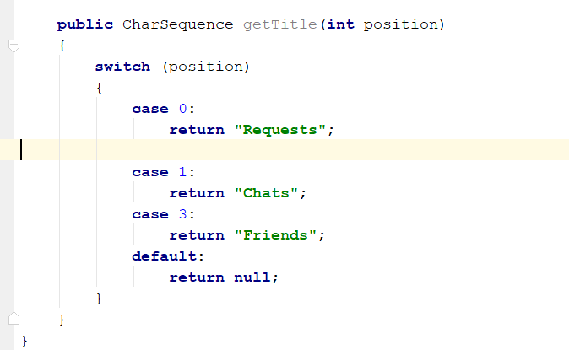
* Now go back to MainActivity.java
* Go to onCreate method
* Add in this line
* *//tab for mainActivity***myViewPager** = (ViewPager) findViewById(R.id.***main_tabs_pager***);  
  **myTabsPagerAdapter** = **new** TabsPagerAdapter(getSupportFragmentManager());  
  **myViewPager**.setAdapter(**myTabsPagerAdapter**);  
  **myTabLayout** = (TabLayout) findViewById(R.id.***main_tabs***);  
  **myTabLayout**.setupWithViewPager(**myViewPager**);
* 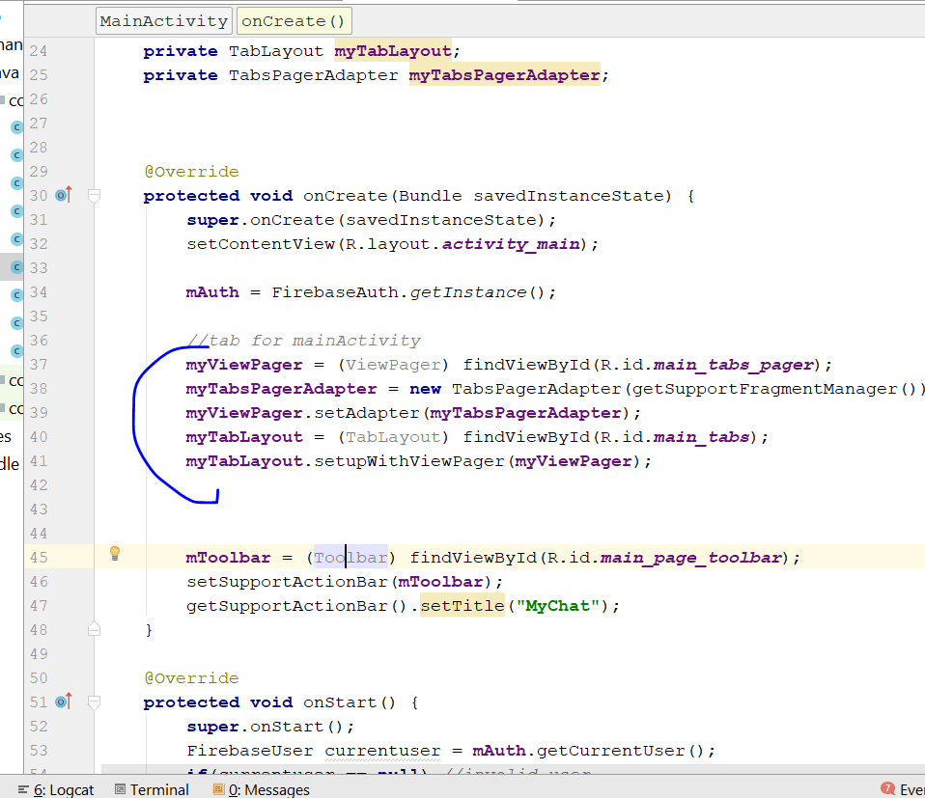
* Rebuild and Run
* GOT BUG, Fragment not showing
* RESOLVED: You need to move the word down

# Step 9: Login Activity

* Go to login activity xml
* Click on the email field, change the input type, to email and multiline
* Click ok
* Password, change the input type, to password and multiline
* Add name for the textfield, login_email
* Add name for password, login_password
* Button = login_btn
* Now go to login activity.java
* Add in Private button LoginButton, EditText LoginEmail, Edit LoginPassword
* Go to onCreate, and cast the button to findviewbyId(R.id. login_email); do the same for button and password
* 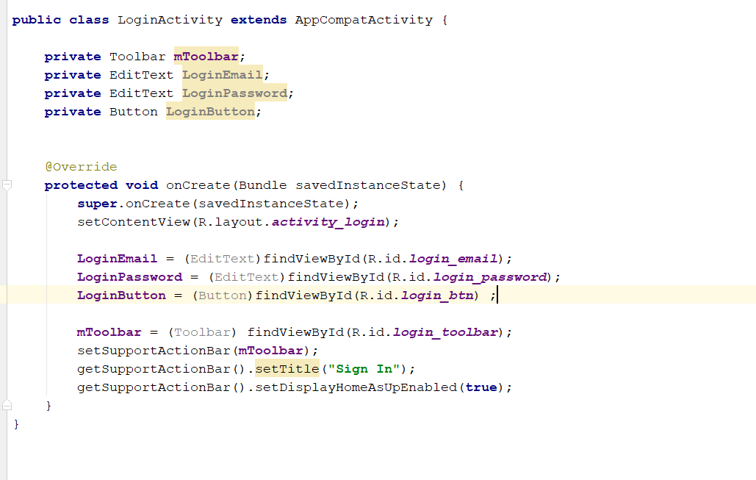
* Now setOnClicklistener for login button
* 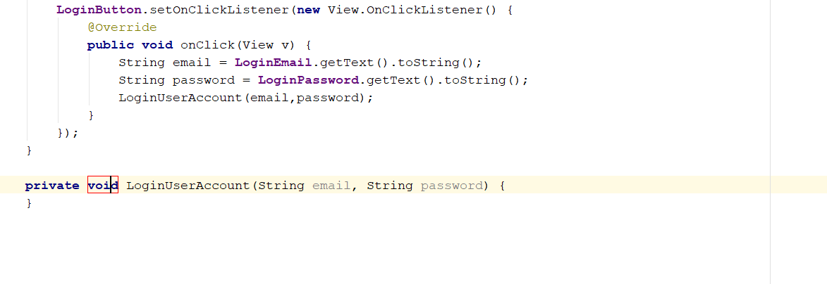
* Create a new method call “LoginUserAccount()”
* Add the following line to check for empty string in the LoginUserAccount()
* 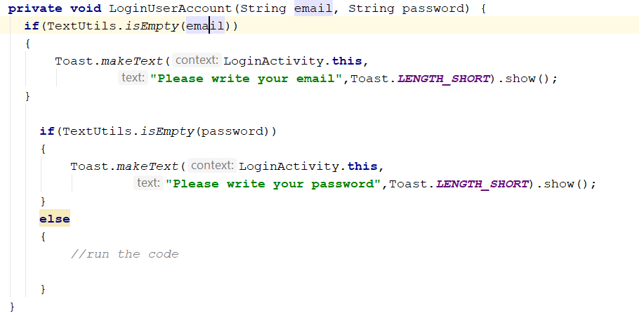
* Now add a firebase object to run the code to login
* Private FireBaseAuth mAuth;
* 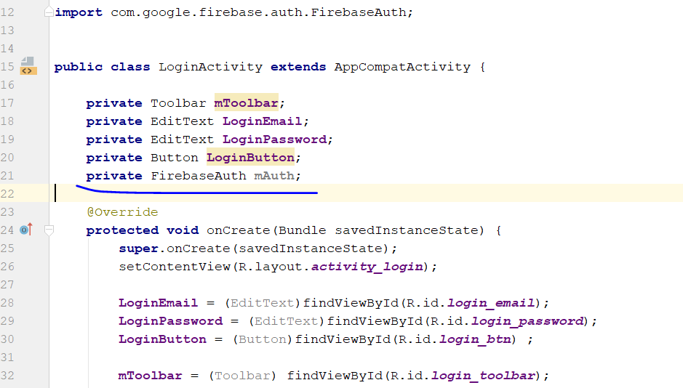
* In the onCreate method, add in this code
* 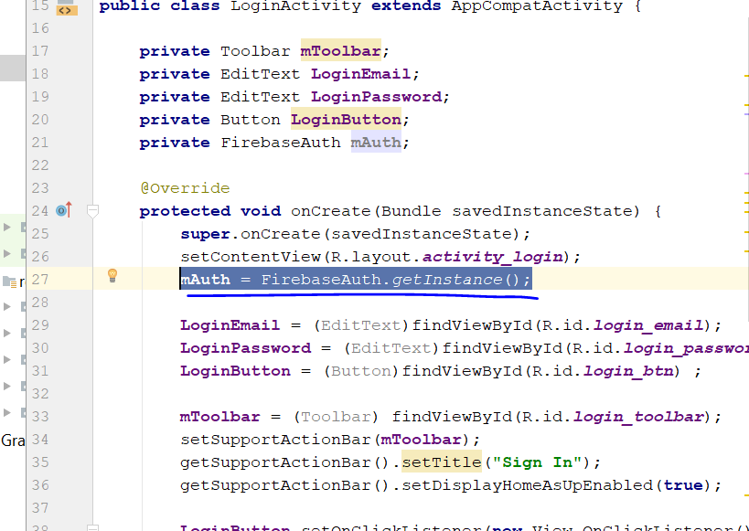
* Inside the else, write something like this
* 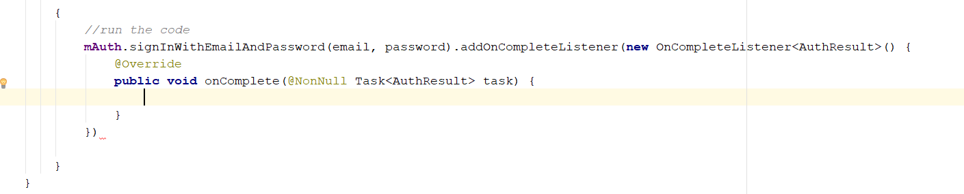
* Add in the following code, if successful, it will bring the user to the mainactivity.java
* 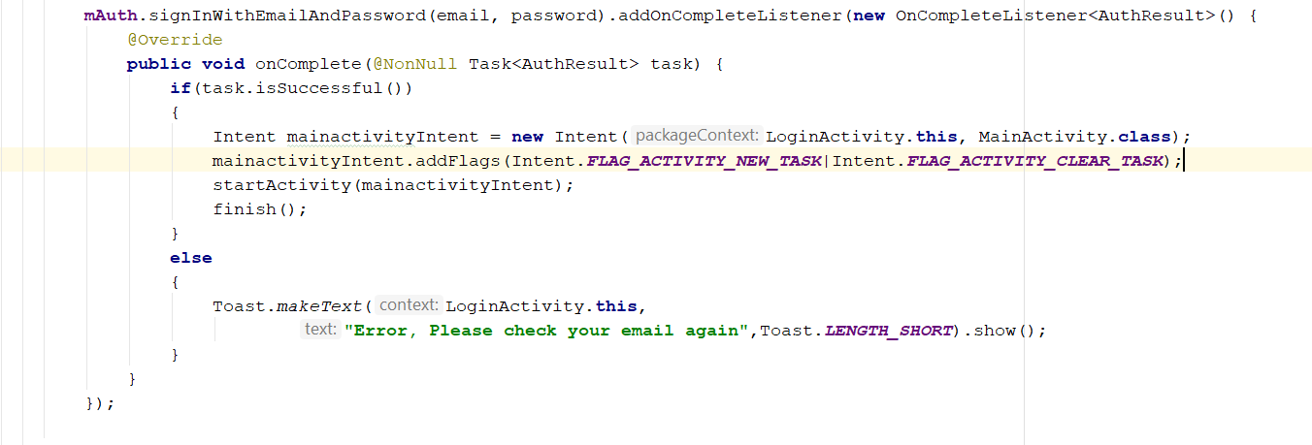
* Now add a ProgressDialog
* **private** ProgressDialog **loadingbar**;
* **loadingbar** = **new** ProgressDialog(**this**);
* add this code in the else statement
* 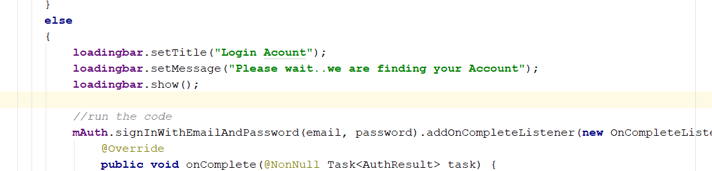
* Rebuild and Run

# Step 10: Setting Activity

* Create new Activity 🡪 Empty Activity
* The activity name will be settingActivity
* Now go to Activity_setting.xml
* Change the layout to relative layout
* 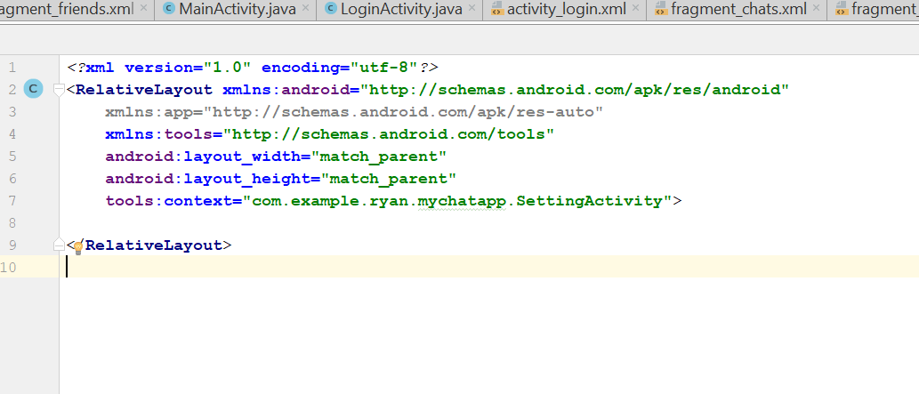
* Now we need to add CircleImage view
* 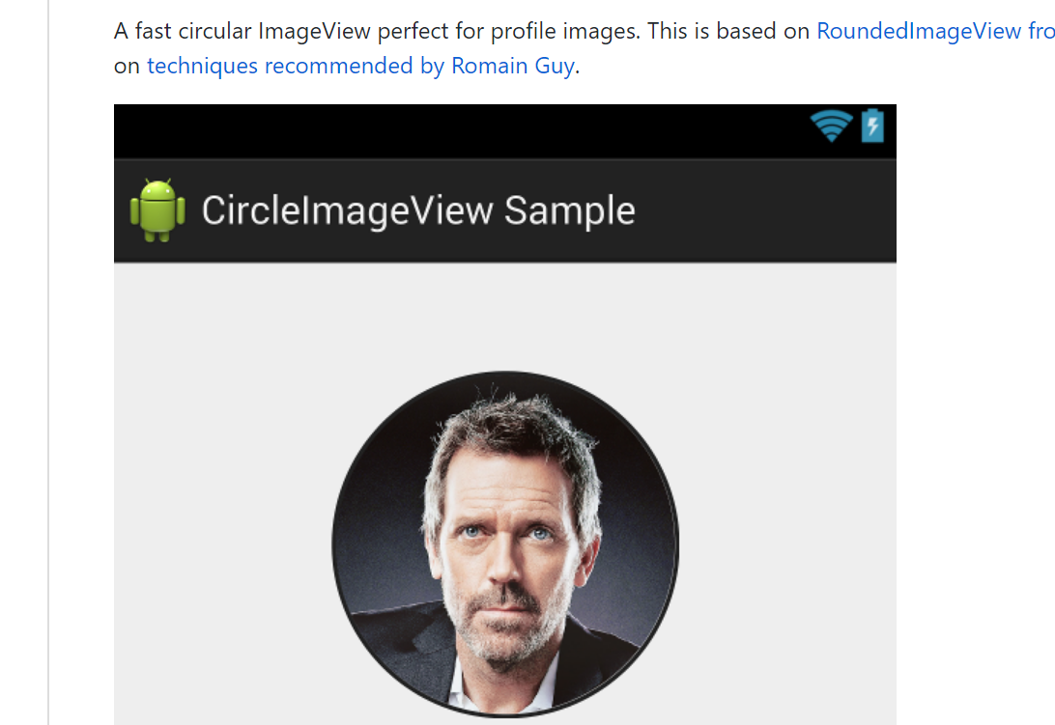
* Add this line for dependencies
* Copy compile 'de.hdodenhof:circleimageview:2.2.0'
* click on this build/gradle
* 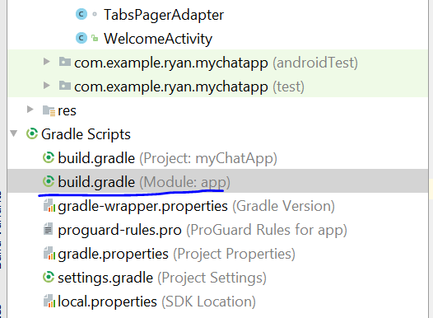
* Copy into the build/gradle and sync
* 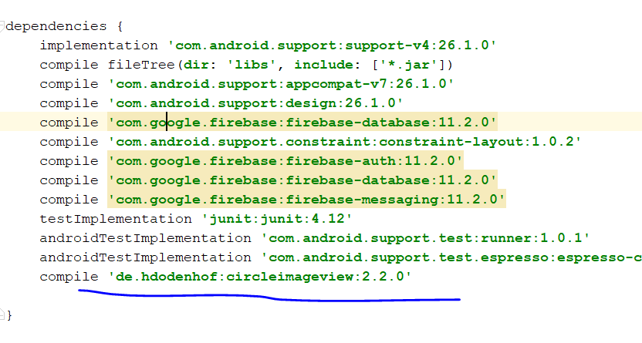
* Now to activity_setting.xml, change the layout colour
* Add in
* **android:background="@color/colorPrimary"**
* download a image and name it default_profile.jpg
* copy into the resource folder
* write those code in the XML
* 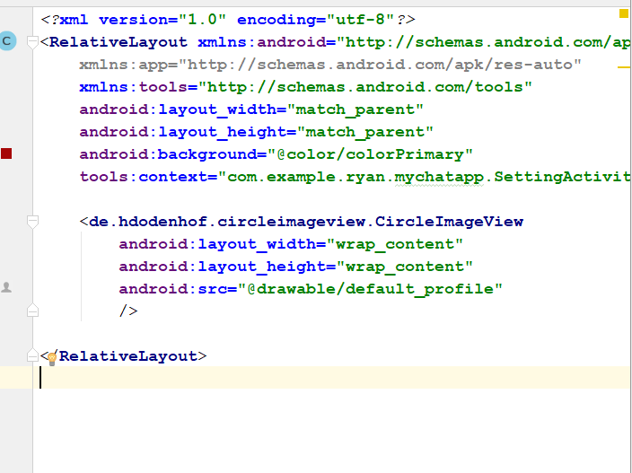
* Preview your setting XML, it now look like this
* 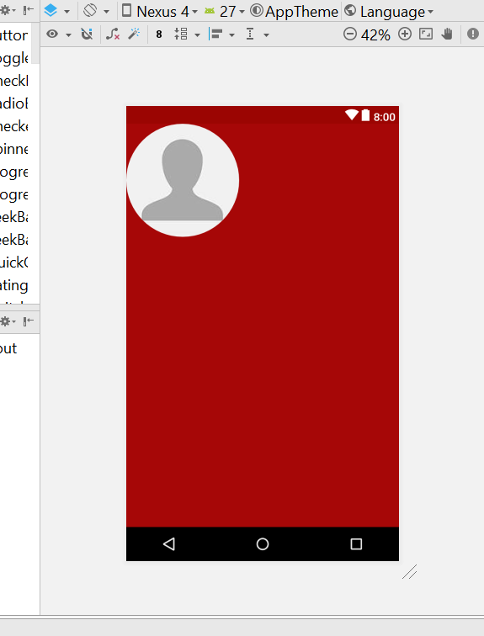
* Change the height and weight to 200dp
* Drag a bit now it become like that
* 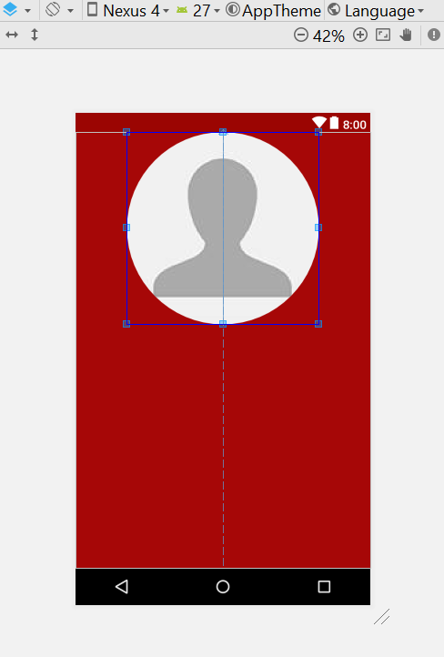
* Drag and drop a textview to the centre, as username
* The size of the text will be 22, and the colour will be background light
* 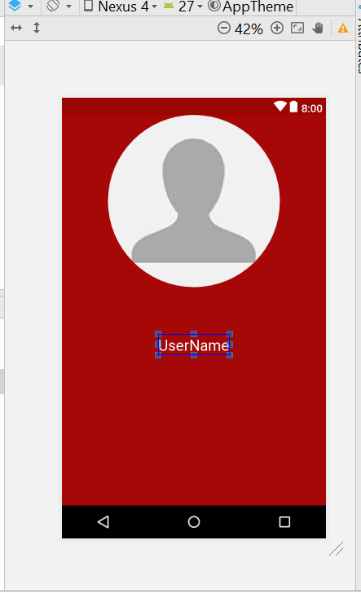
* Drag a new textView into the centre as status
* The size will be 18 dp, also background light
* 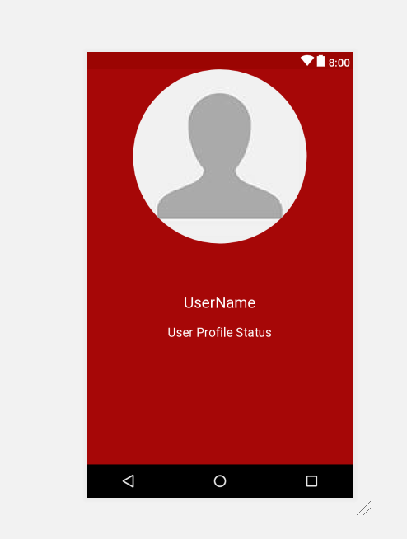
* Now drag two button here
* 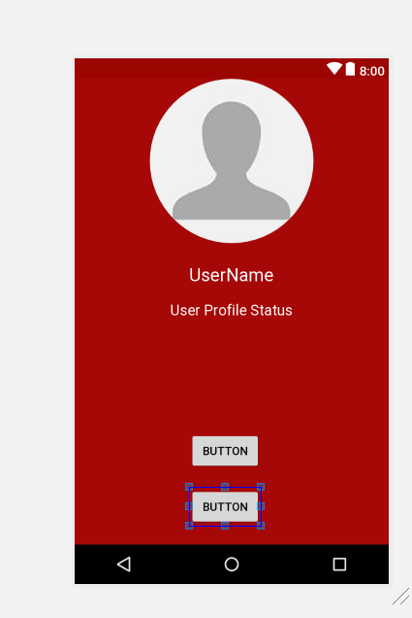
* One is call Change image, one is call change status
* 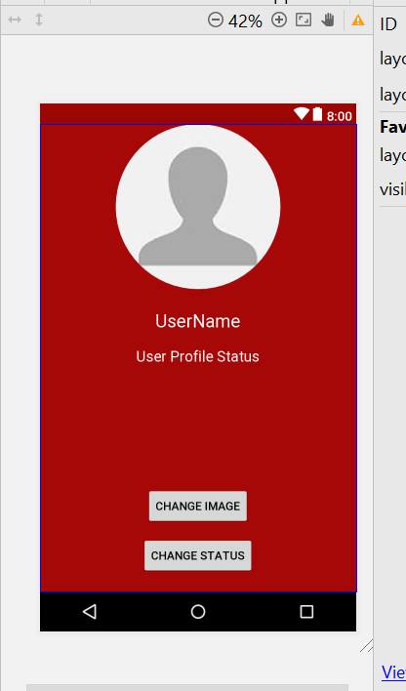
* The change name button background colour change to Background light
* The change status button background colour change to holo green
* The height will be 50, and length will be 200
* The textsize should be 18dp
* 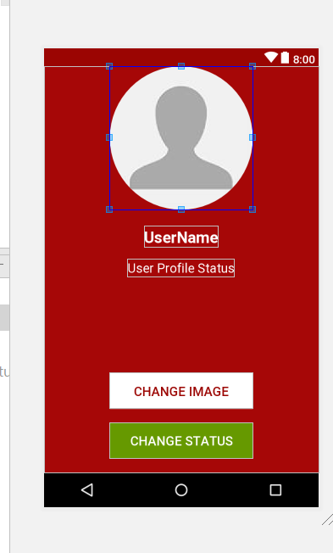
* Change the id of the circle view now -. “settings_profile_image”
* Username 🡪 “settings_profile_username”
* For the image button -> settings_change_profile_image_btn
* For the status button 🡪 settings_change_profile_status_btn
* Go to the MainActivity.java, add in this line
* **if**(item.getItemId() ==R.id.***main_account_settings_button***)  
  {  
   Intent SettingActivityIntent = **new** Intent(MainActivity.**this**,SettingActivity.**class**);  
   startActivity(SettingActivityIntent);  
  }
* 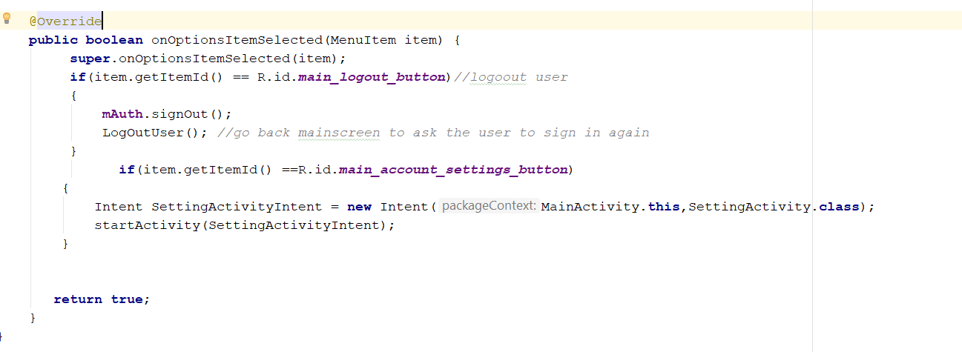
* Now it look something like that

# Step 11: Saving User Data in FireBase Database

* Go to the registerActivity.java
* Add this line
* **private** DatabaseReference storeUserDefaultDataReference
* go to this line
* 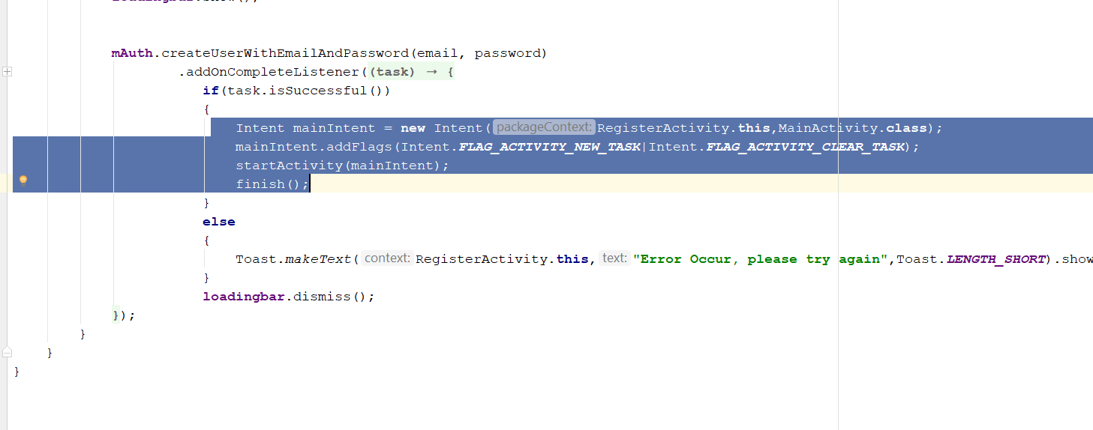
* You need to create a reference to the database
* **storeUserDefaultDataReference** = FirebaseDatabase.*getInstance*().getReference();
* 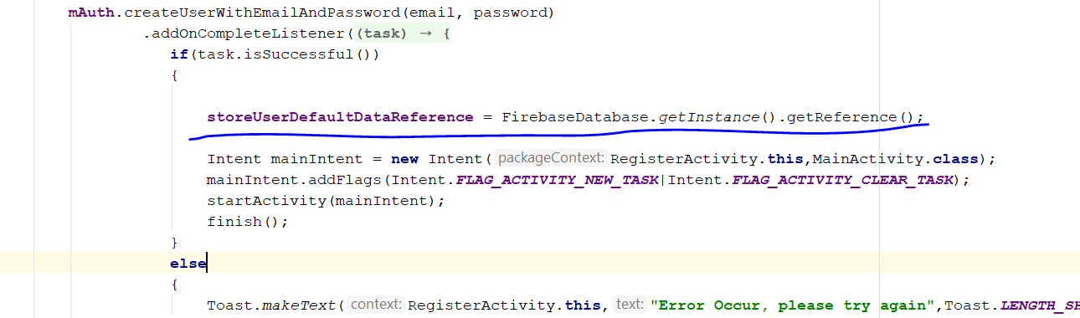
* This code will create and store reference in the variable, it is point to firebase database reoot
* U need to save User_image, User_image, user_status, user_thumb_image
* Next create a child, then “Users”
* **storeUserDefaultDataReference** = FirebaseDatabase.*getInstance*().getReference().child(**"Users"**);
* add in this line
* String current_user_Id = **mAuth**.getCurrentUser().getUid();
* **storeUserDefaultDataReference** = **storeUserDefaultDataReference** = FirebaseDatabase.*getInstance*().getReference().child(**"Users"**).child(current_user_Id);
* String name = **RegisterName**.getText().toString(); change to final
* **storeUserDefaultDataReference** = FirebaseDatabase.*getInstance*().getReference().child(**"Users"**).child(**"current_user_Id"**);  
  **storeUserDefaultDataReference**.child(**"user_name"**).setValue(name);  
  **storeUserDefaultDataReference**.child(**"user_status"**).setValue(**"Hey there, I am using mychat"**);  
  **storeUserDefaultDataReference**.child(**"user_image"**).setValue(**"default_profile"**);  
  **storeUserDefaultDataReference**.child(**"user_thumb_image"**).setValue(**"default_image"**)
* at the end this is how your whole code look like
* 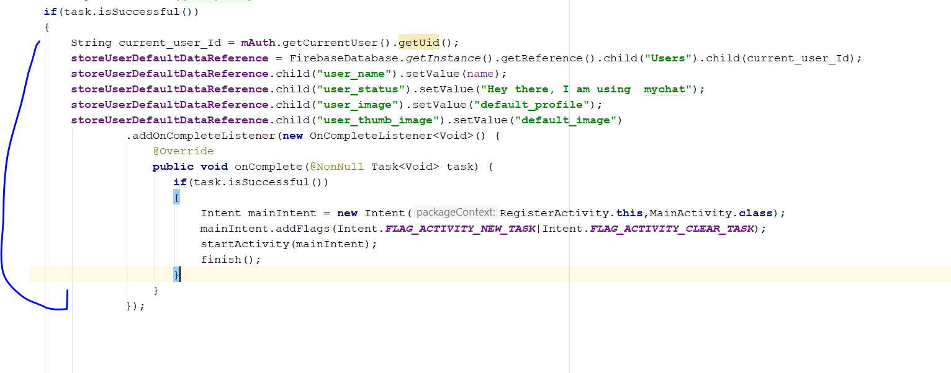
* Rebuild and Run
* Delete any existing account in the firebase
* Then recreate a new account
* 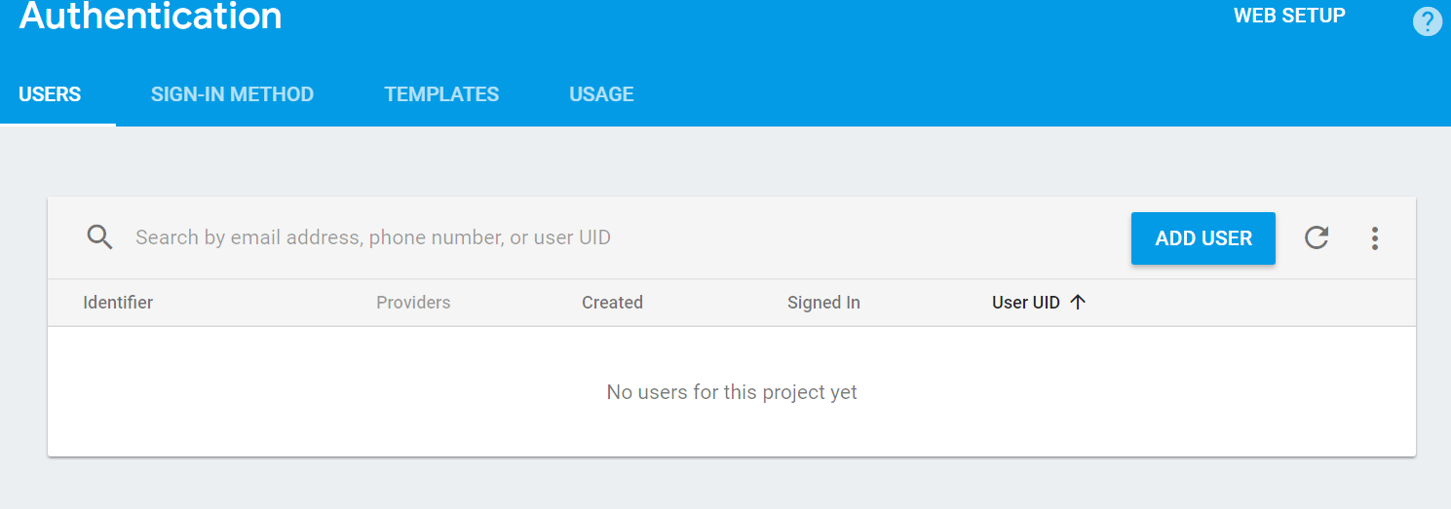
* 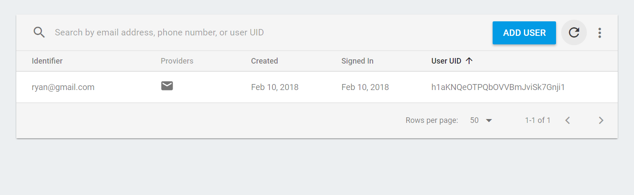
* Then u go to Database
* 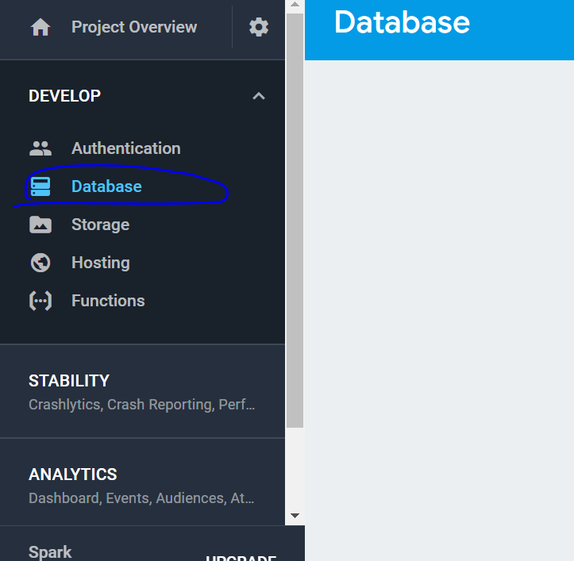
* 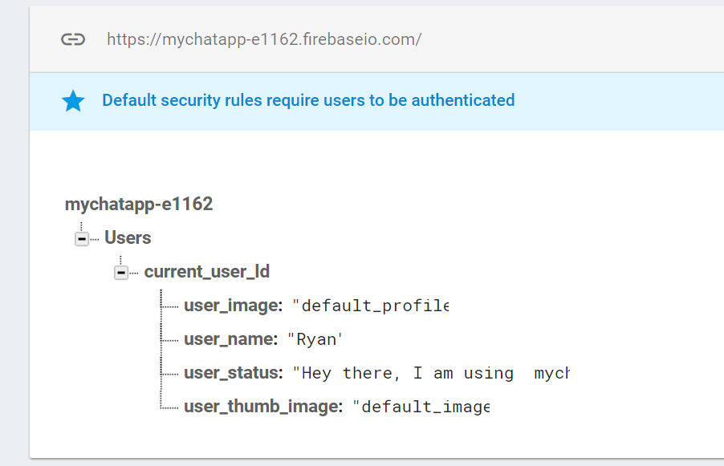
* You will see this

# Step 11: Retrieve user info from Database

* Now we will talk about retrieve those setting at account setting
* Now go to settingActivity
* Declare private CircleImageView settingsDisplayImage;
* Declare private TextView settingsDisplayname;
* Declare private TextView settingsDisplayStatus;
* Private Button settingsChangeProfileImage;
* Private Button settingsChangeStatus;
* 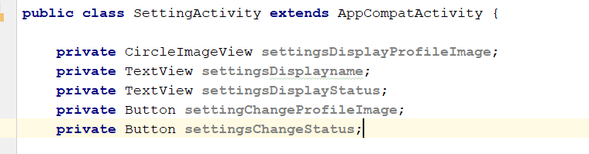
* Now to go onCreate method
* **settingsDisplayProfileImage** = (CircleImageView)findViewById(R.id.***settings_profile_image***);  
  **settingsDisplayname** = (TextView) findViewById(R.id.***settings_username***);  
  **settingsDisplayStatus** = (TextView) findViewById(R.id.***settings_user_status***);  
  **settingChangeProfileImage** = (Button) findViewById(R.id.***settings_change_profile_image_btn***);  
  **settingsChangeStatus** = (Button) findViewById(R.id.***settings_change_profile_status_btn***);
* add in this two line on top
* 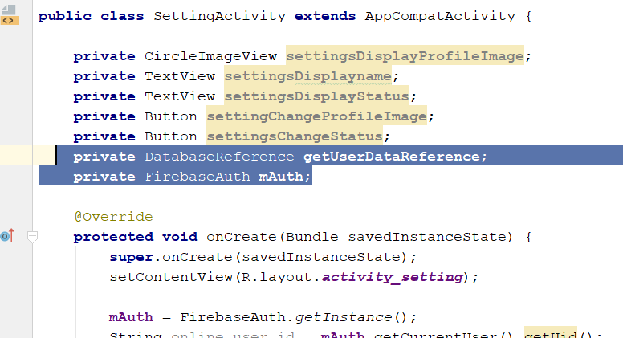
* In the onCreate add in
* **mAuth** = FirebaseAuth.*getInstance*();  
  String online_user_id = **mAuth**.getCurrentUser().getUid();  
  **getUserDataReference** = **getUserDataReference** = FirebaseDatabase.*getInstance*().getReference().child(**"Users"**).child(online_user_id);
* Add this below
* **getUserDataReference**.addValueEventListener(**new** ValueEventListener() {  
   @Override  
   **public void** onDataChange(DataSnapshot dataSnapshot) {  
    
   }  
    
   @Override  
   **public void** onCancelled(DatabaseError databaseError) {  
    
   }  
  });
* In the Datasnapshot, it will retrieve all the information of a particular user, but the UID
* 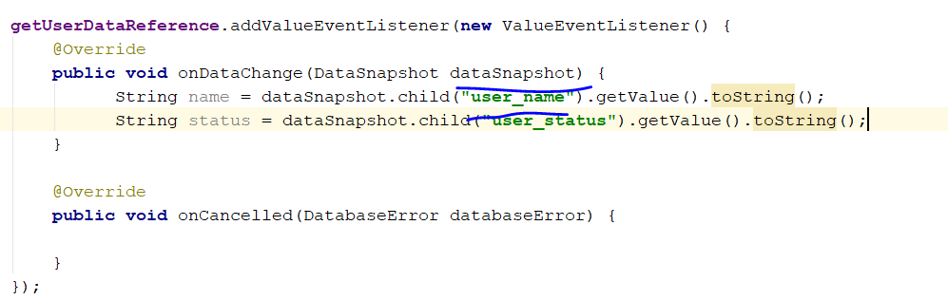
* The child(), must have the same name as the node in the firebase
* 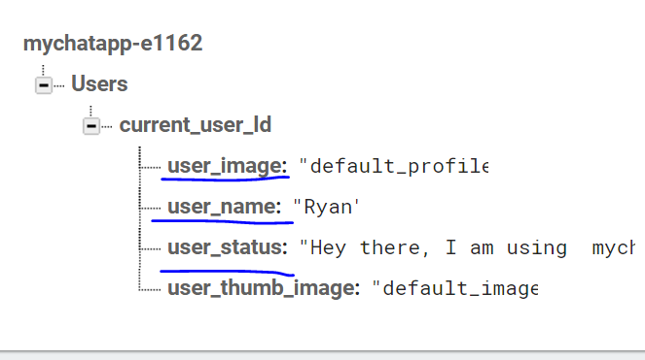
* Basically it will look like this
* 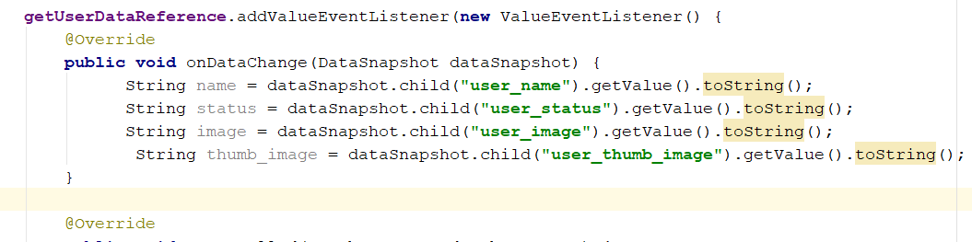
* Add in this two line
* **settingsDisplayname**.setText(name);  
  **settingsDisplayStatus**.setText(status);
* 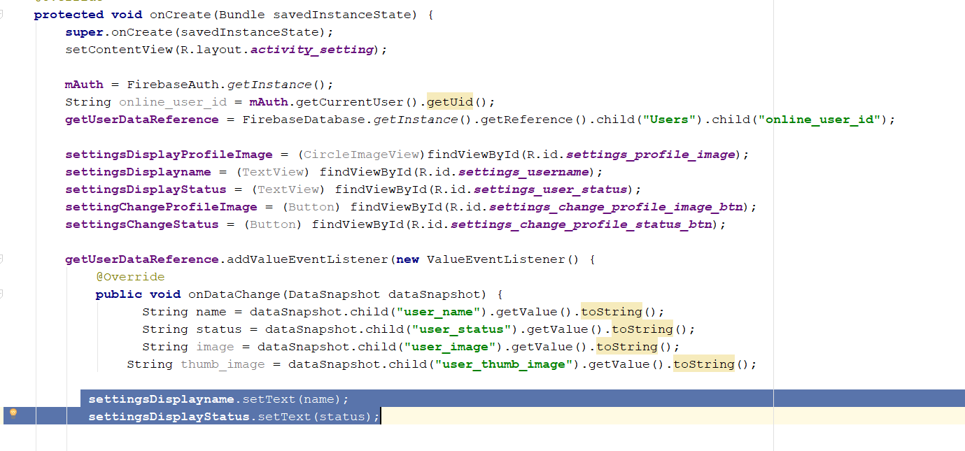
* Rebuild and Run, and see if setting manage to retrieve the name + status

# Step 12: Change Image - User Profile Image

* First go to setting activity
* After the onCancelled (), add in this line
* 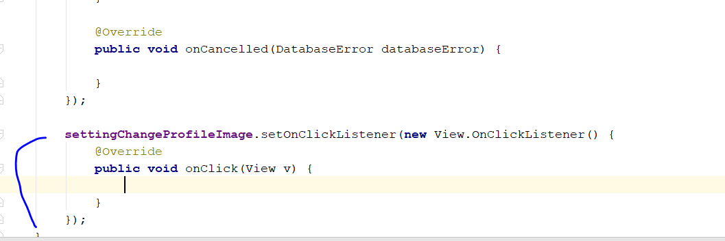
* Add in the following lines
* Intent galleryIntent = **new** Intent();  
  galleryIntent.setAction(Intent.***ACTION_GET_CONTENT***);  
  galleryIntent.setType(**"image/*"**);  
  startActivityForResult(galleryIntent, ***Gallery_Pick***);
* Declare a private variable call Gallery_pick
* 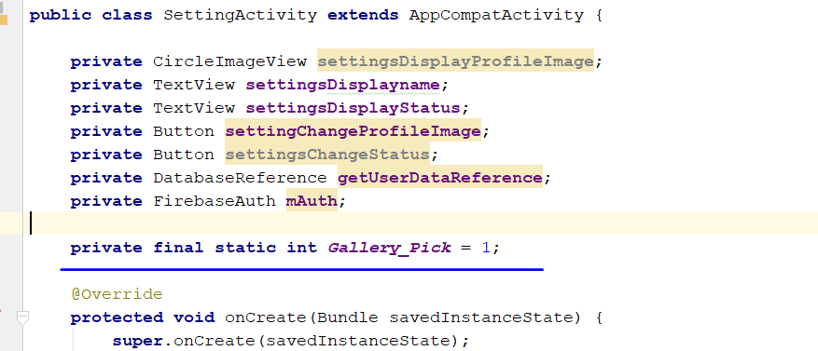
* **private final static int *Gallery_Pick*** = 1;
* 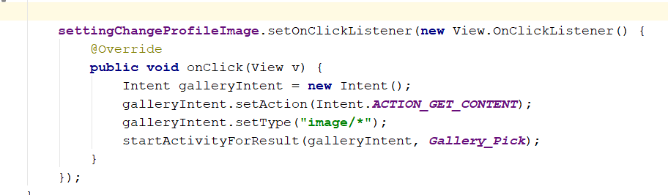
* Rebuild and run, u should be able to access your phone image library
* After that, after your onCreate Method, create this method
* 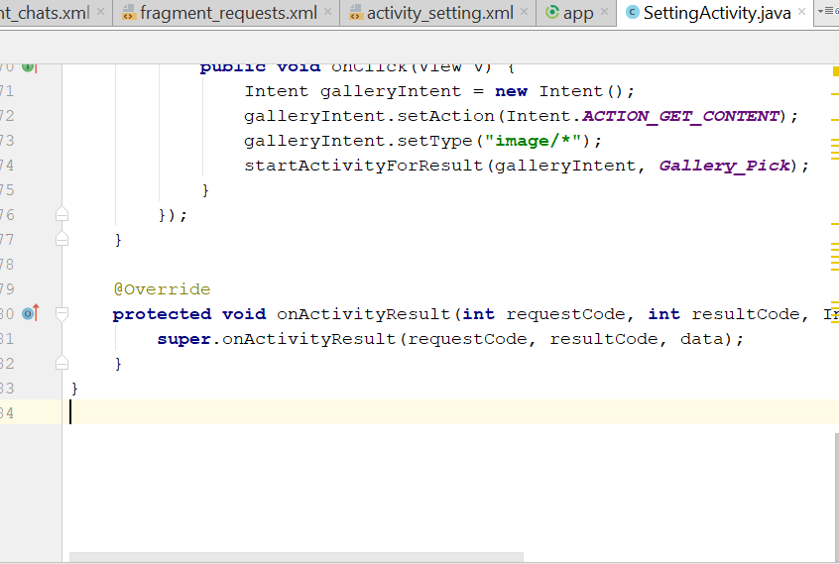
* We need to add some library
* Go this <https://github.com/ArthurHub/Android-Image-Cropper>
* Add this “compile 'com.theartofdev.edmodo:android-image-cropper:2.6.+'”
* Paste this at build.gradle/app
* 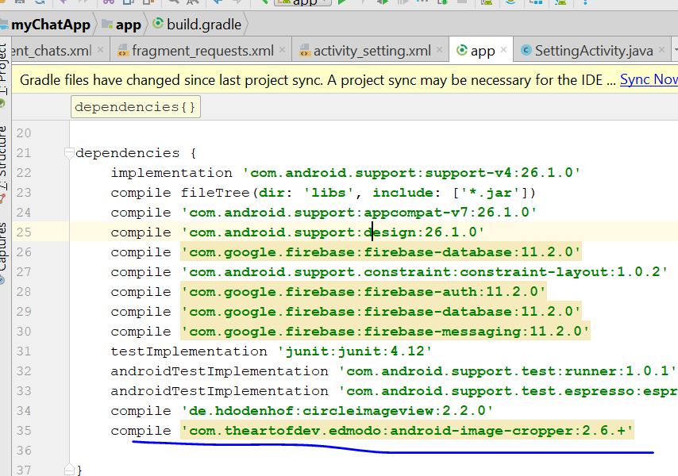

Sync it

* If they is no error, we need to add permission
* <uses-permission android:name="android.permission.READ_EXTERNAL_STORAGE"/>
* <uses-permission android:name="android.permission.WRITE_EXTERNAL_STORAGE"/>
* Now go to AndroidManifest
* 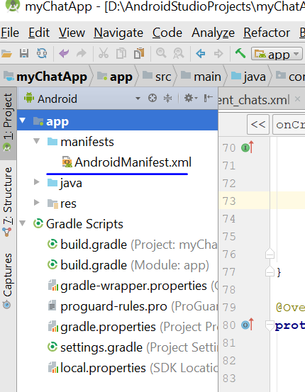
* 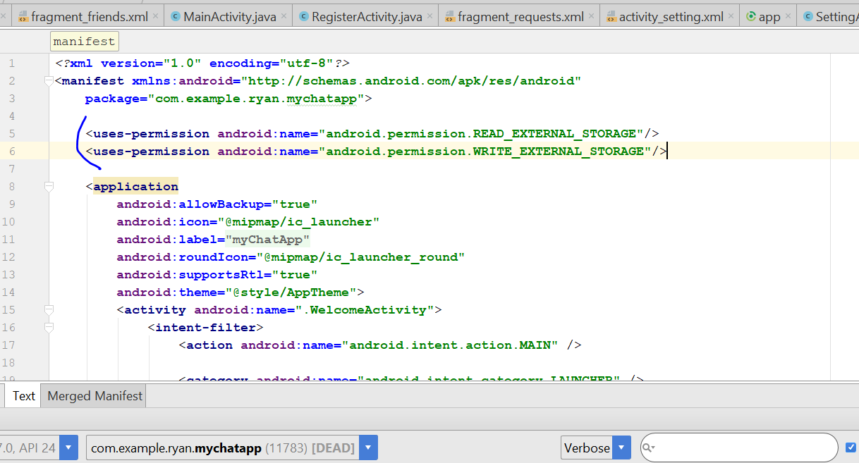
* Paste it there
* Then we copy the following code, to Add CropImageActivity into your AndroidManifest.xml
* <activity android:name="com.theartofdev.edmodo.cropper.CropImageActivity"
* android:theme="@style/Base.Theme.AppCompat"/> <!-- optional (needed if default theme has no action bar) -->
* Inside the application of AndroidManifest
* 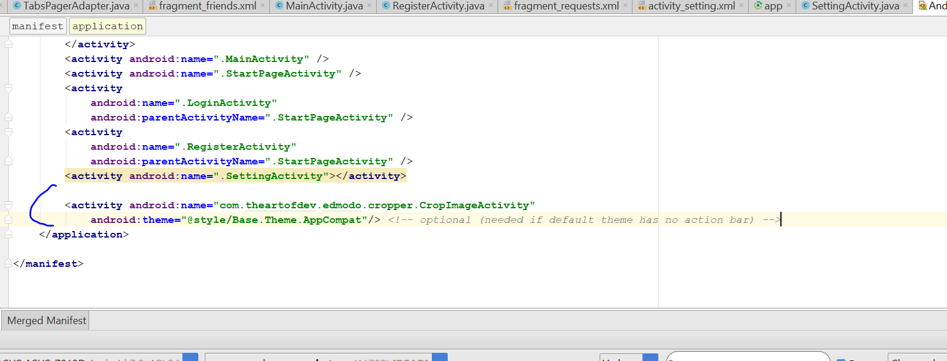
* Go back to SettingActivity.java, then go to onActivityResult
* Add this in the code
* 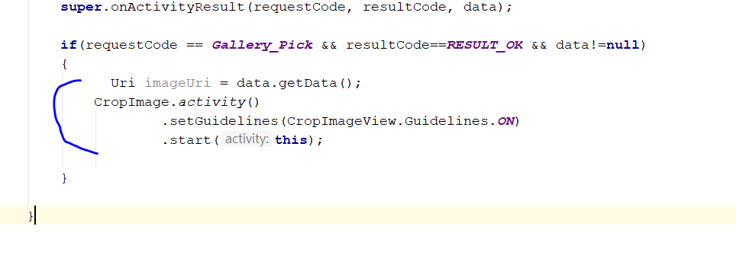
* We now have to define the size of the image
* 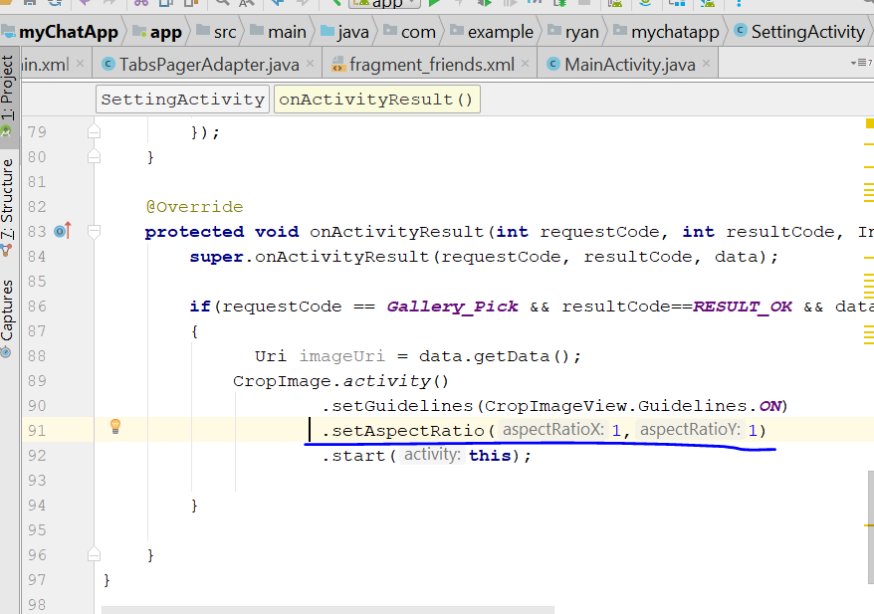
* Add this line in the code
* Click on tools, click on firebase
* Go to Firebase Storage 🡪 add Firebase Storage to your app
* 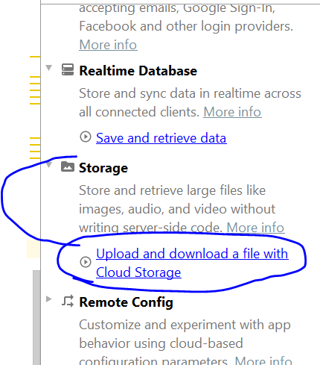
* Double click
* 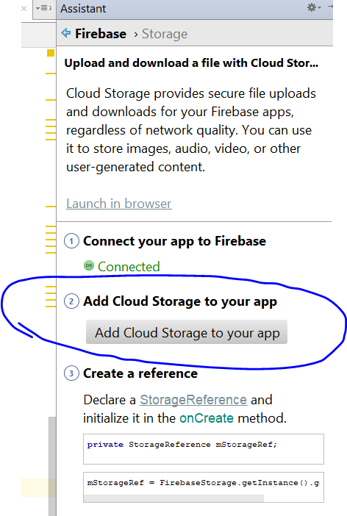
* Double Click
* Then click on accept changes
* Wait a while, for the dependencies to be added
* 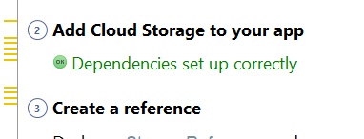
* Add the Build.gradle/app
* 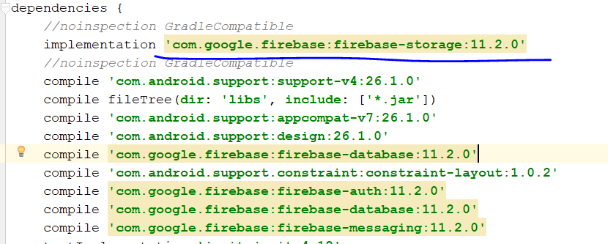
* Now create reference to the firebase storage
* Go to settingActivity.java
* Private StorageReference storeProfileImagestoreRef;
* Then go to onCreate method, add in the following code
* storeProfileImagestorageRef = FirebaseStorage.*getInstance*().getReference().child(**"Profile_Images"**);
* copy this line

if (requestCode == CropImage.CROP_IMAGE_ACTIVITY_REQUEST_CODE) {

CropImage.ActivityResult result = CropImage.getActivityResult(data);

if (resultCode == RESULT_OK) {

Uri resultUri = result.getUri();

} else if (resultCode == CropImage.CROP_IMAGE_ACTIVITY_RESULT_ERROR_CODE) {

Exception error = result.getError();

}

}

* Paste it here, in the onActivityResult
* 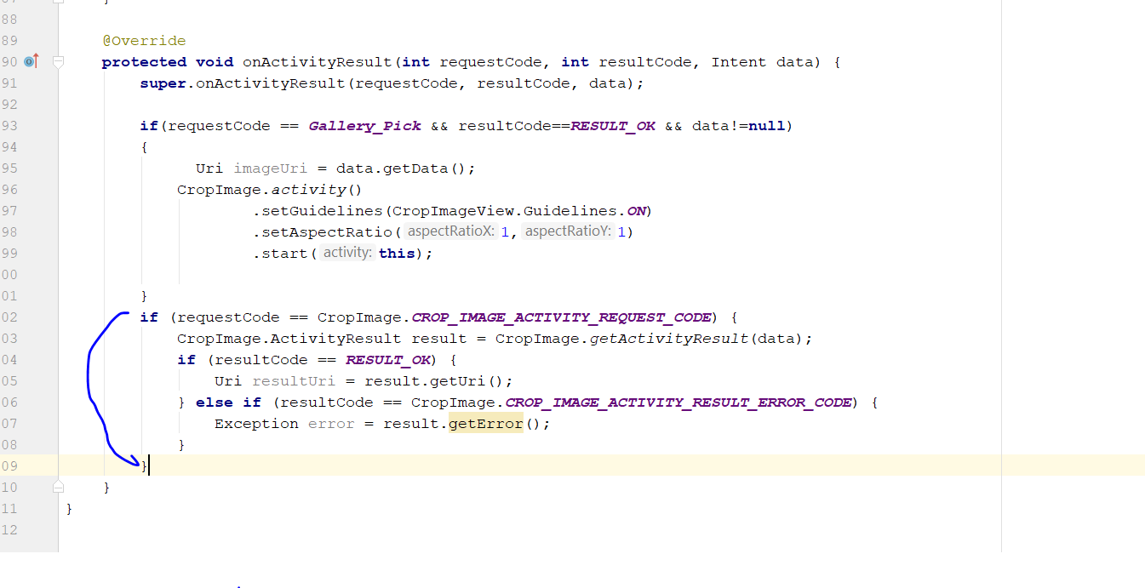
* Add in the following code inside if (resultCode == RESULT_OK)
* String user_id = **mAuth**.getCurrentUser().getUid();  
  StorageReference filePath = **storeProfileImagestorageRef**.child(user_id + **".jpg"**);  
  filePath.putFile(resultUri).addOnCompleteListener(**new** OnCompleteListener<UploadTask.TaskSnapshot>() {  
   @Override  
   **public void** onComplete(@NonNull Task<UploadTask.TaskSnapshot> task) {  
   **if**(task.isSuccessful())  
   {  
   Toast.*makeText*(SettingActivity.**this**, **"Saving your Profile Image"**,Toast.***LENGTH_SHORT***).show();  
   }  
   }  
  });
* 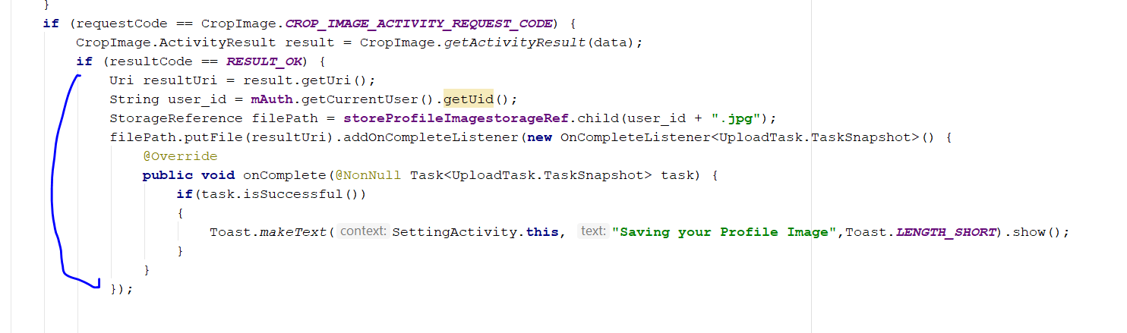
* Add in this in the else statement
* 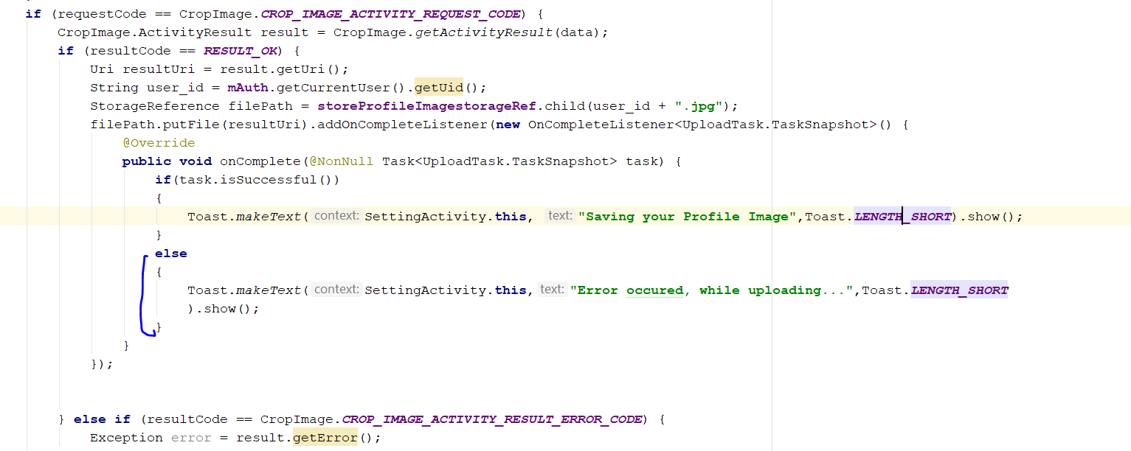
* Rebuild And Run
* Select an image and crop, and see if the image appear in the firebase
* 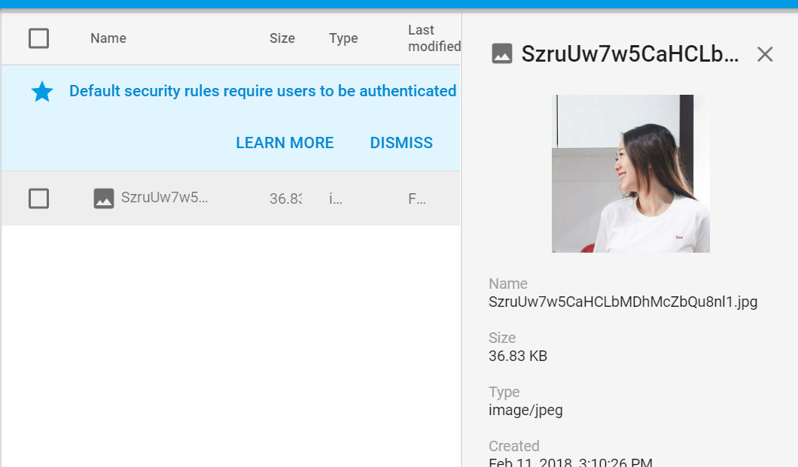

# Step 13: Retrieve image from firebase

* Go to setting Activity.java
* If Task isSuccessful()
* Add in this line
* String downloadUrl = task.getResult().getDownloadUrl().toString();  
  **getUserDataReference**.child(**"user_image"**).setValue(downloadUrl)  
   .addOnCompleteListener(**new** OnCompleteListener<Void>() {  
   @Override  
   **public void** onComplete(@NonNull Task<Void> task) {  
    
   Toast.*makeText*(SettingActivity.**this**,  
   **"Image Uploaded Successfully..."**, Toast.***LENGTH_SHORT***).show();  
   }  
   });
* 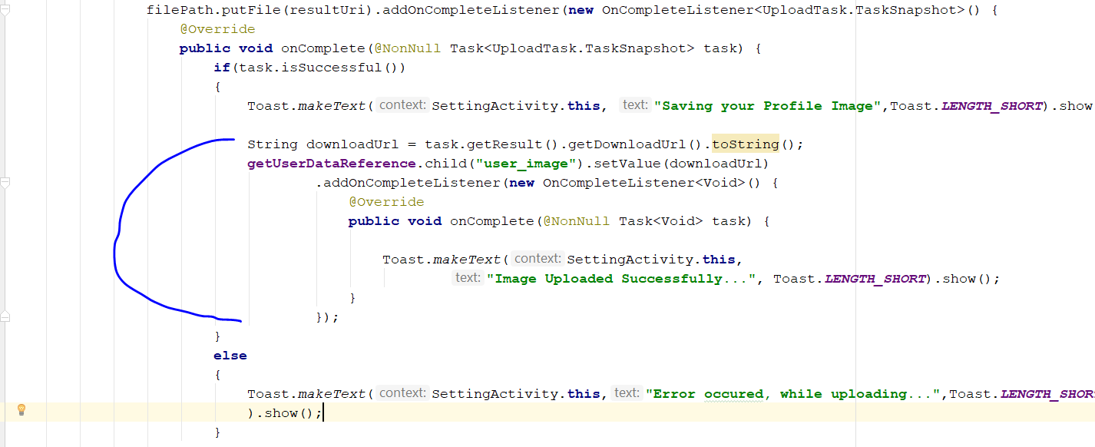
* Add a code on the “onDataChange()” method, after the settingsDisplayStatus.setText(status);
* Go to <http://square.github.io/picasso/>
* Copy this library : compile 'com.squareup.picasso:picasso:2.5.2'
* 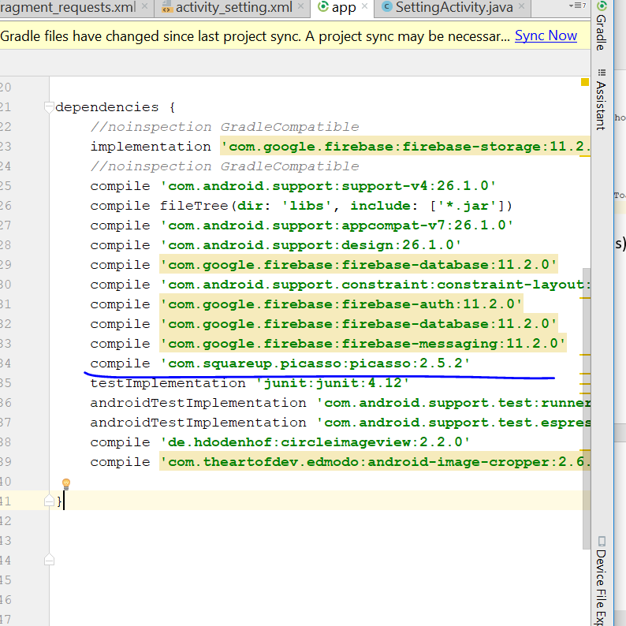
* Paste in build.gradle.app , then sync
* Go back to settingActivity and add in this line
* Picasso.*with*(SettingActivity.**this**).load(image).into(**settingsDisplayProfileImage**);
* 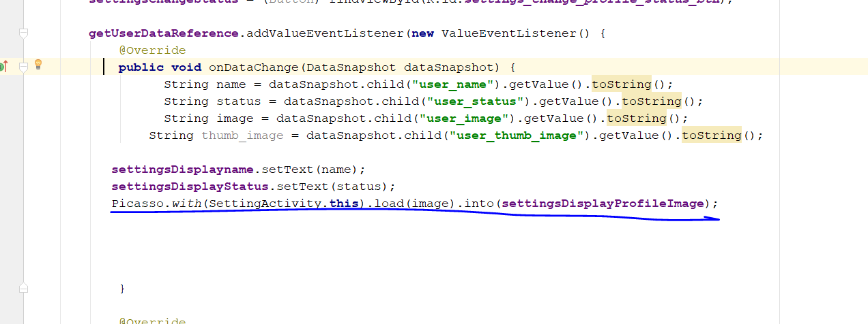
* Rebuild and run, image shld be able to change
* Now we change the status
* First we create a new StatusActivity, create a new activity
* 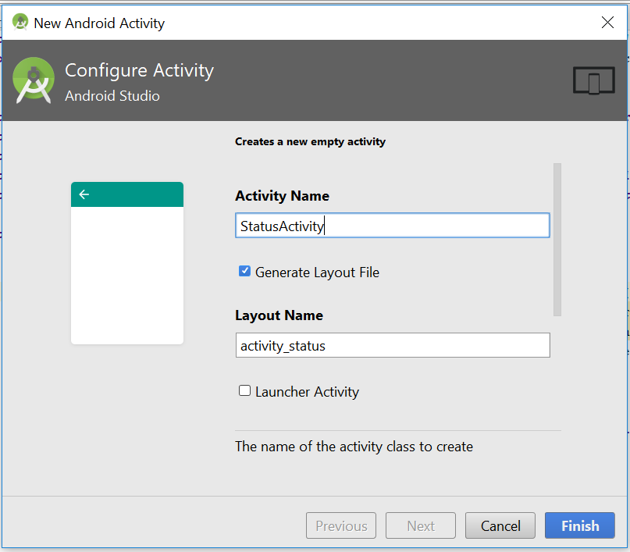
* This is the new activity
* 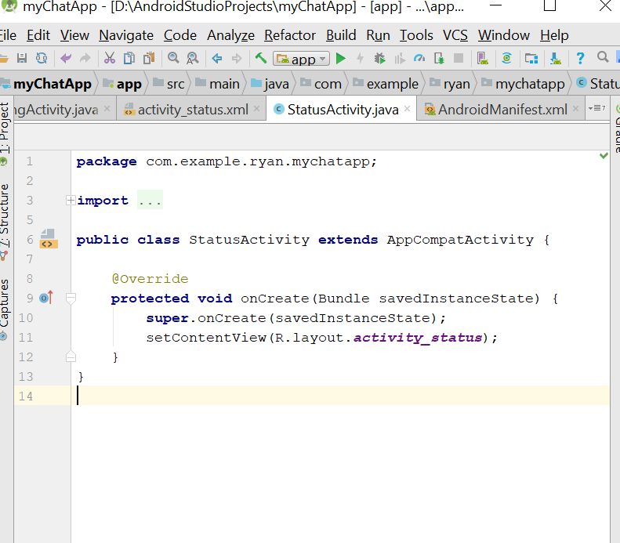
* Go the settingActivity.java, add the setting change button listen a the new StatusActivity.java
* 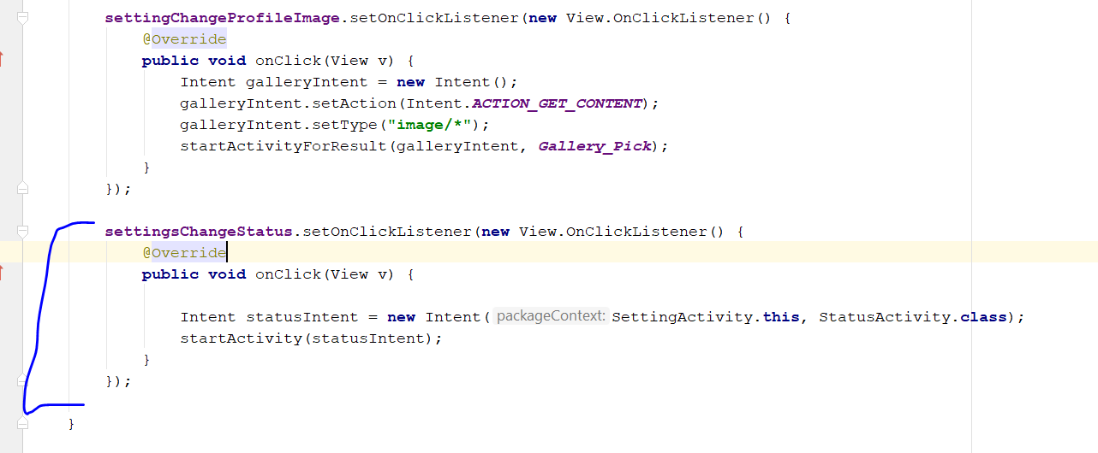
* Change the layout of the activity_startus.xml to relative layout
* 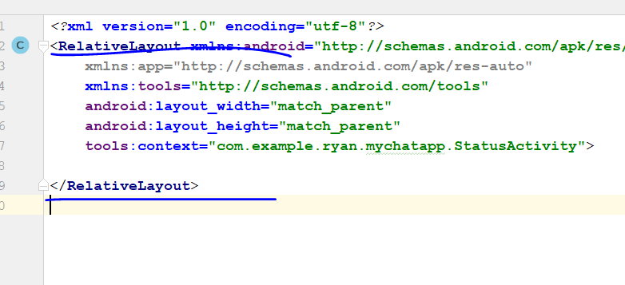
* Add this code
* <**include layout="@layout/app_bar_layout"  
   android:id="@+id/status_app_bar"**>  
     
  </**include**>
* 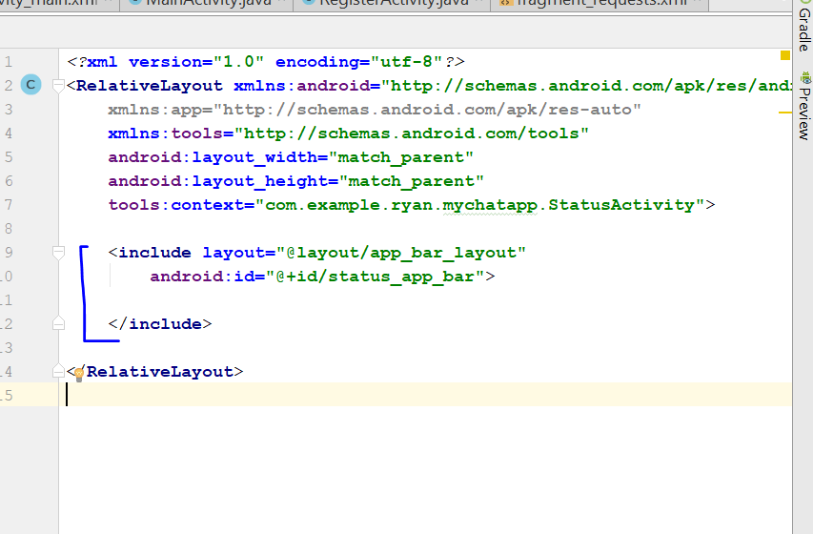
* Add a back button
* Now go to StatusActivity.Java, add the following line
* 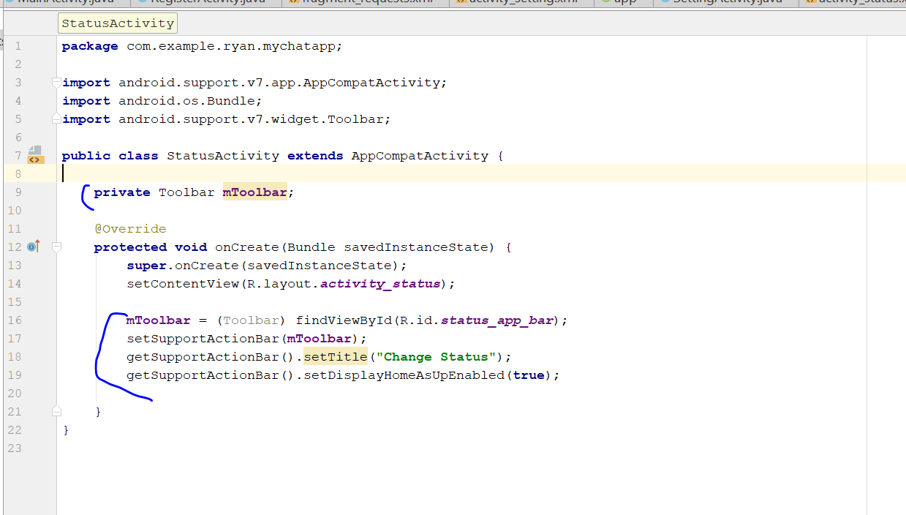
* Then go to Android manifest
* Add in this line
* <**activity android:name=".StatusActivity"  
   android:parentActivityName=".SettingActivity"**></**activity**>
* 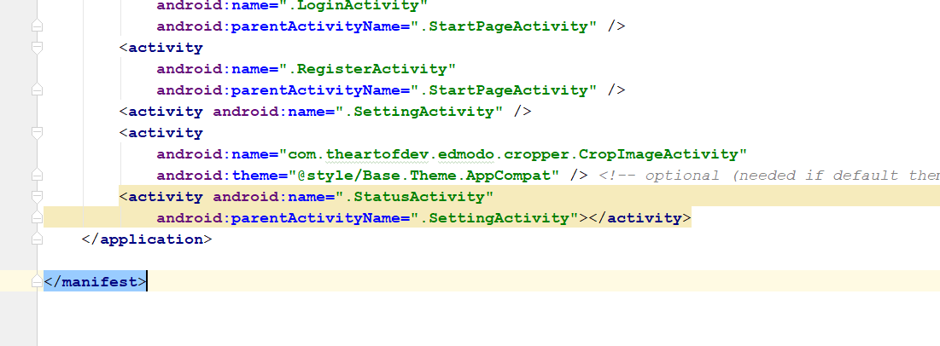
* Now go to activity_status.xml file
* Add in multiline TextView
* Width is match parent, height is match content
* Margin is 30dp, add the hint: Change Status Here
* Drag a new button, change the text to Save Change, width change to 200 dp
* The button background colour change to colour primary
* 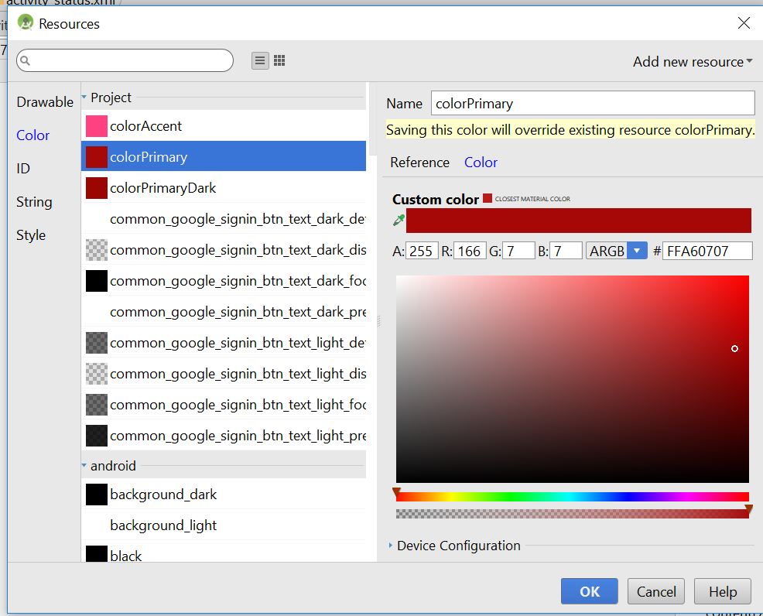
* Text change to background light
* Size change to 20dp
* Now go to statusActivity.java
* Add this two lines
* **private** Button **SaveChangesButton**;  
  **private** EditText **StatusInput**;
* add this inside the oncreate()
* **SaveChangesButton** = (Button) findViewById(R.id.***save_status_change_button***);  
  **StatusInput** = (EditText) findViewById(R.id.***status_input***);
* 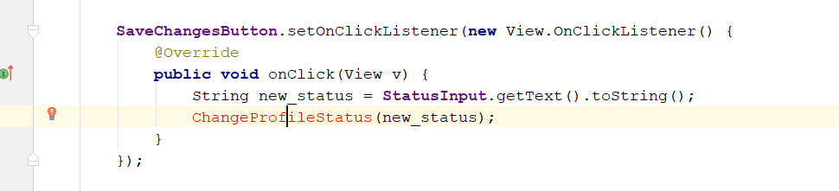
* Add this in the code
* Create a new method call ChangeProfileStatus inside the StatusActivity
* 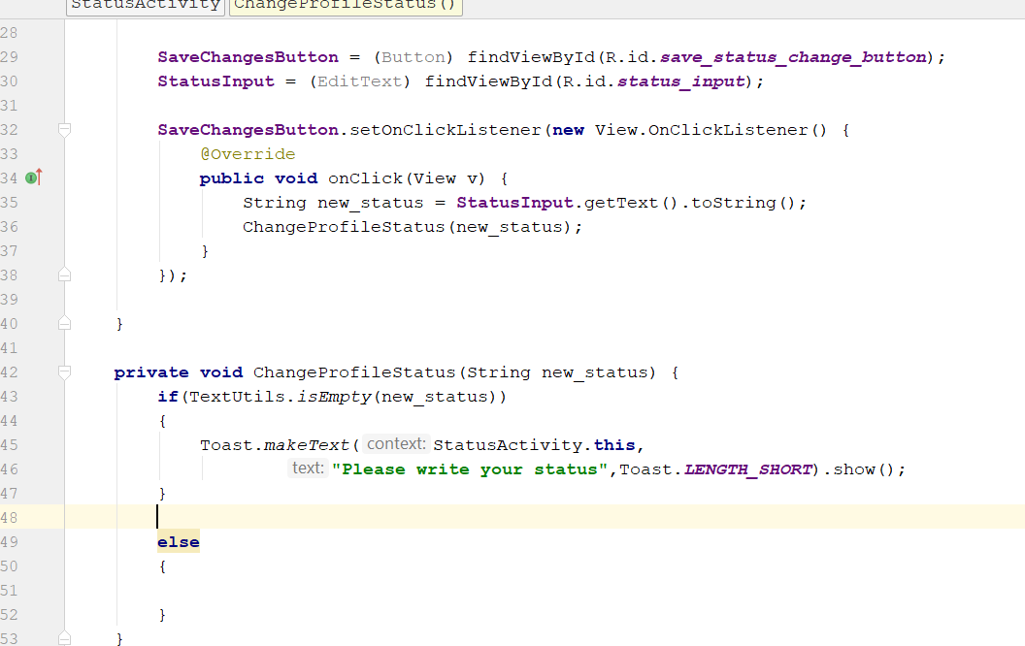
* Declare this two again
* **private** DatabaseReference **changeStatusRef**;  
  **private** FirebaseAuth **mAuth**;
* 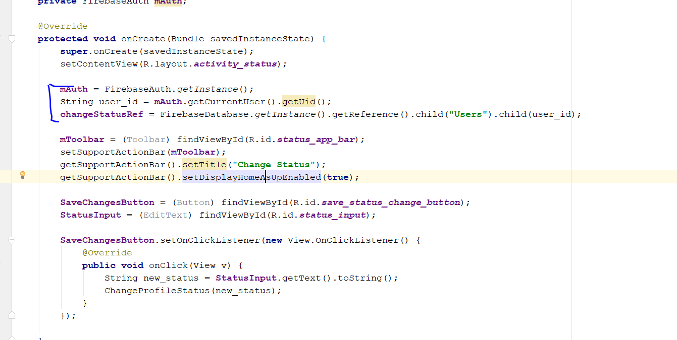
* Add in the following lines
* **changeStatusRef**.child(**"user_status"**).setValue(new_status)  
   .addOnCompleteListener(**new** OnCompleteListener<Void>() {  
   @Override  
   **public void** onComplete(@NonNull Task<Void> task) {  
   **if**(task.isSuccessful())  
   {  
   **loadingbar**.dismiss();  
   Intent settingIntent = **new** Intent(StatusActivity.**this**,SettingActivity.**class**);  
   startActivity(settingIntent);  
    
   Toast.*makeText*(StatusActivity.**this**,  
   **"Profile Status Updated Successfully..."**,  
   Toast.***LENGTH_LONG***).show();  
   }  
    
   **else** {  
   Toast.*makeText*(StatusActivity.**this**,  
   **"Error occured..."**,  
   Toast.***LENGTH_LONG***).show();  
   }  
   }  
   });
* Add those line in the else statement of the ChangeProfileStatus(String new_status)
* 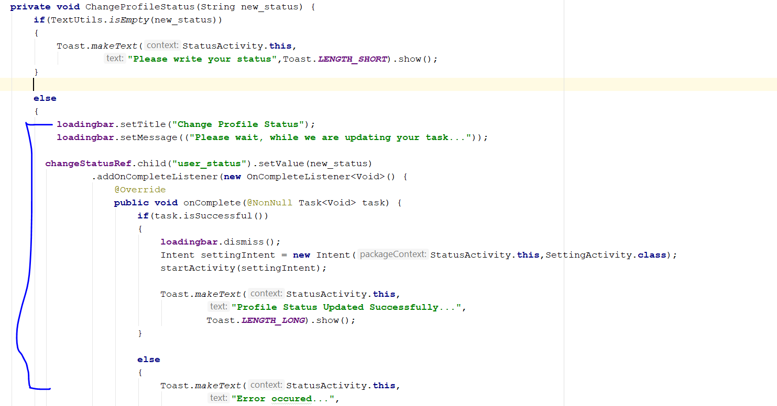
* Now go to settingActivity.java
* Go to settingsChangeStatus.setOnClickListener(new View.OnClickListener()
* 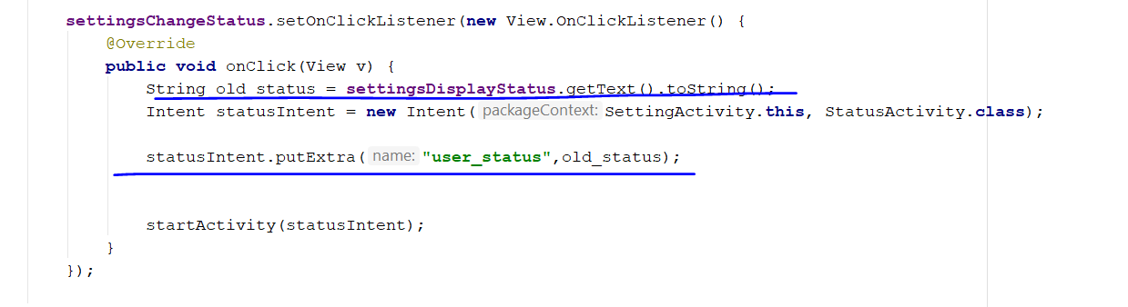
* Now go to StatusActivity.java
* Add in this two code in the onCreate Method
* String old_status = getIntent().getExtras().get(**"user_status"**).toString();  
  **StatusInput**.setText(old_status);
* 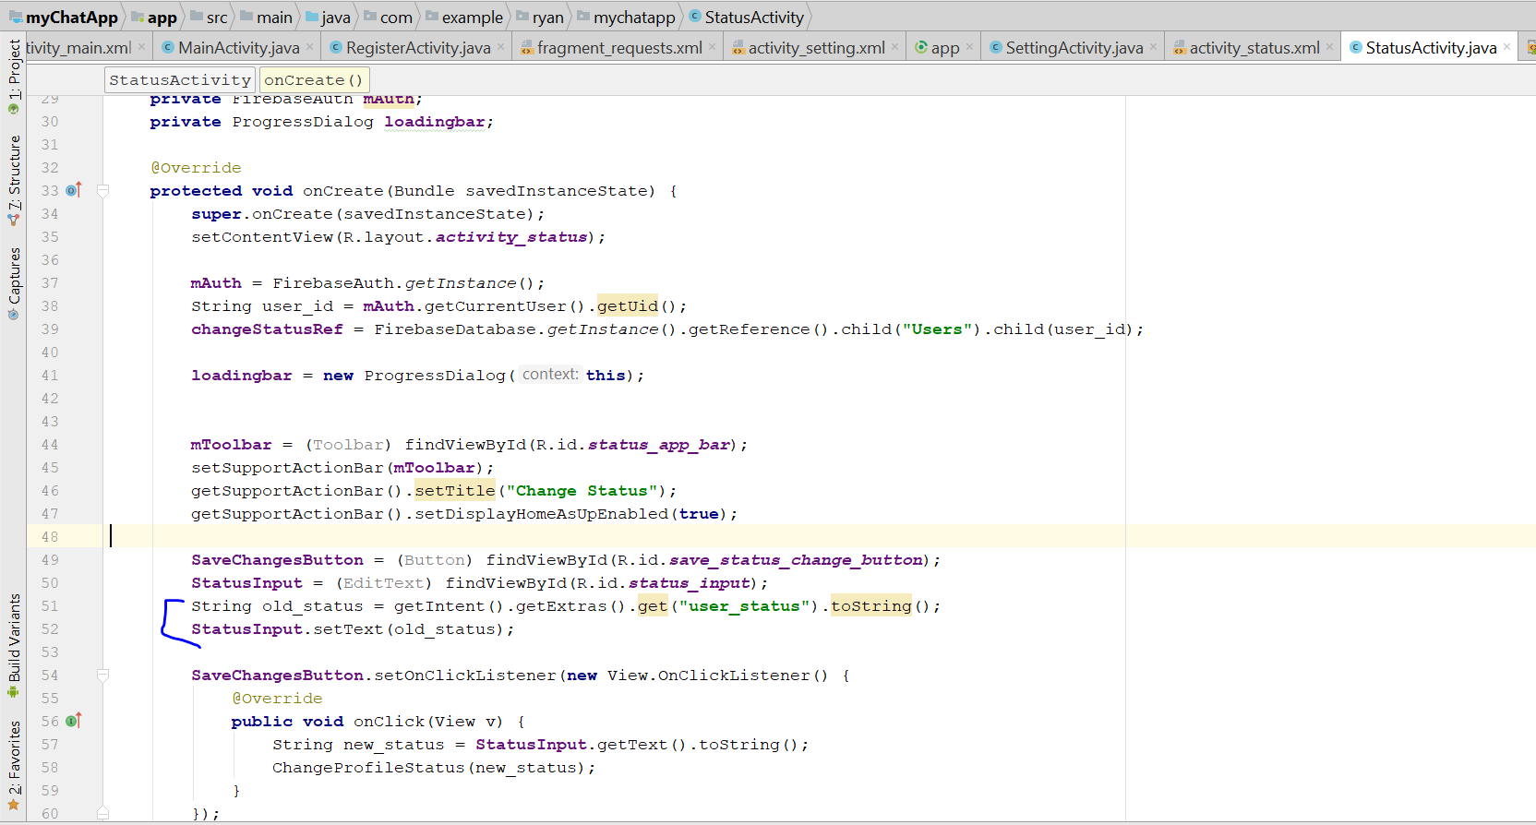
* Rebuild and Run

# Step 14: Create AllUsersActivity

* Create a new Activity call AllUsersActivity
* 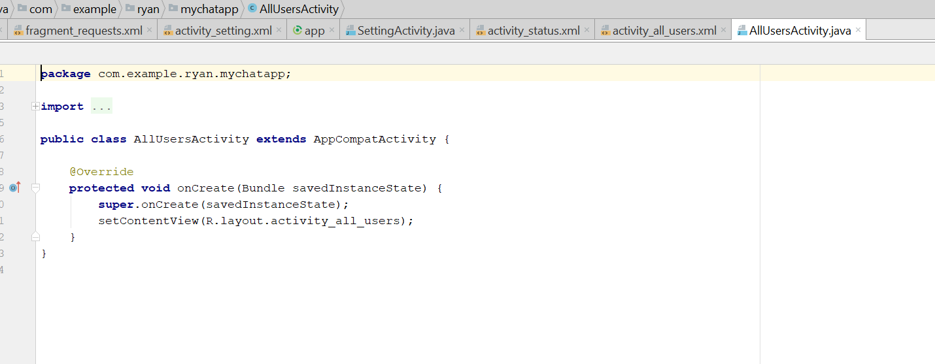
* Change the Activity_user.xml, layout to relative
* In the XML, include the layout=”app_bar_layout”
* Add in the RecycleView, width and height is match parent
* 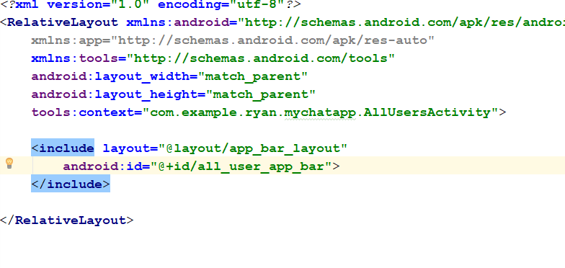
* Add in the Recycle View
* 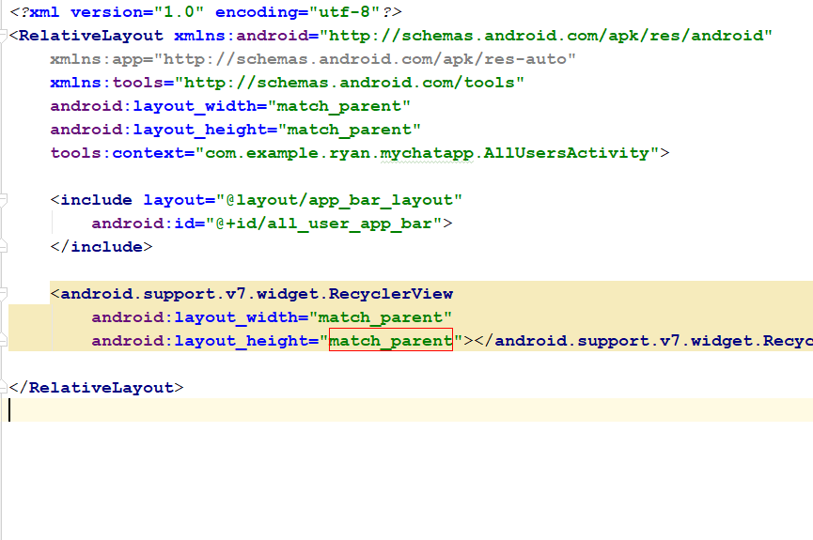
* It should look like this, drag the list slightly below
* 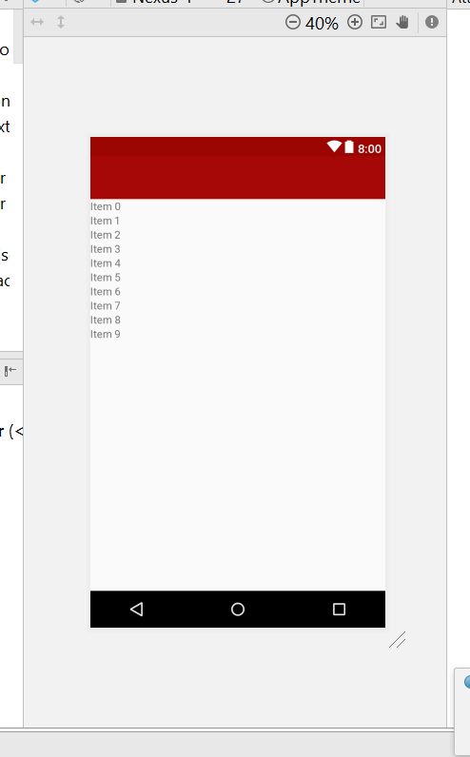
* Name the list ID as “all_users_list”
* 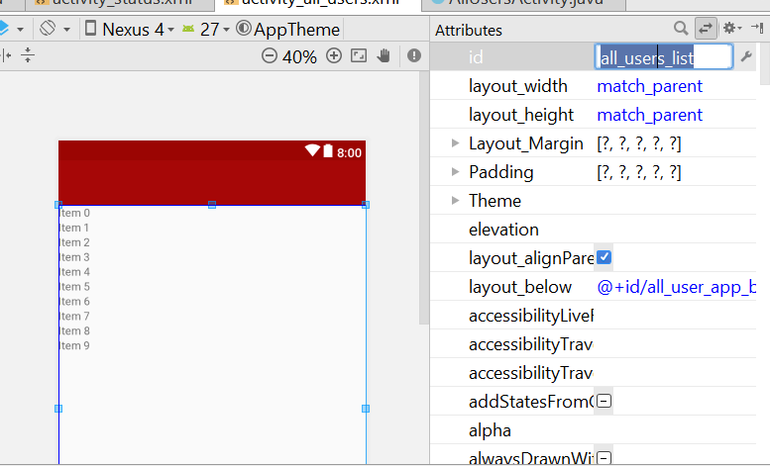
* Go to allUserActivity.java, declare the mToolbar, and findViewbyID in the OnCreate Method
* 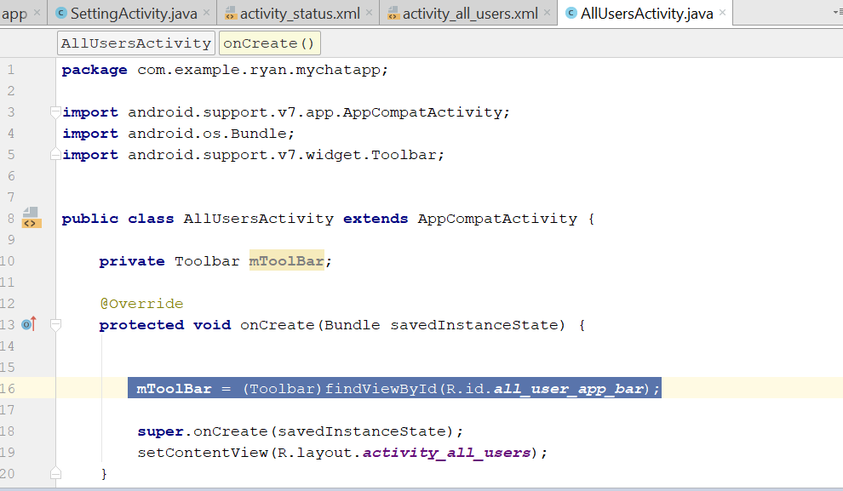
* **mToolBar** = (Toolbar)findViewById(R.id.***all_user_app_bar***);  
  setSupportActionBar(**mToolBar**);  
  getSupportActionBar().setTitle(**"All Users"**);  
  getSupportActionBar().setDisplayHomeAsUpEnabled(**true**);
* Now go to android manifest, and add the parent activity of allUserActivity
* 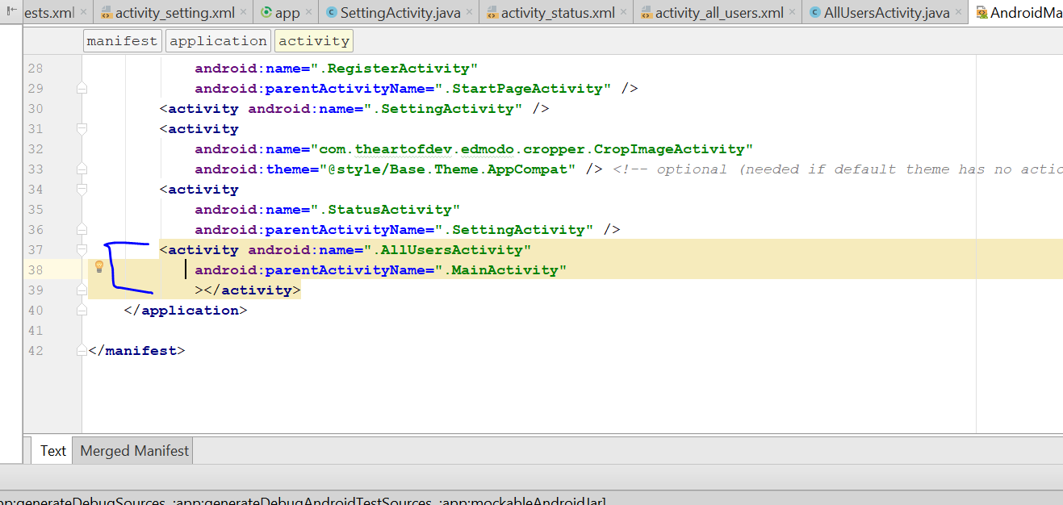
* Now add in Recycleview in the AllUserActivity.Java
* **private** RecyclerView **allUsersList**;
* add in this line in onCreate Method
* **allUsersList** = (RecyclerView)findViewById(R.id.***all_users_list***);
* Now go to main_menu.xml
* 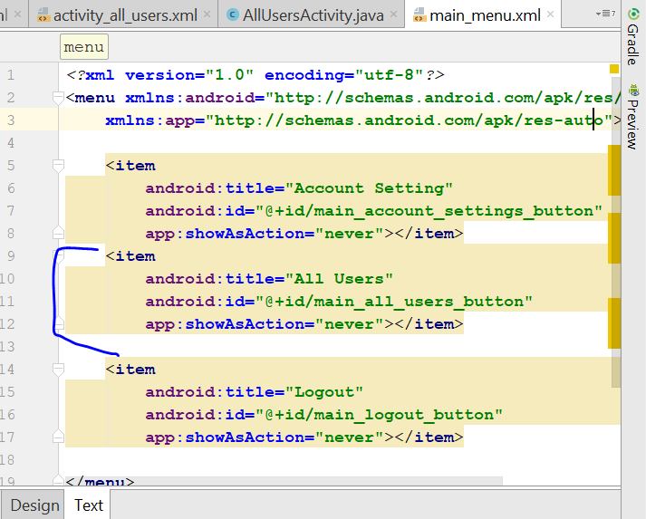
* Add this line in main_menu.xml
* Now go to mainActivity.java
* Add this line in public boolean onOptionsItemSelected(MenuItem item) {
* **if**(item.getItemId() ==R.id.***main_all_users_button***)  
   {  
   Intent SettingActivityIntent = **new** Intent(MainActivity.**this**,AllUsersActivity.**class**);  
   startActivity(SettingActivityIntent);  
   }  
    
  **return true**;
* 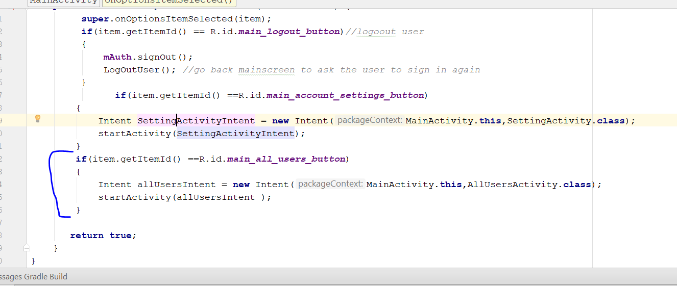
* Rebuild and Run
* Now create new Layout resource file
* Change the root Element to linearlayout
* 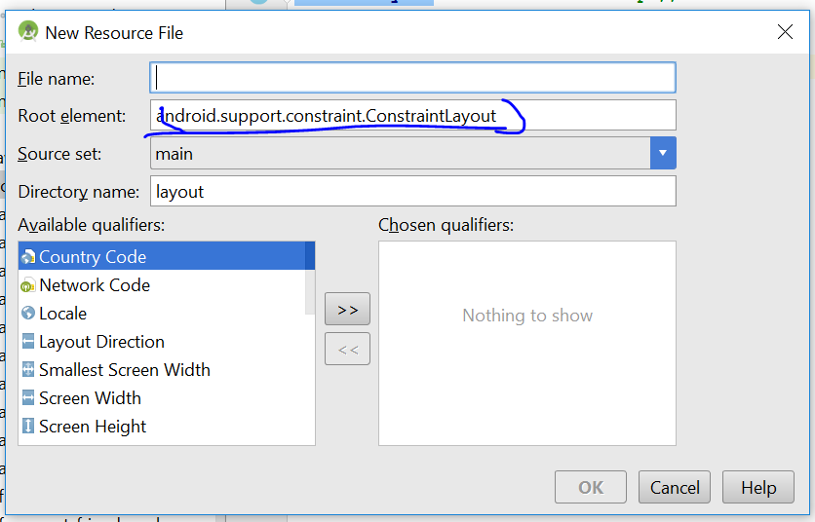
* 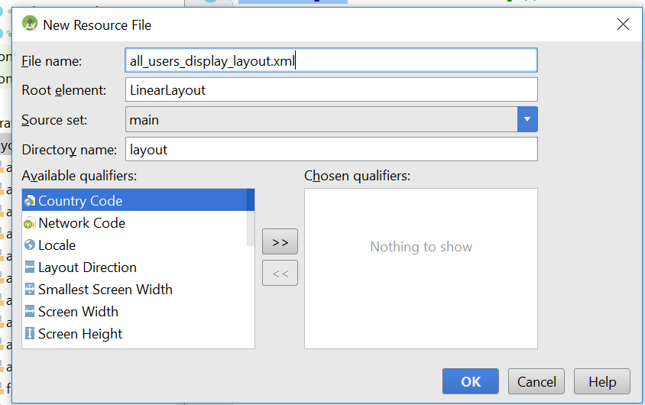
* android:layout_height="wrap_content"
* Now create another linearLayout inside
* 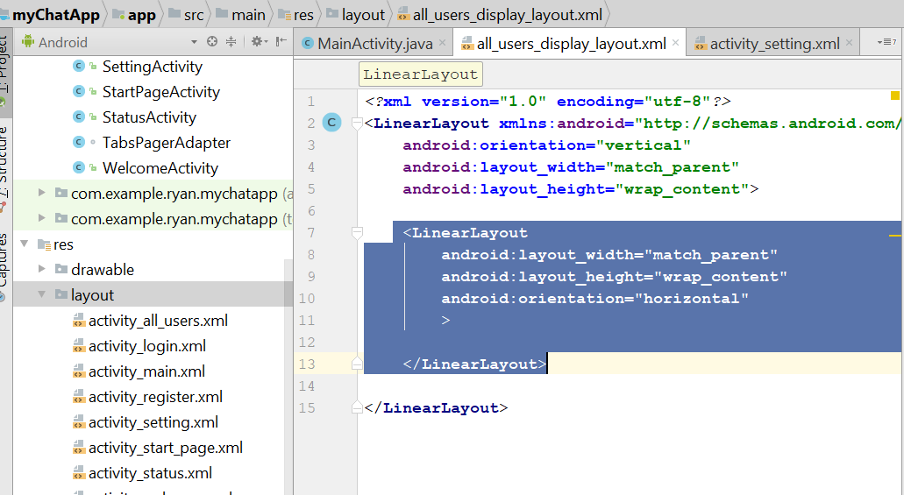
* Now create another circleView inside
* <de.hdodenhof.circleimageview.CircleImageView

android:layout_width="85dp"

android:layout_height="85dp" />

* Now we need to add another linear layout after that
* 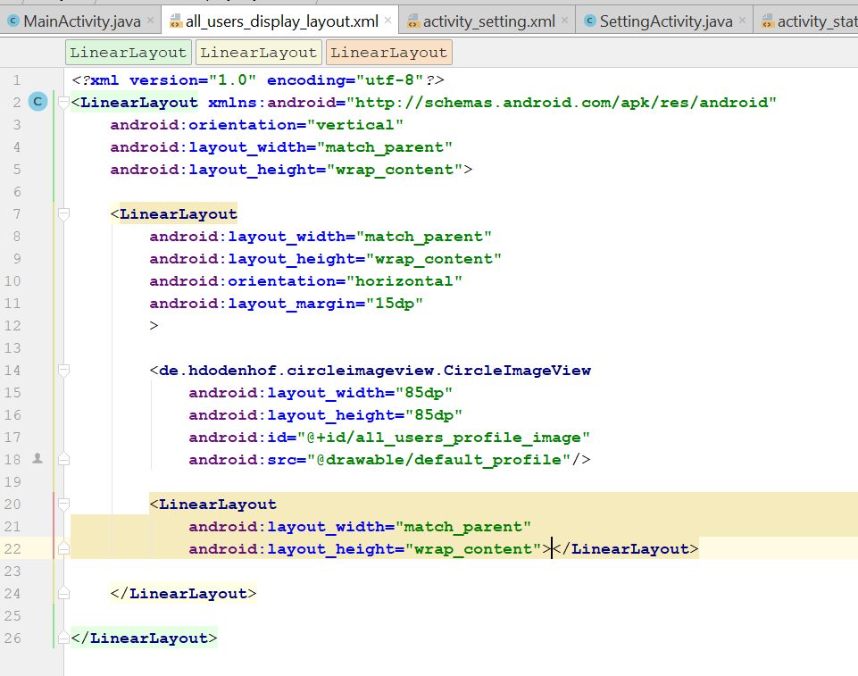
* Add in the following code in the linear layout
* 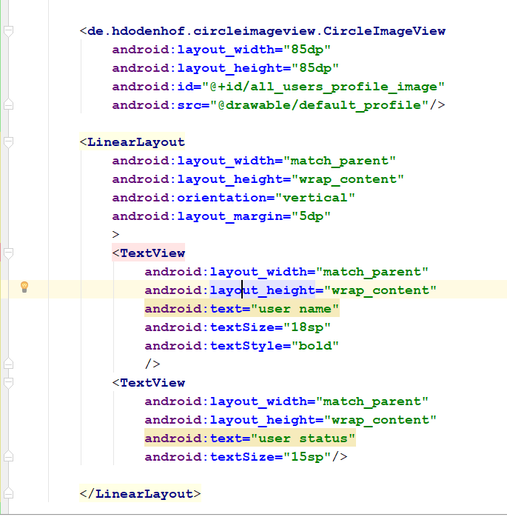
* 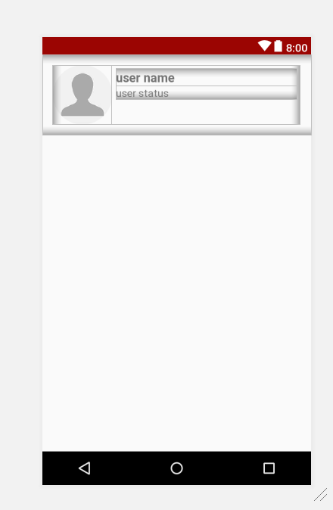
* It should look like it….
* Set the id of the username field: all_users_username
* Set the id of the status field: all_users_status
* Go to AllUsersActivity.java
* After the findViewById of all_users_list, add in the
* **allUsersList**.setHasFixedSize(**true**);  
  **allUsersList**.setLayoutManager(**new** LinearLayoutManager(**this**));
* 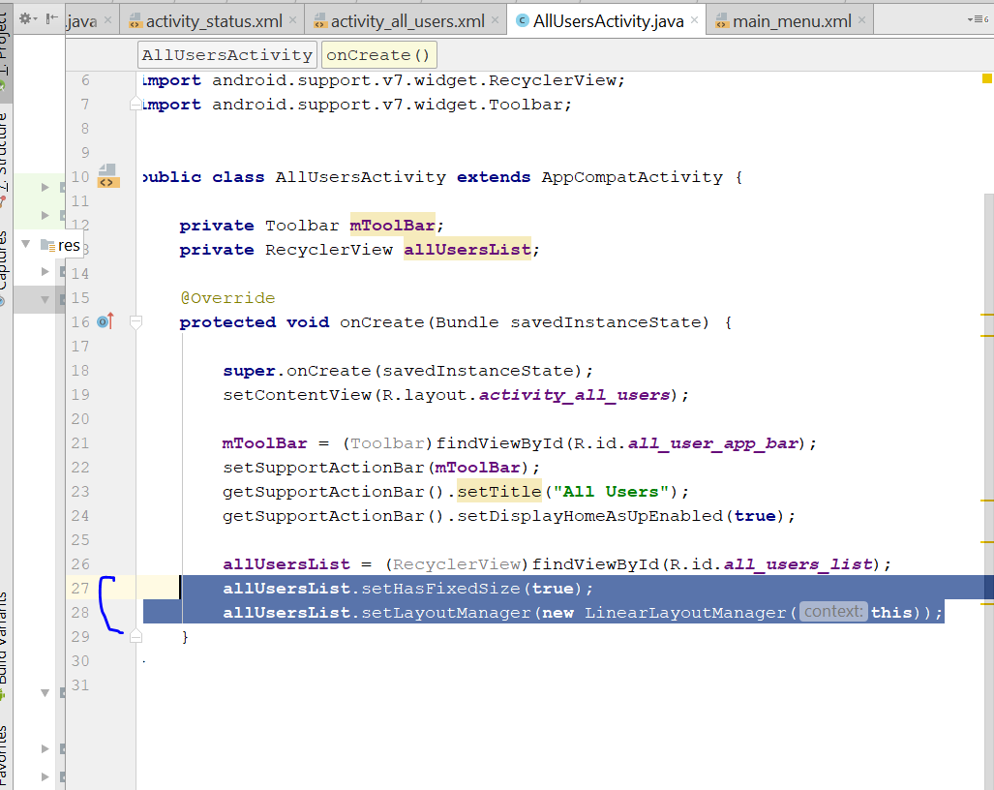
* Add in protected void onStart() {
* super.onStart();
* }
* We need to improve the library from Firebase-UI
* 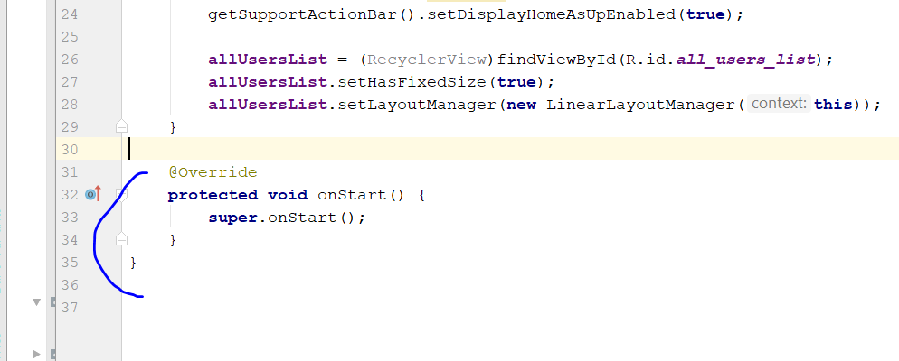
* Go to : <https://github.com/firebase/FirebaseUI-Android>
* Copy this
* 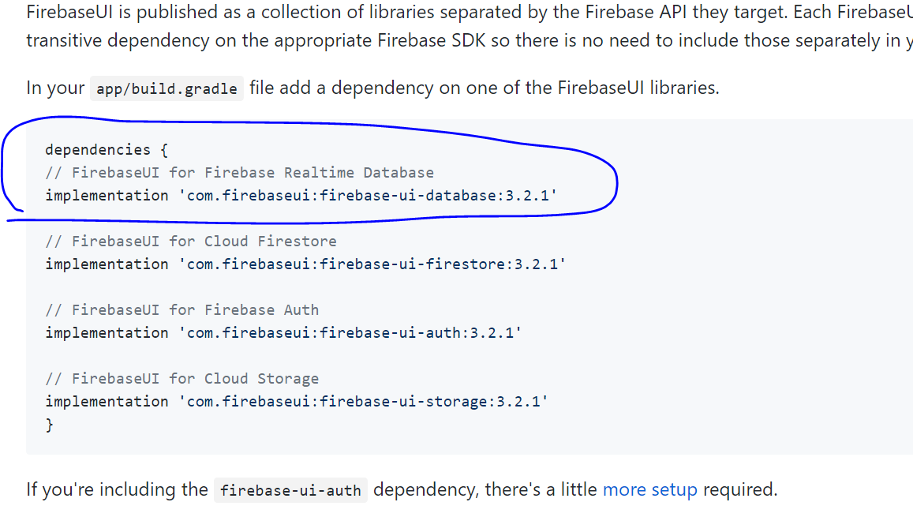
* Go to build.gradle module: app, paste below
* 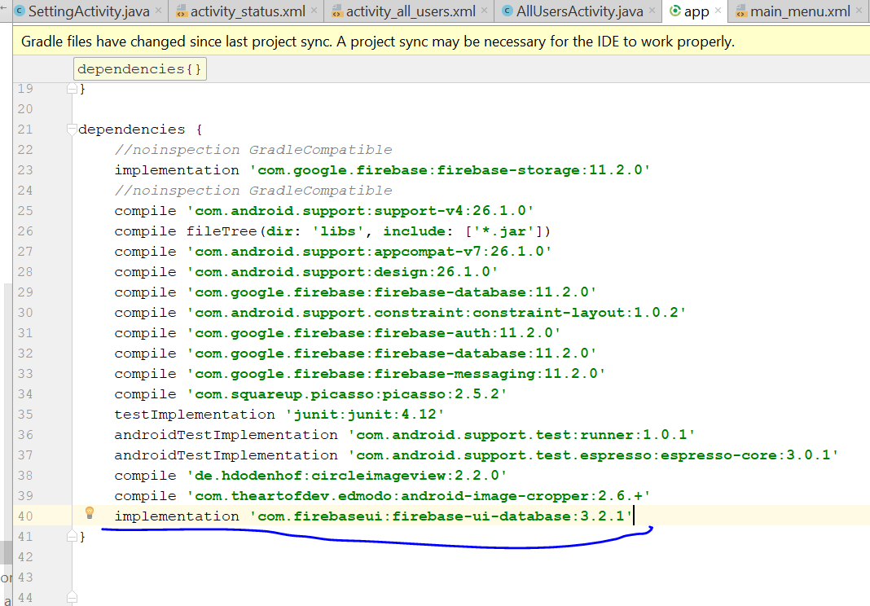
* Follow 11.2.0
* 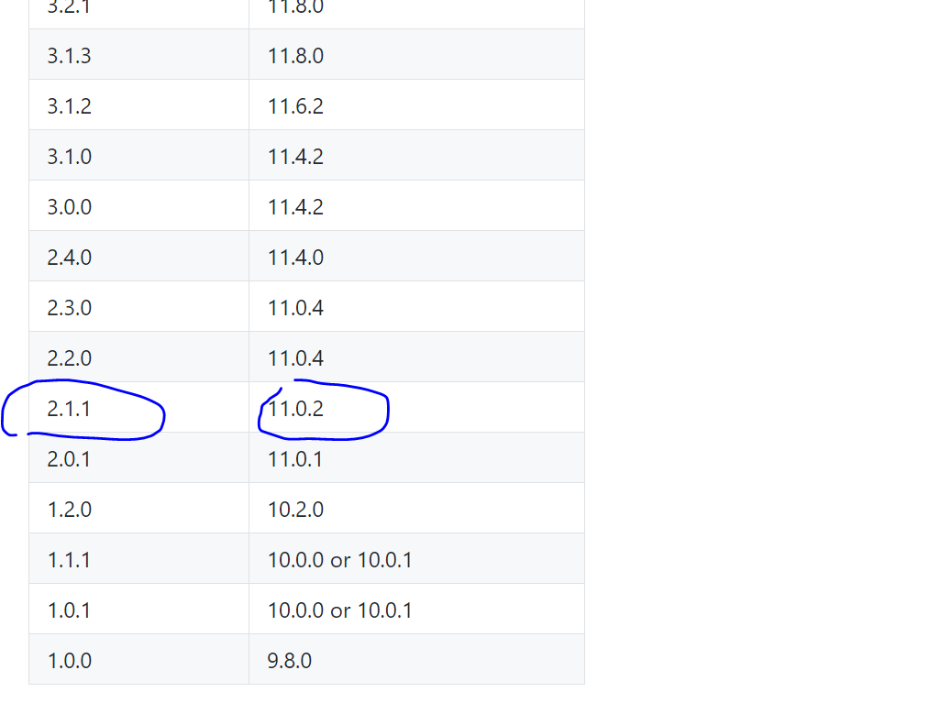
* So we change the number to 2.1.1
* implementation **'com.firebaseui:firebase-ui-database:2.1.1'**
* click sync now to see if it sync successfully
* Now create a new class, call AllUsers.java
* Create the 3 string inside the AllUser class
* 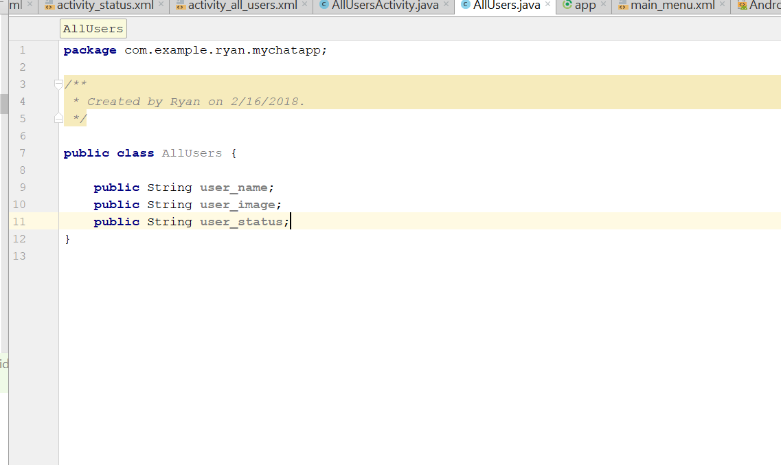
* Generate the getter and setters
* 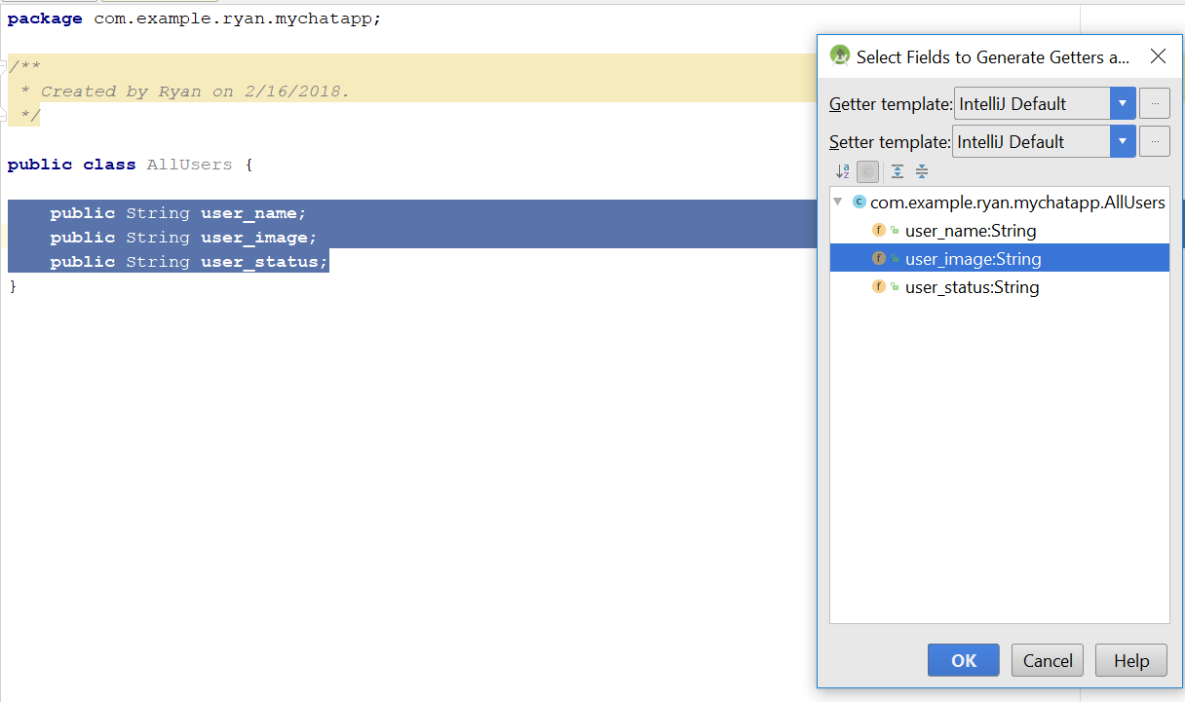
* Now it look like this
* 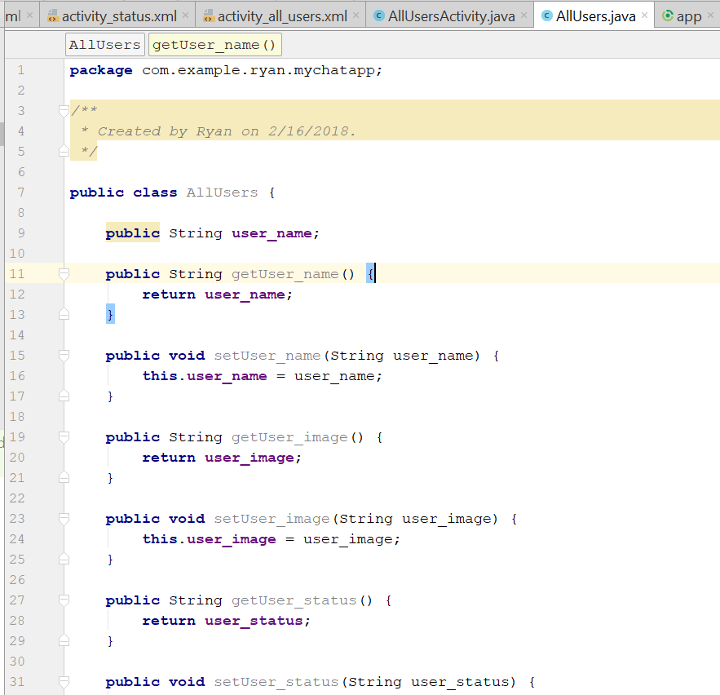
* Then now generate constructor
* 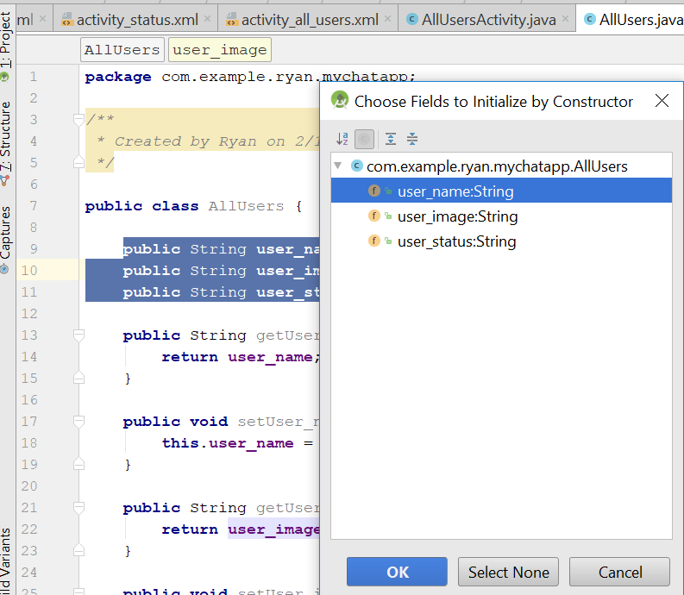
* Now in the AllUserActivity.java
* Add in this line
* **public static class** AllUsersViewHolder **extends** RecyclerView.ViewHolder  
  {  
   View **mView**;  
   **public** AllUsersViewHolder(View itemView) {  
   **super**(itemView);  
   **mView** = itemView;  
    
   }  
  }
* Import this two lines
* **import** com.google.firebase.database.DatabaseReference;  
  **import** com.google.firebase.database.FirebaseDatabase;
* add in this lines in the onStart()
* 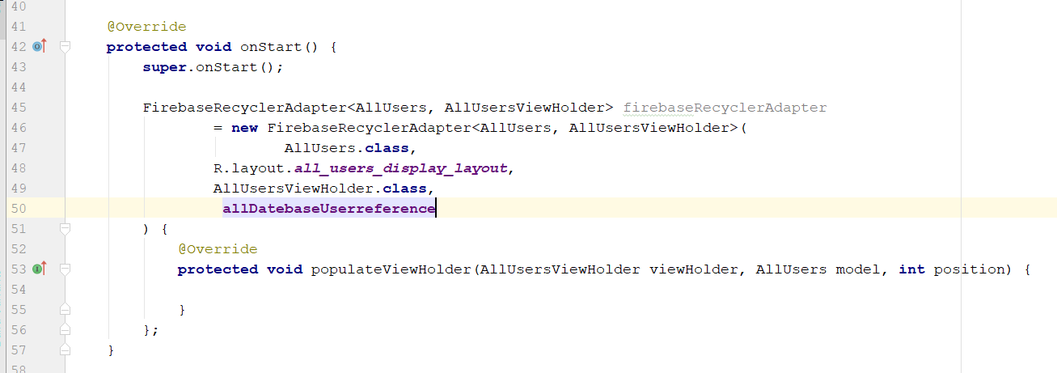
* FirebaseRecyclerAdapter<AllUsers, AllUsersViewHolder> firebaseRecyclerAdapter  
   = **new** FirebaseRecyclerAdapter<AllUsers, AllUsersViewHolder>(  
   AllUsers.**class**,  
   R.layout.***all_users_display_layout***,  
   AllUsersViewHolder.**class**,  
   **allDatebaseUserreference**) {  
   @Override  
   **protected void** populateViewHolder(AllUsersViewHolder viewHolder, AllUsers model, **int** position) {  
    
   }  
  };
* Declare this one top
* **private** DatabaseReference **allDatebaseUserreference**;
* Now need to populate the field
* **allDatebaseUserreference** = FirebaseDatabase.*getInstance*().getReference().child(**"Users"**);
* Add in this line in the AllUserViewHolders class
* **public void** setUser_name(String user_name)  
  {  
   TextView name = (TextView)**mView**.findViewById(R.id.***all_users_username***);  
   name.setText(user_name);  
  }
* now go to onStart method
* Go to the populateViewholder()
* Add this
* viewHolder.setUser_name(model.getUser_name());
* Then now add in another method
* **public void** setUser_status(String user_status)  
  {  
   TextView status = (TextView) **mView**.findViewById(R.id.***all_users_userstatus***);  
   status.setText(user_status);  
  }
* Go the populateViewHolder and add
* viewHolder.setUser_status(model.getUser_status());
* Now add in the 3rd Method again
* **public void** setUser_image(Context ctx, String user_image)  
  {  
   CircleImageView image = (CircleImageView) **mView**.findViewById(R.id.***all_users_profile_image***);  
   Picasso.*with*(ctx).load(user_image).into(image);  
  }
* 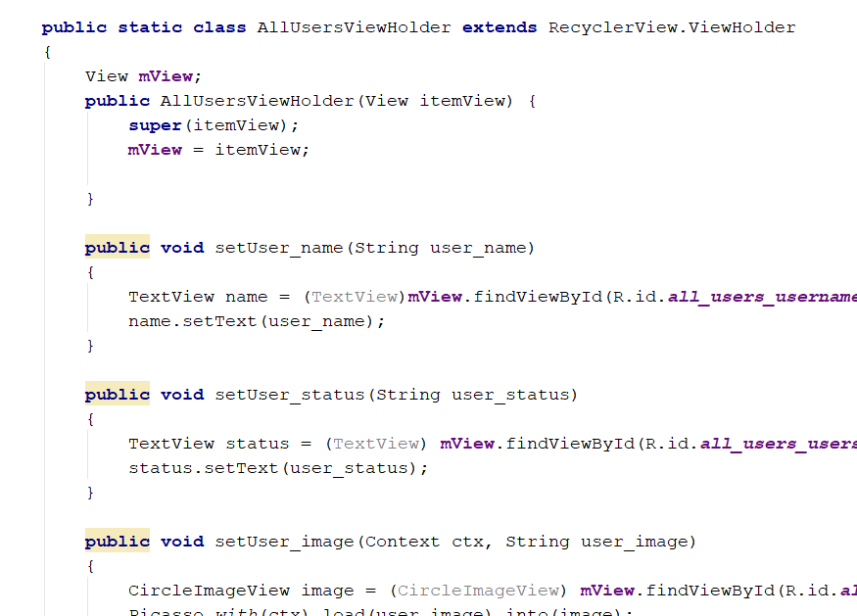
* Add in this line in the populateViewHolder
* viewHolder.setUser_image(getApplicationContext(),model.getUser_image());
* add in this line in the onStart()
* allUsersList.setAdapter(firebaseRecyclerAdapter);
* it look like this
* 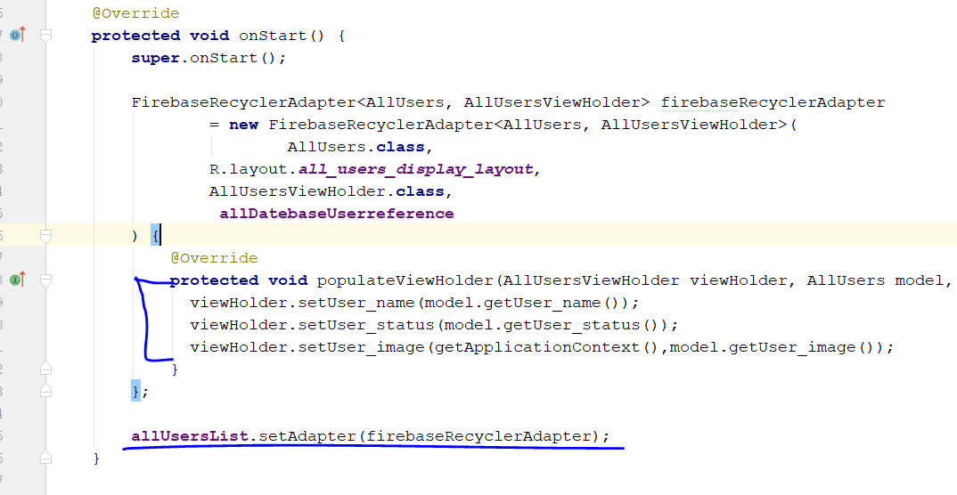
* Rebuild and run

# Step 15: set default profile picture for new user

* Go to settingActivity.java
* In the onDataChange Method, add in the line
* If(!image.equals(“default_profile”))  
  {}
* 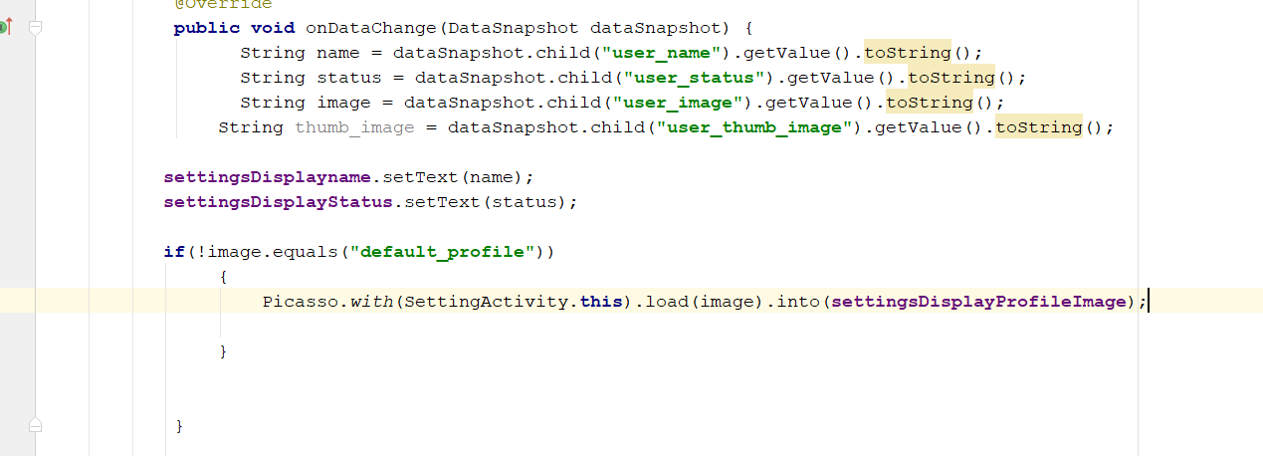
* Rebuild and run
* Now it shld display a default profile image normally, even it no image

# Step 16: Reduce the loading time of images, display default image meanhwhile

* Go to settingActivity.java
* In the onDataChange Method, change to this line
* Picasso.*with*(SettingActivity.**this**).load(image).placeholder(R.drawable.default_profile).into(**settingsDisplayProfileImage**);
* 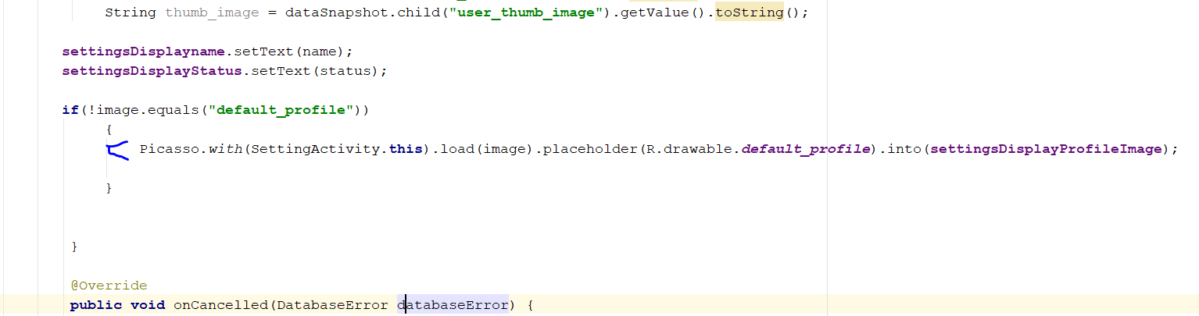
* Rebuild and run

# Step 17. Compress Thumb images

* This will reduce the loading time of profile image by compression
* Go to settingActivity
* Go protected void onActivityResult
* Go to this space
* 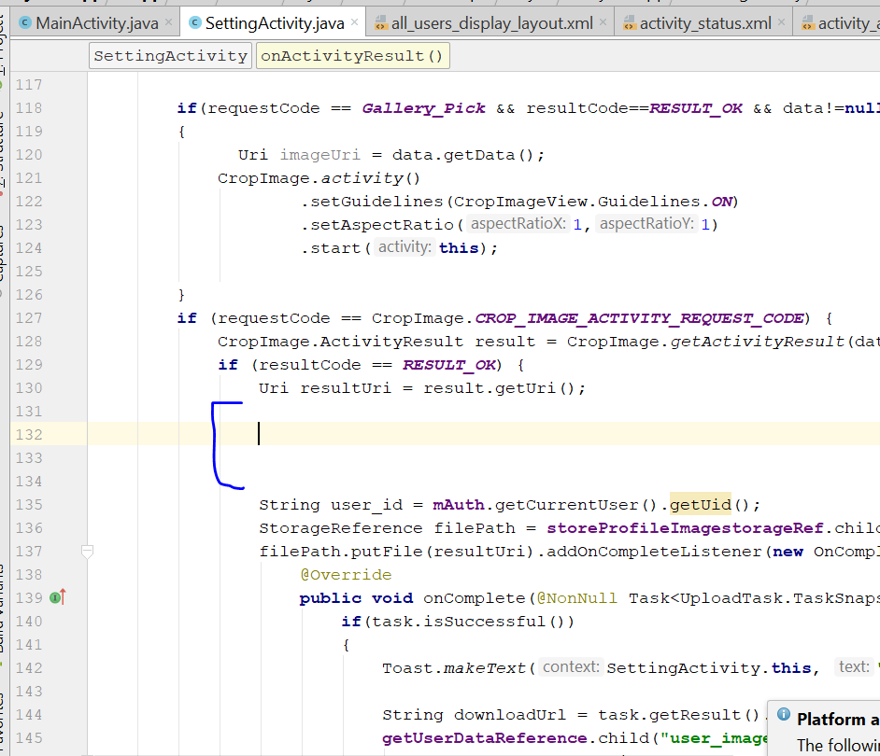
* Add this line
* File thumb_filePath = **new** File(resultUri.getPath());
* Import File Library
* Now go to <https://github.com/zetbaitsu/Compressor>
* Include this dependency
* 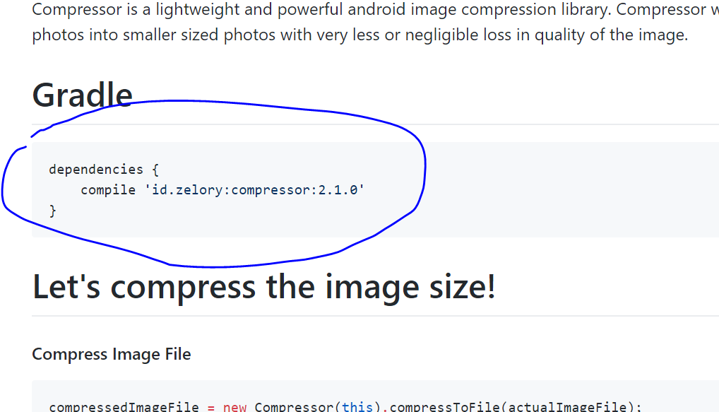
* Copy and paste to the build.gradle (Module app)
* 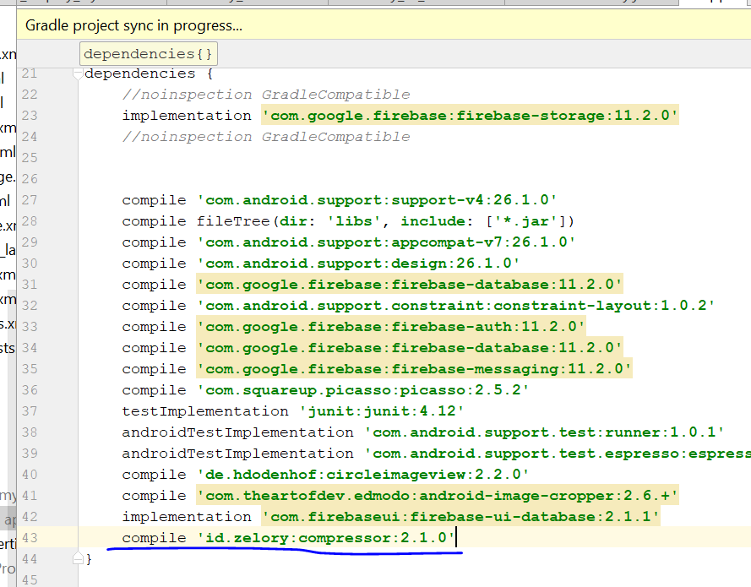
* Then you click sync now
* Go back to settingActivity.java
* Declare Bitmap thumb_bitmap = null
* 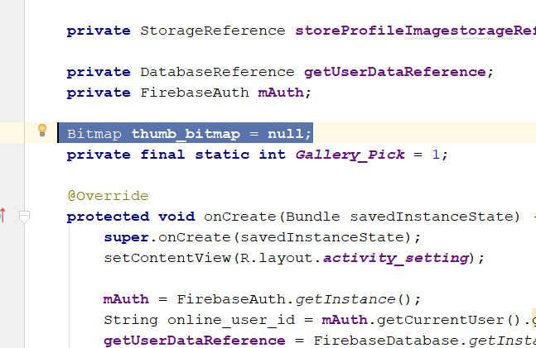
* Then go back to protected void onActivityResult
* Add in this line
* File thumb_filePathUri = **new** File(resultUri.getPath());  
    
    
  String user_id = **mAuth**.getCurrentUser().getUid();  
  **try**{  
   **thumb_bitmap** = **new** Compressor(**this**)  
   .setMaxWidth(200)  
   .setMaxHeight(200)  
   .setQuality(50)  
   .compressToBitmap(thumb_filePathUri);  
  }  
  **catch** (IOException e)  
  {  
   e.printStackTrace();  
  }
* 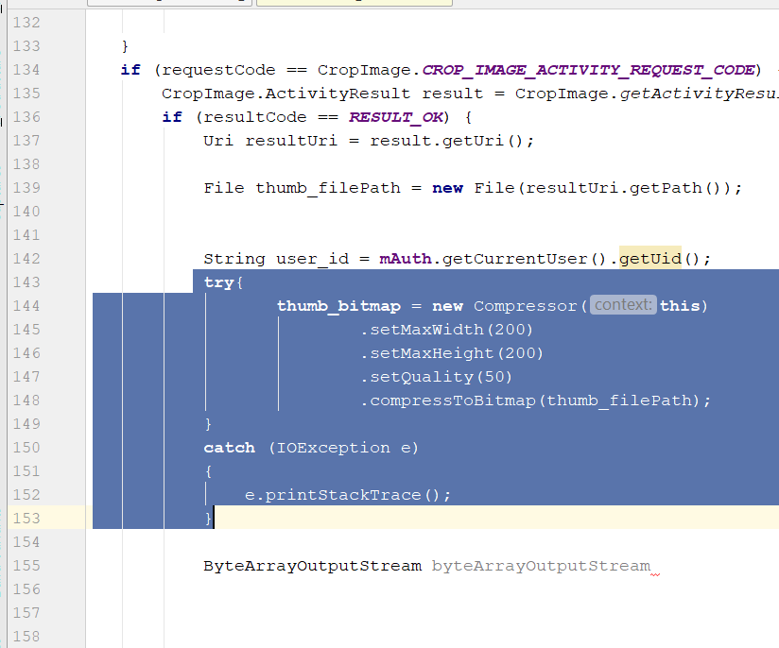
* Add in those lines
* ByteArrayOutputStream byteArrayOutputStream = **new** ByteArrayOutputStream();  
  **thumb_bitmap**.compress(Bitmap.CompressFormat.***JPEG***,50,byteArrayOutputStream);  
  **final byte**[] thumb_byte = byteArrayOutputStream.toByteArray();
* 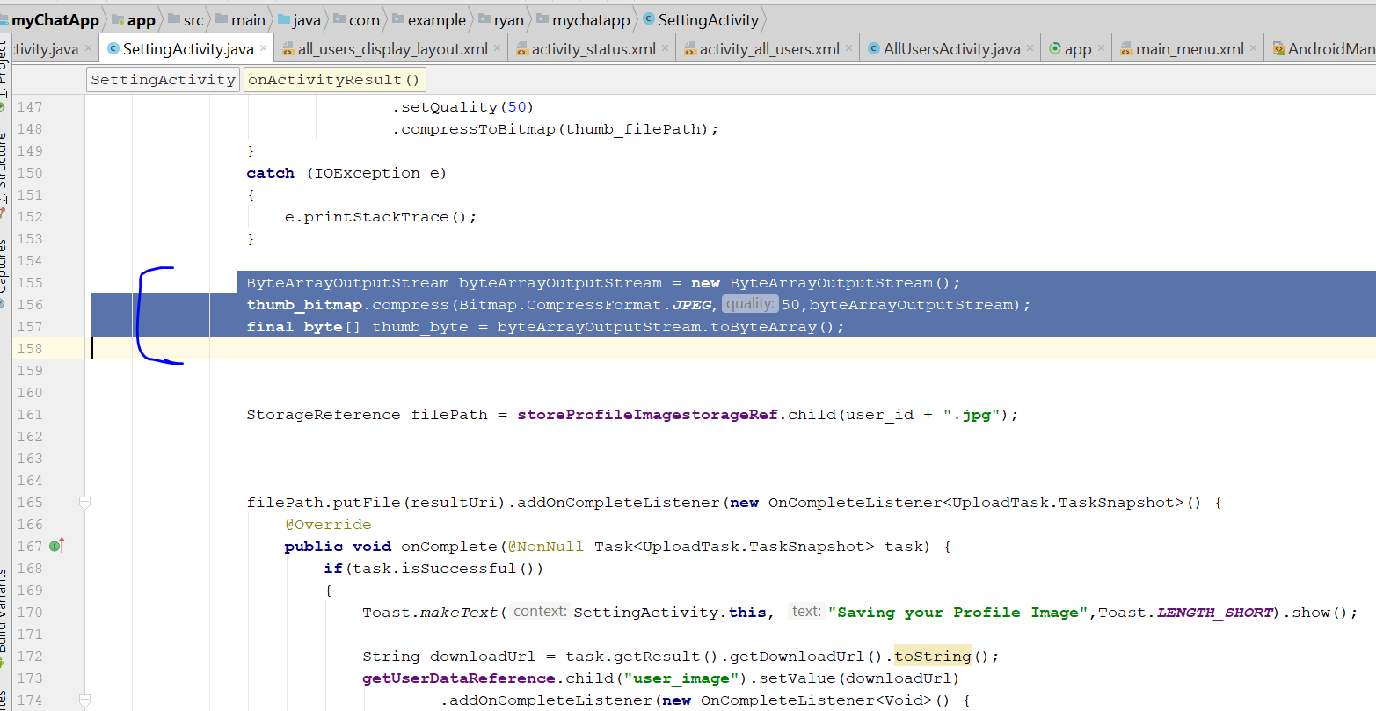
* Now need to add a new firebase reference
* **private** StorageReference **thumbImageRef**;
* 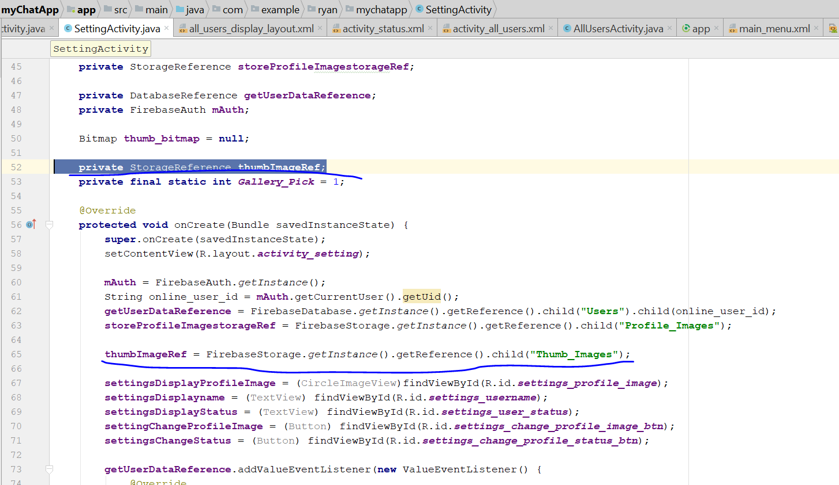
* Add this line in the method below
* StorageReference thumb_filePath = **thumbImageRef**.child(user_id + **".jpg"**);
* 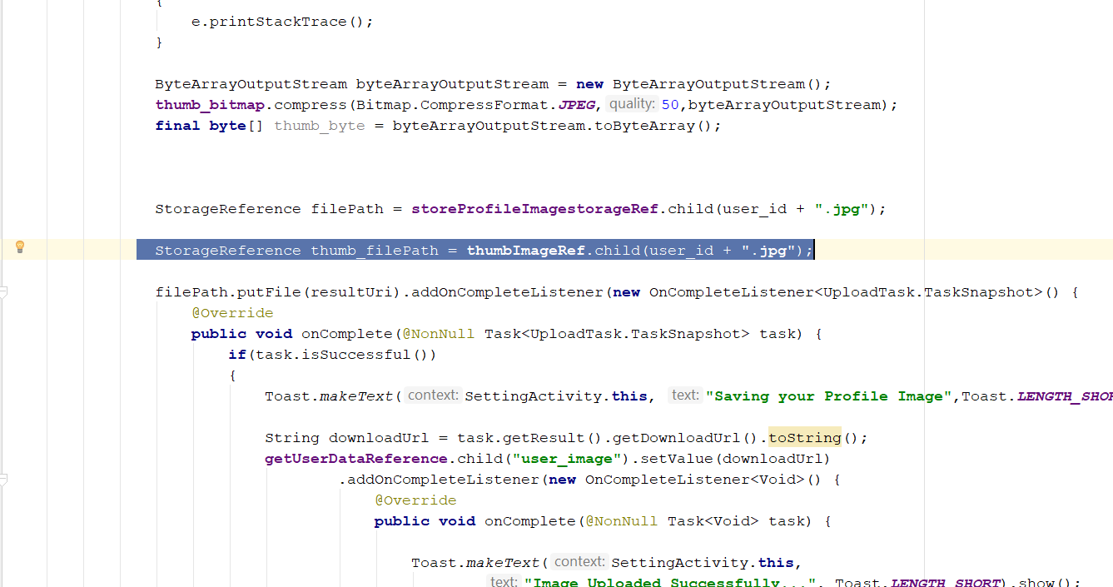
* Add a final here
* 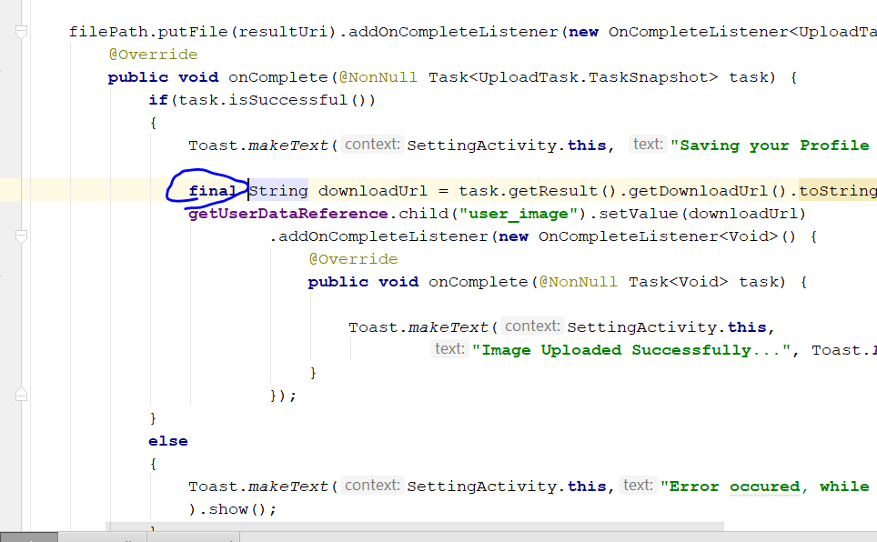
* Add this lines after the final String downloadUrl
* UploadTask uploadTask = thumb_filePath.putBytes(thumb_byte);  
  uploadTask.addOnCompleteListener(**new** OnCompleteListener<UploadTask.TaskSnapshot>() {  
   @Override  
   **public void** onComplete(@NonNull Task<UploadTask.TaskSnapshot> thumb_task) {  
   String thumb_downloadUrl = thumb_task.getResult().getDownloadUrl().toString();  
    
   **if** (task.isSuccessful())  
   {  
   Map update_user_data = **new** HashMap();  
   update_user_data.put(**"user_image"**,downloadUrl);  
   update_user_data.put(**"user_thumb_image"**,thumb_downloadUrl);  
    
   **getUserDataReference**.updateChildren(update_user_data)  
   .addOnCompleteListener(**new** OnCompleteListener<Void>() {  
   @Override  
   **public void** onComplete(@NonNull Task<Void> task) {  
    
   Toast.*makeText*(SettingActivity.**this**,  
   **"Image Uploaded Successfully..."**, Toast.***LENGTH_SHORT***).show();  
   }  
   });  
   }  
   }
* 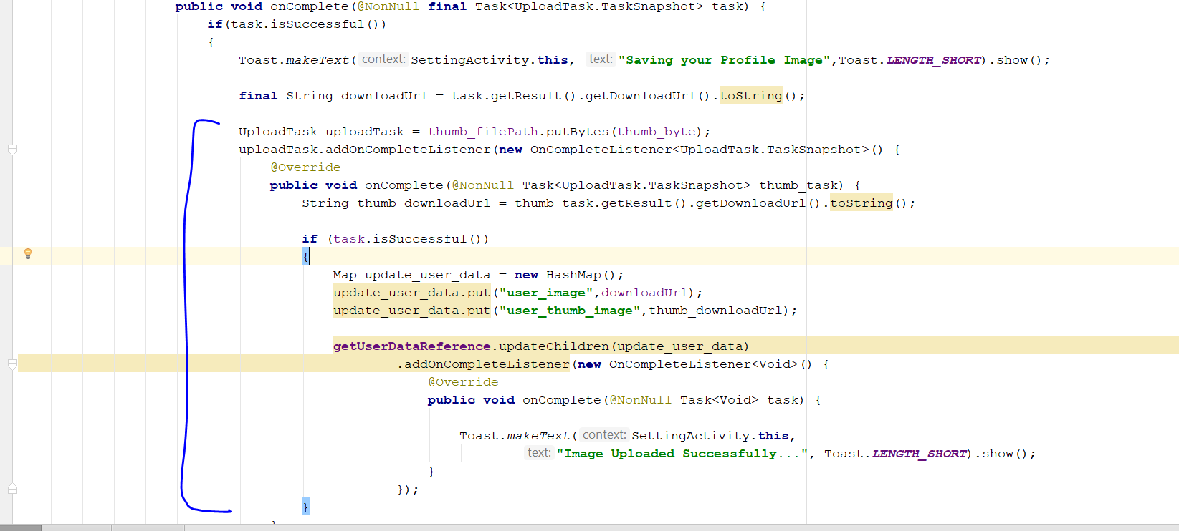
* Cut and paste the code from below
* **getUserDataReference**.updateChildren(update_user_data)  
   .addOnCompleteListener(**new** OnCompleteListener<Void>() {  
   @Override  
   **public void** onComplete(@NonNull Task<Void> task) {  
    
   Toast.*makeText*(SettingActivity.**this**,  
   **"Image Uploaded Successfully..."**, Toast.***LENGTH_SHORT***).show();  
   }  
   });
* Now add a loading Bar
* 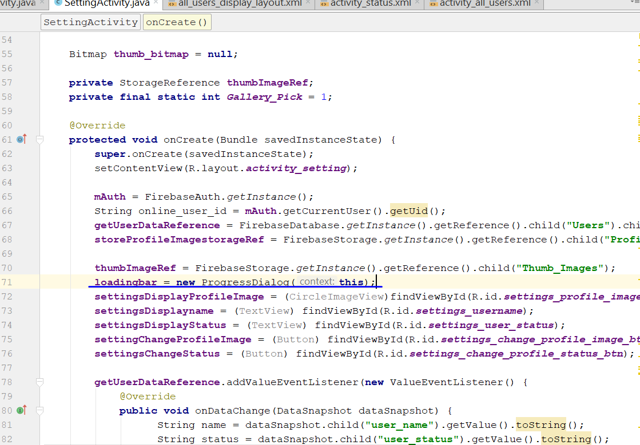
* Now go the line if the resultcode = result_ok
* 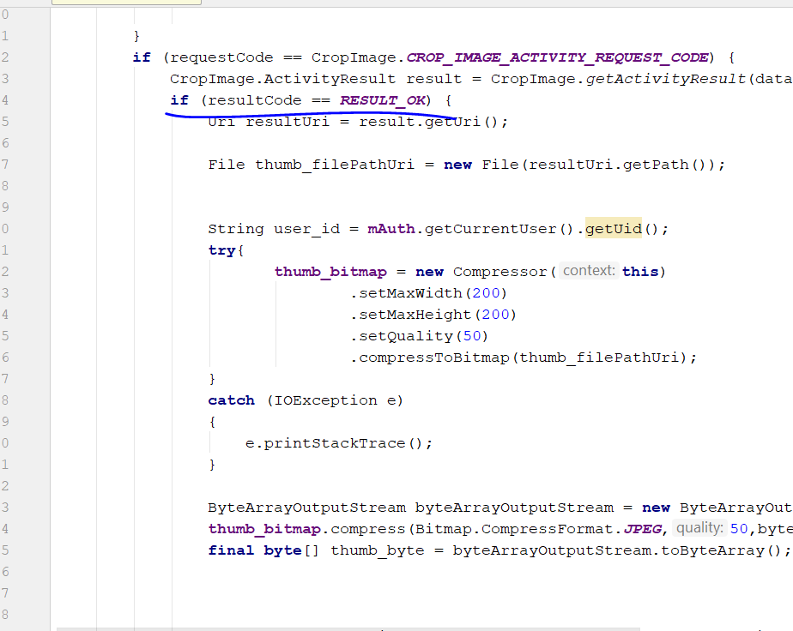
* Add in the following codes
* loadingbar.setTitle(**"Updating Profile Image"**);  
  loadingbar.setMessage(**"Please wait, while we are updating your profile image..."**);  
  loadingbar.show();
* 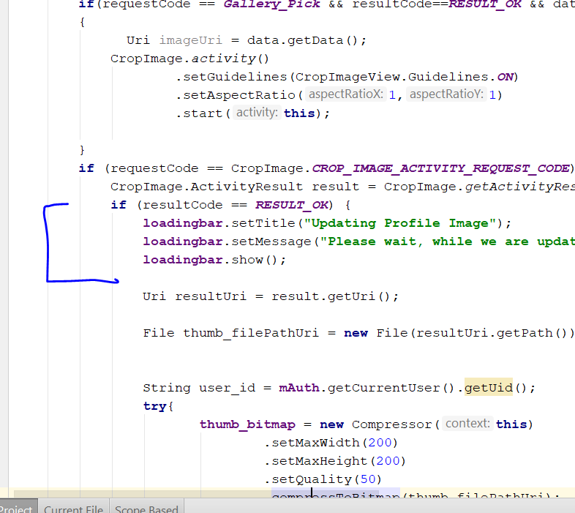
* Add in the loadingbar.dismiss();
* 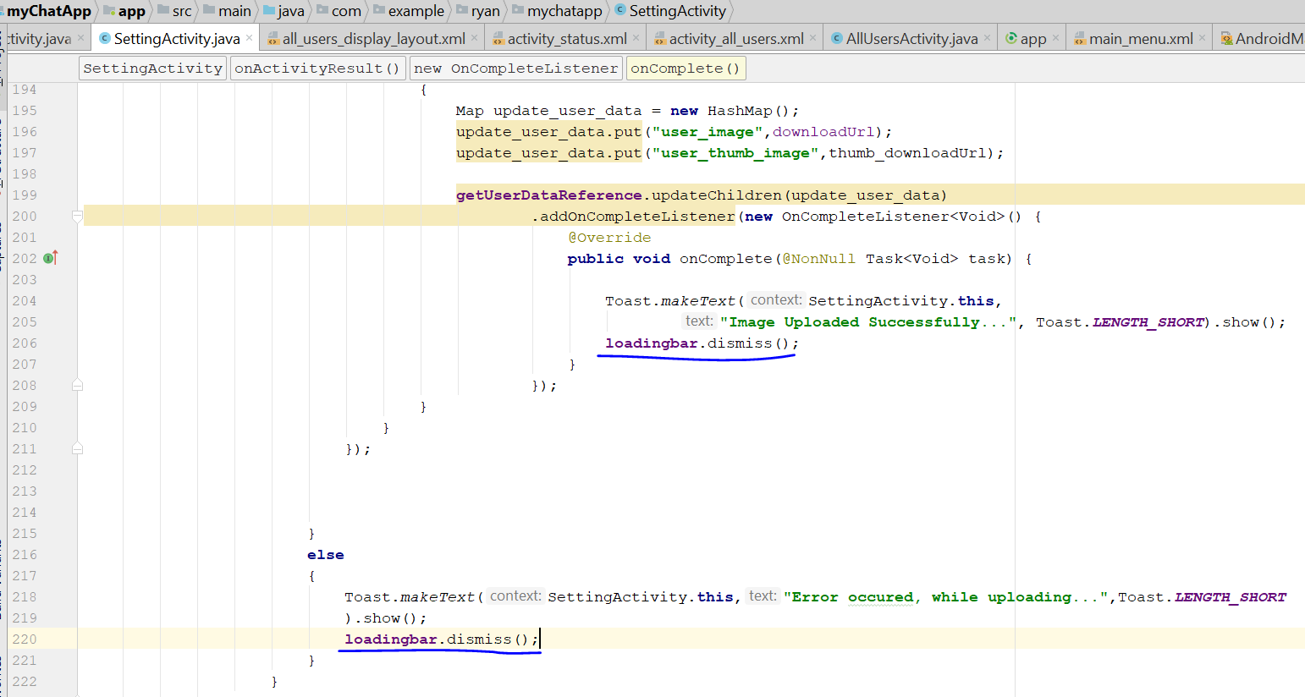
* Rebuild and run
* Change the profile picture
* Now go the browser firebase and check if the thumb_image folder is created
* 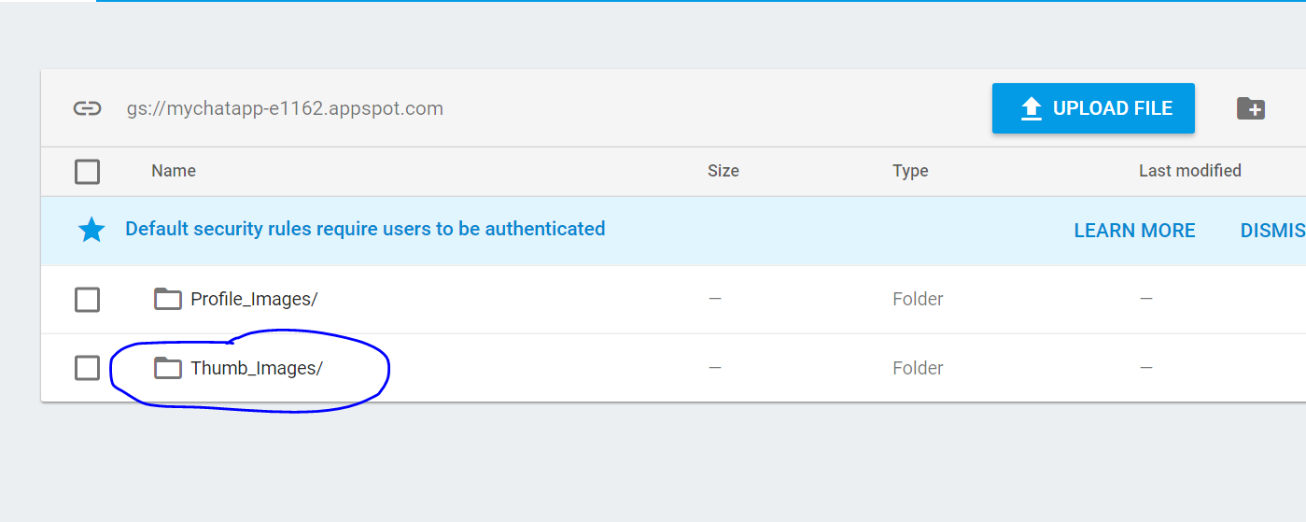
* Now we proceed to the next step
* Go to allUser.java
* Add this two point below
* 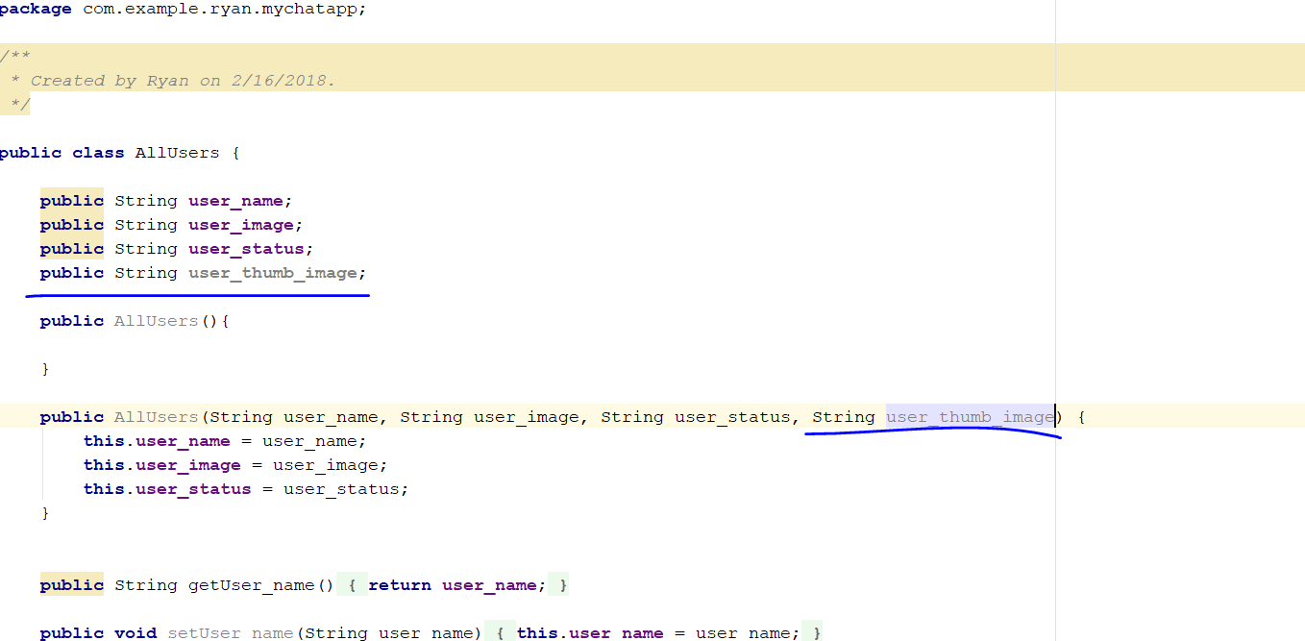
* Add this line
* **this**.**user_thumb_image** = user_thumb_image
* 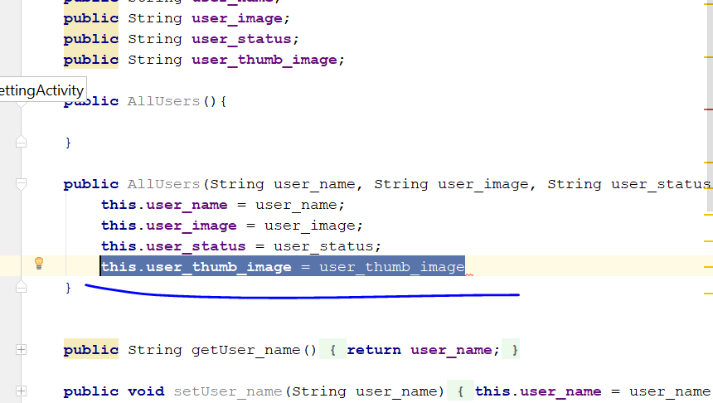
* Generate getter and setter
* 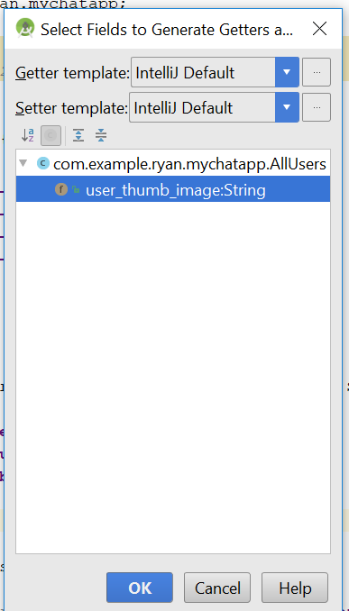
* Now go to AllUsersActivity.java
* Change this line to thumb image
* 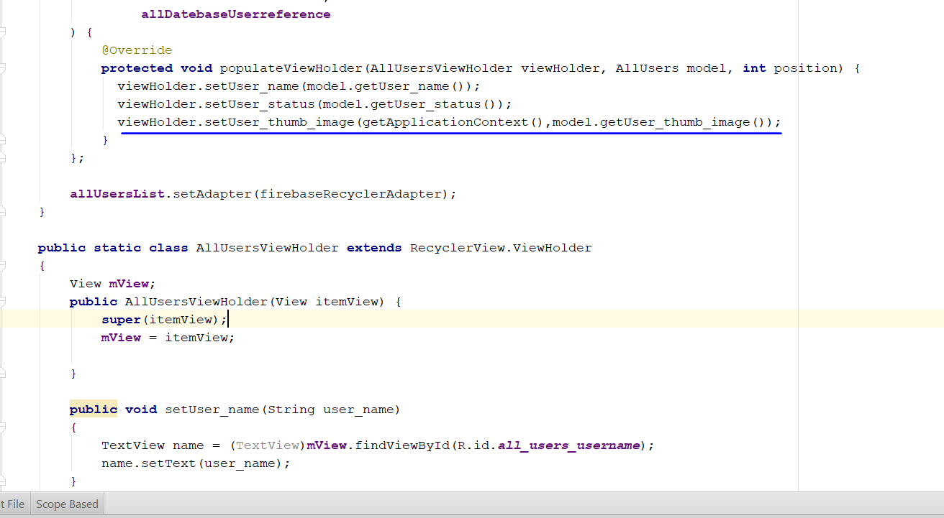
* And this line to thumb_image
* 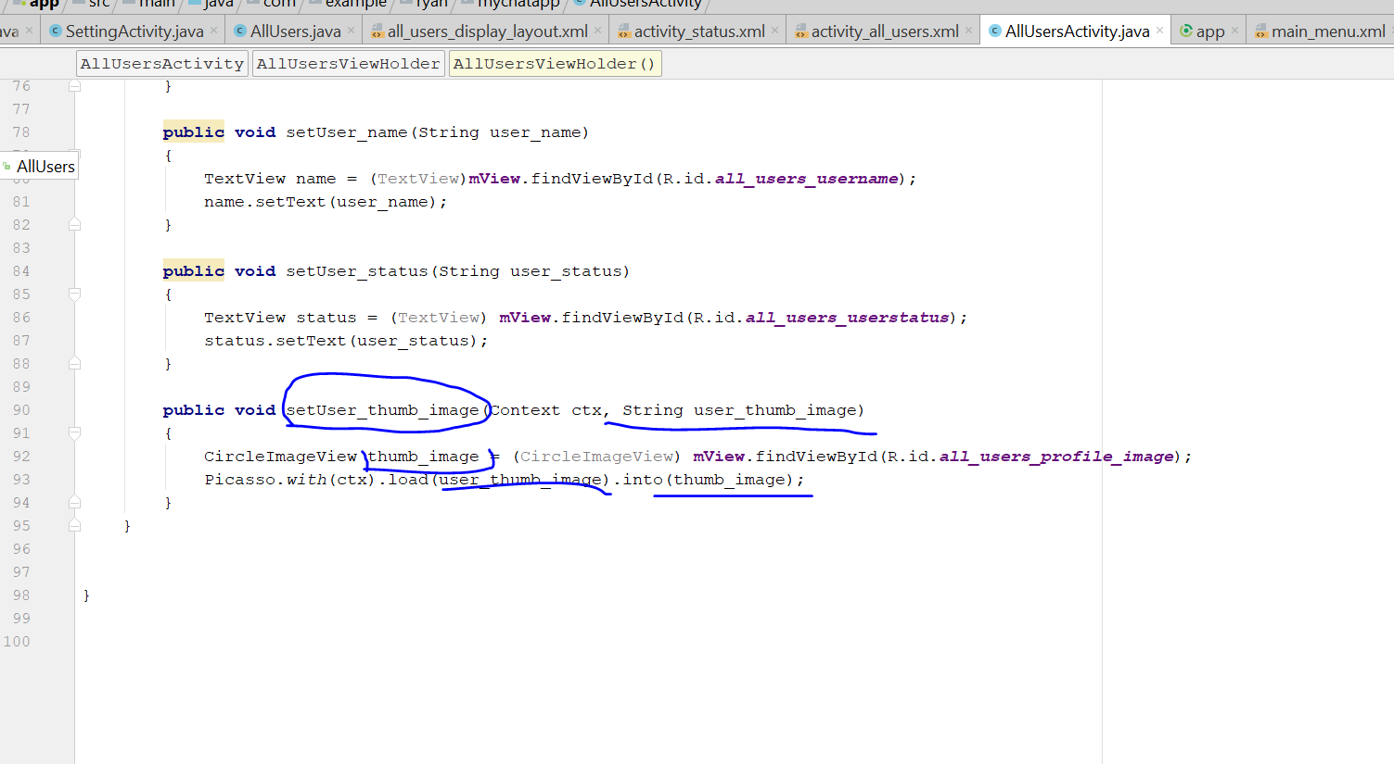
* **public void** setUser_thumb_image(Context ctx, String user_thumb_image)  
  {  
   CircleImageView thumb_image = (CircleImageView) **mView**.findViewById(R.id.***all_users_profile_image***);  
   Picasso.*with*(ctx).load(user_thumb_image).into(thumb_image);  
  }
* rebuild and run

# Step 18: Profile Activity

* Create a new Activity call ProfileActivity.java
* 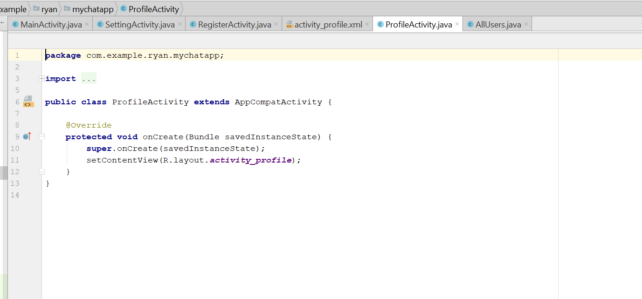
* Now go to activity_profile.xml, change the layout to relative
* 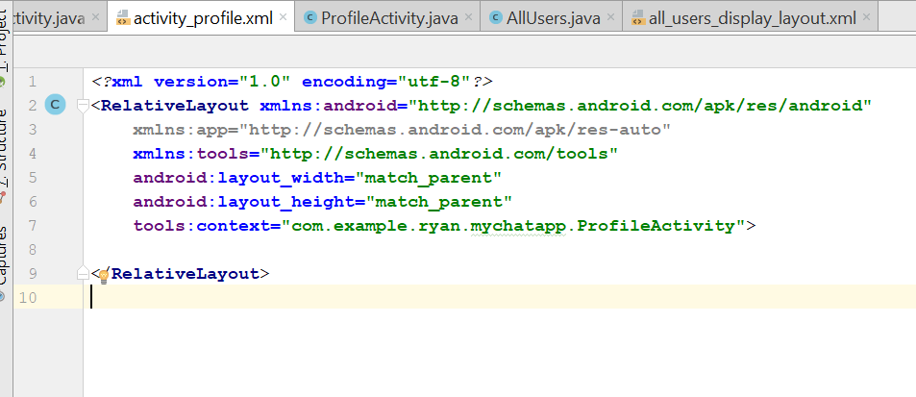
* Now to the RES-> colors.xml
* Change the colorAccent
* #313335
* 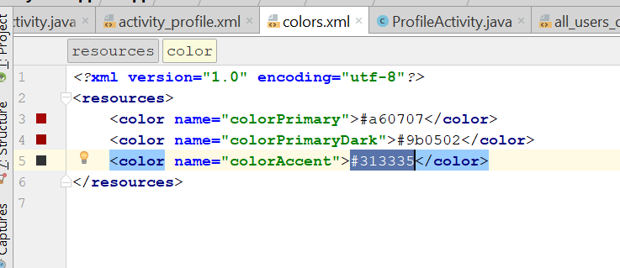
* Go to activity_profile.xml, add in
* android:background="@color/colorAccent"
* 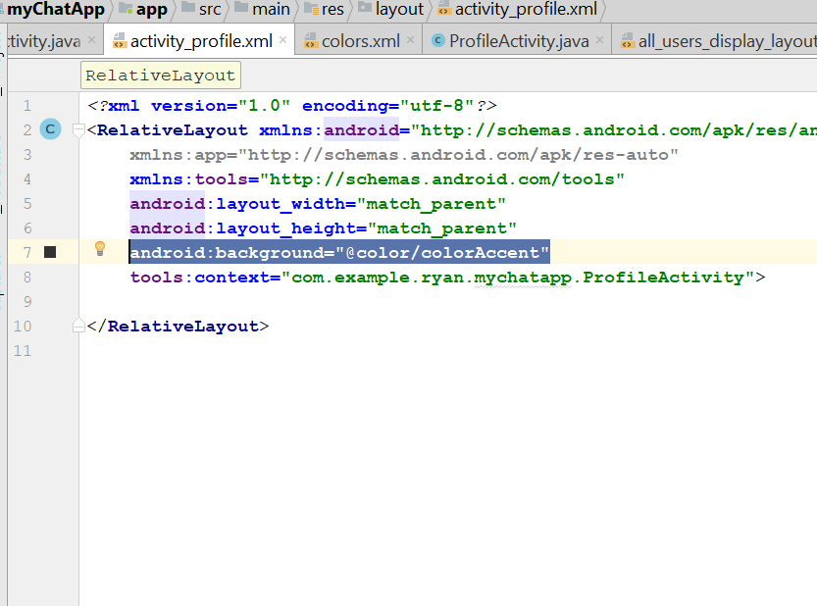
* It will look like this
* 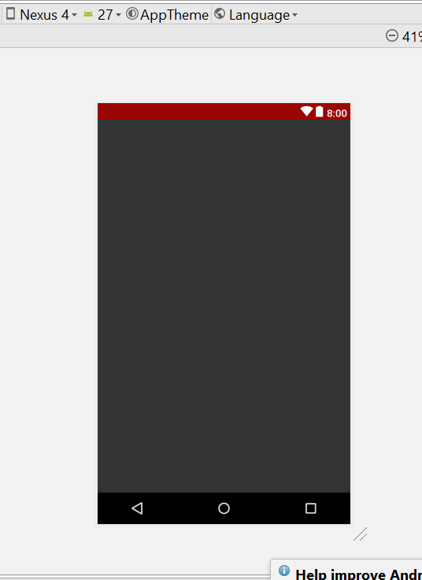
* Add this line
* <**ImageView  
   android:id="@+id/profile_visit_user_image"  
   android:layout_width="match_parent"  
   android:layout_height="280dp"   
   android:src="@drawable/default_profile"**/>
* 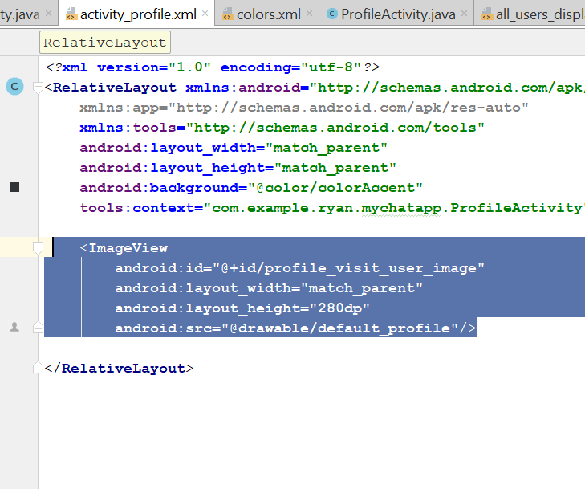
* 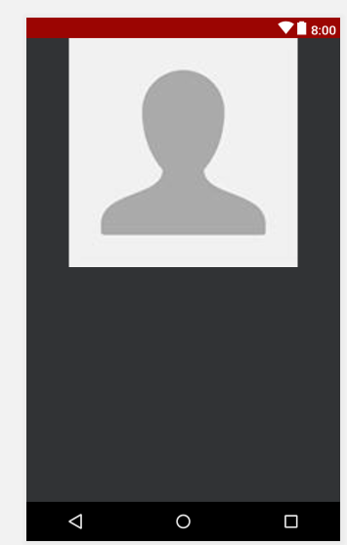
* Now drag the textview into the XML for username
* 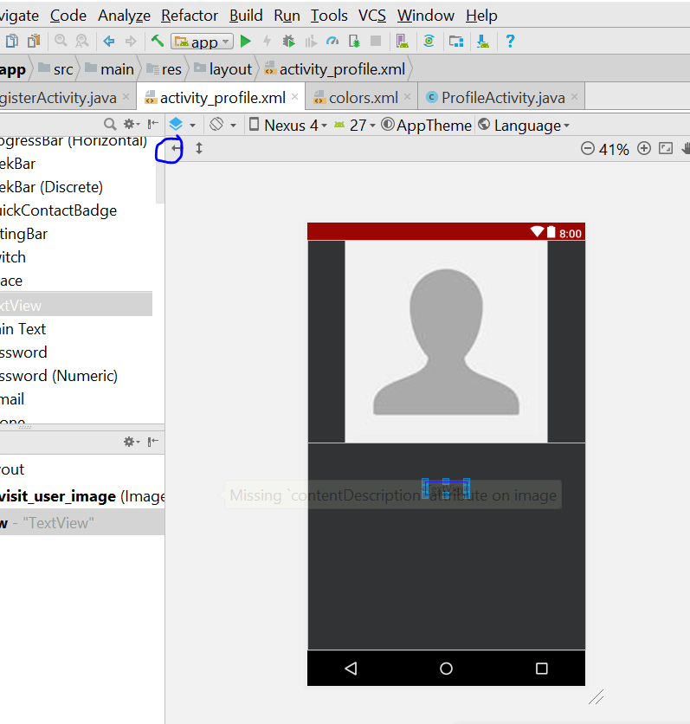
* Click on this
* TextSize is 22dp
* 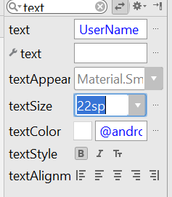
* Textcolour is background light
* 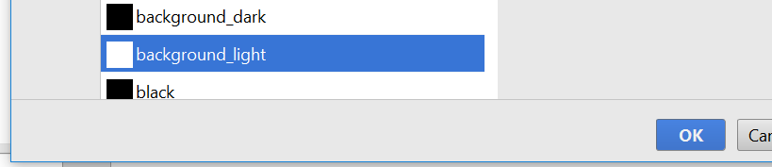
* And make it bold
* Now it look like that
* 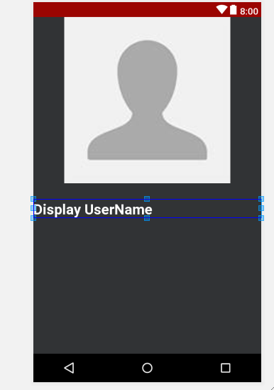
* Add in this code in the XML, android:gravity="center"
* 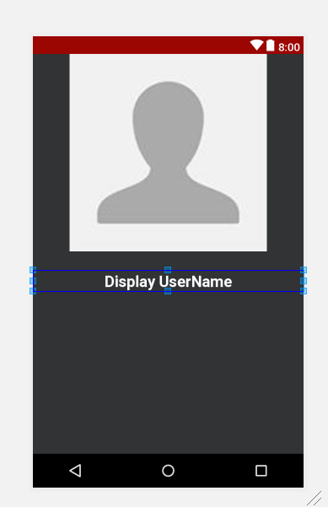
* Now drag another TextView and set the same properties
* 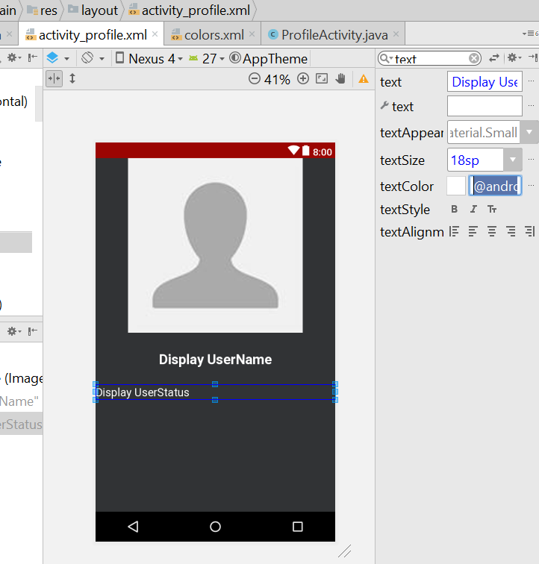
* The text is Display userStatus, and the top margin is 5dp
* Display username the top margin is 10dp
* 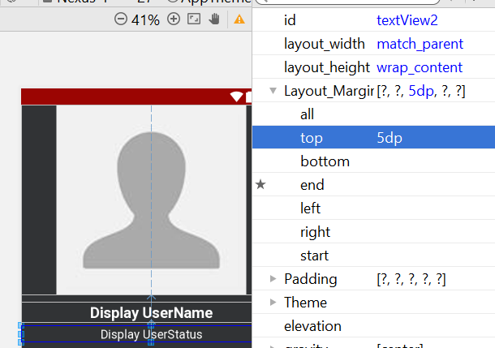
* Now drag another button to the XML
* The Text change to SEND FRIEND REQUEST
* Now drag another button to the XML
* 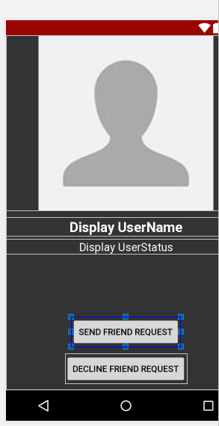
* Now textcolour change to background light
* Button background change to colour_primary (RED)
* Width change to 230dp
* 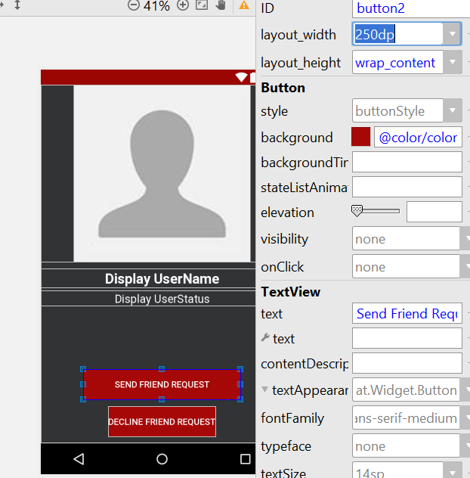
* Text size change to 16dp
* Button Bottom Margin both put 10dp
* The Display Username id is change to profile_visit_username
* The Display UserStatus id is change to profile_visit_user_status
* Send request button id is profile_visit_send_req_btn
* Decline request button id is profile_decline_friend_req_btn
* Now go to allUserActivity.java
* Go to populateViewHolder
* Add this line
* viewHolder.**mView**.setOnClickListener(**new** View.OnClickListener() {  
   @Override  
   **public void** onClick(View v) {  
   String visit_user_id = getRef(position).getKey();  
   Intent profileIntent = **new** Intent(AllUsersActivity.**this**,ProfileActivity.**class**);  
   profileIntent.putExtra(**"visit_user_id"**,visit_user_id);  
   startActivity(profileIntent);  
    
   }  
  });
* 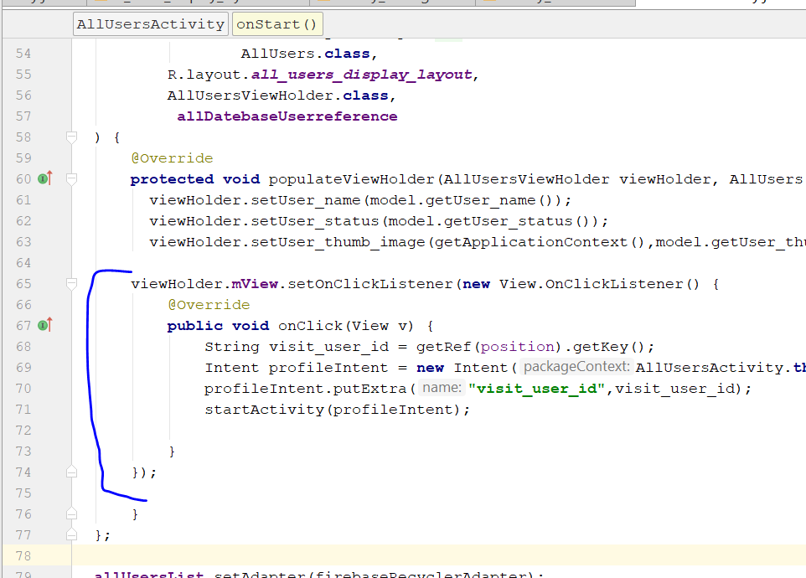
* Now go to profileActivity.java
* Add this line

String visit_user_id = getIntent().getExtras().get(**"visit_user_id"**).toString();  
Toast.*makeText*(ProfileActivity.**this**, visit_user_id, Toast.***LENGTH_SHORT***).show();

* Now go to allUsersActivity.java
* Change the last line
* 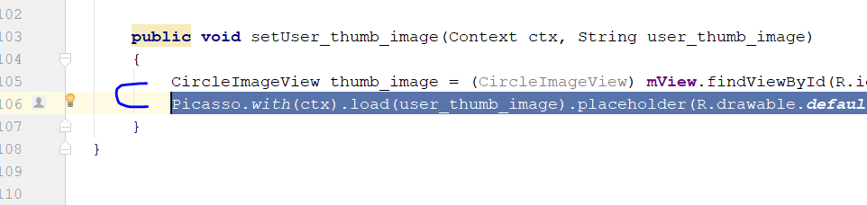
* Picasso.with(ctx).load(user_thumb_image).placeholder(R.drawable.***default_profile***).into(thumb_image);
* Now go to profileActivity
* Declare those variable
* **private** Button **sendFriendrequest**;  
  **private** Button **declineFriendRequest**;  
  **private** TextView **ProfileName**;  
  **private** TextView **ProfileStatus**;  
  **private** ImageView **ProfileImage**;
* then in the onCreate part, add in those code
* **sendFriendrequest** = (Button)findViewById(R.id.***profile_visit_send_req_btn***);  
  **declineFriendRequest** = (Button)findViewById(R.id.***profile_decline_friend_req_btn***);  
  **ProfileName** = (TextView) findViewById(R.id.***profile_visit_username***);  
  **ProfileStatus** = (TextView) findViewById(R.id.***profile_visit_user_status***);  
  **ProfileImage** = (ImageView)findViewById(R.id.***profile_visit_user_image***);
* 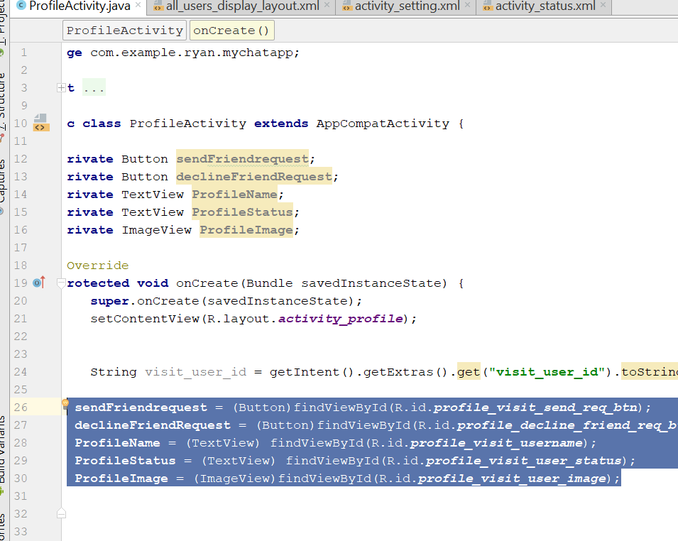
* Now add in the database Refence of firebase
* **private** DatabaseReference **UsersReference**;
* **UsersReference** = FirebaseDatabase.*getInstance*().getReference().child(**"Users"**);
* Then u add this few lines
* **UsersReference**.child(visit_user_id).addValueEventListener(**new** ValueEventListener() {  
   @Override  
   **public void** onDataChange(DataSnapshot dataSnapshot) {  
   String name = dataSnapshot.child(**"user_name"**).getValue().toString();  
   String status = dataSnapshot.child(**"user_status"**).getValue().toString();  
   String image = dataSnapshot.child(**"user_image"**).getValue().toString();  
   **ProfileName**.setText(name);  
   **ProfileStatus**.setText(status);  
   Picasso.*with*(ProfileActivity.**this**).load(image).placeholder(R.drawable.***default_profile***).into(**ProfileImage**);  
   }  
    
   @Override  
   **public void** onCancelled(DatabaseError databaseError) {  
    
   }  
  });
* 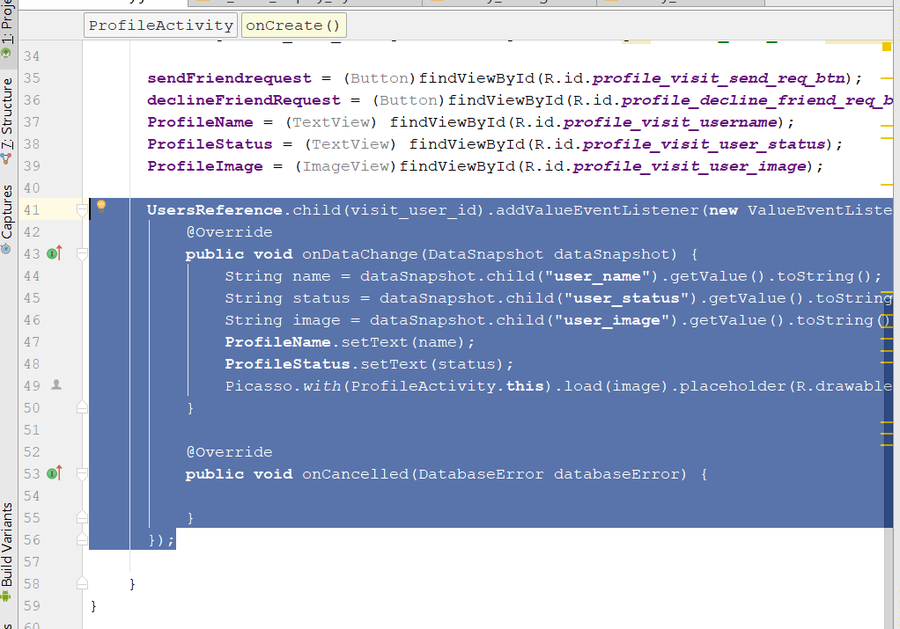
* Rebuild and Run

# Step 19: Send Friend Request

* Go to ProfileActivity
* Declare this
* **private** String **CURRENT_STATE**;  
  **private** DatabaseReference **FriendRequestReference**;  
  **private** FirebaseAuth **mAuth**;  
  String **sender_user_id**;
* String **receiver_user_id**;
* now to onCreate method
* declare this
* CURRENT_STATE = **"not_friends"**;
* **FriendRequestReference** = FirebaseDatabase.*getInstance*().getReference().child(**"Friend_Requests"**);  
   **mAuth** = FirebaseAuth.*getInstance*();  
   **sender_user_id** = **mAuth**.getCurrentUser().getUid();
* 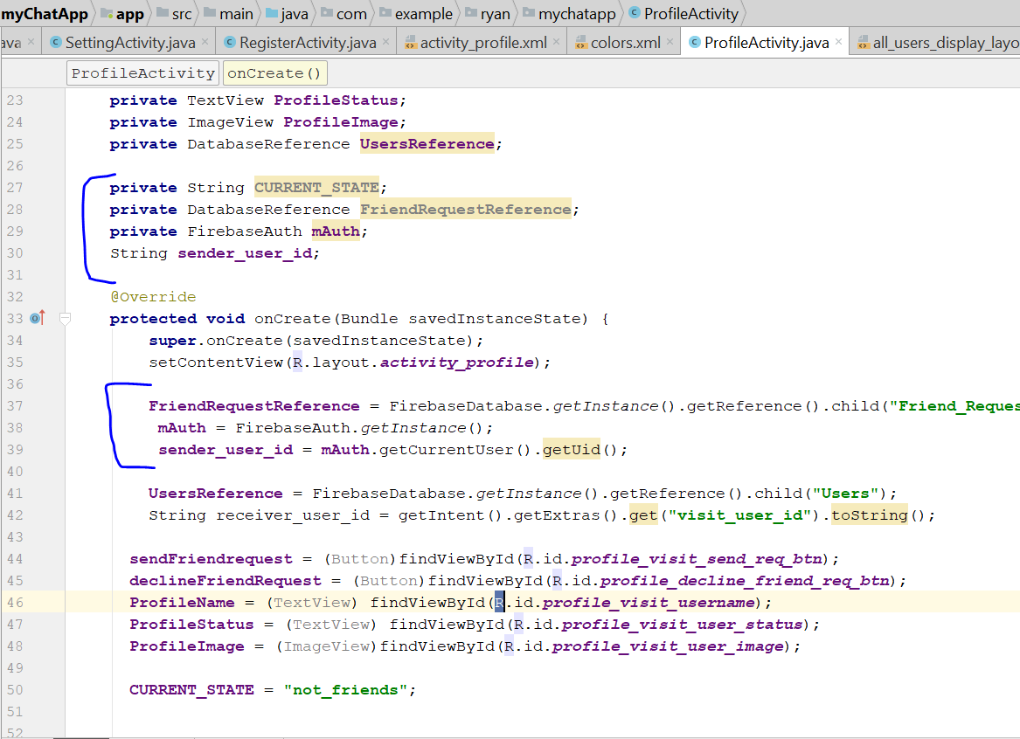
* Set onclicklistener to sendFriendRequest
* Receiver_user_id set to global
* 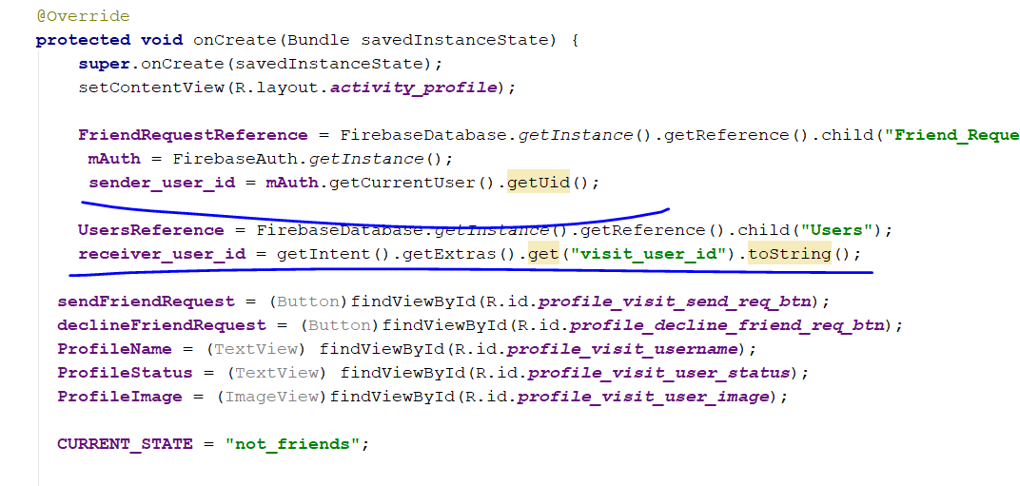
* Add this below
* **sendFriendRequest**.setOnClickListener(**new** View.OnClickListener() {  
   @Override  
   **public void** onClick(View v) {  
    
   }  
  });
* 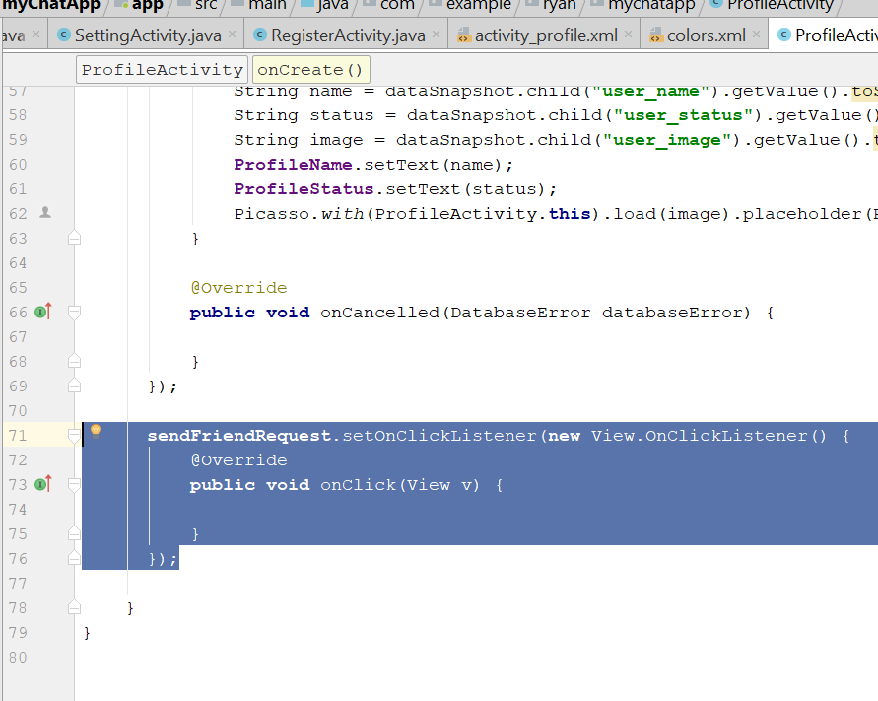
* Create a new method call
* **private void** SendFriendRequestToaFriend()
* **private void** SendFriendRequestToaFriend() {  
   **FriendRequestReference**.child(**sender_user_id**)  
   .child(**receiver_user_id**).child(**"request_type"**)  
   .setValue(**"sent"**)  
   .addOnCompleteListener(**new** OnCompleteListener<Void>() {  
   @Override  
   **public void** onComplete(@NonNull Task<Void> task) {  
   **if**(task.isSuccessful())  
   {  
   **FriendRequestReference**.child(**receiver_user_id**)  
   .child(**sender_user_id**).child(**"request_type"**).setValue(**"received"**)  
   .addOnCompleteListener(**new** OnCompleteListener<Void>() {  
   @Override  
   **public void** onComplete(@NonNull Task<Void> task) {  
   **if**(task.isSuccessful())  
   {  
   **sendFriendRequest**.setEnabled(**true**);  
   **CURRENT_STATE** = **"request_sent"**;  
   **sendFriendRequest**.setText(**"Cancel Friend Request"**);  
   }  
   }  
   });  
   }  
   }  
   });  
  }
* 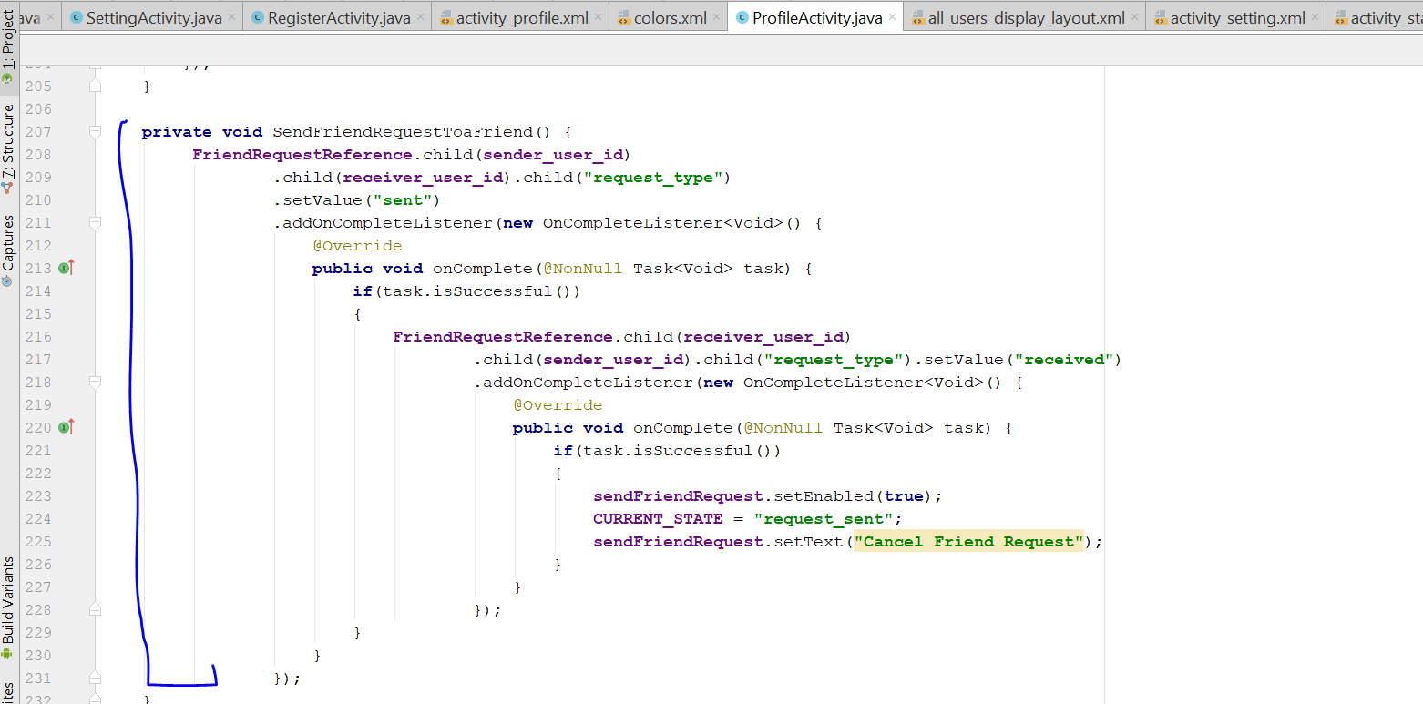
* Add this line after the Picasso
* **FriendRequestReference**.child(**sender_user_id**)  
   .addListenerForSingleValueEvent(**new** ValueEventListener() {  
   @Override  
   **public void** onDataChange(DataSnapshot dataSnapshot) {  
   **if** (dataSnapshot.hasChild(**receiver_user_id**))  
   {  
   String req_type = dataSnapshot.child(**receiver_user_id**)  
   .child(**"request_type"**).getValue().toString();  
   **if**(req_type.equals(**"sent"**))  
   {  
   **CURRENT_STATE** = **"request_sent"**;  
   **sendFriendRequest**.setText(**"Cancel Friend Request"**);  
   }  
   }  
   }  
    
   @Override  
   **public void** onCancelled(DatabaseError databaseError) {  
    
   }  
   });
* 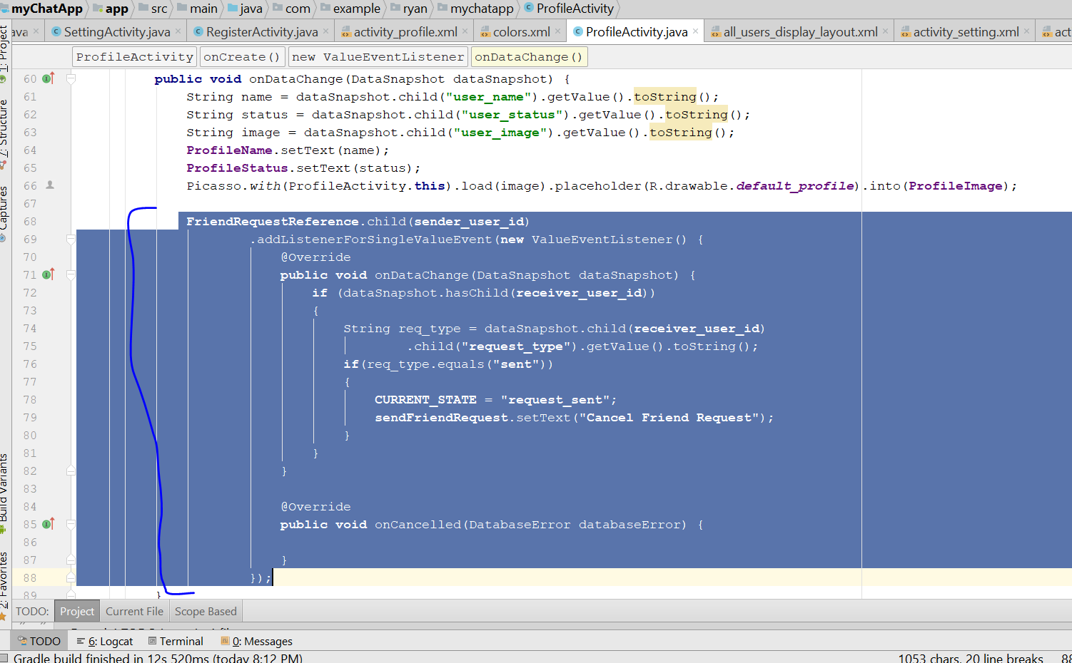
* Rebuild and run
* U should see this in the firebase, after you add friend request
* 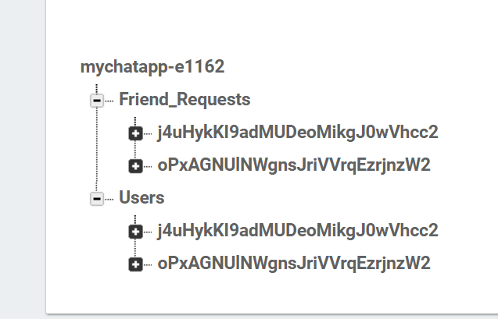
* Now do the cancel friend request
* Go to ProfileActivity.java
* Go to **sendFriendRequest**.setOnClickListener(**new** View.OnClickListener()
* 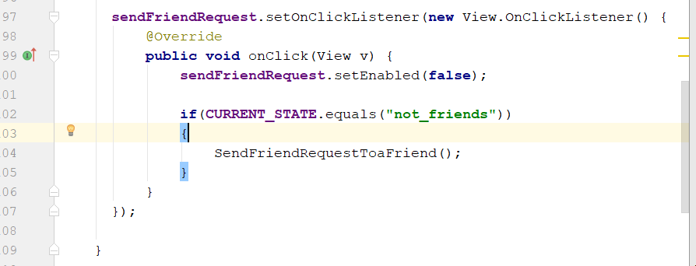
* Add this
* **if**(**CURRENT_STATE**.equals(**"request_sent"**)){  
   CancelFriendRequest();  
  }
* 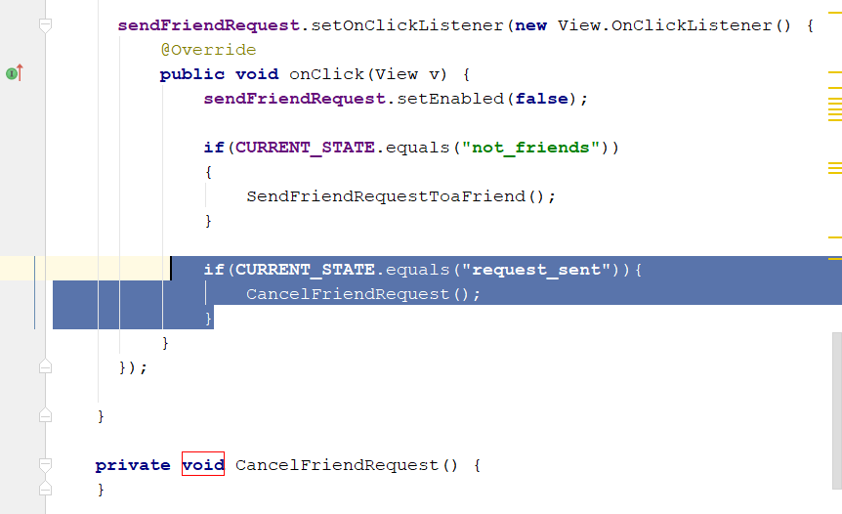
* Create a new Method call CancelFriendRequest() in profile activity
* **private void** CancelFriendRequest() {  
   **FriendRequestReference**.child(**sender_user_id**).child(**receiver_user_id**)  
   .removeValue().addOnCompleteListener(**new** OnCompleteListener<Void>() {  
   @Override  
   **public void** onComplete(@NonNull Task<Void> task) {  
   **if**(task.isSuccessful())  
   {  
   **FriendRequestReference**.child(**receiver_user_id**).child(**sender_user_id**)  
   .removeValue().addOnCompleteListener(**new** OnCompleteListener<Void>() {  
   @Override  
   **public void** onComplete(@NonNull Task<Void> task) {  
   **if**(task.isSuccessful())  
   {  
   **sendFriendRequest**.setEnabled(**true**);  
   **CURRENT_STATE** = **"not_friend"**;  
   **sendFriendRequest**.setText(**"Send Friend Request"**);  
   }  
   }  
   });  
   }  
   }  
   });
* 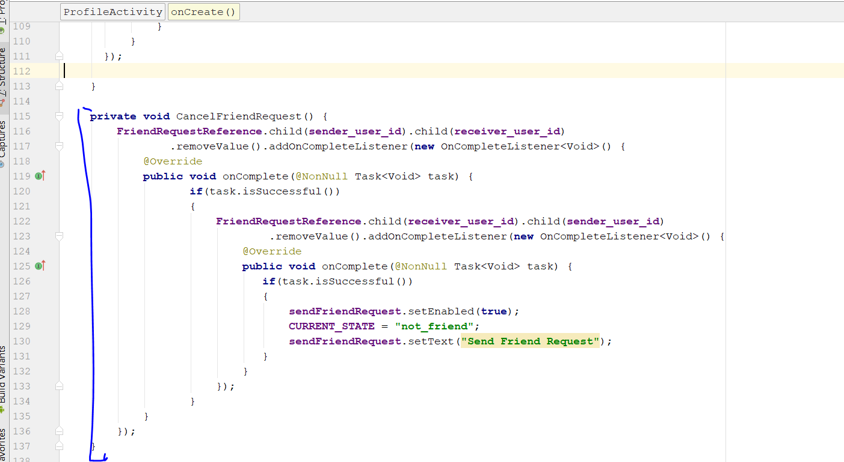
* Rebuild and run, and try cancel friend request, the request shld be deleted in the firebase console
* 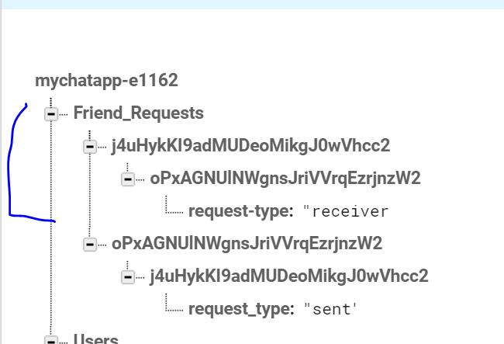
* After u click on cancel request
* 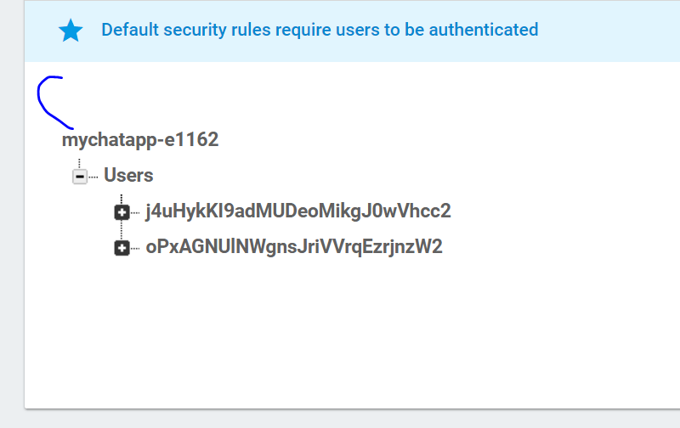

# Step 20: Accept Friend Request

* Now go to profileActivity.java
* Add another current state
* At here
* 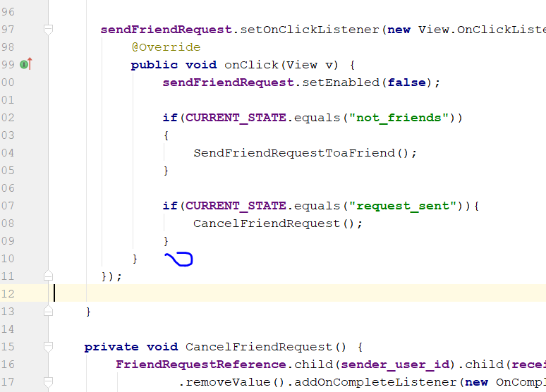
* **if**(**CURRENT_STATE**.equals(**"request_received"**))  
  {  
   AcceptFriendRequest();  
  }
* 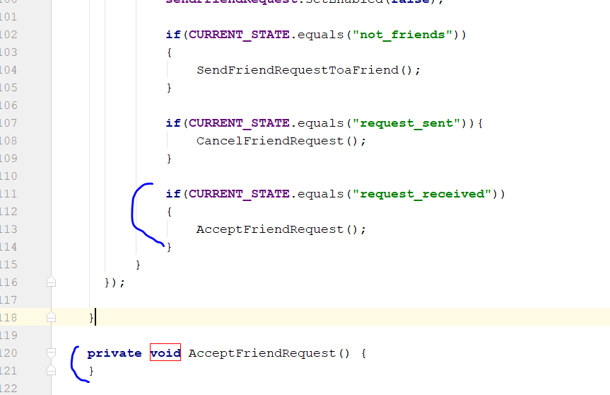
* Now create another database reference
* 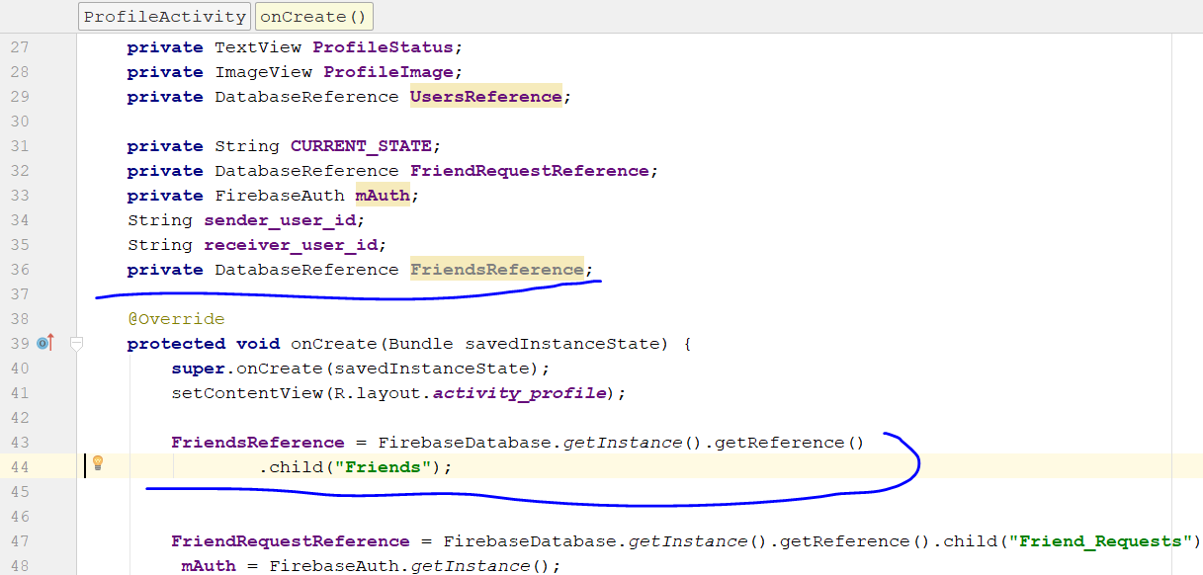
* Now import this
* **import** android.icu.util.Calendar;
* **import** android.icu.text.SimpleDateFormat;
* For the AcceptFriendRequest() method, now it become like this
* **private void** AcceptFriendRequest() {  
   Calendar calFordAte = Calendar.*getInstance*();  
   SimpleDateFormat currentDate = **new** SimpleDateFormat(**"dd-MMMM-yyyy"**);  
  }
* 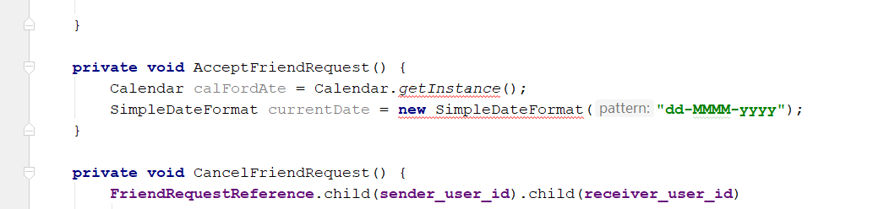
* You can just remove the red line, it is not a error
* Add in the following code
* **FriendsReference**.child(**sender_user_id**)  
   .child(**receiver_user_id**).setValue(saveCurrentDate)  
   .addOnSuccessListener(**new** OnSuccessListener<Void>() {  
   @Override  
   **public void** onSuccess(Void aVoid) {  
   **FriendsReference**.child(**receiver_user_id**)  
   .child(**sender_user_id**)  
   .setValue(saveCurrentDate)  
   .addOnSuccessListener(**new** OnSuccessListener<Void>() {  
   @Override  
   **public void** onSuccess(Void aVoid) {  
    
   }  
   });  
   }  
   });
* 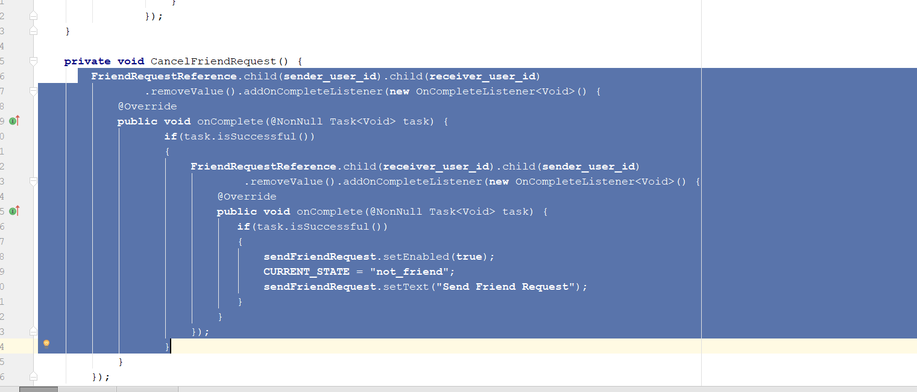
* Copy and paste the cancelfriendrequest code into here
* 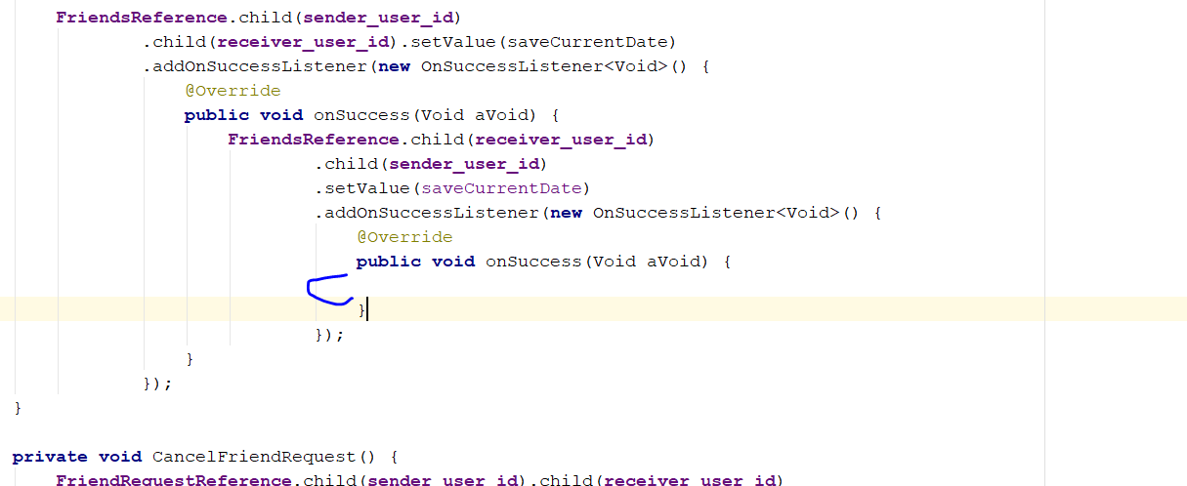
* So now it look like this
* 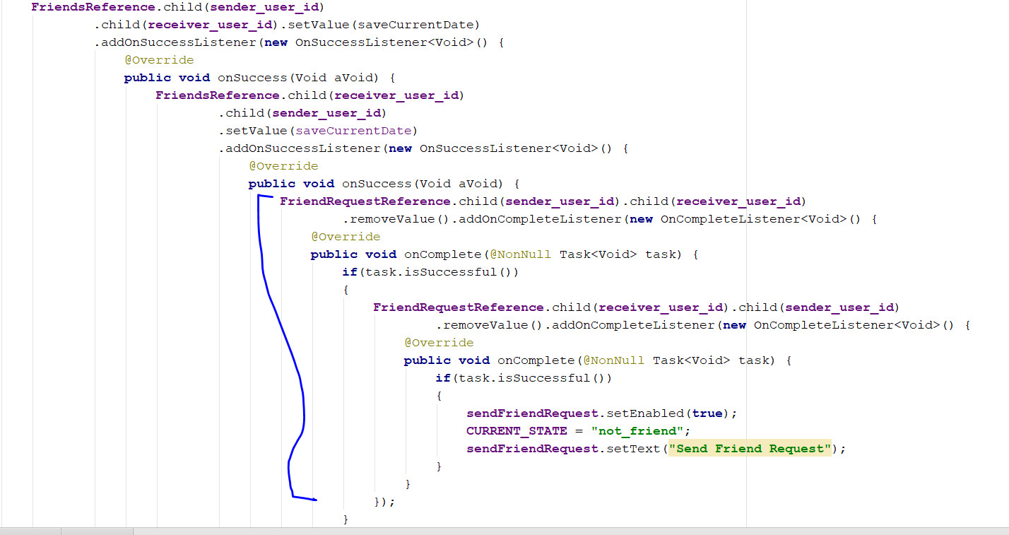
* Change the state
* **CURRENT_STATE** = **"friends"**;
* 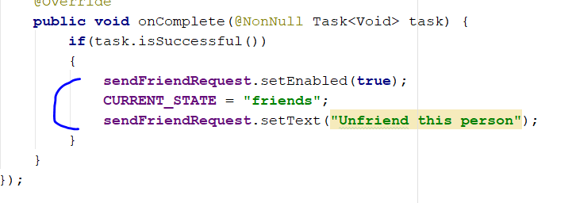
* Go to oncreate method, add in this Current_state
* **else if**(req_type.equals(**"received"**))  
  {  
   **CURRENT_STATE** = **"request_received"**;  
   **sendFriendRequest**.setText(**"Accept Friend Request"**);  
  }
* 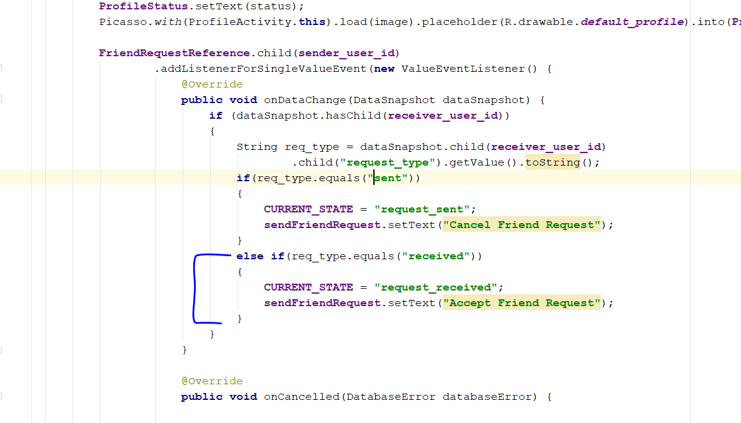
* Add in this line
* 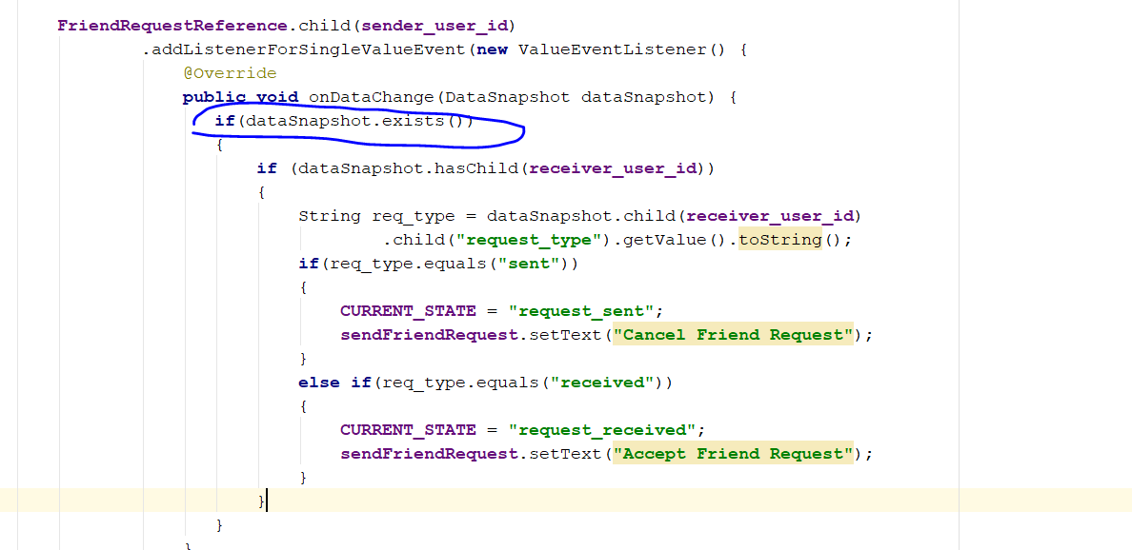
* Go to private void SendFriendRequestToaFriend()
* Rebuild and run, after u accept friend request, you should see this in firebase
* 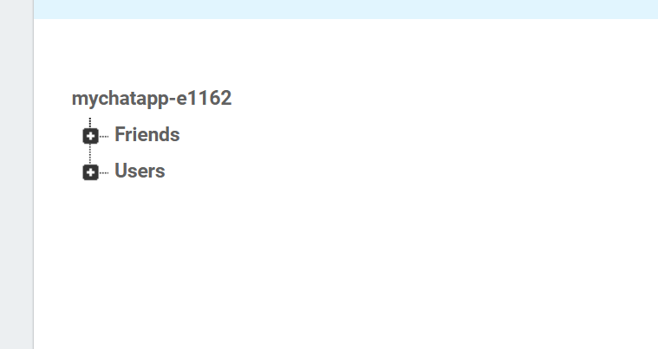

# Step 21: Unfriend friend

* Go to ProfileActivity.java
* Go to sendFriendRequest.setOnClickListener
* Add
* **if**(**CURRENT_STATE**.equals(**"friends"**))  
  {  
   UnFriendsFriend();  
  }
* create the method UnFriendsFriend();
* **private void** UnFriendsFriend() {  
   **FriendsReference**.child(**sender_user_id**).child(**receiver_user_id**).removeValue()  
   .addOnCompleteListener(**new** OnCompleteListener<Void>() {  
   @Override  
   **public void** onComplete(@NonNull Task<Void> task) {  
   **if**(task.isSuccessful())  
   {  
   **FriendsReference**.child(**receiver_user_id**).child(**sender_user_id**).removeValue()  
   .addOnCompleteListener(**new** OnCompleteListener<Void>() {  
   @Override  
   **public void** onComplete(@NonNull Task<Void> task) {  
   **if**(task.isSuccessful())  
   {  
   **sendFriendRequest**.setEnabled(**true**);  
   **CURRENT_STATE** = **"not_friends"**;  
   **sendFriendRequest**.setText(**"Send Friend Request"**);  
   }  
   }  
   });  
   }  
   }  
   });  
  }
* 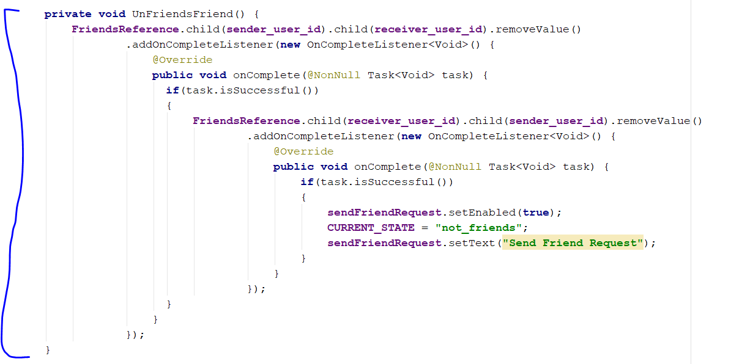
* Now go to the public void onDataChange(DataSnapshot dataSnapshot)
* Add a else statement
* Add the code below inside the else state
* **FriendsReference**.child(**sender_user_id**)  
   .addListenerForSingleValueEvent(**new** ValueEventListener() {  
   @Override  
   **public void** onDataChange(DataSnapshot dataSnapshot) {  
   **if**(dataSnapshot.hasChild(**receiver_user_id**))  
   {  
   **CURRENT_STATE** = **"friends"**;  
   **sendFriendRequest**.setText(**"Unfriend This Person"**);  
    
   }  
   }  
    
   @Override  
   **public void** onCancelled(DatabaseError databaseError) {  
    
   }  
   });
* 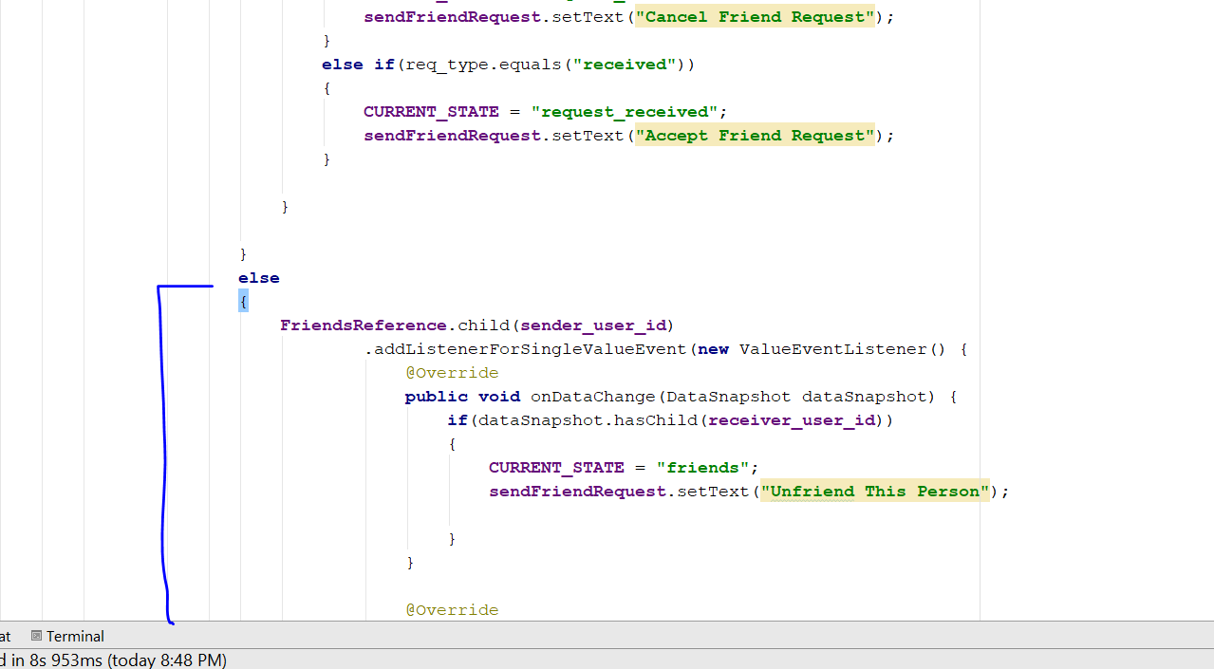
* Rebuild and Run
* Now we need to make sure, you cannot add ownself as friend
* Go to sendFriendRequest.setOnClickListener
* Add this condition before execute that method
* **if**(!**sender_user_id**.equals(**receiver_user_id**))  
  {
* }
* 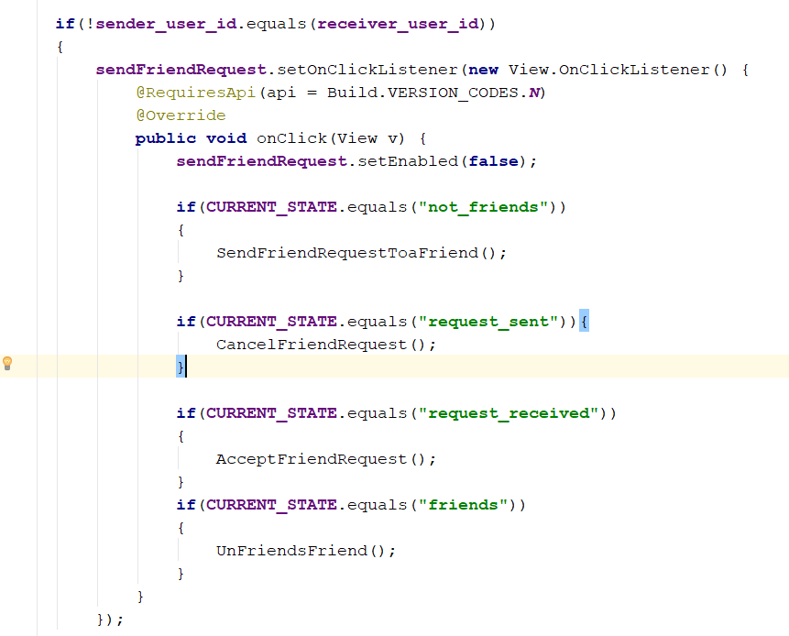
* Add a else statement with this code
* **else**{  
   **declineFriendRequest**.setVisibility(View.***INVISIBLE***);  
   **sendFriendRequest**.setVisibility(View.***INVISIBLE***);  
  }
* 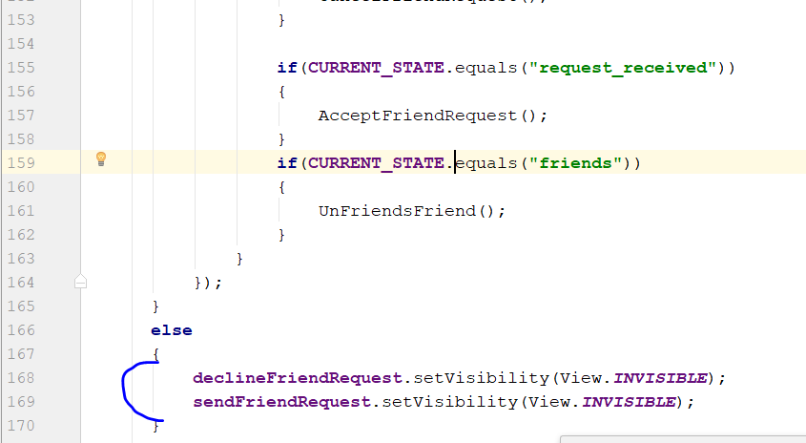
* Rebuild and run

# Step 22: Use App offline

* Currently it will not display all user, without internet
* Create a new Java class, myChat_Offline
* 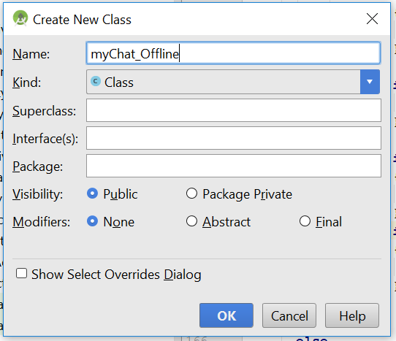
* Click okay
* Extends the class, extends Application
* **public class** myChat_Offline **extends** Application {  
    
   @Override  
   **public void** onCreate() {  
   **super**.onCreate();  
   FirebaseDatabase.*getInstance*().setPersistenceEnabled();  
   }  
  }
* 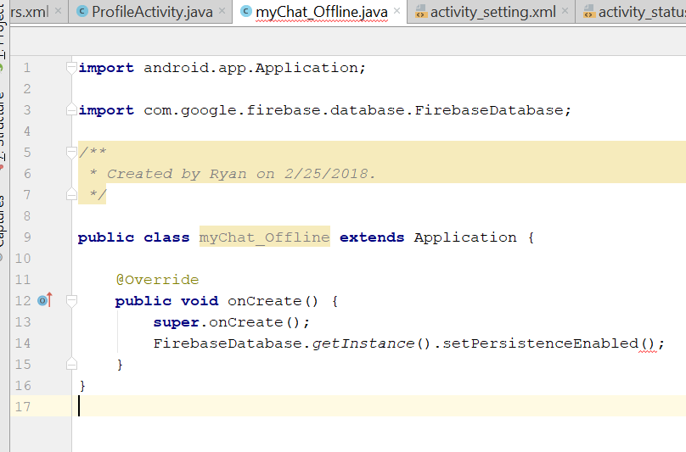
* Add this following code inside onCreate
* **public void** onCreate() {  
   **super**.onCreate();  
   FirebaseDatabase.*getInstance*().setPersistenceEnabled(**true**);  
   *//load picture offline* Picasso.Builder builder = **new** Picasso.Builder(**this**);  
   builder.downloader(**new** OkHttpDownloader(**this**,Integer.***MAX_VALUE***));  
   Picasso built = builder.build();  
   built.setIndicatorsEnabled(**true**);  
   built.setLoggingEnabled(**true**);  
   Picasso.*setSingletonInstance*(built);  
    
  }
* 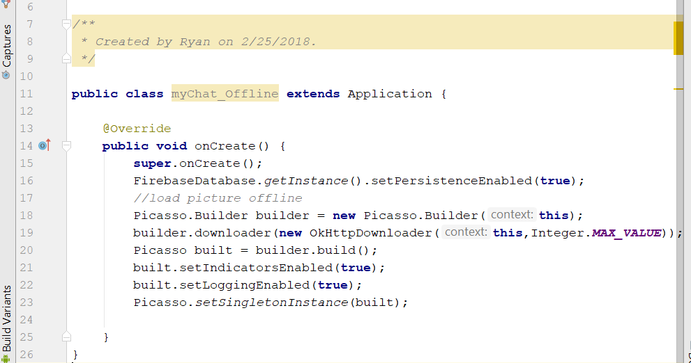
* Now go to allUserActivity.java
* Add this line: allDatebaseUserreference.keepSynced(true);
* 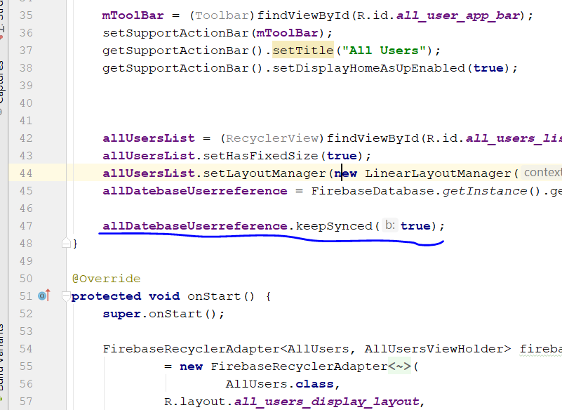
* Go to public void setUser_thumb_image
* Change the code inside
* **final** CircleImageView thumb_image = (CircleImageView) **mView**.findViewById(R.id.***all_users_profile_image***);  
  Picasso.*with*(ctx).load(user_thumb_image).networkPolicy(NetworkPolicy.***OFFLINE***).placeholder(R.drawable.***default_profile***)  
   .into(thumb_image, **new** Callback() {  
   @Override  
   **public void** onSuccess() {  
    
   }  
    
   @Override  
   **public void** onError() {  
   Picasso.*with*(ctx).load(user_thumb_image).placeholder(R.drawable.***default_profile***).into(thumb_image);  
    
   }  
   });
* 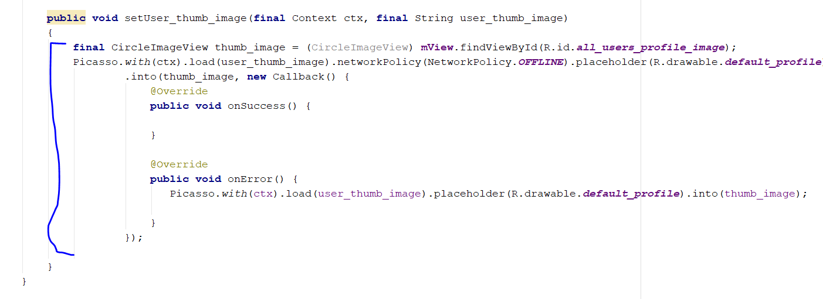
* Now go profileActivity.java
* Go to onCreate and add this two line
* FriendRequestReference.keepSynced(**true**);
* **FriendsReference**.keepSynced(**true**);
* 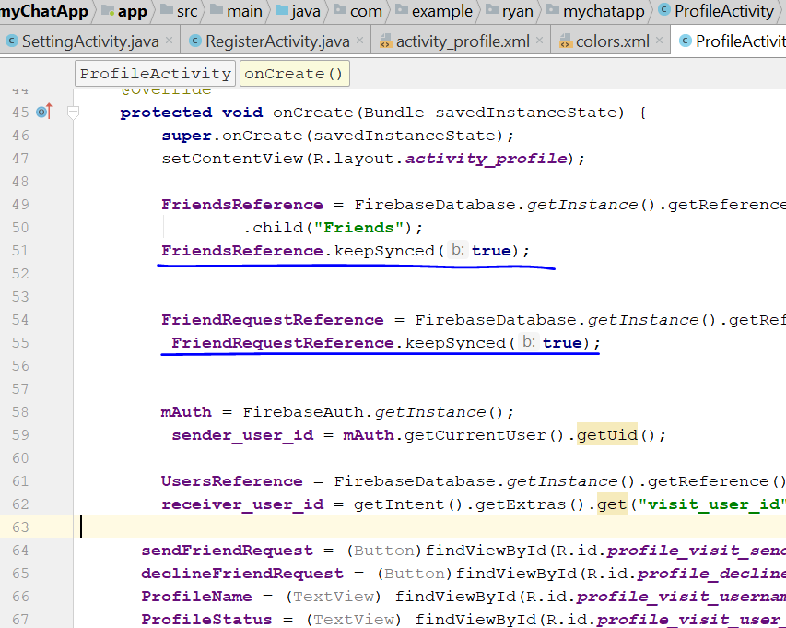
* Go to SettingActivity
* Go to getUserDataReference.addValueEventListener
* Add this
* **if**(!image.equals(**"default_profile"**))  
   {  
   *//Picasso.with(SettingActivity.this).load(image).placeholder(R.drawable.default_profile).into(settingsDisplayProfileImage);* Picasso.*with*(SettingActivity.**this**).load(image).networkPolicy(NetworkPolicy.***OFFLINE***)  
   .placeholder(R.drawable.***default_profile***).into(**settingsDisplayProfileImage**, **new** Callback() {  
   @Override  
   **public void** onSuccess() {  
    
   }  
    
   @Override  
   **public void** onError() {  
   Picasso.*with*(SettingActivity.**this**).load(image).placeholder(R.drawable.***default_profile***).into(**settingsDisplayProfileImage**);  
    
   }  
   });  
    
   }  
    
    
   }
* add this line in onCreate
* **getUserDataReference**.keepSynced(**true**);
* 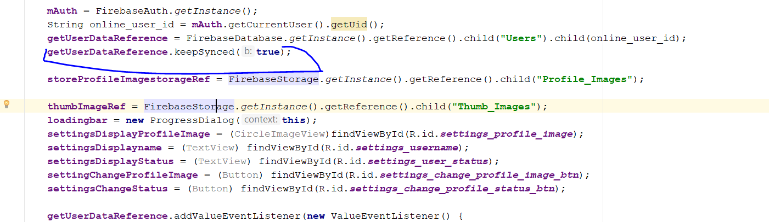
* getUserDataReference
* 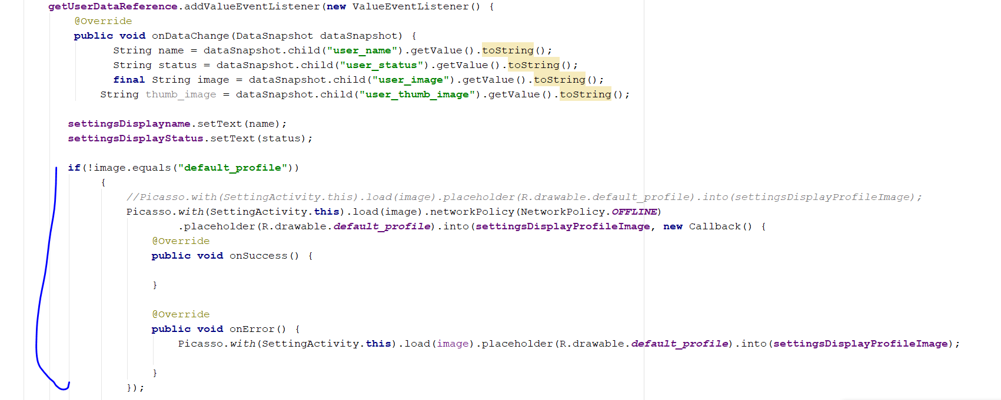
* Go to androidManifest now
* Add this line
* **android:name=".myChat_Offline"**
* 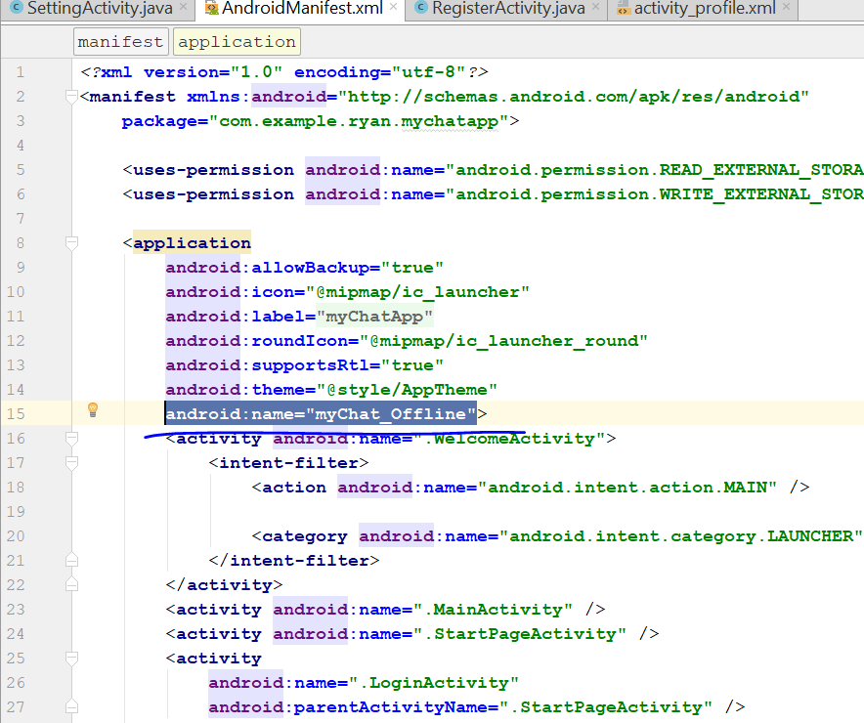
* Go to build.gradle app module
* Add the library for okHttp
* Go to <http://square.github.io/okhttp/>
* Copy this line
* 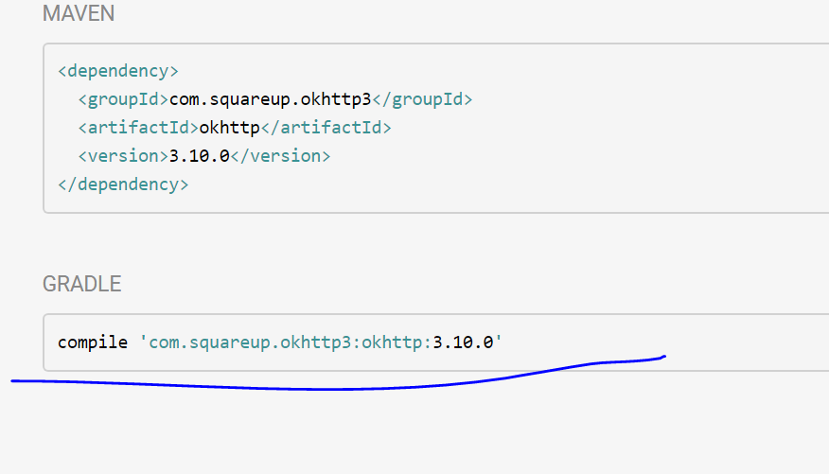
* Paste into buildgradle, change to
* **'com.squareup.okhttp:okhttp:2.5.0'**
* lower than the Picasso version
* rebuild and run, off the the wifi, u should be able to view all user even when there is no internet
* 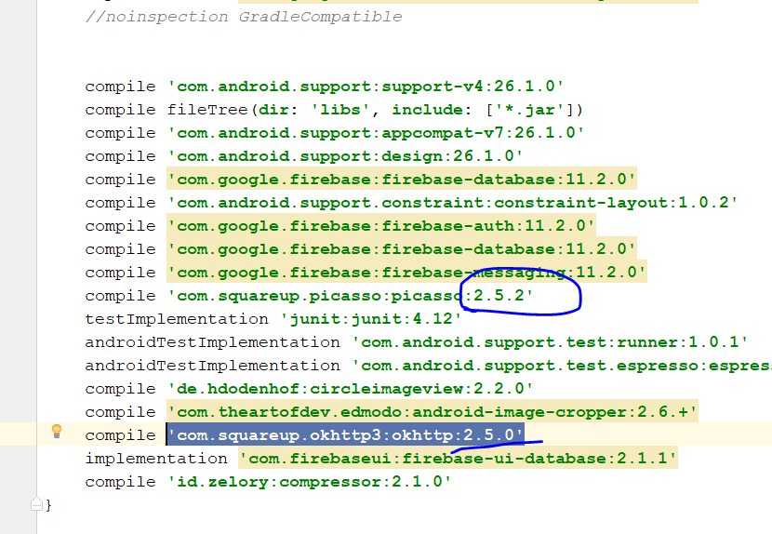
* Now work on decline friend request

# Step 23: decline friend request

* Go to Profile Activity
* Go to onCreate Method
* Go to sendFriendRequest.setOnClickListener
* Add the code before if(!sender_user_id.equals(receiver_user_id))
* **declineFriendRequest**.setVisibility(View.***INVISIBLE***);  
  **declineFriendRequest**.setEnabled(**false**);
* 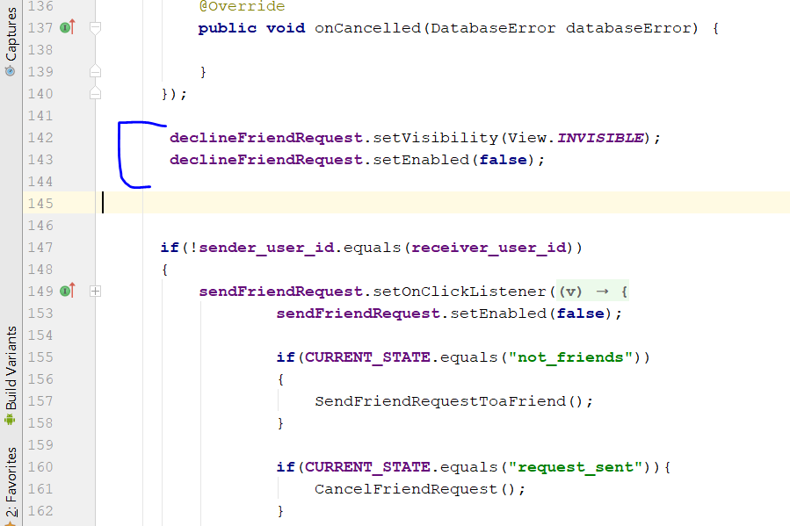
* Copy and the paste the 2 line of code
* Into
* **private void** CancelFriendRequest() {
* **private void** UnFriendsFriend()
* 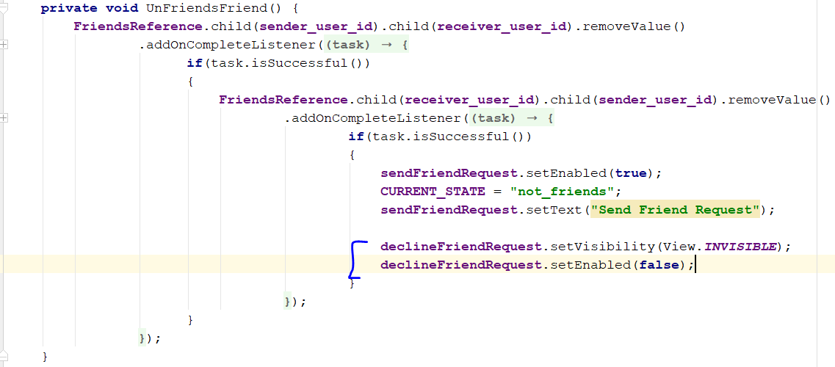
* 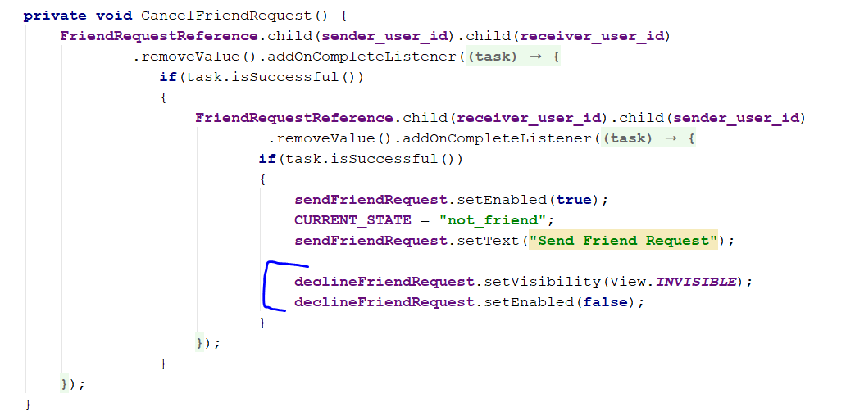
* Copy and paste at the location above
* Now go to FriendRequestReference.child(sender_user_id)
* If datasnapshot is receiver_user_id
* 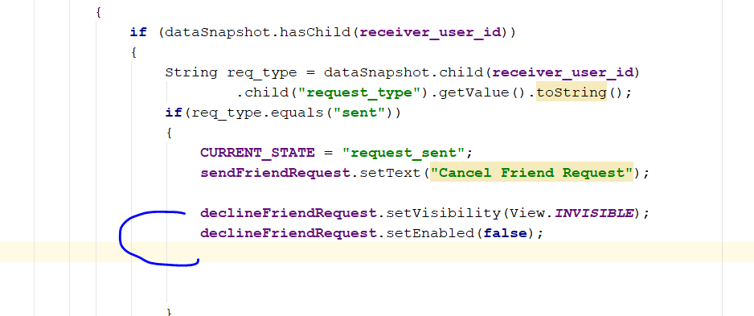
* In the else statement
* 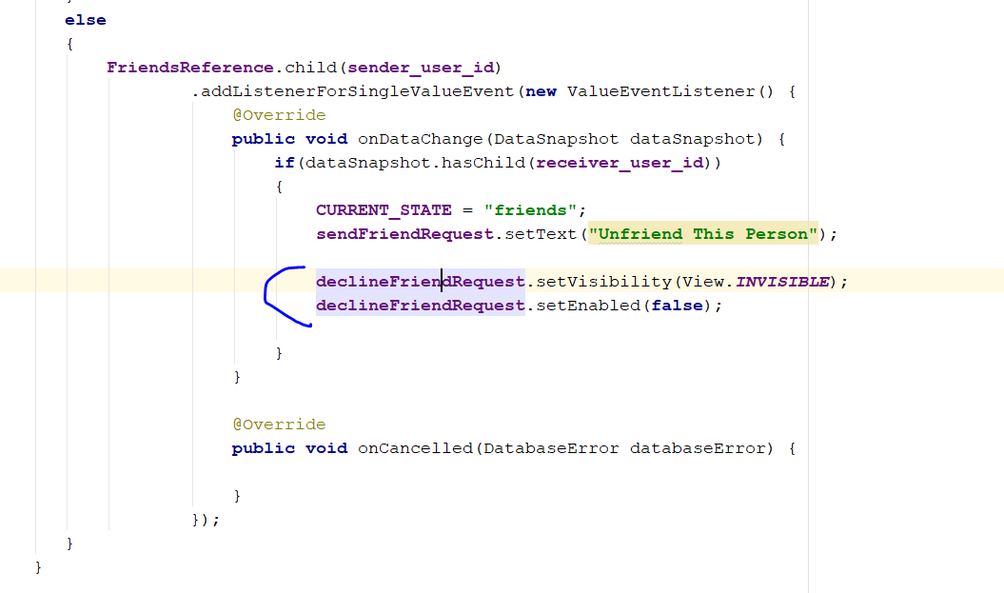
* Add the following code
* **declineFriendRequest**.setVisibility(View.***VISIBLE***);  
  **declineFriendRequest**.setEnabled(**true**);
* at the else if(req_type.equals("received"))
* 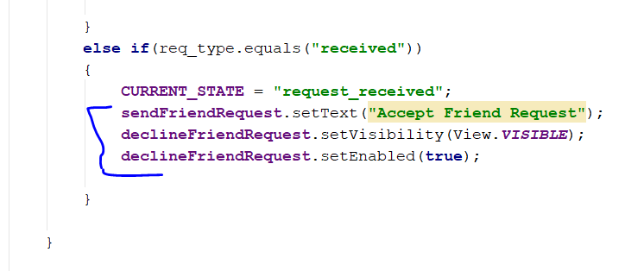
* Add this code
* **declineFriendRequest**.setOnClickListener(**new** View.OnClickListener() {  
   @Override  
   **public void** onClick(View v) {  
   DeclineFriendRequest();  
   }  
  });
* 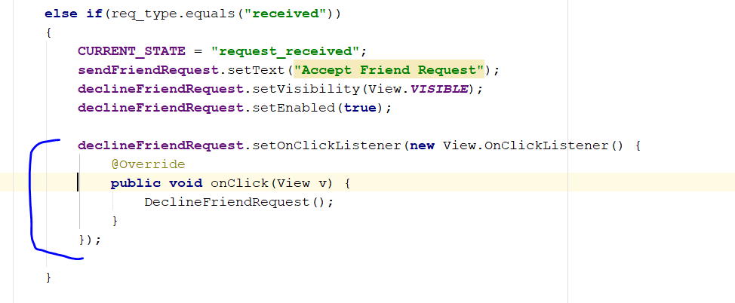
* Create the method DeclineFriendRequest() in profileActivity.java
* Copy the code in the cancelfriendRequest()
* 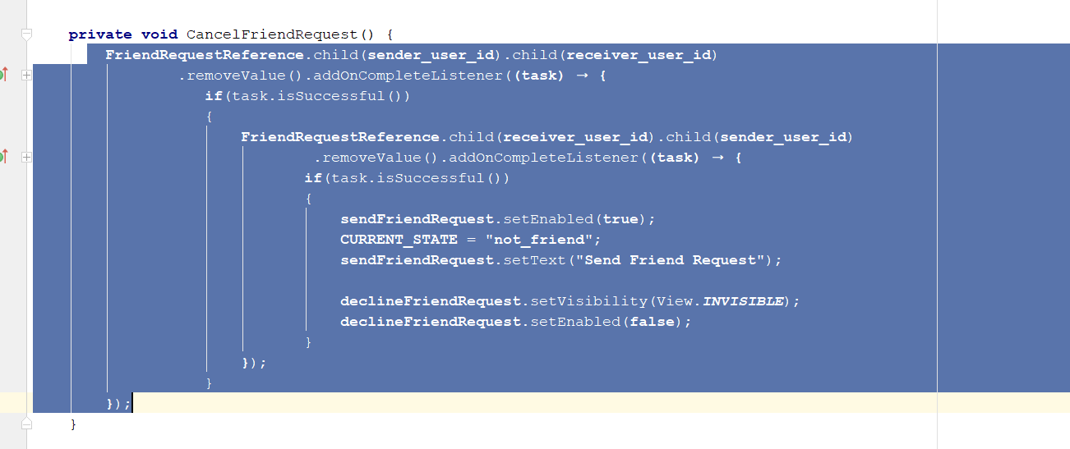
* Paste it inside DeclineFriendRequest()
* Rebuild and Run, if you sent a request to a user, if the user decline the request, the request node will be deleted
* You **will only see send request button**, the accept and decline button will be disappear
* Now we should hide decline Friend Request button after user accept
* Go to the ProfileActivity.java
* Go to AcceptFriendRequest()
* Add this lines
* **declineFriendRequest**.setVisibility(View.***INVISIBLE***);  
  **declineFriendRequest**.setEnabled(**false**);
* 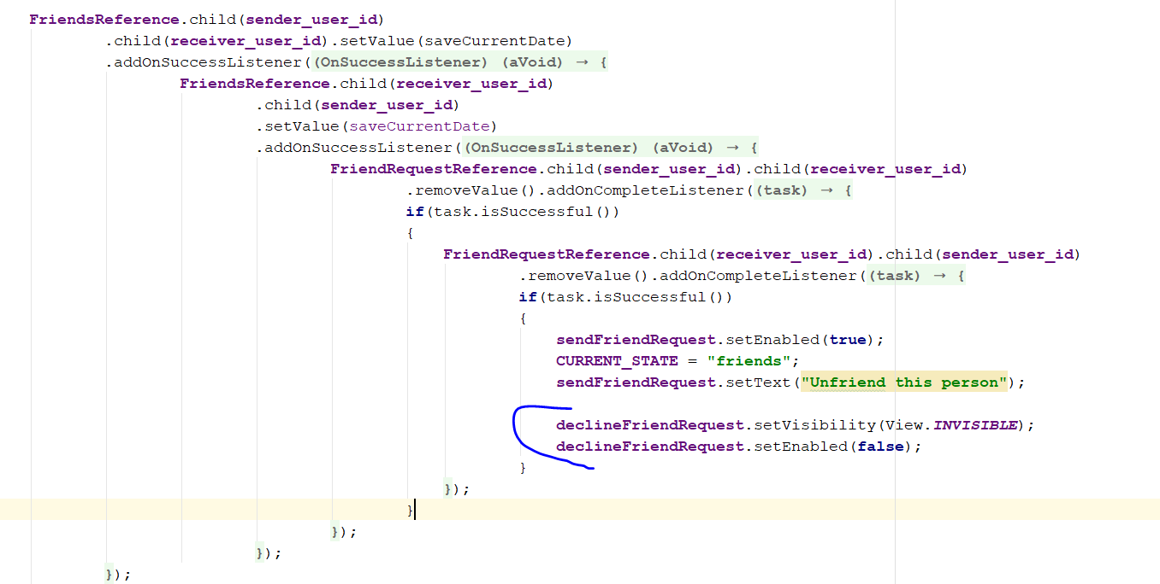
* Rebuild and run

# S**tep 24: Change App icon**

* Copy the image into the resource folder/ MIPMAP folder
* 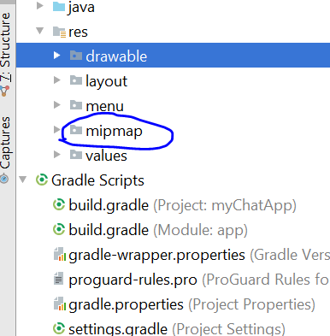
* Go to androidManifest, change this line
* **android:roundIcon="@mipmap/ic_launcher_round"**
* **change to**
* **android:roundIcon="@mipmap/app_icon"**
* rebuild and run

# Step 25: Push Notification for friend request

* Go to profileActivity.java
* Add this
* **private** DatabaseReference **NotificationsReference**;
* go to onCreate method
* add this
* **NotificationsReference** = FirebaseDatabase.*getInstance*().getReference().child(**"Notifications"**);  
  **NotificationsReference**.keepSynced(**true**);
* Go to private void SendFriendRequestToaFriend()
* Add this code
* HashMap<String, String> notificationData = HashMap<String,String>  
  notificationData.put(**"from"**,**sender_user_id**);  
  notificationData.put(**"type"**,**"request"**);  
    
  **NotificationsReference**.child(**receiver_user_id**).push().setValue(notificationData)  
   .addOnCompleteListener(**new** OnCompleteListener<Void>() {  
   @Override  
   **public void** onComplete(@NonNull Task<Void> task) {  
     
   **if**(task.isSuccessful()) {  
   **sendFriendRequest**.setEnabled(**true**);  
   **CURRENT_STATE** = **"request_sent"**;  
   **sendFriendRequest**.setText(**"Cancel Friend Request"**);  
    
   **declineFriendRequest**.setVisibility(View.***INVISIBLE***);  
   **declineFriendRequest**.setEnabled(**false**);  
   }  
   }  
   });
* 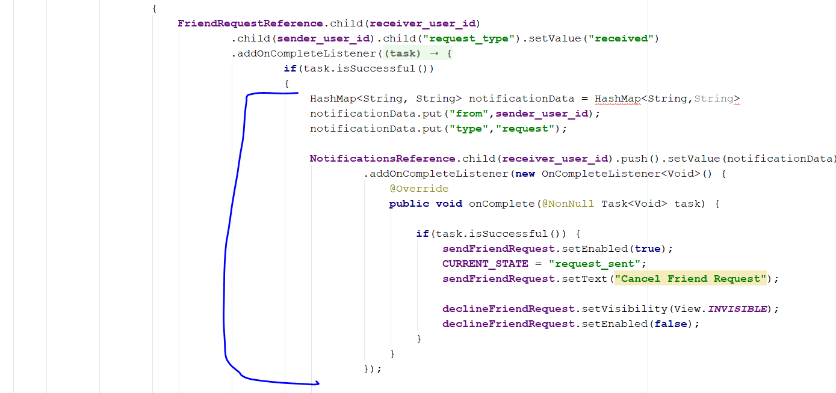
* Rebuild and run, send some request, see if NOTIFICATION node appear in the firebase
* 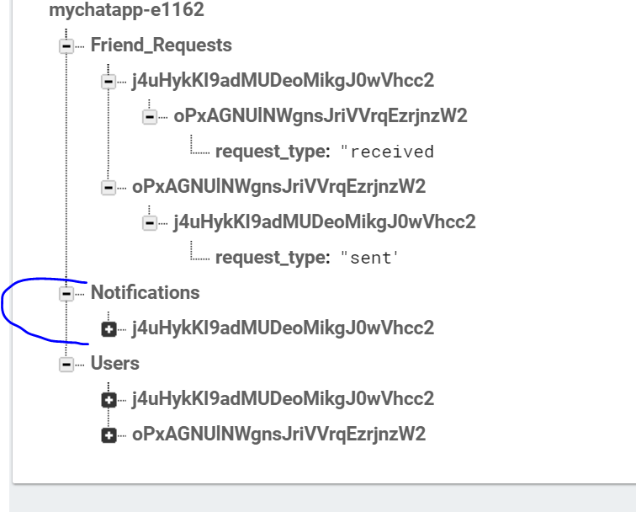
* Search for Node.js google
* 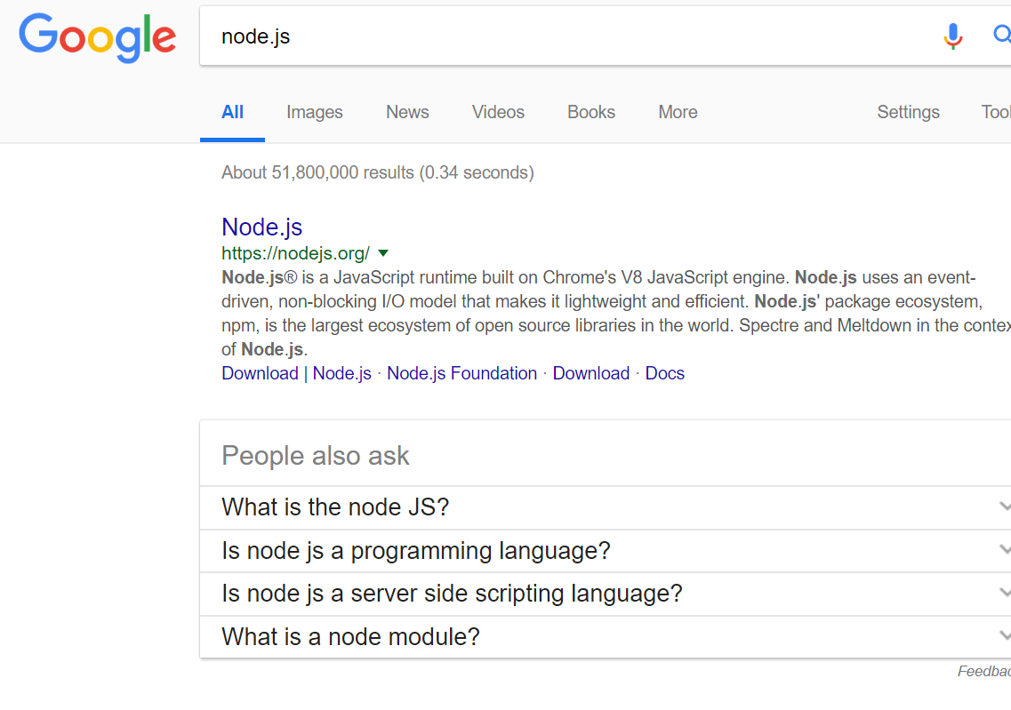
* 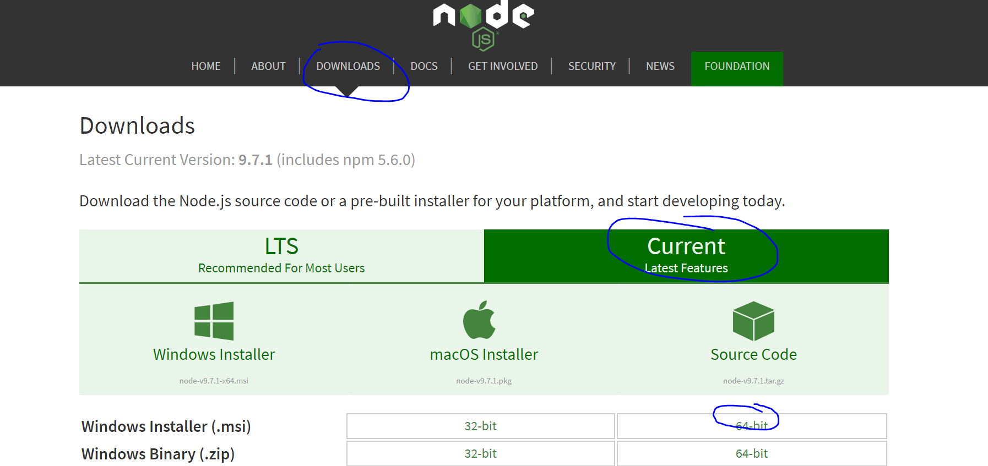
* Click on the window installer
* Click next and install
* After install, check if it install successfully
* 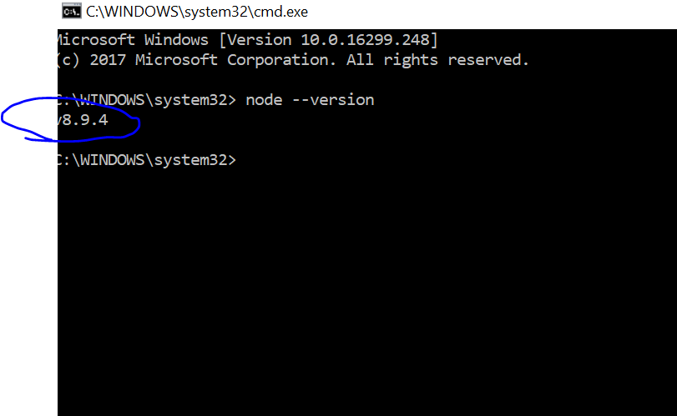
* Type : npm install -g firebase -tools
* Press enter in cmd
* It will take some time
* 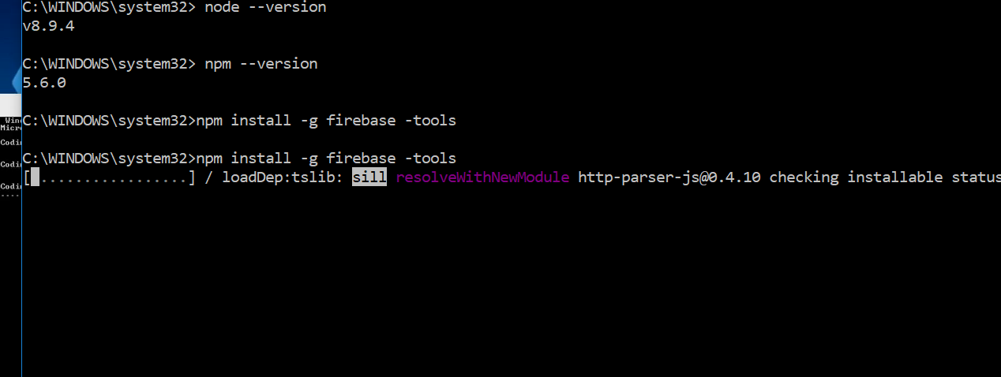
* Create a folder, notificationFunction
* Go to this folder
* 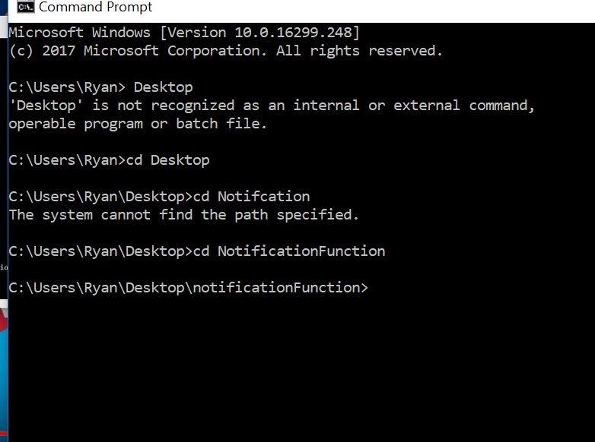
* Enter firebase login, you should see this below
* 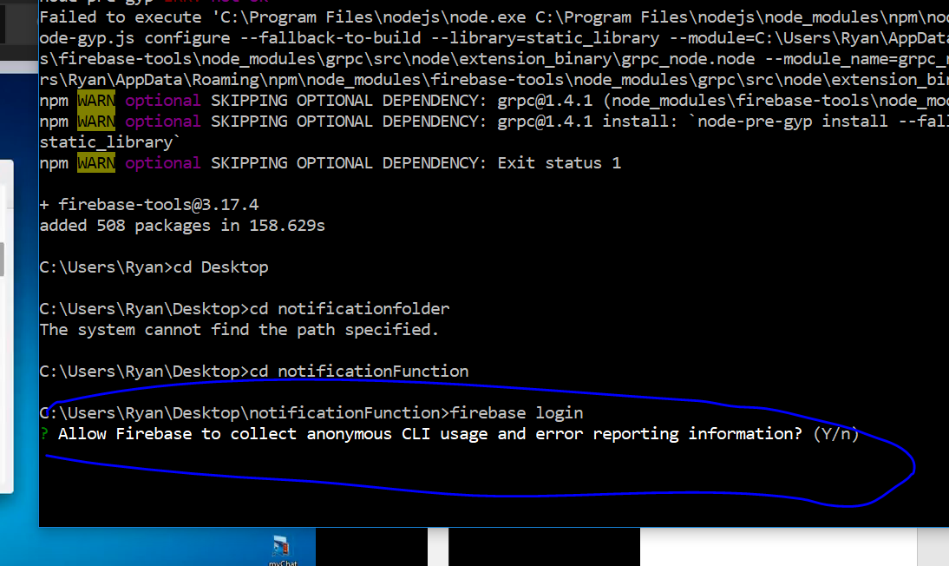
* Enter Y
* 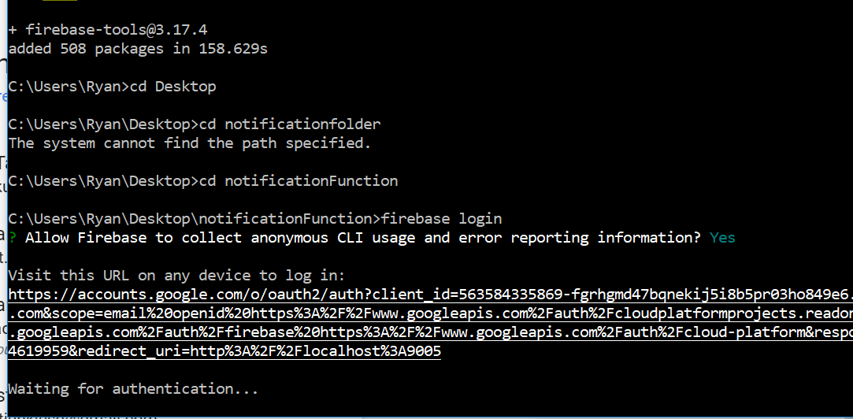
* It will redirect u to a website, on browser
* 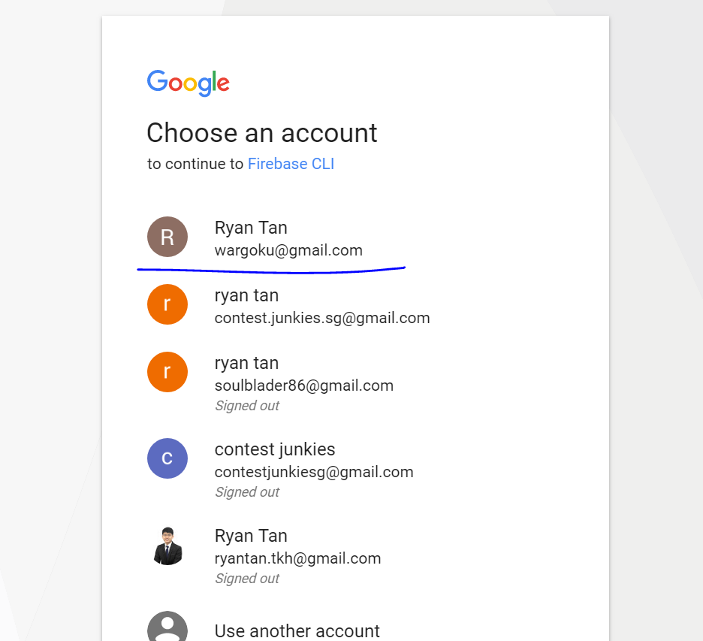
* Click on the email you use for firebase
* 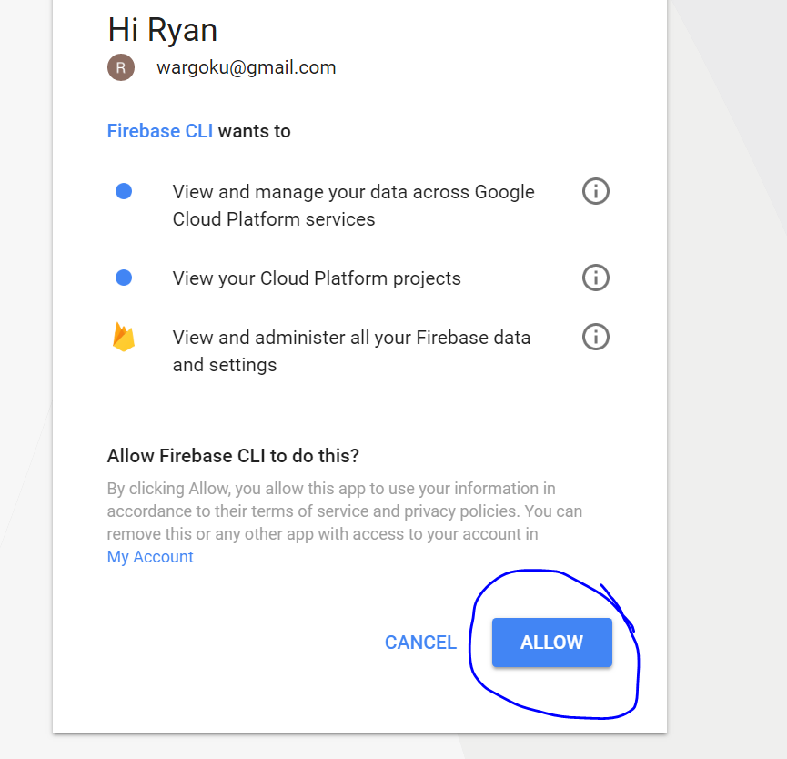
* Click on allow
* 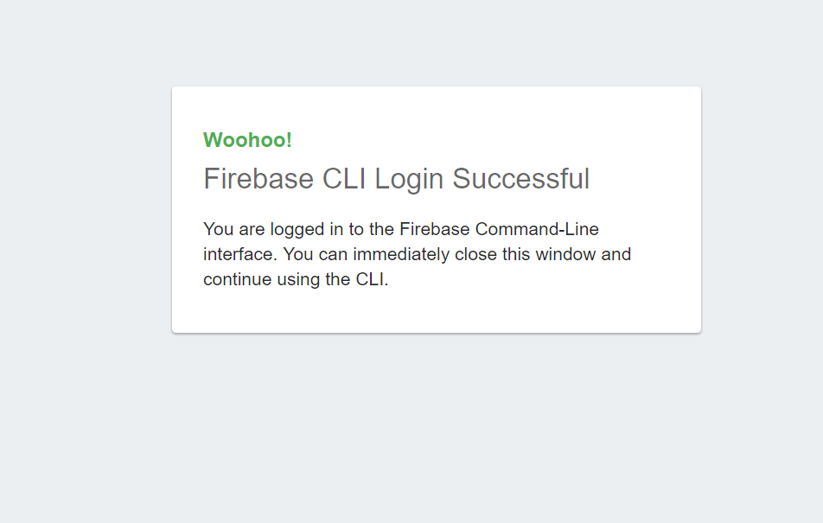
* You are done
* This change
* 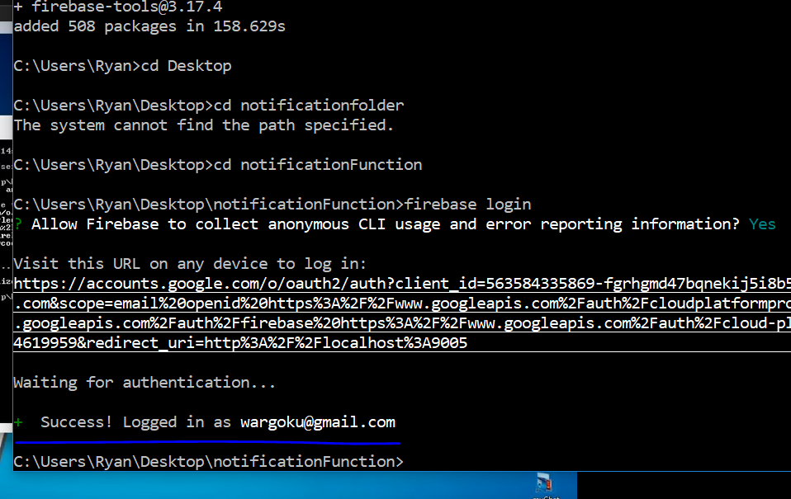
* Enter firebase init
* 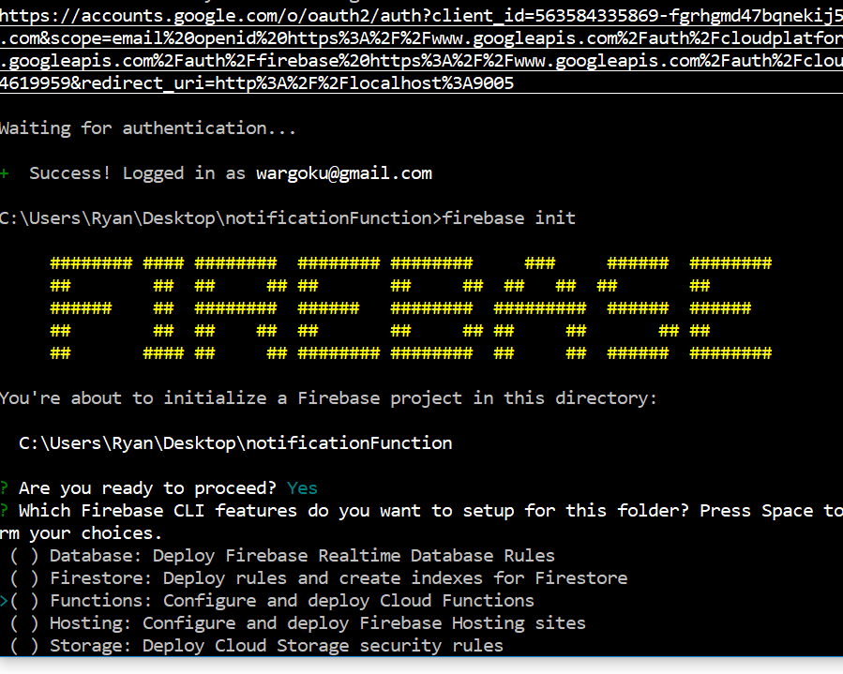
* Select this functions, and press space on keyboard, then enter key
* Select your project
* 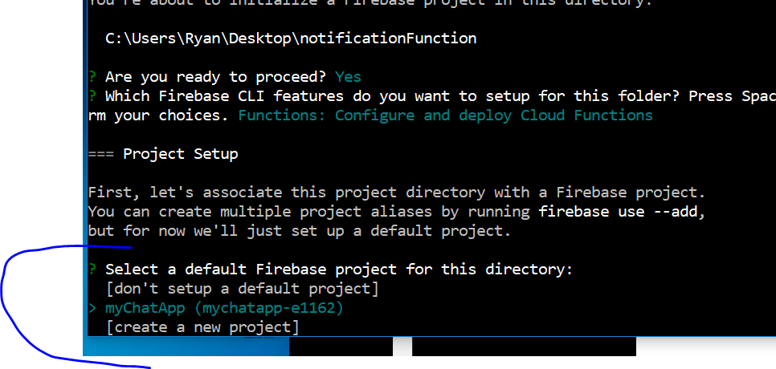
* You will see this
* 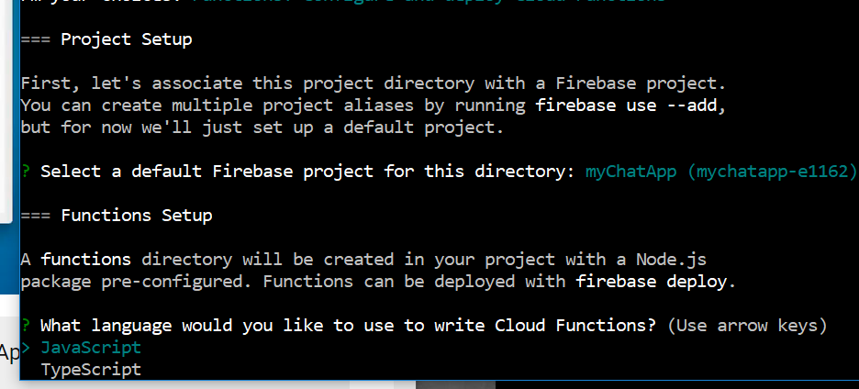
* Just select yes
* 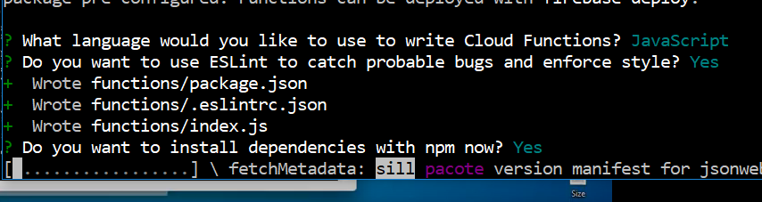
* 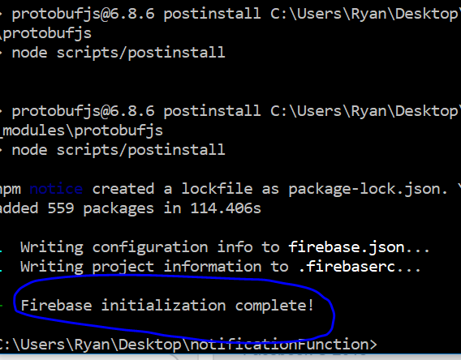
* You are done
* Go to LoginActivity.java
* Add this
* **private** DatabaseReference **userreference**;
* add this line in onCreate()
* 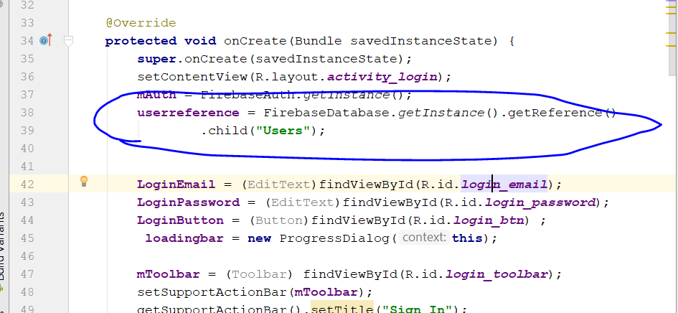
* Go to LoginUserAccount()
* 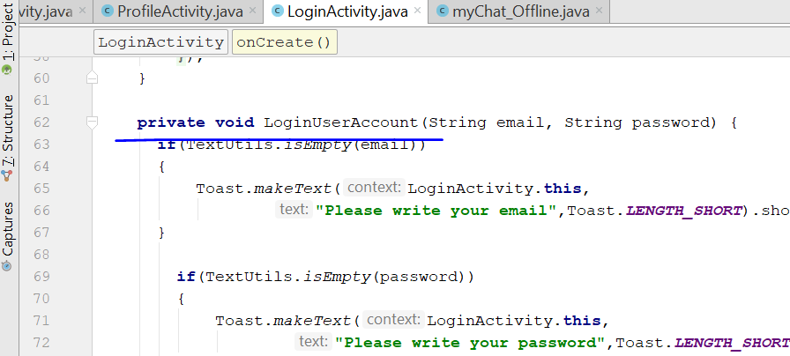
* **if**(task.isSuccessful())  
  {  
    
   String online_user_id = **mAuth**.getCurrentUser().getUid();  
   String DeviceToken = FirebaseInstanceId.*getInstance*().getToken();  
    
   **userreference**.child(online_user_id).child(**"device_token"**).setValue(DeviceToken)  
   .addOnSuccessListener(**new** OnSuccessListener<Void>() {  
   @Override  
   **public void** onSuccess(Void aVoid) {  
   Intent mainactivityIntent = **new** Intent(LoginActivity.**this**, MainActivity.**class**);  
   mainactivityIntent.addFlags(Intent.***FLAG_ACTIVITY_NEW_TASK***|Intent.***FLAG_ACTIVITY_CLEAR_TASK***);  
   startActivity(mainactivityIntent);  
   finish();  
   }  
   });  
     
  }
* 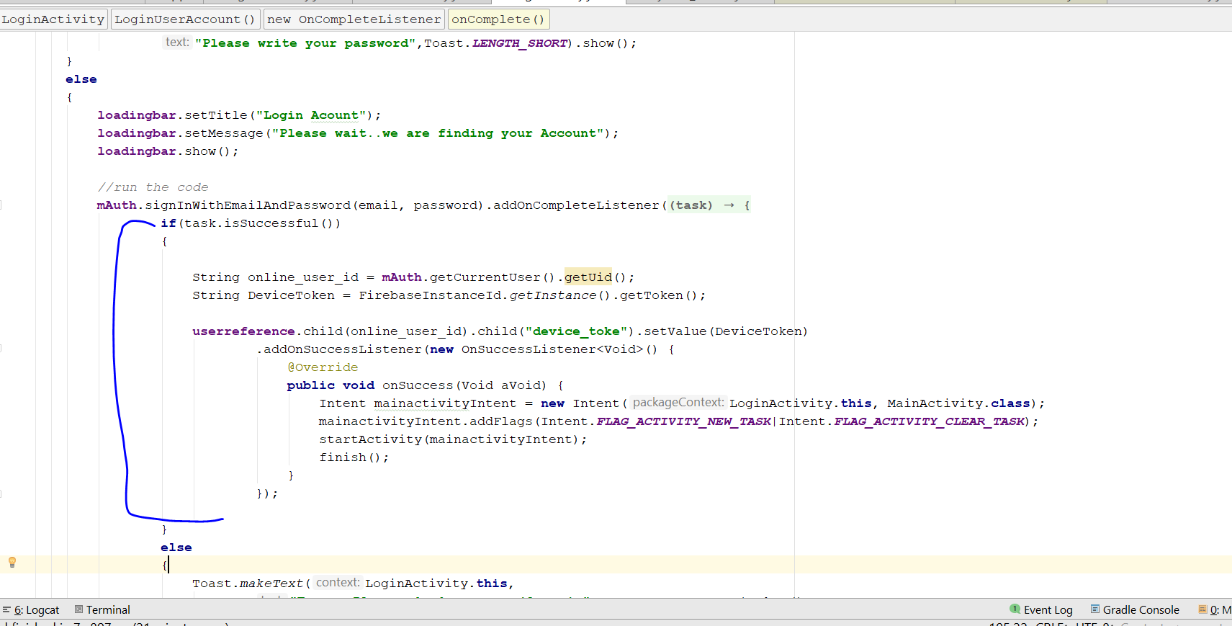
* Copy this line of code
* String DeviceToken = FirebaseInstanceId.*getInstance*().getToken();
* Go to registerActivity.java
* Go to registerAccount method
* Go to this line
* **mAuth**.createUserWithEmailAndPassword(email, password)
* paste the code inside task.isSuccessful()
* 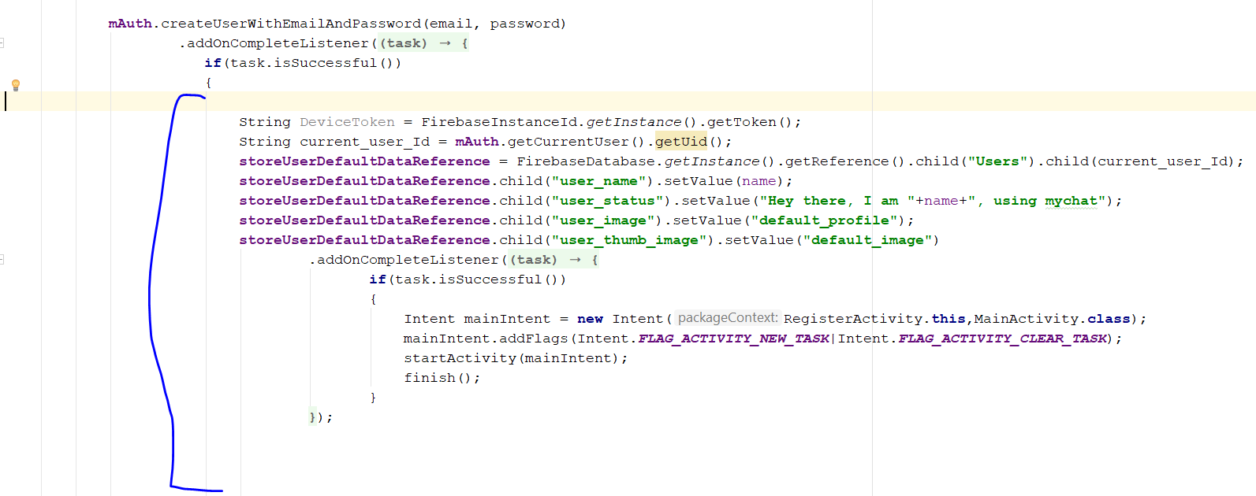
* Add this line
* **storeUserDefaultDataReference**.child(**"device_token"**).setValue(DeviceToken);
* 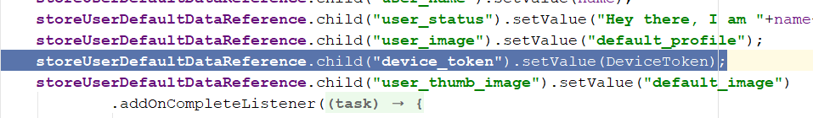
* Rebuild and run, login again
* You will see this
* 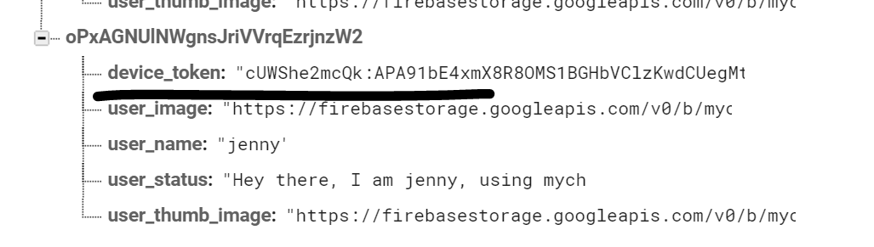
* Now go to the NotificationFunction folder
* You will see this
* 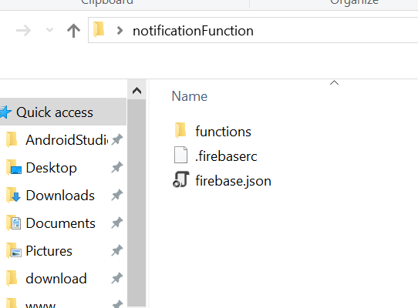
* Click on function then edit the index file, use notepad ++
* 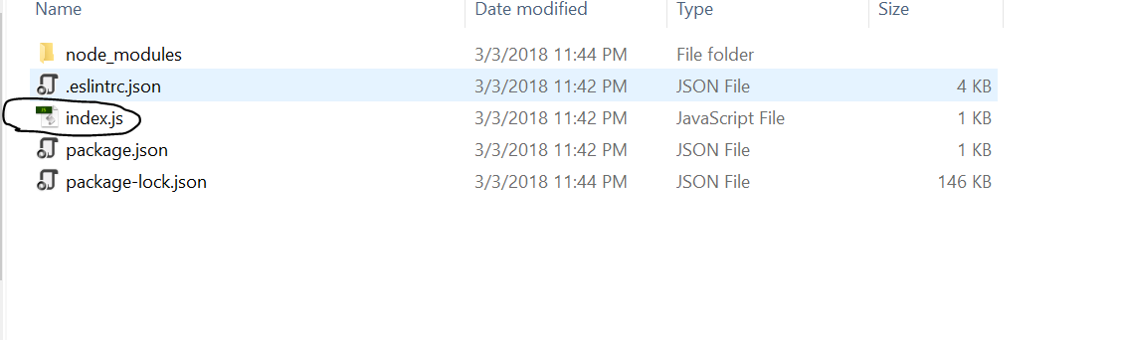
* Enter the code
* 'use strict' in the textfile
* Enter this in the cmd
* 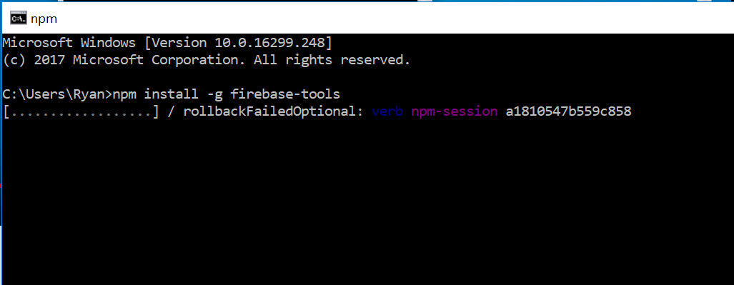
* Npm install -g firebase-tools
* Follow the step through
* Type cd to the notificationFunction folder and type firebase init
* 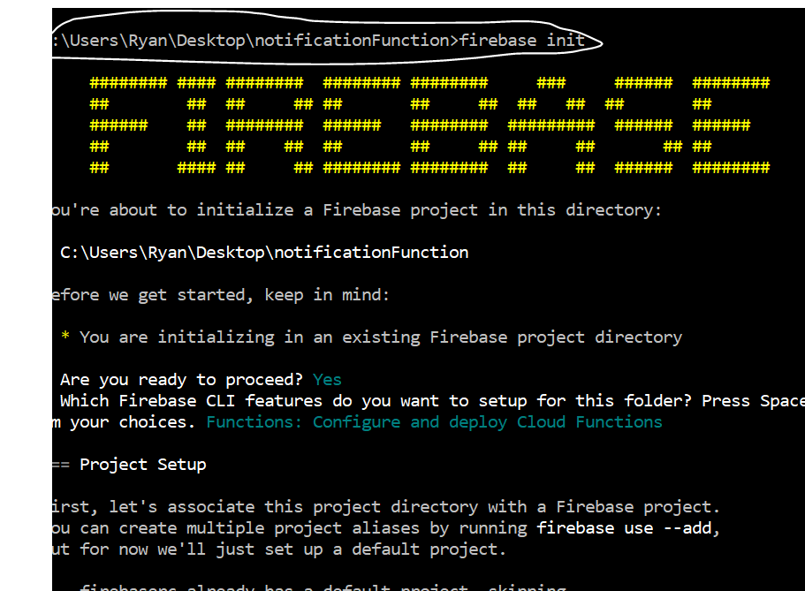
* 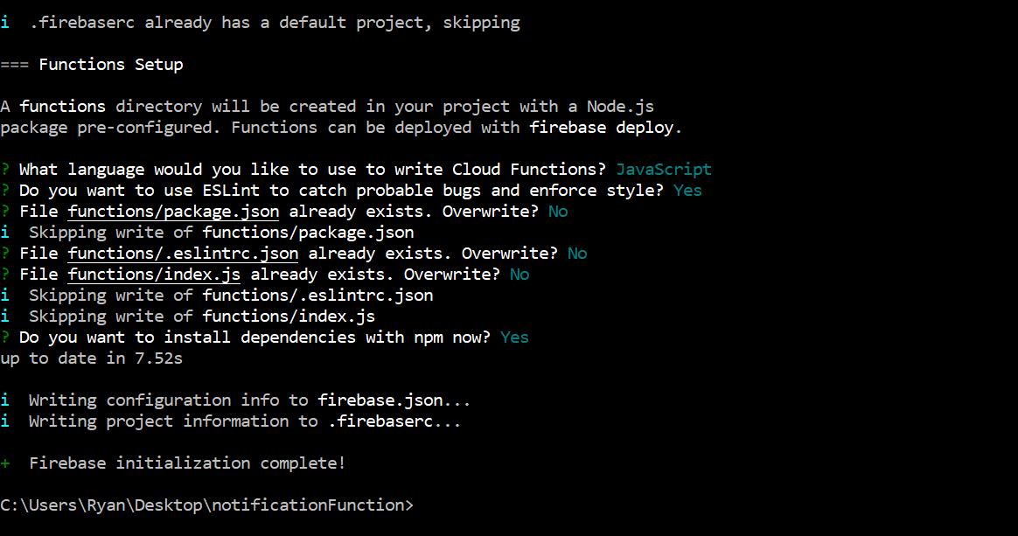
* In the index.js, enter those code
* const functions = require('firebase-functions');
* const admin = require('firebase-admin');
* admin.initializeApp(functions.config().firebase);
* exports.sendNotification = function.database.ref('/Notifications/{receiver_id}/{notification_id}');
* 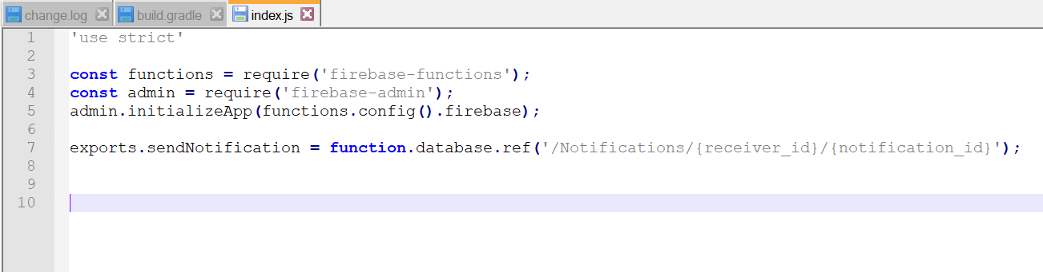
* 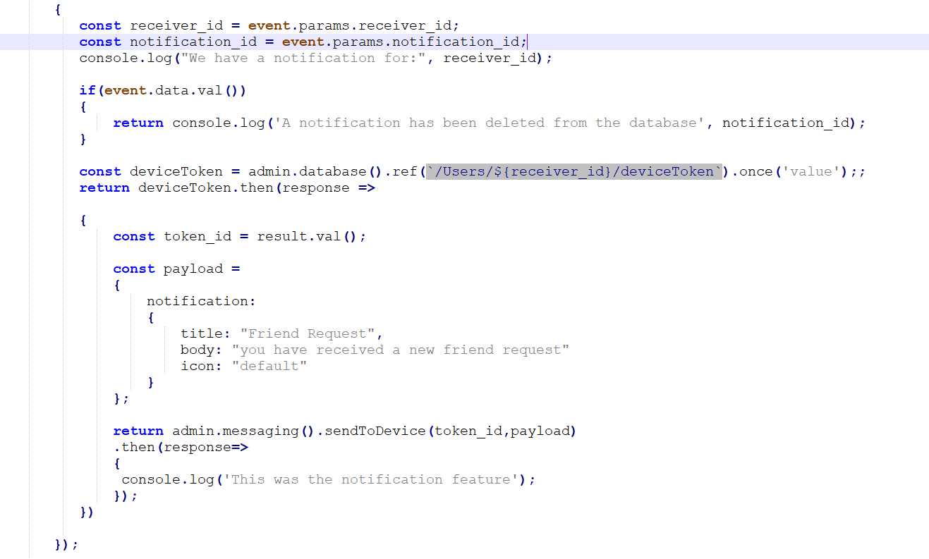
* This is the code to enter in the notepad++
* const admin = require('firebase-admin');
* admin.initializeApp(functions.config().firebase);
* exports.sendNotification = function.database.ref('/Notifications/{receiver_id}/{notification_id}')
* .OnWrite(event =>
* {
* const receiver_id = event.params.receiver_id;
* const notification_id = event.params.notification_id;
* console.log("We have a notification for:", receiver_id);
* if(event.data.val())
* {
* return console.log('A notification has been deleted from the database', notification_id);
* }
* const deviceToken = admin.database().ref(`/Users/${receiver_id}/device_Token`).once('value');;
* return deviceToken.then(response =>
* {
* const token_id = result.val();
* const payload =
* {
* notification:
* {
* title: "Friend Request",
* body: "you have received a new friend request"
* icon: "default"
* }
* };
* return admin.messaging().sendToDevice(token_id,payload)
* .then(response=>
* {
* console.log('This was the notification feature');
* });
* })
* });
* Now go to the Command prompt
* Enter firebase deploy
* Run your app, you should see the Notification the stop, if you send friend request to another side
* Take note, the app that on the receiving end, must be running on the background.
* Error Encounter:
* Error:Execution failed for task ':app:transformDexArchiveWithExternalLibsDexMergerForDebug'. > java.lang.RuntimeException: com.android.builder.dexing.DexArchiveMergerException: Unable to merge dex
* Solution: check the gradle, make sure the version is 11.2.0
* Rebuild and Run, u shld see something like this, when u received notification
* 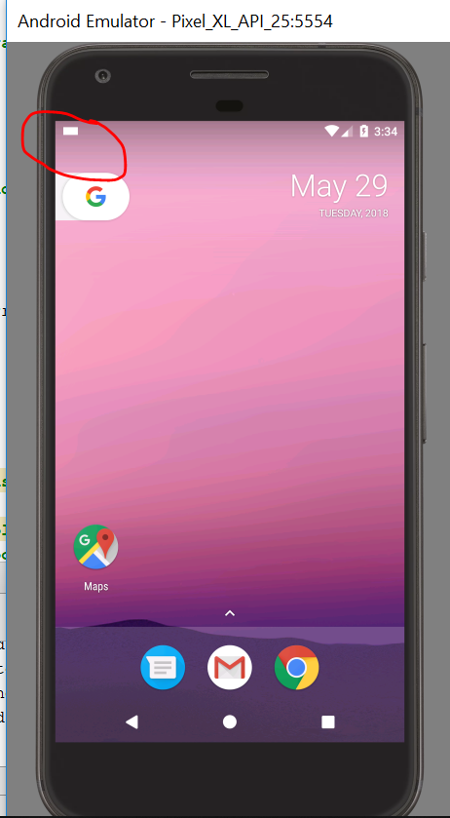
* 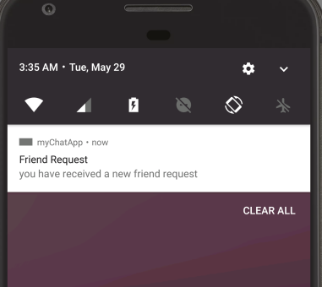
* Create a new Java Class
* **Call it FirebaseMessagingService.java**
* 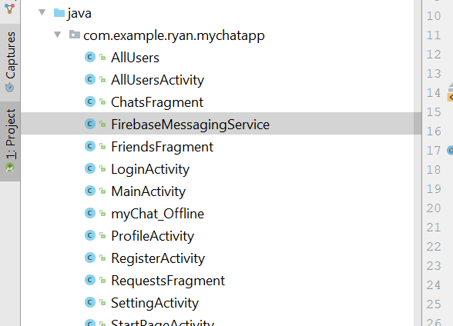
* First extends FirebaseMessagingService
* Create a Method call onMessageReceived(RemoteMessage)
* 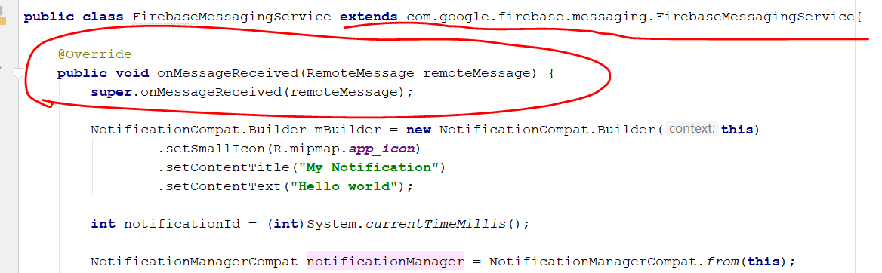
* Copy this line
* NotificationCompat.Builder mBuilder = **new** NotificationCompat.Builder(**this**)  
   .setSmallIcon(R.mipmap.***app_icon***)  
   .setContentTitle(**"My Notification"**)  
   .setContentText(**"Hello world"**);
* 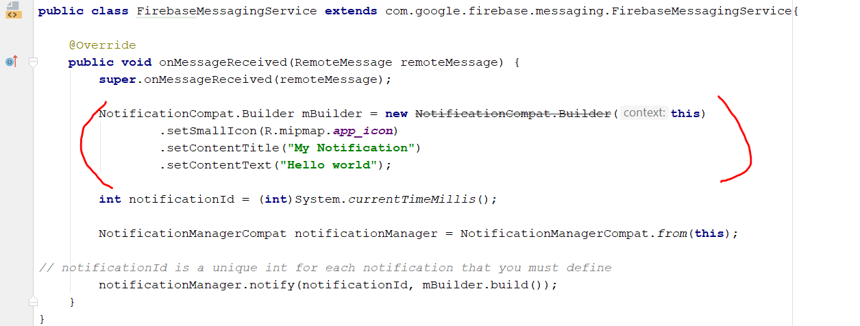
* Type the following to issue the notification
* **int** notificationId = (**int**)System.*currentTimeMillis*();
* then go to Android Manifest
* Copy this line into Manifest
* <**service  
   android:name=".FirebaseMessagingService"**>  
   <**intent-filter**>  
   <**action android:name="com.google.firebase.MESSAGING_EVENT"**/>  
   </**intent-filter**>  
  </**service**>
* 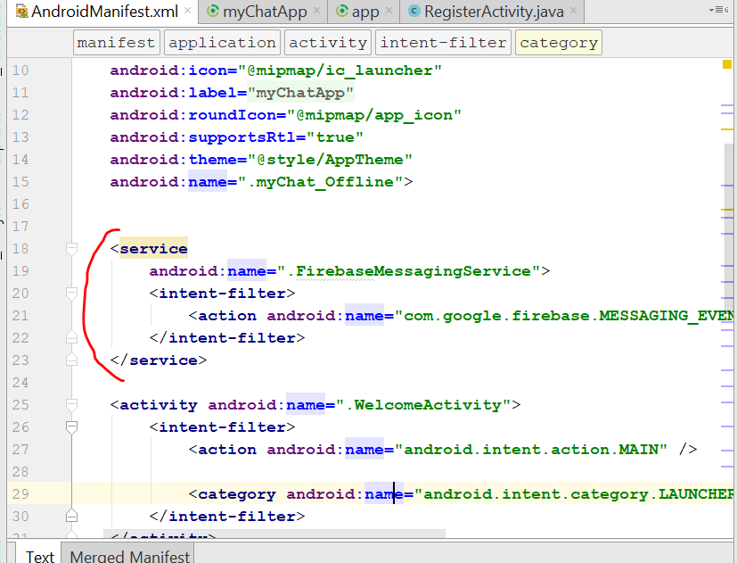
* Rebuild and Run
* U shld be able to get notification without minimize the app
* Now we shall add notification with Username
* Go to index.js
* Add this line
* `/Notifications/${receiver_id}/${notification_id}`).once('value');
* return sender_id.then(fromUserResult =>
* {
* const from_sender_id = fromUserResult.val().from;
* console.log('you have new notification from: ', from_sender_id);
* const senderUserQuery = admin.database().ref(`/Users/${from_sender_id}/user_name`).once('value');
* return senderUserQuery.then(senderUserNameResult =>
* {
* const senderUserName = senderUserNameResult.val();
* });
* });
* 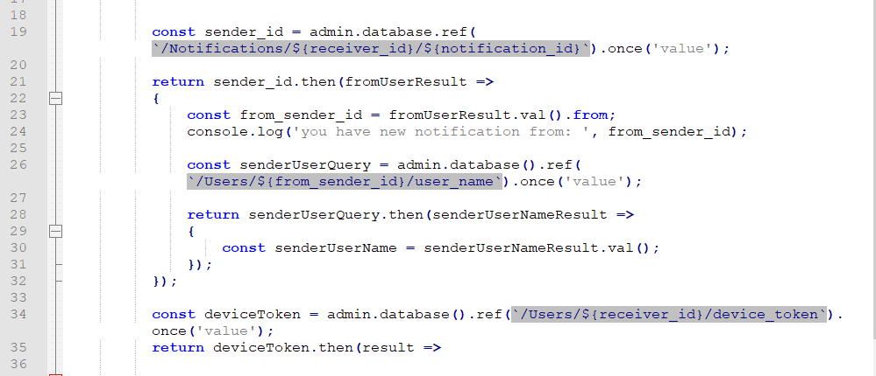
* Cut this code
* 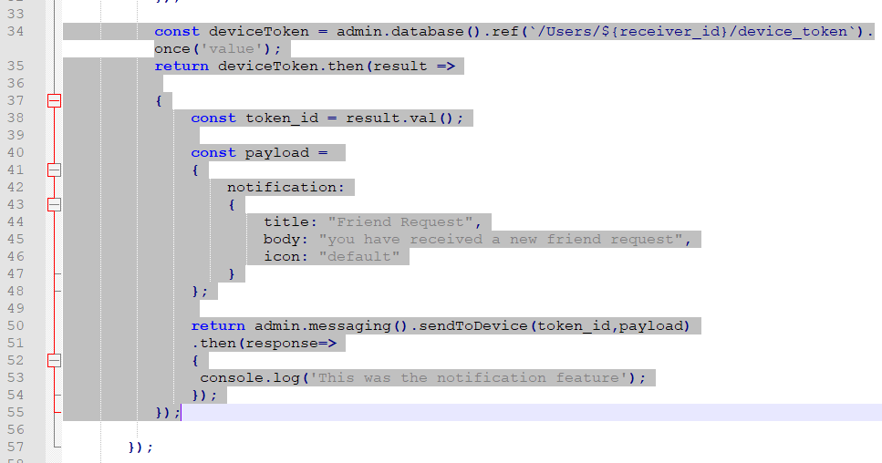
* Paste it inside here
* 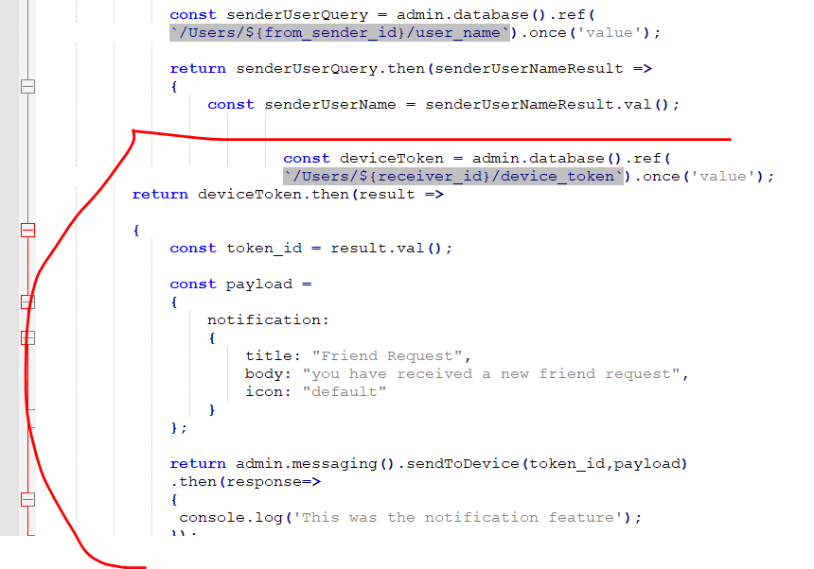
* Change this line
* 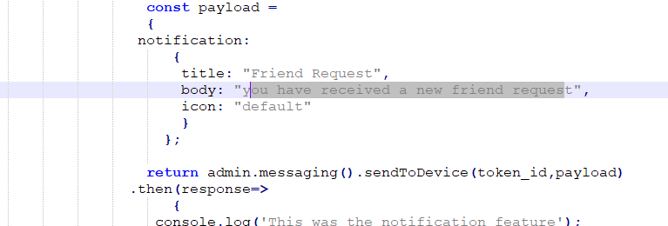
* body: `${senderUserName} has sent you a friend request.`,
* now to FireBaseMessagingService.java
* Add new line at the space below
* 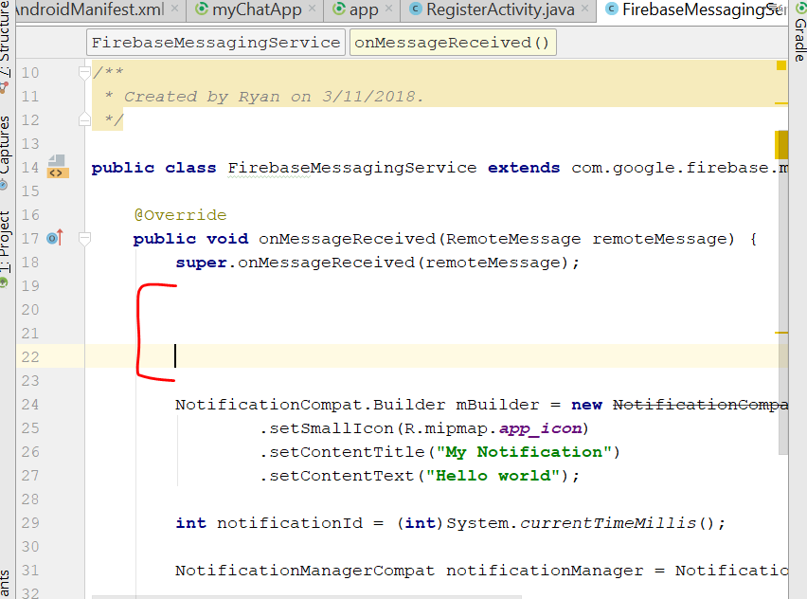
* Add this two line
* String notification_title = remoteMessage.getNotification().getTitle();  
  String notification_body = remoteMessage.getNotification().getBody();
* Change the hello world to the NotificationTitle
* 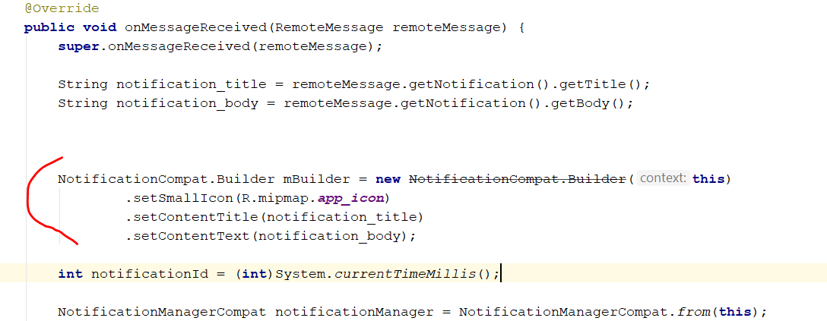
* Now save ur Notepad++ Index.js, and open the CMD
* Type in npm install -g firebase-tools
* Then wait a while until it is done
* Then navigate to the notificationfunction folder on desktop using cmd
* 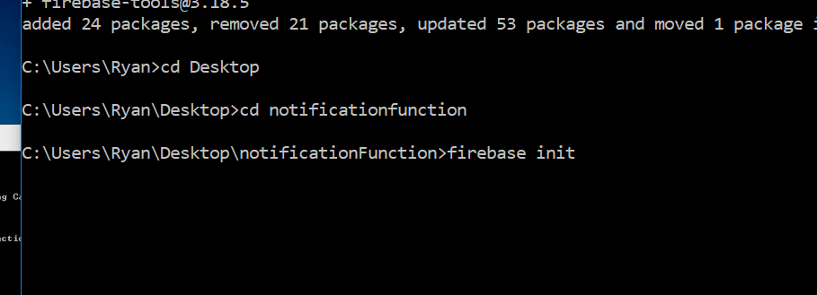

Then type firebase init, press ENTER

* Just follow the instruction, Y and N
* Type firebase deploy after all is done
* 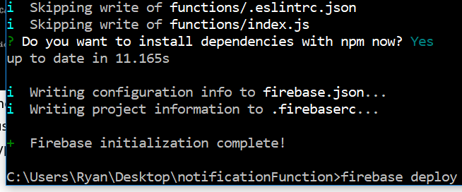
* Wait for it to finish, then u run your app, you should be able to see the notification with names of the sender
* Error Encountered:
* TypeError: admin.database.ref is not a function
* at exports.sendNotification.functions.database.ref.onWrite.event (/user_code/index.js:19:38)
* Lesson learnt, always backup my Index.js file at each stage
* Got merge error, refer to this
* <https://stackoverflow.com/questions/49123990/errorcom-android-dex-dexexception-multiple-dex-files-define-landroid-support-d>
* In order for the notification to work in version APi 26
* Use the following code
* String notification_title = remoteMessage.getNotification().getTitle();  
   String notification_body = remoteMessage.getNotification().getBody();  
    
    
   NotificationManager notificationManager = (NotificationManager) getSystemService(***NOTIFICATION_SERVICE***);  
   String NOTIFICATION_CHANNEL_ID = **"channel_id_01"**;  
    
   **if** (Build.VERSION.***SDK_INT*** >= Build.VERSION_CODES.***O***) {  
   NotificationChannel notificationChannel = **new** NotificationChannel(NOTIFICATION_CHANNEL_ID, **"My Notifications"**, NotificationManager.***IMPORTANCE_HIGH***);  
    
   *// Configure the notification channel.* notificationChannel.setDescription(**"Channel description"**);  
   notificationChannel.enableLights(**true**);  
   notificationChannel.setLightColor(Color.***BLUE***);  
   notificationChannel.setVibrationPattern(**new long**[]{0, 1000, 500, 1000});  
   notificationChannel.enableVibration(**true**);  
   notificationManager.createNotificationChannel(notificationChannel);  
   }  
    
   NotificationCompat.Builder notificationBuilder = **new** NotificationCompat.Builder(**this**, NOTIFICATION_CHANNEL_ID);  
    
   notificationBuilder.setAutoCancel(**true**)  
   .setDefaults(Notification.***DEFAULT_ALL***)  
   .setWhen(System.*currentTimeMillis*())  
   .setSmallIcon(R.mipmap.***app_icon***)  
   .setTicker(**"Hearty365"**)  
   .setPriority(Notification.***PRIORITY_MAX***)  
   .setContentTitle(notification_title)  
   .setContentText(notification_body)  
   .setContentInfo(**"Info"**);  
    
   **int** mNotificationId = (**int**) System.*currentTimeMillis*();  
   notificationManager.notify(mNotificationId, notificationBuilder.build());
* Now will redirect to the Sender profile
* Go to Index.js
* Add the following line
* 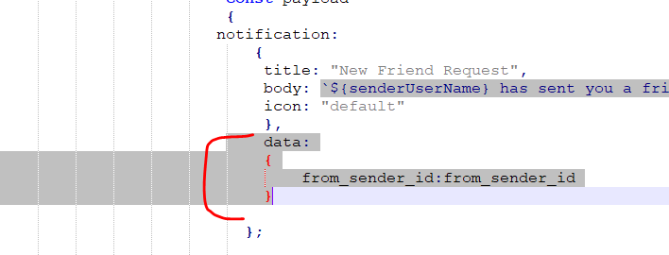
* Now go to the FirebaseMessagingService.Java
* Add this line
* String from_sender_id = remoteMessage.getData().get(**"from_sender_id"**).toString();
* 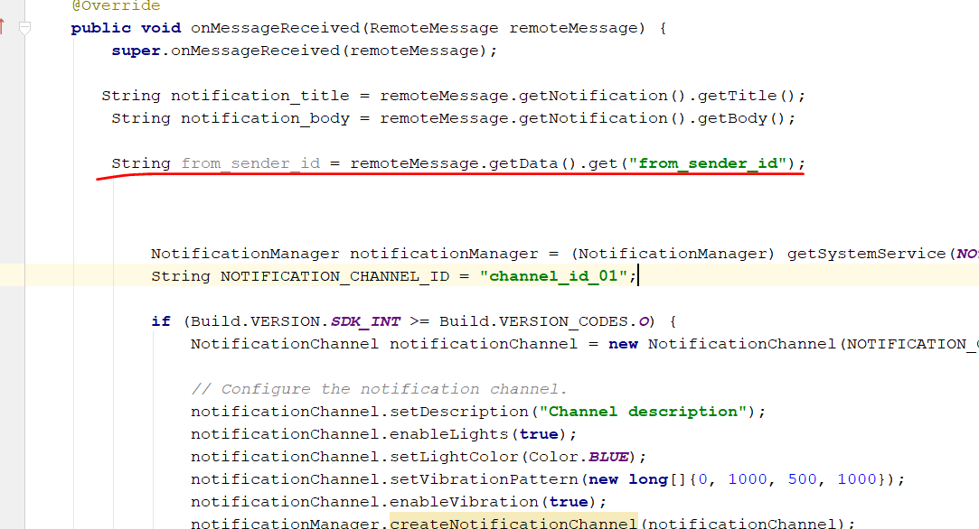
* Copy the code below from the website
* 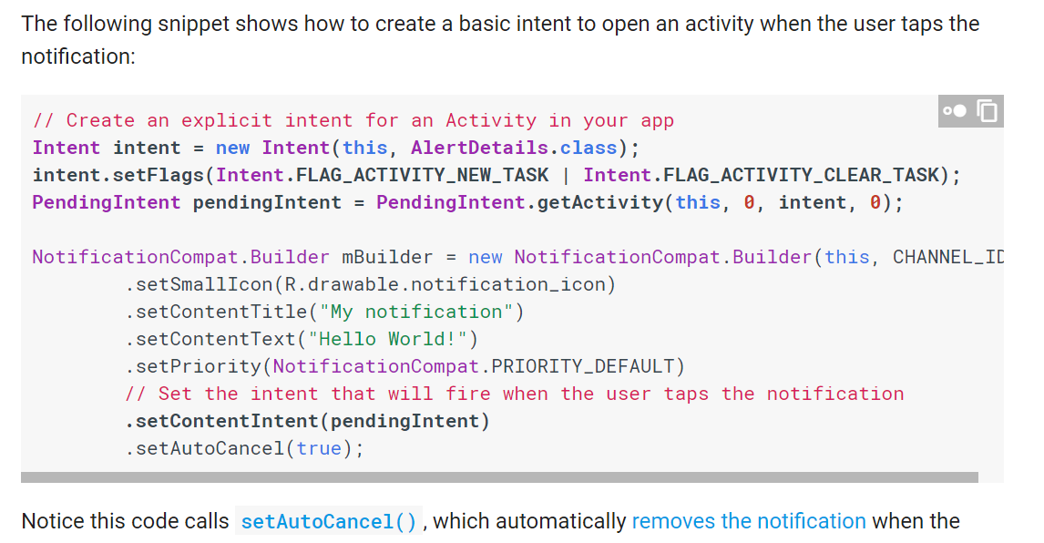
* // Create an explicit intent for an Activity in your app  
  **Intent intent = new Intent(this, AlertDetails.class);**
* **intent.setFlags(Intent.FLAG_ACTIVITY_NEW_TASK | Intent.FLAG_ACTIVITY_CLEAR_TASK);  
  PendingIntent pendingIntent = PendingIntent.getActivity(this, 0, intent, 0);**
* Then copy this from the website
* 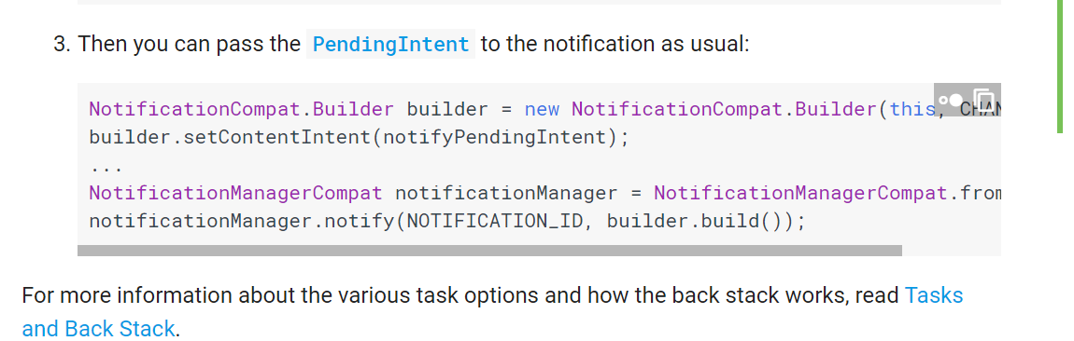
* builder.setContentIntent(notifyPendingIntent);
* 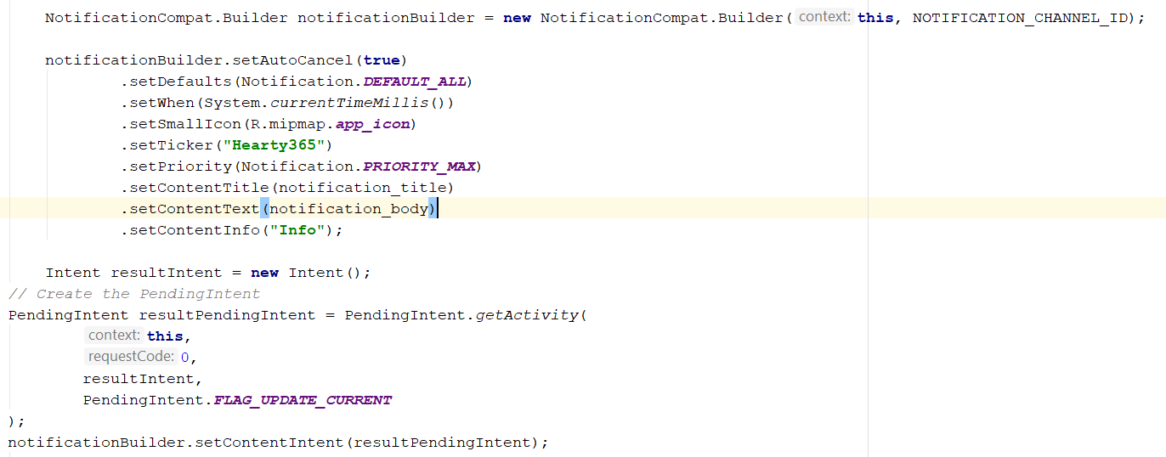
* Intent resultIntent = **new** Intent(click_action);  
   resultIntent.putExtra(**"visit_user_id"**,from_sender_id);  
    
    
  *// Create the PendingIntent*PendingIntent resultPendingIntent = PendingIntent.*getActivity*(  
   **this**,  
   0,  
   resultIntent,  
   PendingIntent.***FLAG_UPDATE_CURRENT***);  
  notificationBuilder.setContentIntent(resultPendingIntent);
* Import everything necessary
* Then Copy this from the profile activity
* 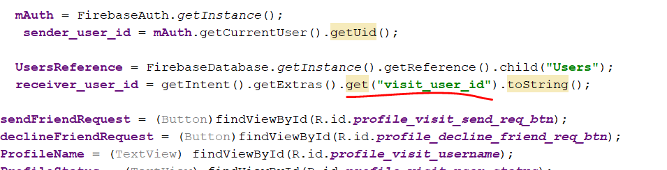
* On the firebase activity Java, it become like that
* Intent resultIntent = **new** Intent(click_action);  
  resultIntent.putExtra(**"visit_user_id"**,from_sender_id);
* Go the top of the java file
* Add this
* String click_action = remoteMessage.getNotification().getClickAction();
* 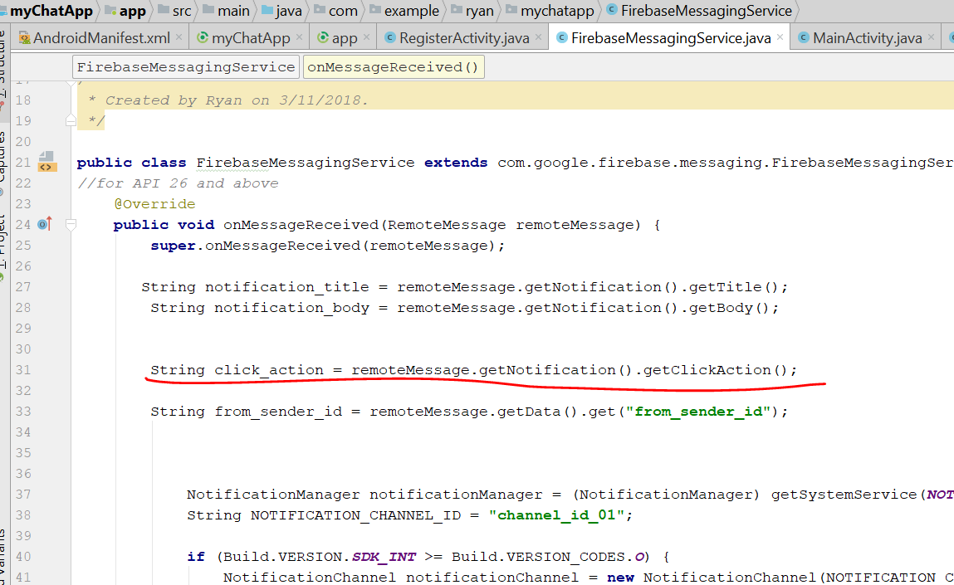
* Then now click go to Android Manifest
* Edit this
* <**activity android:name=".ProfileActivity"**>  
   <**intent-filter**>  
   <**action android:name="com.example.ryan.mychatapp_TARGET_NOTIFICATION"**></**action**>  
   <**category android:name="android.intent.category.DEFAULT"**></**category**>  
   </**intent-filter**>
* 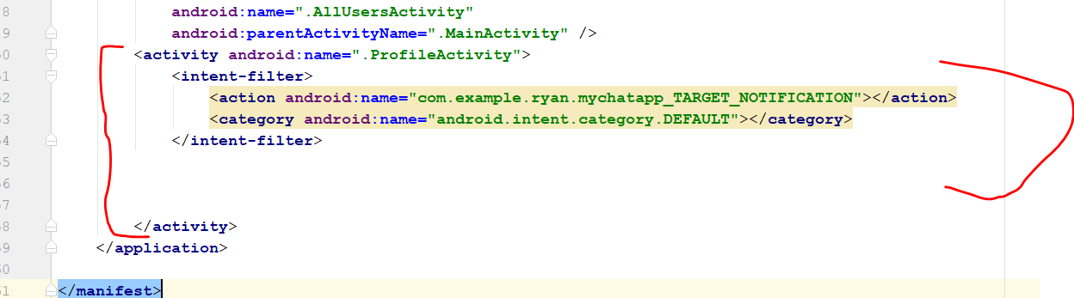
* Now go to the Index.js
* Add this line
* click_action:"com.example.ryan.mychatapp_TARGET_NOTIFICATION";
* 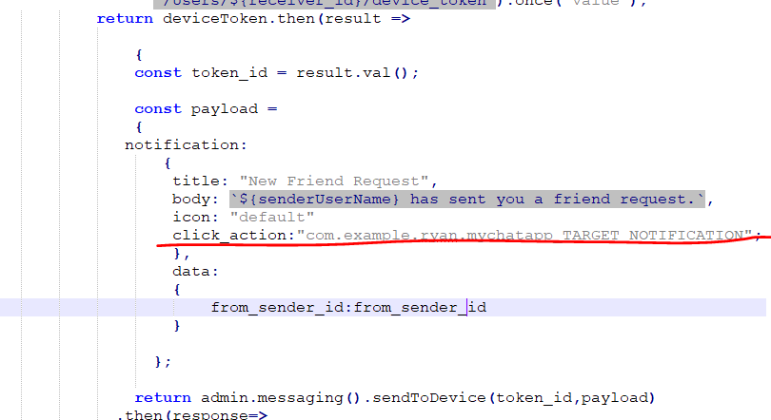
* Try to update the system, install the npm install again, then init the firebase
* Then firebase deploy
* Rebuild and run
* When u click the notification, it will bring u to the user profile
* There will be some error when u tap the notification when it is minimize
* In this case change your index.js
* 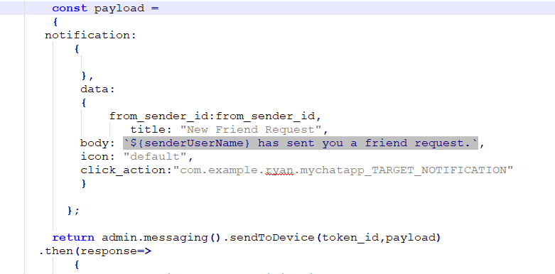
* Leave your notification empty
* Go to command prompt and try firebase deploy
* Then go to FirebaseMessagingService.java, then edit the following
* String from_sender_id = remoteMessage.getData().get(**"from_sender_id"**).toString();  
    
  String notification_title = remoteMessage.getData().get(**"title"**);  
  String notification_body = remoteMessage.getData().get(**"body"**);String click_action = remoteMessage.getData().get(**"click_action"**);
* It should look like this
* 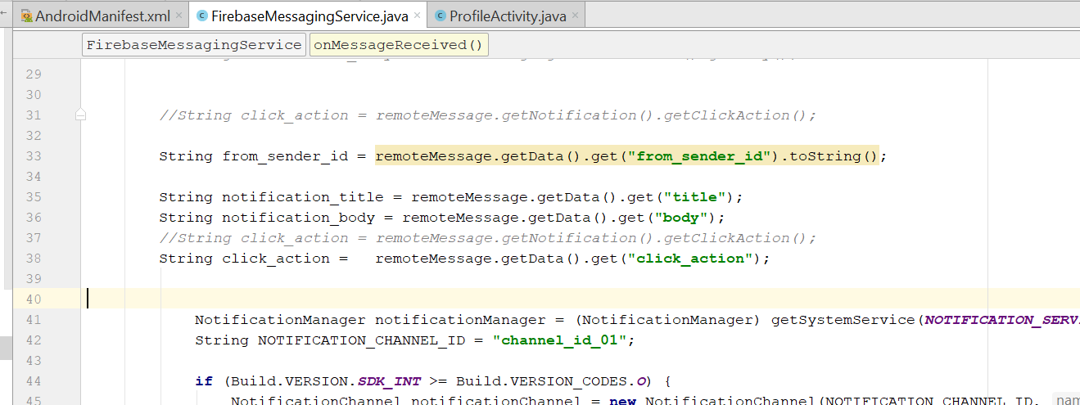
* Rebuild and run, the error should be fixed

# Step 26: Friend Fragment display list of Friends

* First step go to friendfragment.java
* Remove the text, change the layout to relativelayout
* 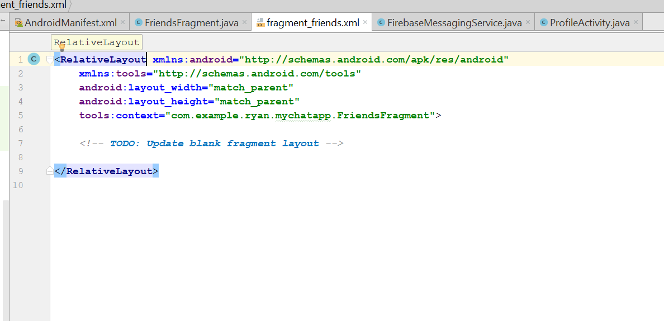
* Add a recycleview for list, drag and drop to the centre
* 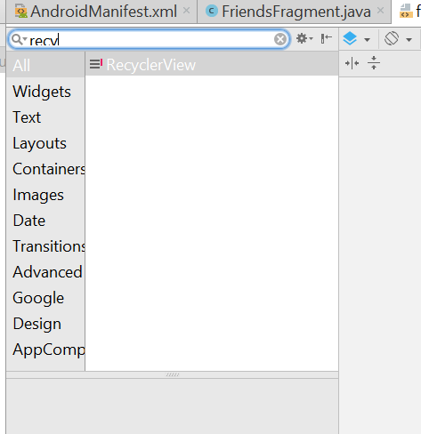
* 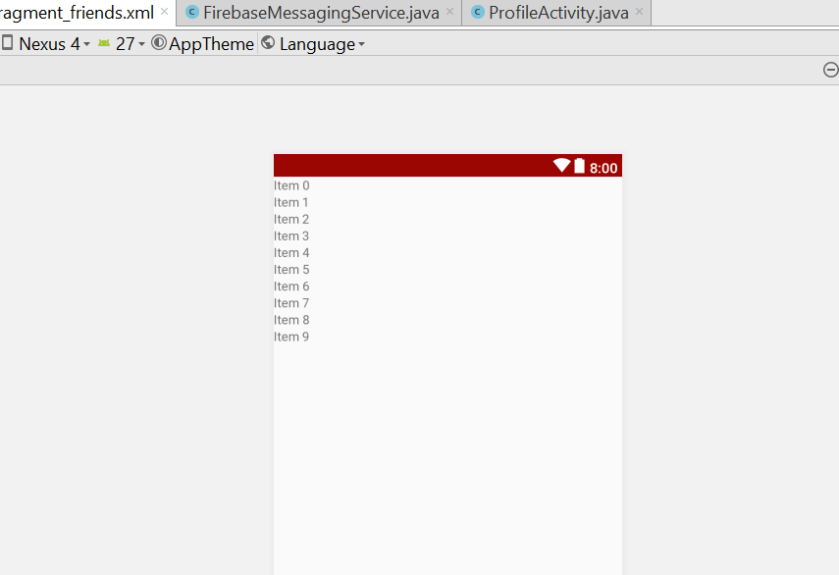
* Give it a name known as friend_list  
  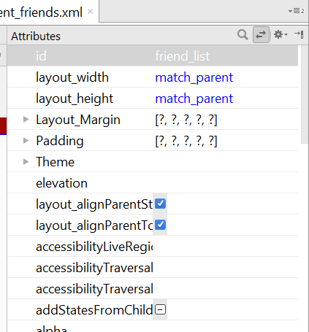
* Now go to friendfragment.java
* Add this line
* 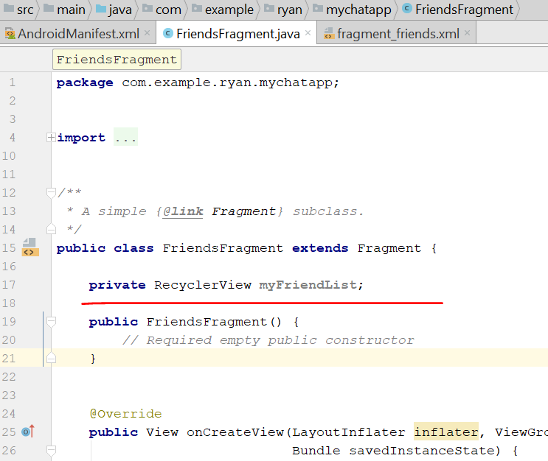
* Then now go to profileActivity.java
* Go to private void AcceptFriendRequest()
* Add this line
* 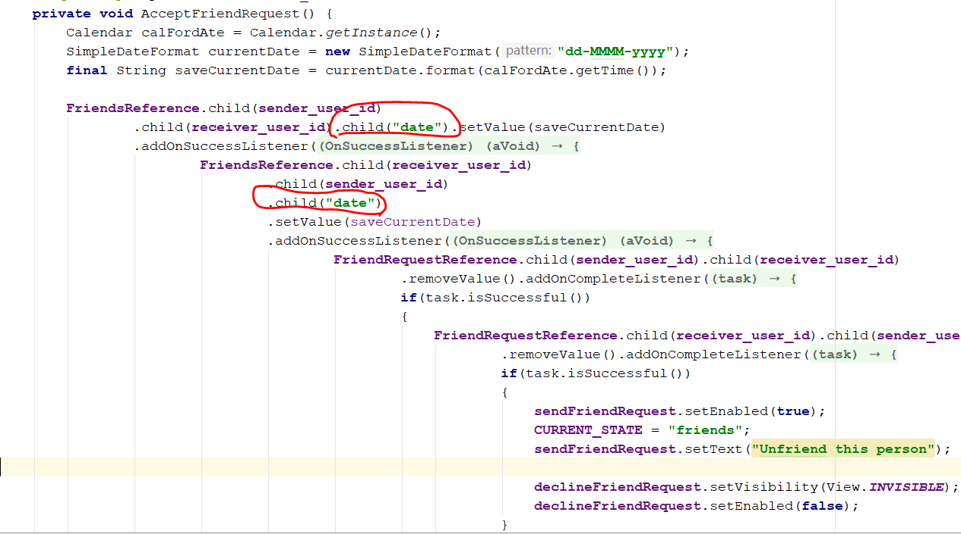
* Create a new Java class call Friends
* 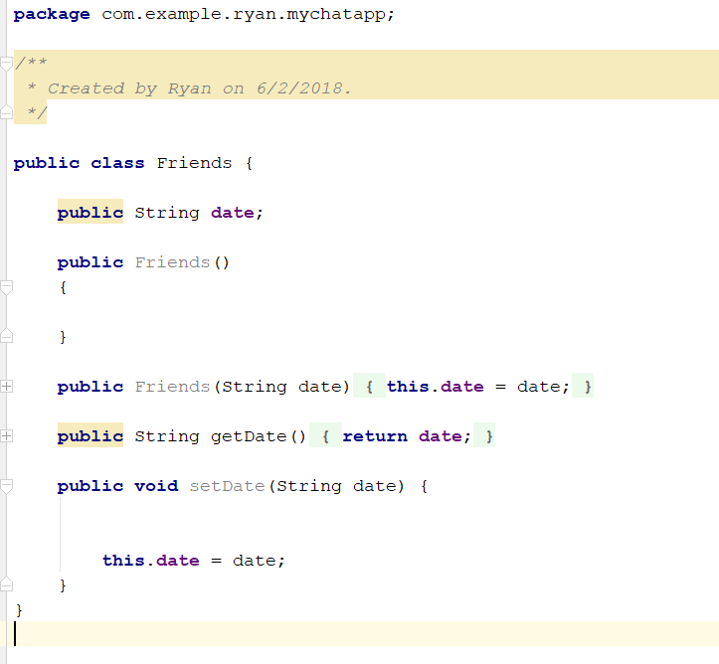
* Now go back to friendFragment
* **public** FriendsFragment() {  
   *// Required empty public constructor*}  
    
    
  @Override  
  **public** View onCreateView(LayoutInflater inflater, ViewGroup container,  
   Bundle savedInstanceState) {  
   *// Inflate the layout for this fragment* **myMainView** = inflater.inflate(R.layout.***fragment_friends***, container, **false**);  
   **myFriendList** = (RecyclerView) **myMainView**.findViewById(R.id.***friend_list***);  
    
   **mAuth** = FirebaseAuth.*getInstance*();  
   **online_user_id** = **mAuth**.getCurrentUser().getUid();  
   **FriendReference** = FirebaseDatabase.*getInstance*().getReference().child(**"Friends"**).child(**online_user_id**);  
   **UsersReference** = FirebaseDatabase.*getInstance*().getReference().child(**"Users"**);  
   **myFriendList**.setLayoutManager(**new** LinearLayoutManager(getContext()));  
    
   *//inflate the layout* **return myMainView**;  
  }  
    
  @Override  
  **public void** onStart() {  
   **super**.onStart();  
   FirebaseRecyclerAdapter<Friends, FriendsViewHolder> firebaseRecyclerAdapter  
   = **new** FirebaseRecyclerAdapter<Friends, FriendsViewHolder>(  
   Friends.**class**,  
   R.layout.***all_users_display_layout***,  
   FriendsViewHolder.**class**,  
   **FriendReference** ) {  
   @Override  
   **protected void** populateViewHolder(FriendsViewHolder viewHolder, Friends model, **int** position) {  
   viewHolder.setDate(model.getDate());  
   String list_user_id = getRef(position).getKey();  
   **UsersReference**.child(list_user_id).addValueEventListener(**new** ValueEventListener() {  
   @Override  
   **public void** onDataChange(DataSnapshot dataSnapshot) {  
   String userName = dataSnapshot.child(**"user_name"**).getValue().toString();  
   String thumbImage = dataSnapshot.child(**"user_thumb_image"**).getValue().toString();  
   FriendsViewHolder.*setUserName*(userName);  
   FriendsViewHolder.*setThumbImage*(thumbImage, getContext());  
    
    
   }  
    
   @Override  
   **public void** onCancelled(DatabaseError databaseError) {  
    
   }  
   });  
    
    
   }  
   };  
   **myFriendList**.setAdapter(firebaseRecyclerAdapter);  
  }  
  **public static class** FriendsViewHolder **extends** RecyclerView.ViewHolder  
  {  
   **static** View *mView*;  
   **public** FriendsViewHolder(View itemView) {  
   **super**(itemView);  
   *mView* = itemView;  
   }  
    
   **public void** setDate(String date) {  
    
    
   TextView sinceFriendDate = (TextView)*mView*.findViewById(R.id.***all_users_userstatus***);  
   sinceFriendDate.setText(date);  
   }  
    
   **public static void** setUserName(String userName)  
   {  
   TextView userNameDisplay = (TextView)*mView*.findViewById(R.id.***all_users_username***);  
   userNameDisplay.setText(userName);  
   }  
    
   **public static void** setThumbImage(**final** String thumbImage, **final** Context ctx)  
   {  
   **final** CircleImageView thumb_image = (CircleImageView) *mView*.findViewById(R.id.***all_users_profile_image***);  
   Picasso.*with*(ctx).load(thumbImage).networkPolicy(NetworkPolicy.***OFFLINE***).placeholder(R.drawable.***default_profile***)  
   .into(thumb_image, **new** Callback() {  
   @Override  
   **public void** onSuccess() {  
    
   }  
    
   @Override  
   **public void** onError() {  
   Picasso.*with*(ctx).load(thumbImage).placeholder(R.drawable.***default_profile***).into(thumb_image);  
    
   }  
   });  
    
   }  
  }
* 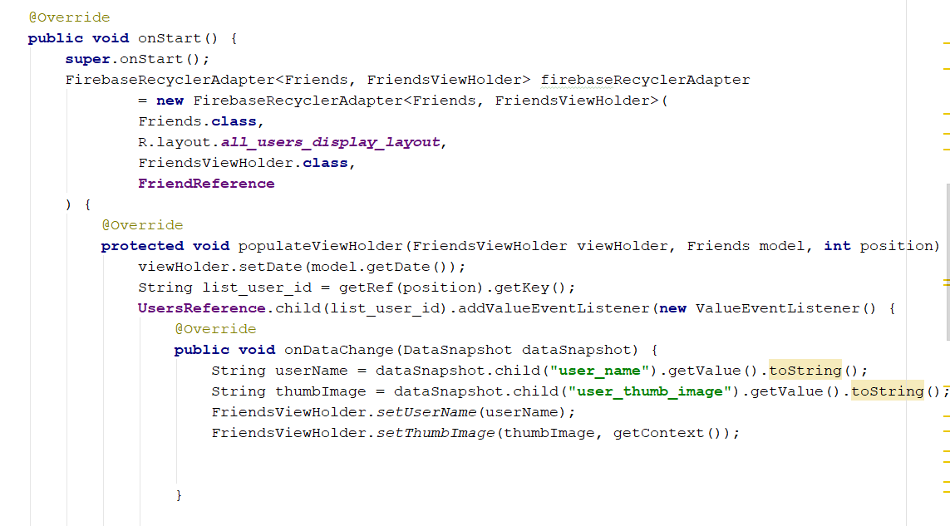
* 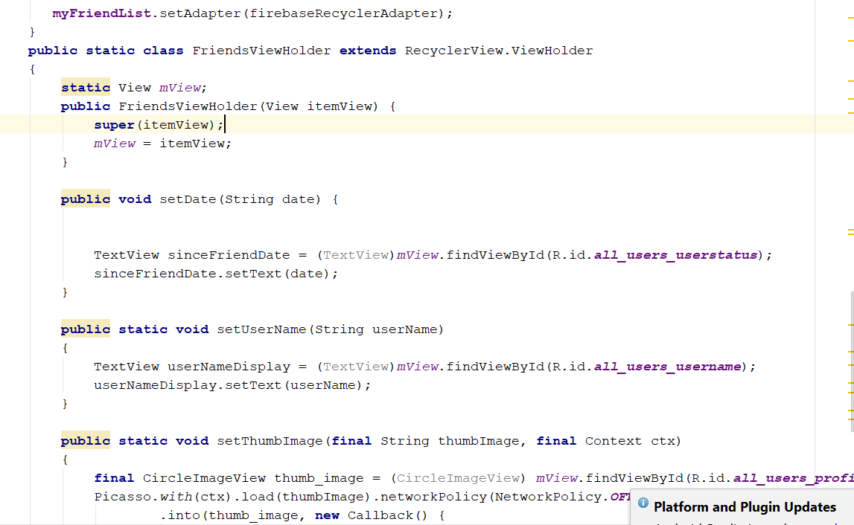
* Rebuild and run, you should see the friend appear on the friend tab, with photo and date as friends
* Go to friendFragment.java
* Go to public static class FriendsViewHolder extends RecyclerView.ViewHolder
* 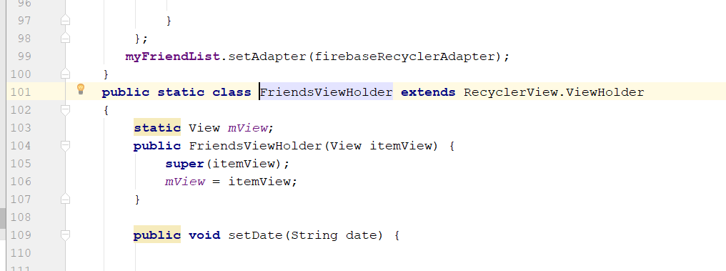
* remove static view
* 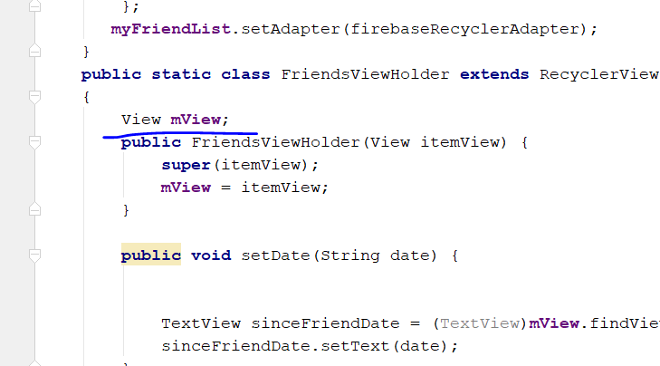
* go to public static void setUserName(String userName)
* remove all the static
* 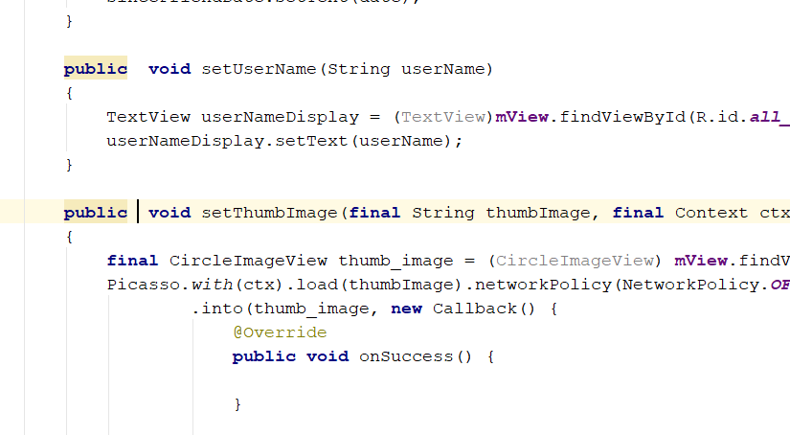
* Go to protected void populateViewHolder
* You will see this two error
* 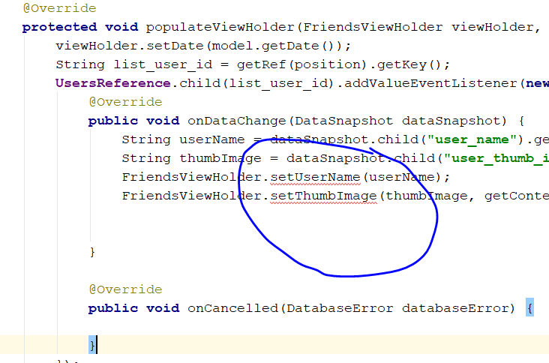
* Change to view holder, set to final viewholder
* 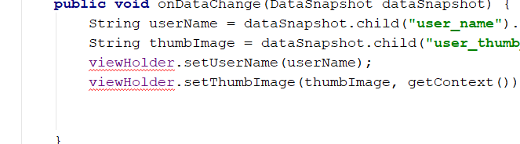

# Step 27: Display online status

* Go to mychat offline.java
* 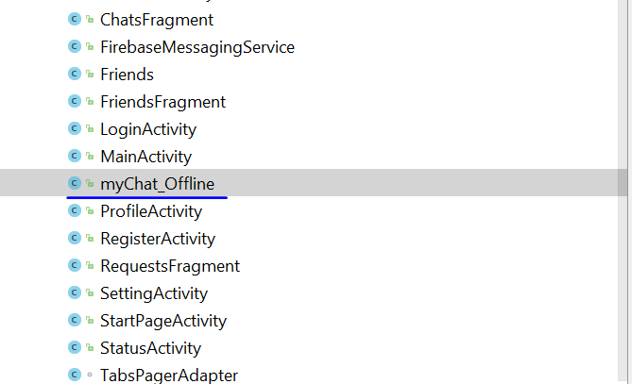
* Write this before onCreate()
* **private** DatabaseReference **UsersReference**;  
  **private** FirebaseAuth **mAuth**;  
  **private** FirebaseUser **currentUser**;
* 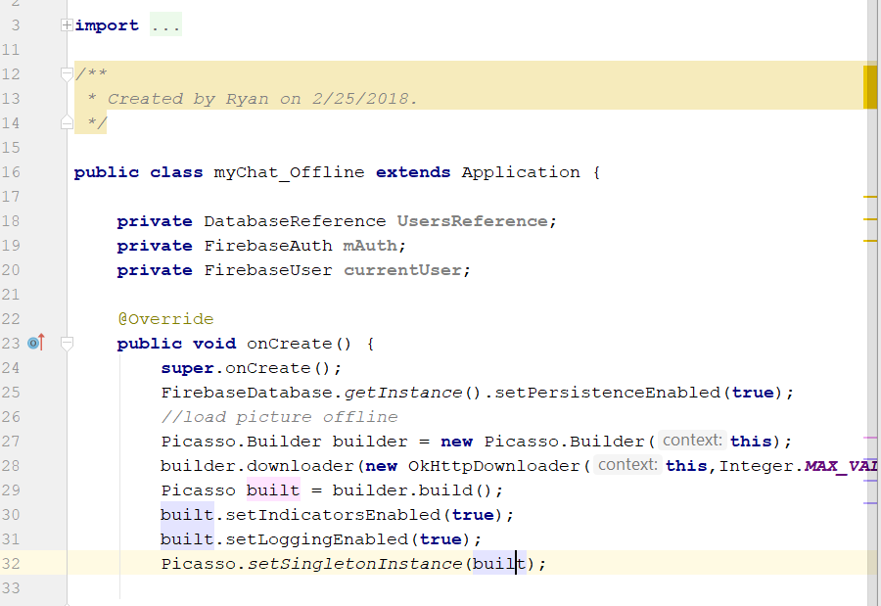
* Then add this
* 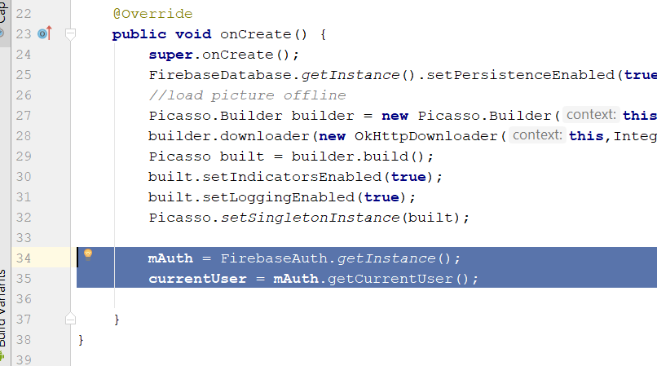
* Add this below
* String online_user_id = **mAuth**.getCurrentUser().getUid();  
  **UsersReference** = FirebaseDatabase.*getInstance*().getReference().child(**"Users"**).child(online_user_id);  
    
  **UsersReference**.addValueEventListener(**new** ValueEventListener() {  
   @Override  
   **public void** onDataChange(DataSnapshot dataSnapshot) {  
   **UsersReference**.child(**"online"**).onDisconnect().setValue(**false**);  
     
    
   }  
    
   @Override  
   **public void** onCancelled(DatabaseError databaseError) {  
    
   }  
  });
* 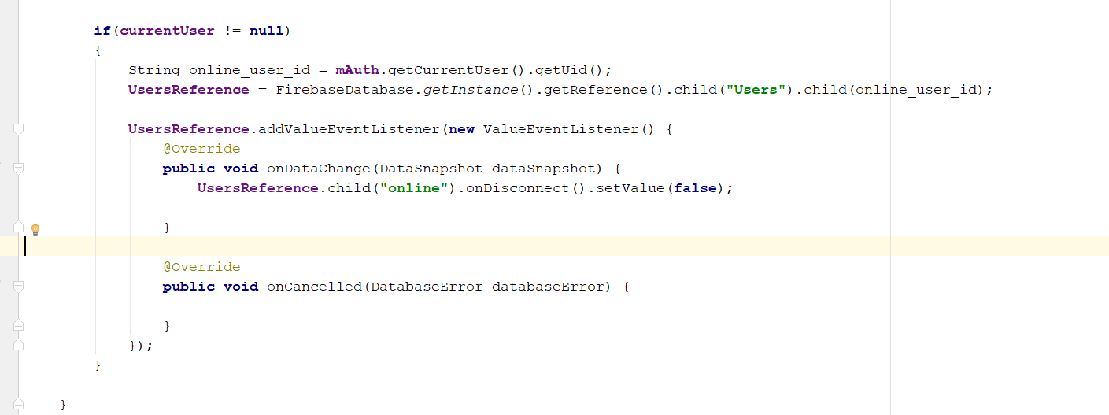
* Rebuild and run
* Then go firebase console and see
* 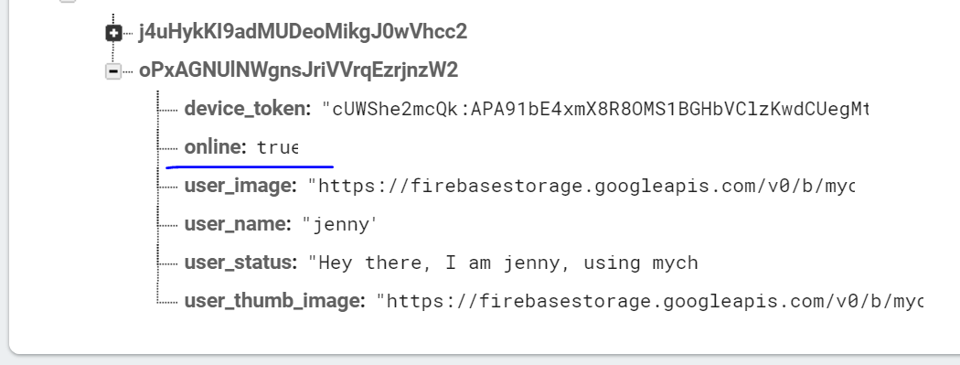
* Now work on minimize the app to display offline
* Remove this line
* **UsersReference**.child(**"online"**).setValue(**true**);
* Go to MainActivity
* Change this
* 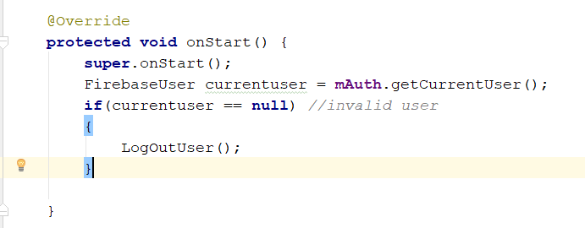
* To this
* 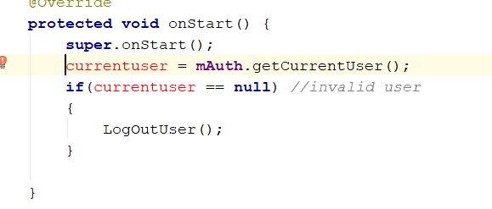
* Paste this above
* FirebaseUser **currentuser**;
* 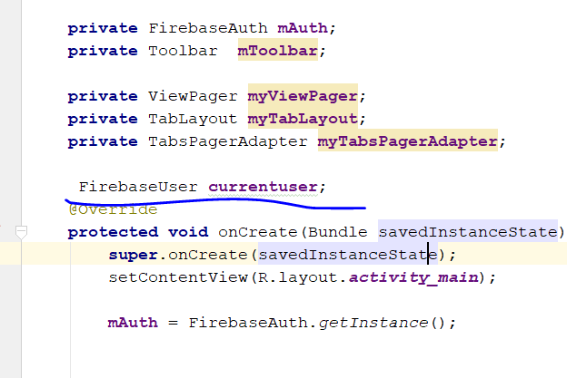
* Add this
* **if**(**currentuser** != **null**)  
  {  
   String online_user_id = **mAuth**.getCurrentUser().getUid();  
   **UsersReference** = FirebaseDatabase.*getInstance*()  
   .getReference().child(**"Users"**).child(online_user_id);  
  }
* 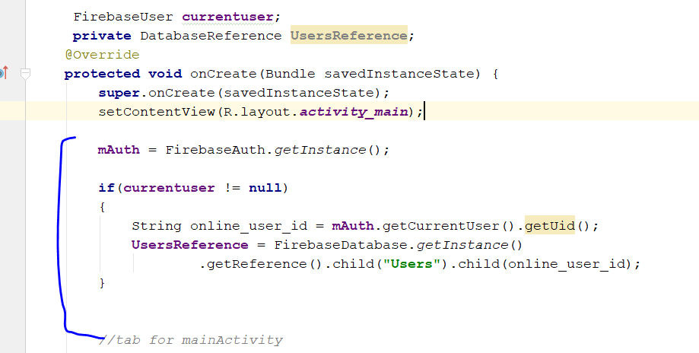
* Now go to onStart method
* **else if**(**currentuser** != **null**)  
  {  
   **UsersReference**.child(**"online"**).setValue(**true**);  
  }
* 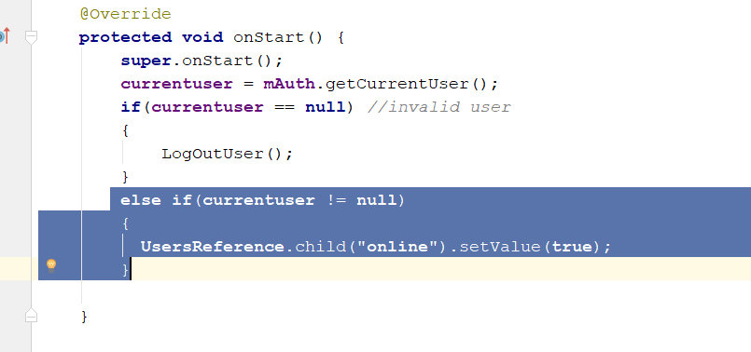
* Then add this
* @Override  
  **protected void** onStop() {  
   **super**.onStop();  
  }
* Add this line here
* 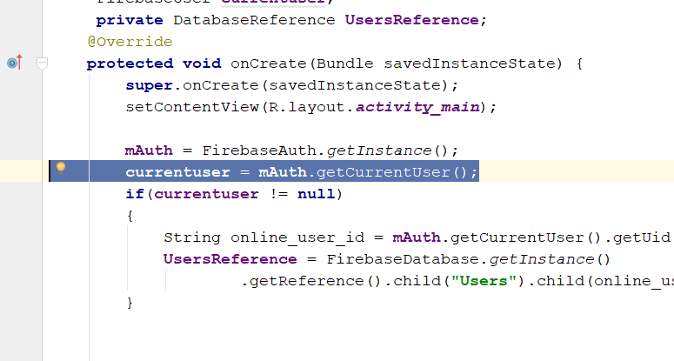
* Add this
* **protected void** onStart() {  
   **super**.onStart();  
   **currentuser** = **mAuth**.getCurrentUser();  
   **if**(**currentuser** == **null**) *//invalid user* {  
   LogOutUser();  
   }  
   **else if**(**currentuser** != **null**)  
   {  
   **UsersReference**.child(**"online"**).setValue(**false**);  
   }  
    
  }
* 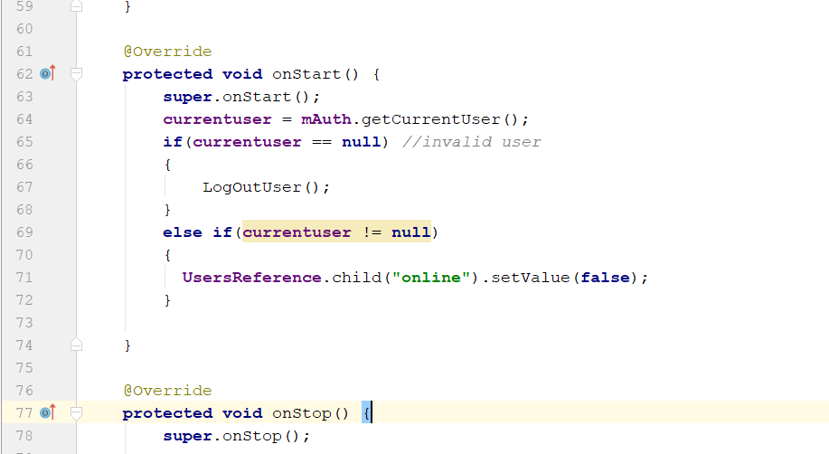
* Rebuild and run, now if you minimize ur app, it should appear offline
* The online icon png paste into the image folder
* 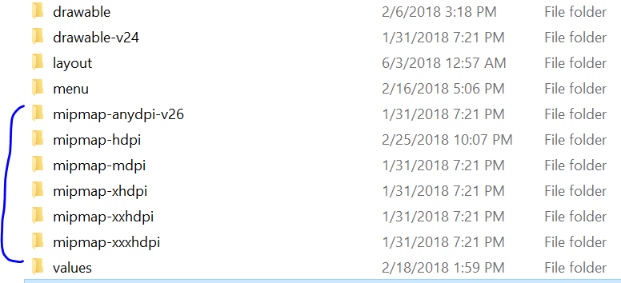
* Go to all_user_display_layout.xml
* Change to this
* <**LinearLayout  
   android:layout_width="match_parent"  
   android:layout_height="wrap_content"  
   android:orientation="horizontal"**>  
   <**TextView  
   android:id="@+id/all_users_username"  
   android:layout_width="match_parent"  
   android:layout_height="wrap_content"  
   android:text="user name"  
   android:textSize="18sp"  
   android:textStyle="bold"** />  
   <**ImageView  
   android:id="@+id/online_status"  
   android:layout_width="15dp"  
   android:layout_height="15dp"** />  
    
  </**LinearLayout**>
* 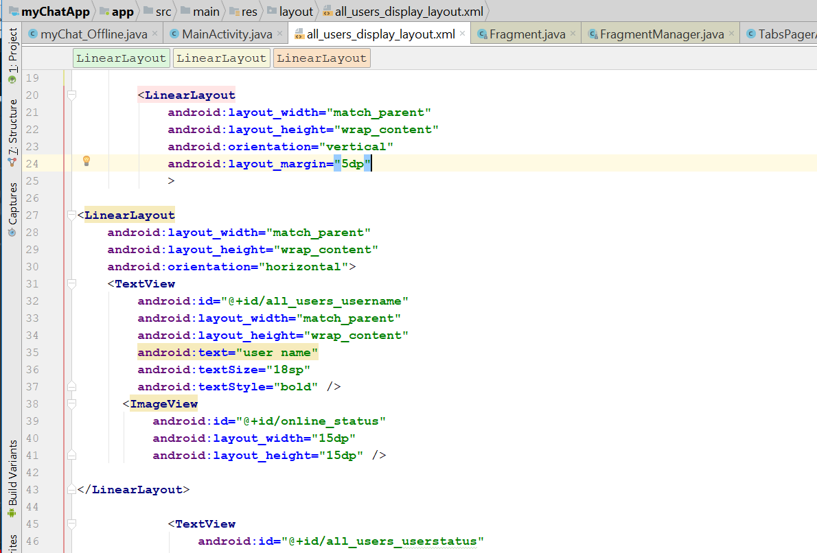
* For the image view, visibility change to invisible
* 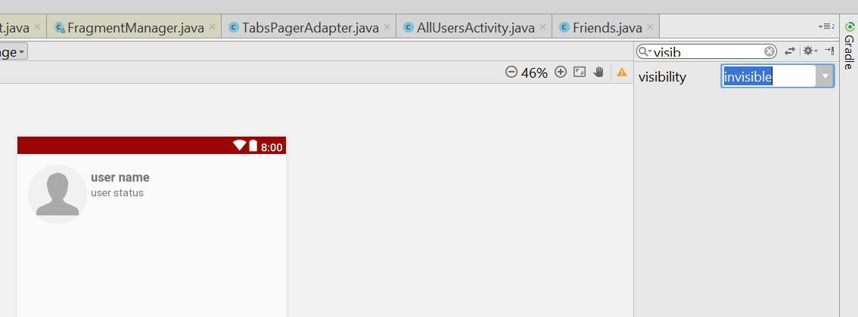
* Now go to FriendsFragment
* Add this line
* **if**(dataSnapshot.hasChild(**"online"**))  
  {  
   **boolean** online_status = (**boolean**)dataSnapshot.child(**"online"**).getValue();  
   viewHolder.setUserOnline(online_status);  
  }
* 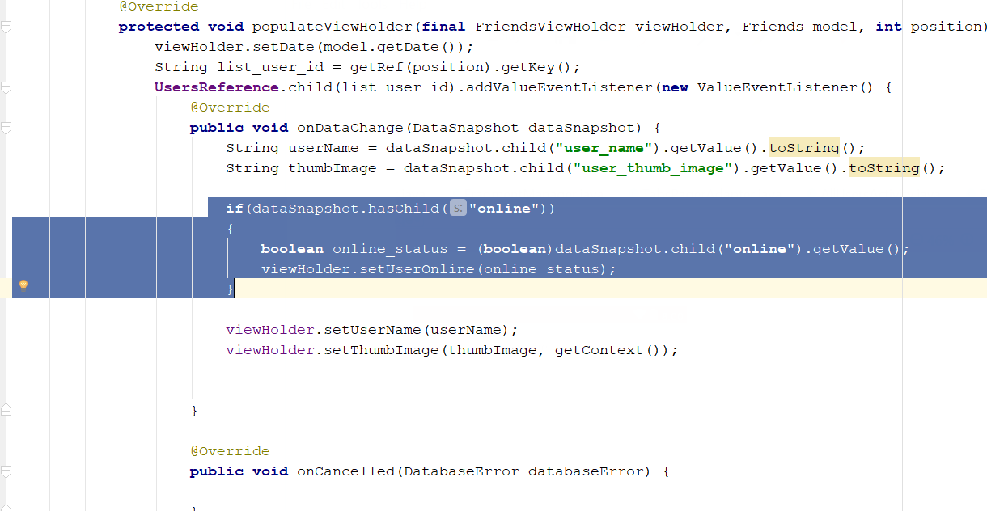
* 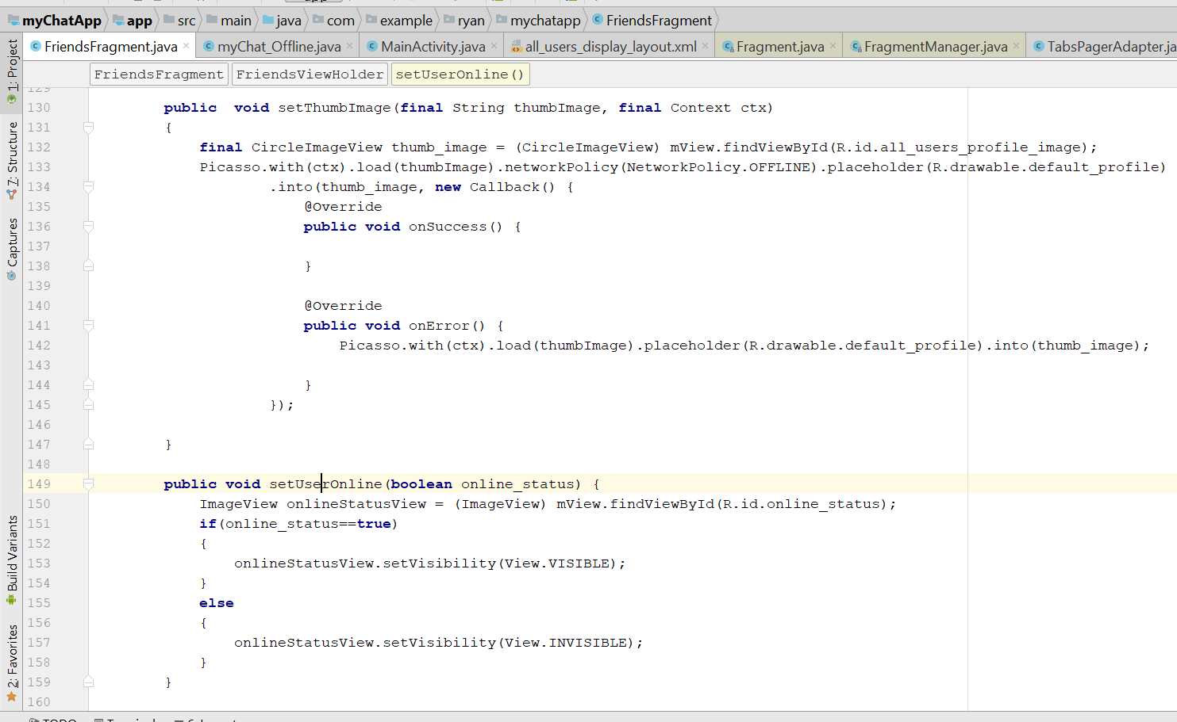Add this line
* 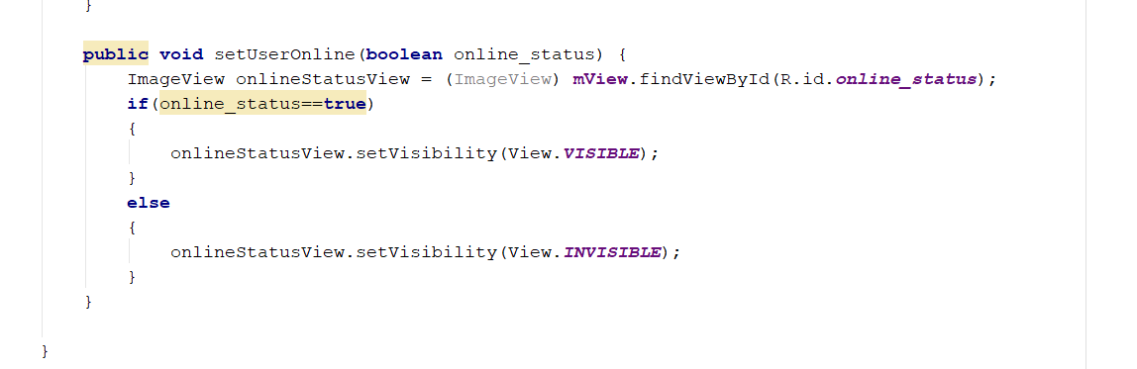
* **public void** setUserOnline(**boolean** online_status) {  
   ImageView onlineStatusView = (ImageView) **mView**.findViewById(R.id.***online_status***);  
   **if**(online_status==**true**)  
   {  
   onlineStatusView.setVisibility(View.***VISIBLE***);  
   }  
   **else** {  
   onlineStatusView.setVisibility(View.***INVISIBLE***);  
   }  
  }
* Rebuild and Run

# Step 28: Chat Fragment

* Go to FriendFragment.java
* Go to this part
* 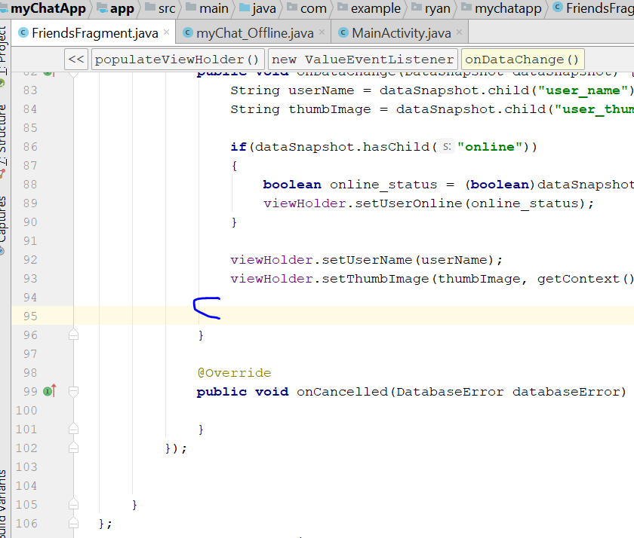
* Add this
* viewHolder.**mView**.setOnClickListener(**new** View.OnClickListener() {  
   @Override  
   **public void** onClick(View v) {  
   CharSequence options[] = **new** CharSequence[]  
   {  
   userName + **"'s profile"**,  
   **"Send Message"** };  
    
   AlertDialog.Builder builder = **new** AlertDialog.Builder(getContext());  
   builder.setTitle(**"Select Option"**);  
   builder.setItems(options, **new** DialogInterface.OnClickListener() {  
   @Override  
   **public void** onClick(DialogInterface dialog, **int** position) {  
   **if**(position == 0)  
   {  
   Intent profileIntent = **new** Intent(getContext(), ProfileActivity.**class**);  
   profileIntent.putExtra(**"visit_user_id"**, list_user_id);  
   startActivity(profileIntent);  
   }  
   **if**(position == 1)  
   {  
   Intent chatIntent = **new** Intent(getContext(), ProfileActivity.**class**);  
   chatIntent.putExtra(**"visit_user_id"**, list_user_id);  
   startActivity(chatIntent);  
   }  
   }  
   });  
   }  
  });
* 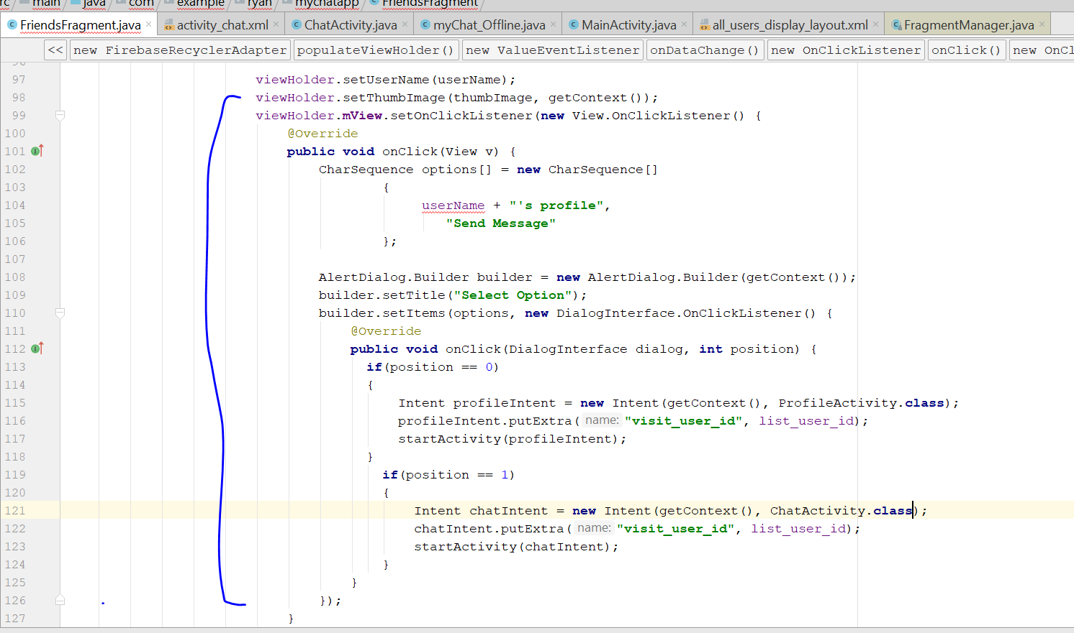
* Now create ChatActivity.java
* Create a blank Activity
* 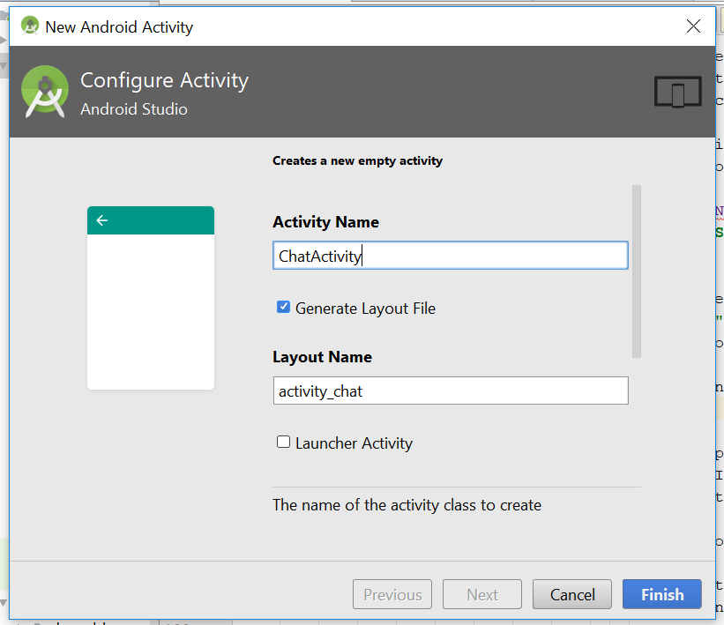
* Now go to the activity_chat.xml
* Go to friendFragment and add this line
* 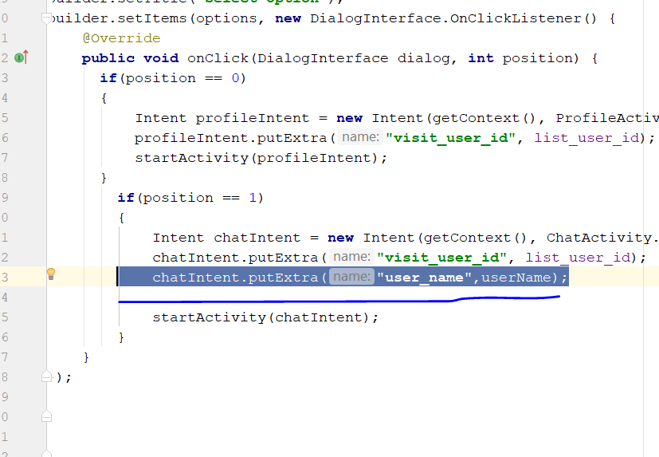
* Go to ChatActivity and add in this line
* **public class** ChatActivity **extends** AppCompatActivity {  
    
   **private** String **messageReceiverId**;  
   **private** String **messageReceiverName**;  
   @Override  
   **protected void** onCreate(Bundle savedInstanceState) {  
   **super**.onCreate(savedInstanceState);  
   setContentView(R.layout.***activity_chat***);  
    
   **messageReceiverId** = getIntent().getExtras().get(**"visit_user_id"**).toString();  
   **messageReceiverName** = getIntent().getExtras().get(**"user_name"**).toString();  
    
   Toast.*makeText*(**this**, **messageReceiverId**, Toast.***LENGTH_SHORT***).show();  
   Toast.*makeText*(**this**, **messageReceiverName**, Toast.***LENGTH_SHORT***).show();  
    
   }  
  }
* }
* 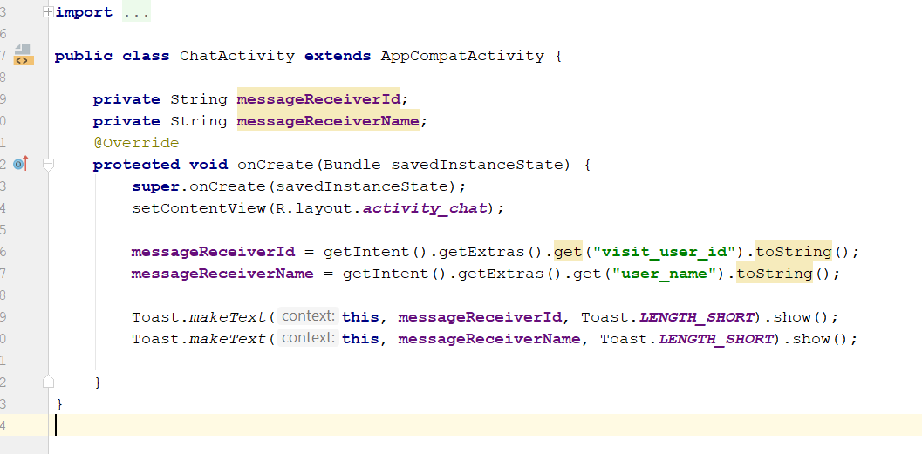
* Add in this line at FriendFragment
* builder.show();
* 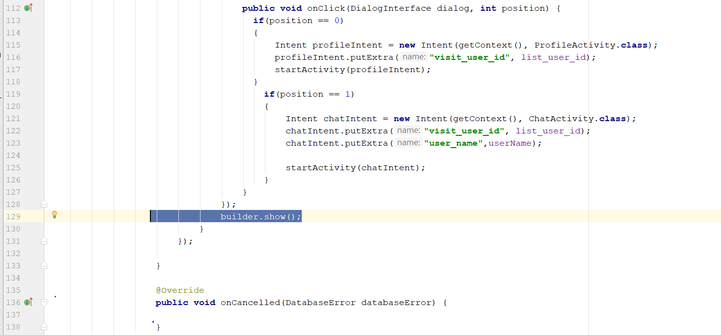
* Now rebuild and run, you should see two option when u click on the user name
* Create a new layout resource file
* 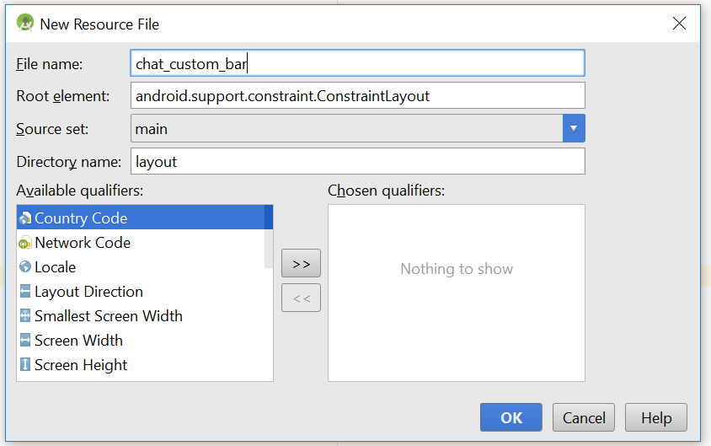
* Change to relative layout
* You will see something like that
* 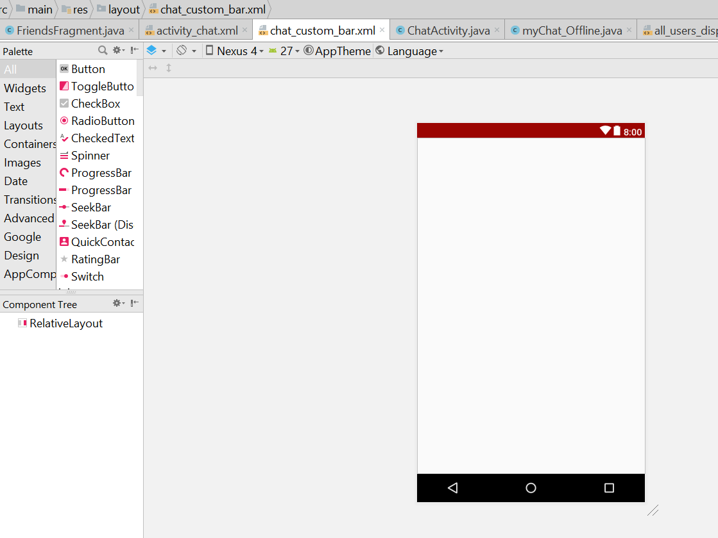
* Drag and drop 2 textview on the XML, one is Display Username and Last Seen
* 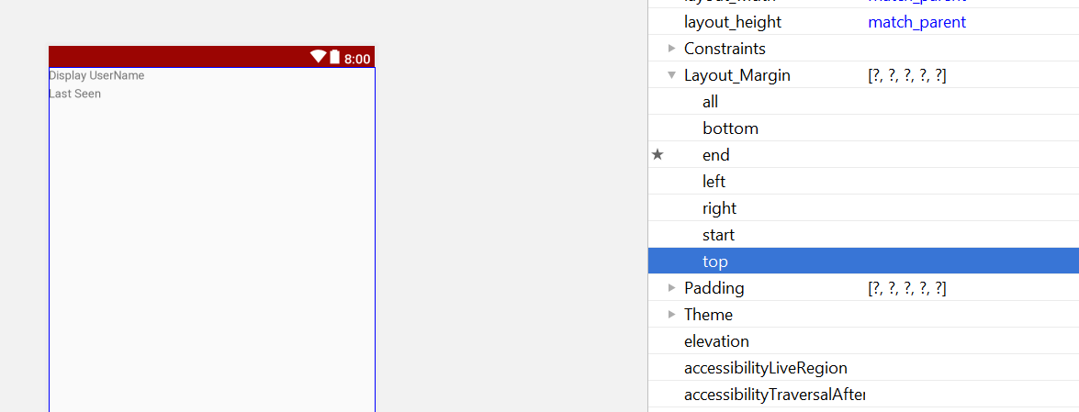
* Last seen top margin change to 3dp
* 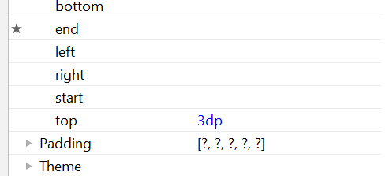
* Click on relative layout and click i a background colour
* 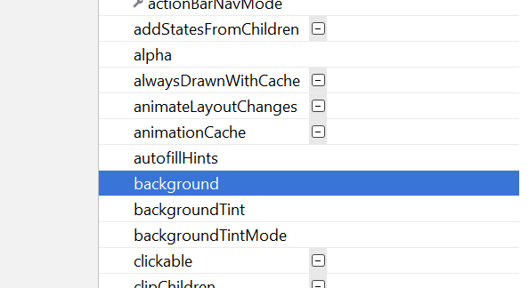
* Select colour primary
* 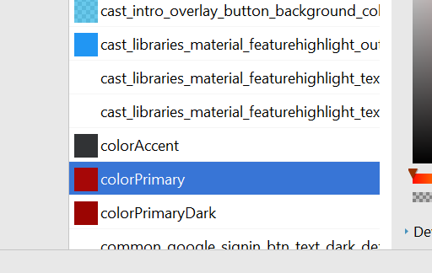
* It will look something like this
* 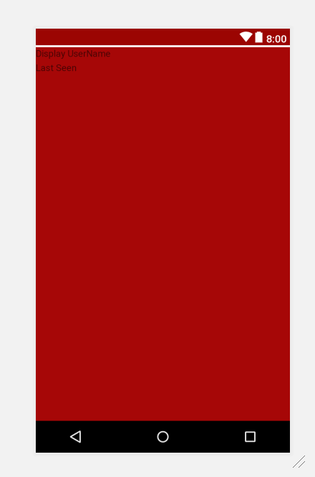
* Change the display username textview to 18dp
* Change the text colour to background light
* 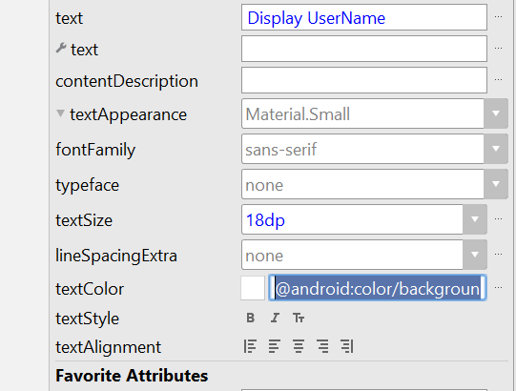
* For the last seen, change to 14 dp and colour change to background light, and make it bold
* Now it look like this
* 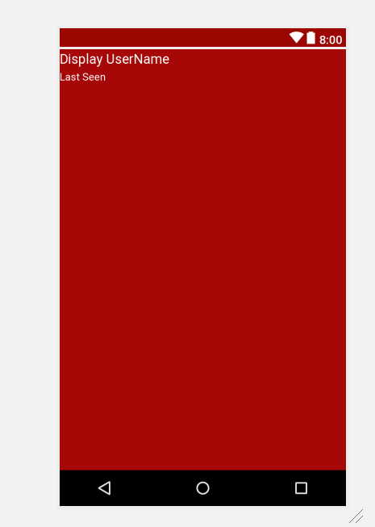
* Add this in the text
* <**de.hdodenhof.circleimageview.CircleImageView  
   android:layout_width="40dp"  
   android:layout_height="40dp"  
   android:src="@drawable/default_profile"**/>
* 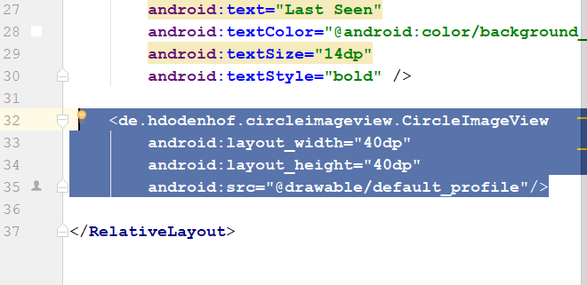
* Drag the white circle to the right side
* 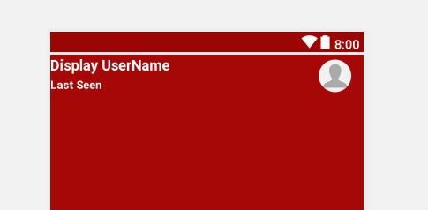
* Id for the username
* 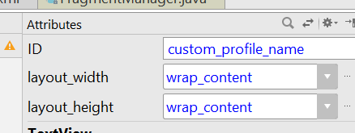
* Id for the Last seen
* 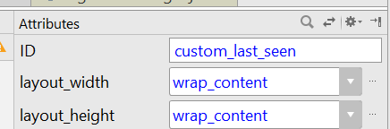
* Id for the circle
* 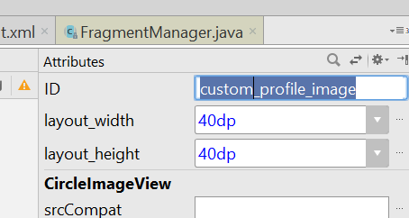
* Now to the activity_chat.xml
* Add this
* <**LinearLayout  
   android:layout_width="match_parent"  
   android:layout_height="wrap_content"  
   android:orientation="horizontal"** >  
    
    
    
  </**LinearLayout**>
* 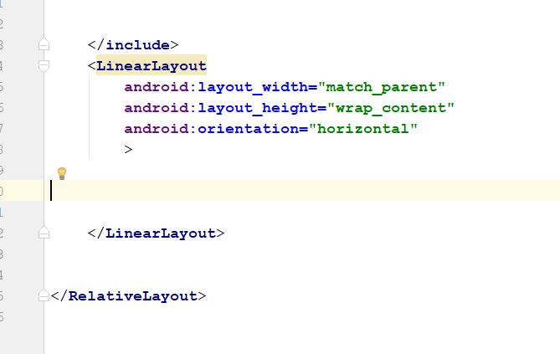
* Go res, click on new 🡪image asset
* 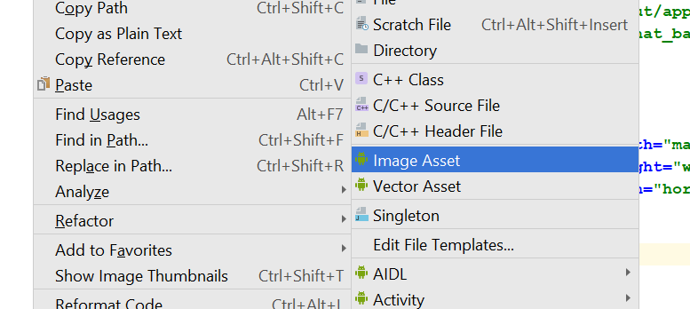
* You will see something like this
* 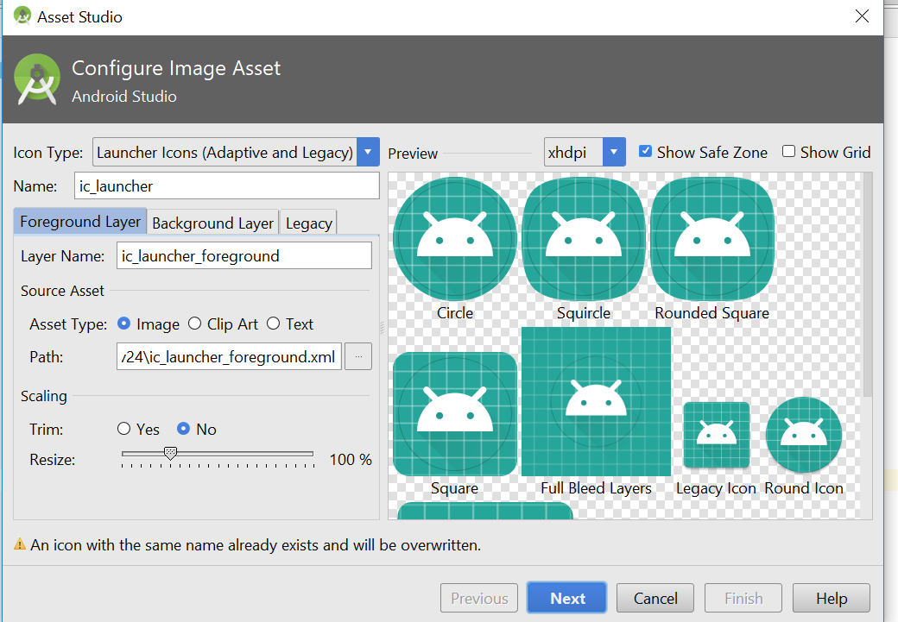
* Select action bar and tab icon
* 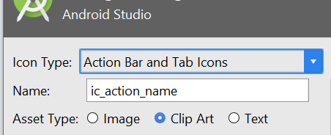
* Click on this
* 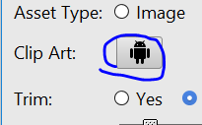
* Select the photo icon
* 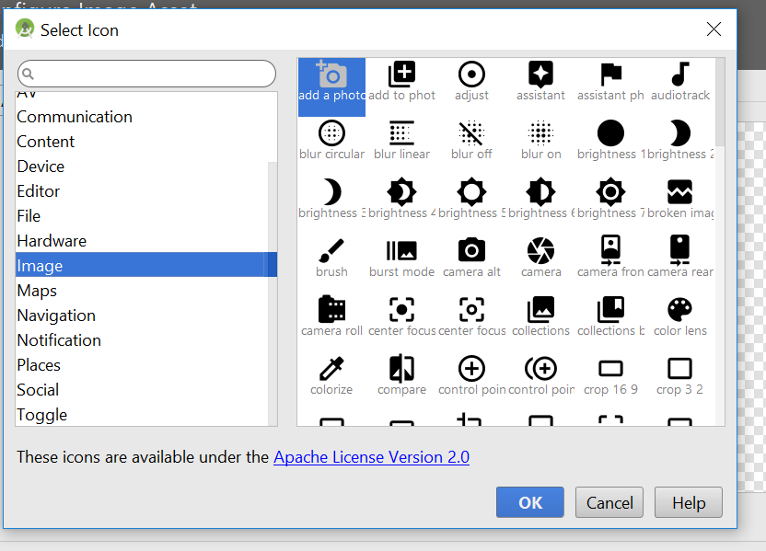
* Change the name to ic_select_image
* 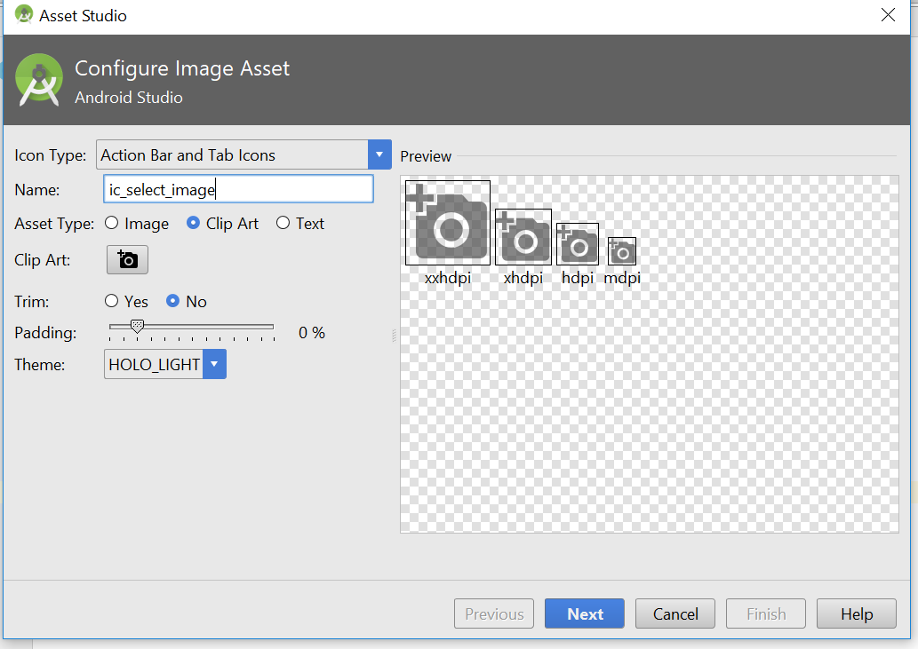
* Change the name of the image to ic_select_image_to_send
* Click next, click finish
* Create a send message button, create image asset again
* Select this again
* 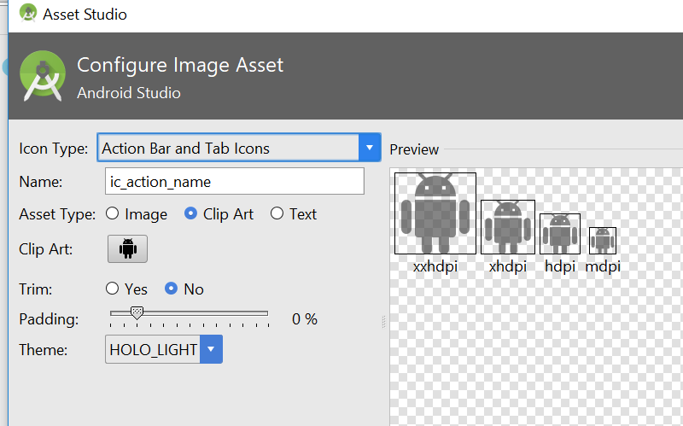
* Choose this icon
* 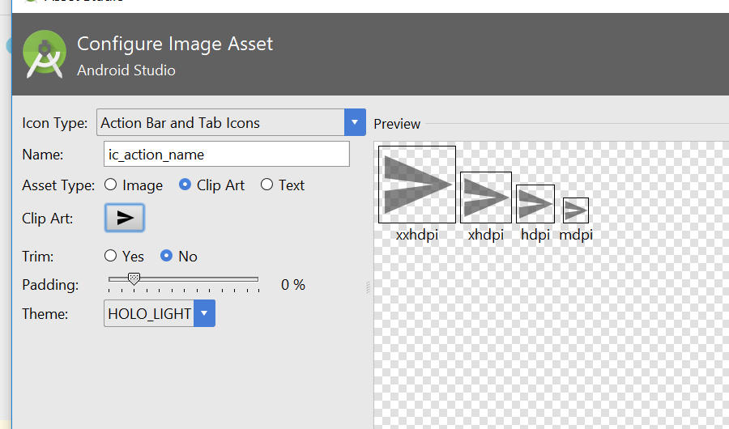
* Change the name to send_message
* 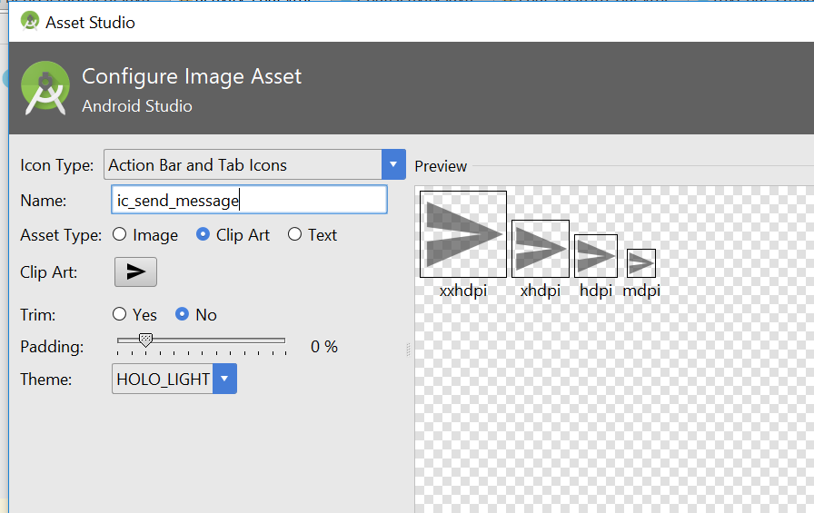
* Go to activity_chat.xml
* Add this line
* <**ImageView  
   android:layout_width="50dp"  
   android:layout_height="wrap_content"  
   android:src="@drawable/ic_select_image_to_send"**/>
* 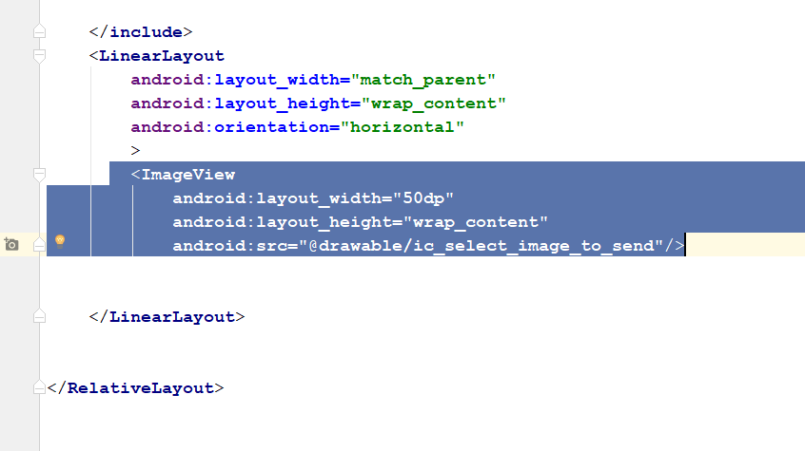
* Drag the icon down to below, then drag a multi line text to the add image button
* 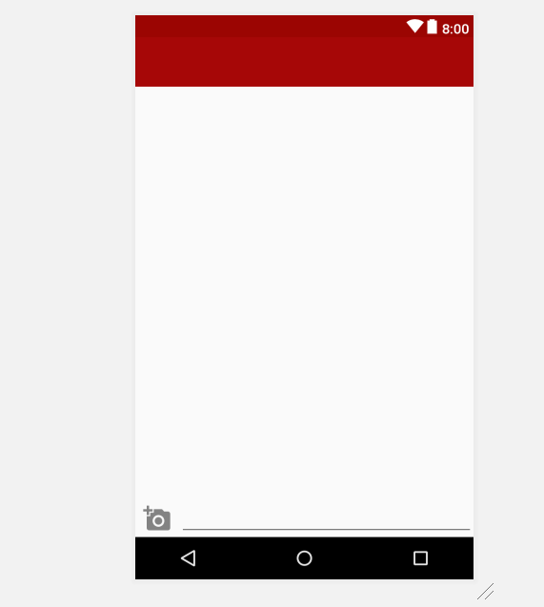
* 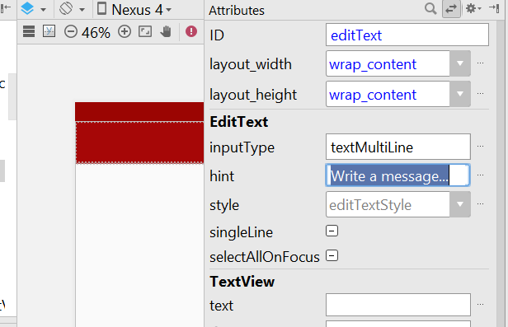
* Give a hint to the text
* Change the width to 250dp
* 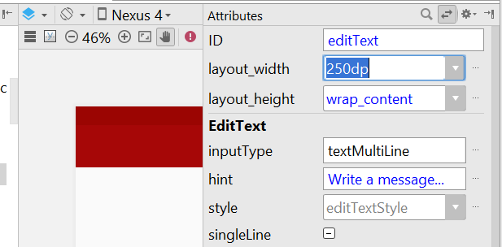
* Write the hint “: write a message
* Now drag another image view into the right side
* Then u select this
* 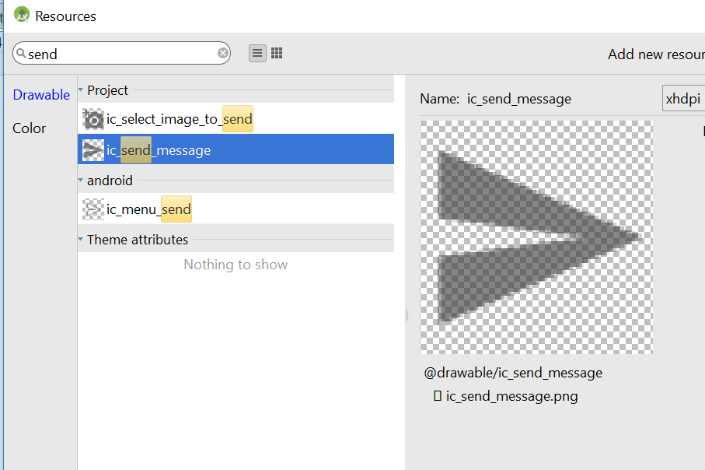
* Now it look like this
* 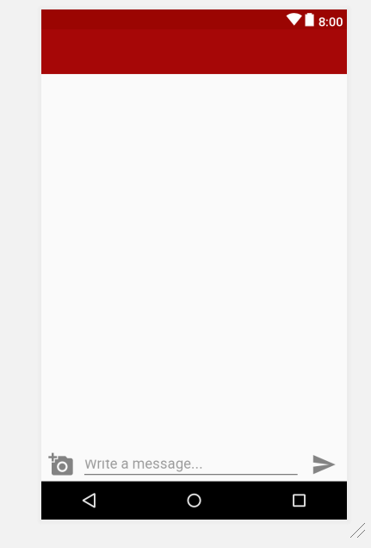
* For the linear layout, give it a padding of 5dp
* For the select image, give it a padding of 5dp
* For the edit text, give it a padding of 10dp
* For the send messag, give it a padding of 5dp
* Go to relative layout and select the background for it
* Select darker_gray
* 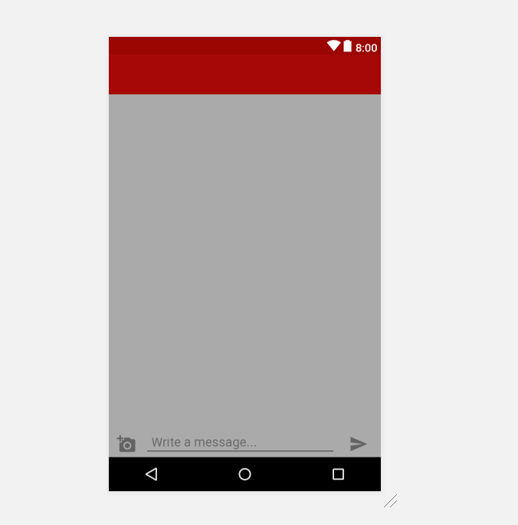
* Select linear layout, select background_light
* 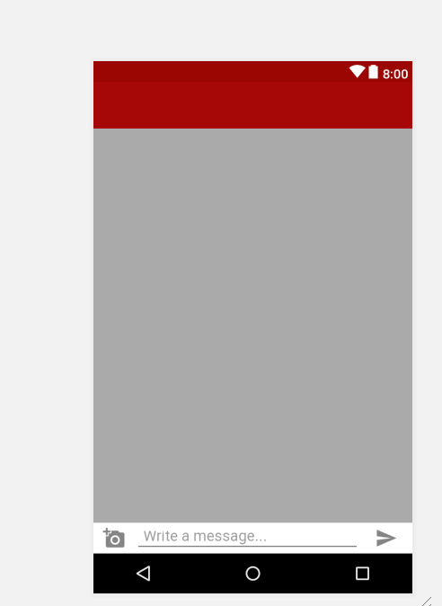
* Change the text id to input_message
* 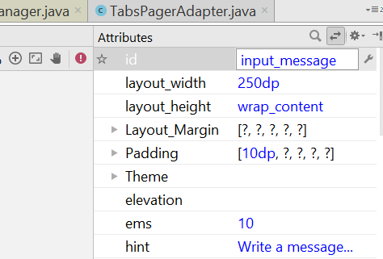
* Send button id is send_message
* Rebuild and run
* Now go to chat activity
* Remove the two toast line
* Add this line
* **private** Toolbar **ChatToolbar**;
* 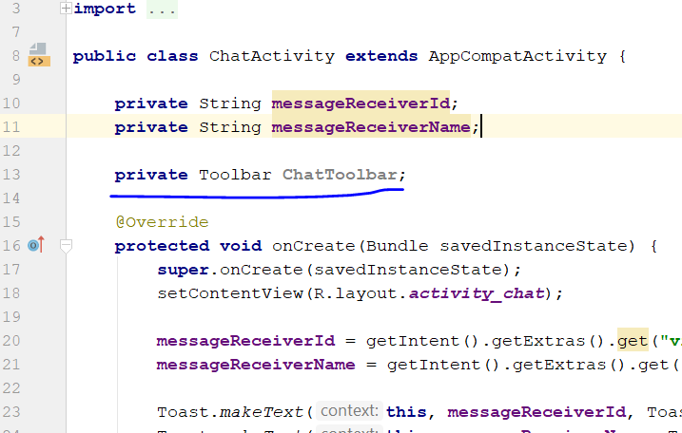
* Add in the following
* **private** Toolbar **ChatToolbar**;  
  **private** TextView **usernameTitle**;  
  **private** TextView **userLastSeen**;  
  **private** CircleImageView **userChatProfileImage**;
* Then add this line
* **ChatToolbar** = (Toolbar) findViewById(R.id.***chat_bar_layout***);  
  setSupportActionBar(**ChatToolbar**);

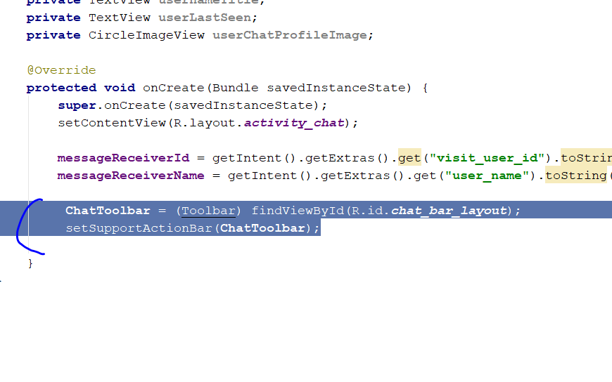

* Add this line
* ActionBar actionBar = getSupportActionBar();  
  actionBar.setDisplayHomeAsUpEnabled(**true**);  
  actionBar.setDisplayShowCustomEnabled(**true**);
* 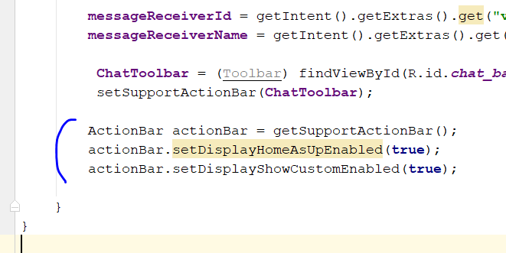
* Now go to android Manifest
* Edit this
* <activity android:name=".ChatActivity"
* android:parentActivityName=".MainActivity">
* 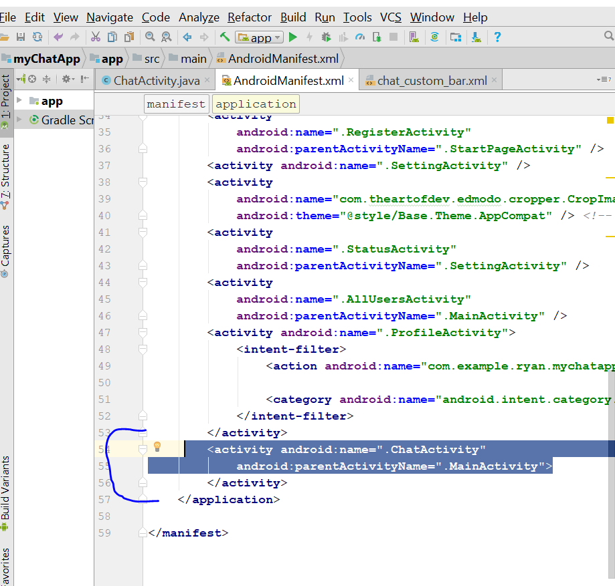
* Go back to chatactivty.java
* Type in this line below
* **usernameTitle** = (TextView) findViewById(R.id.***custom_profile_name***);  
  **userLastSeen** = (TextView) findViewById(R.id.***custom_last_seen***);  
  **userChatProfileImage** = (CircleImageView)findViewById(R.id.***custom_profile_image***);  
  **usernameTitle**.setText(**messageReceiverName**);
* 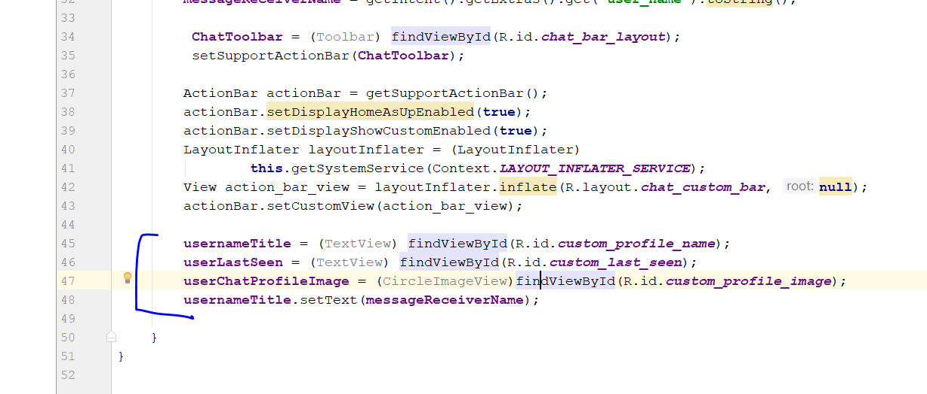
* Go to friendFragment.java
* 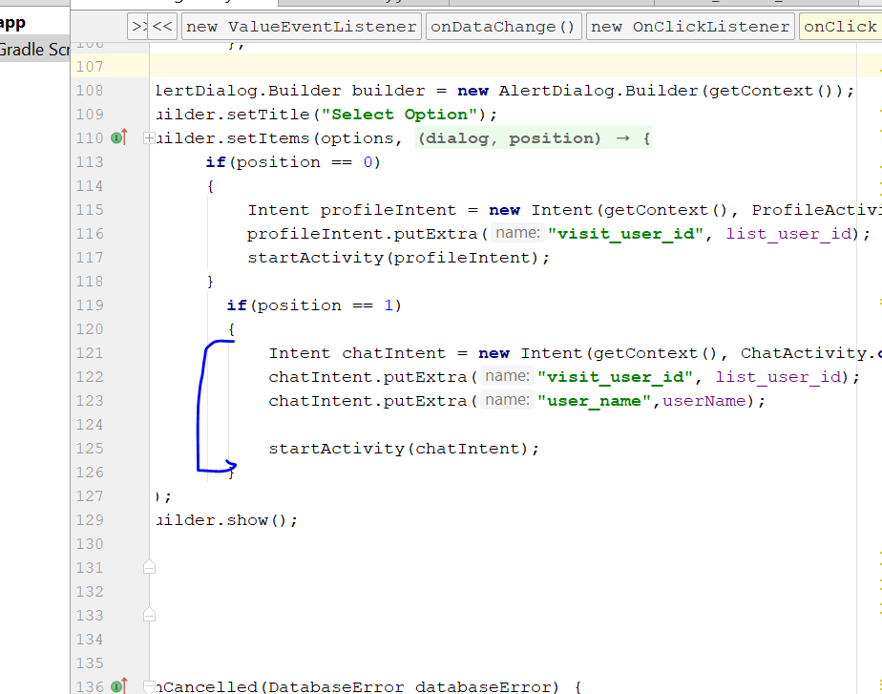
* Control X this line, cut this line
* Write this inside
* **if**(dataSnapshot.child(**"online"**).exists())  
  {  
   Intent chatIntent = **new** Intent(getContext(), ChatActivity.**class**);  
   chatIntent.putExtra(**"visit_user_id"**, list_user_id);  
   chatIntent.putExtra(**"user_name"**,userName);  
    
   startActivity(chatIntent);  
  }  
  **else**{  
   **UsersReference**.child(list_user_id).child(**"online"**)  
   .setValue(ServerValue.***TIMESTAMP***).addOnSuccessListener(**new** OnSuccessListener<Void>() {  
   @Override  
   **public void** onSuccess(Void aVoid) {  
    
   }  
   });  
  }
* 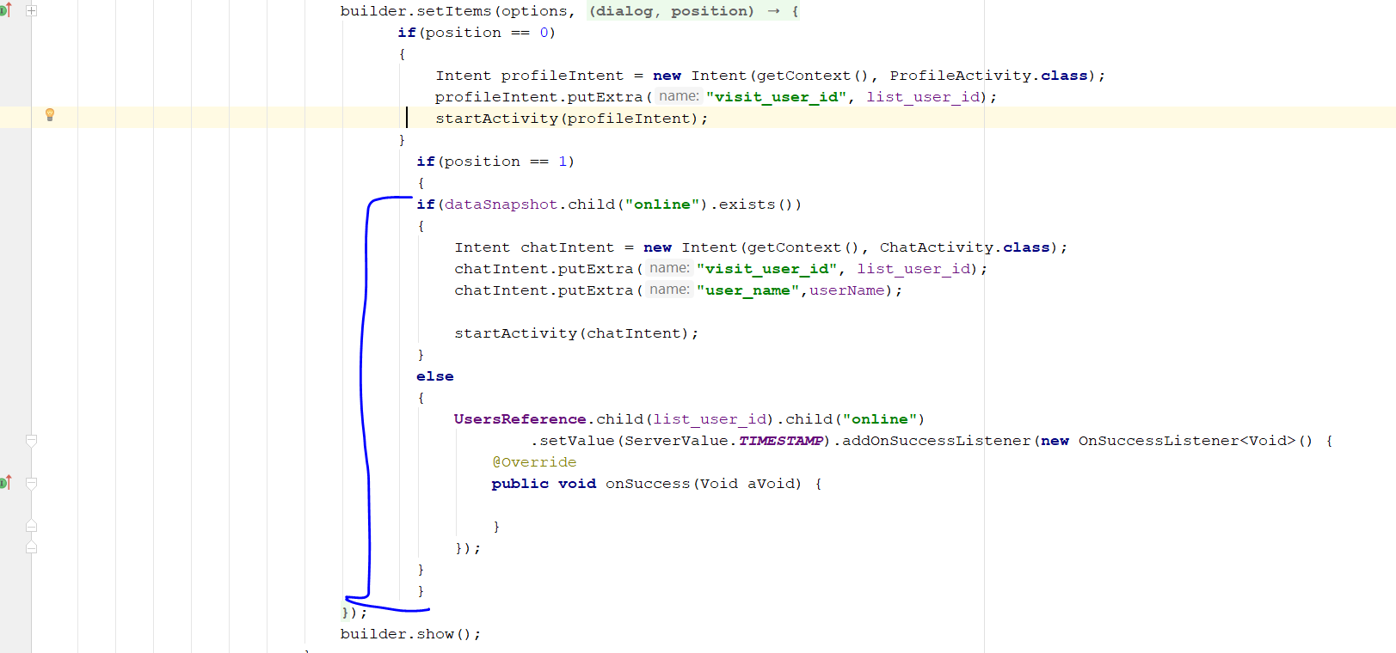
* Now go to MainActivity.java again
* Go to protected void onStop()
* 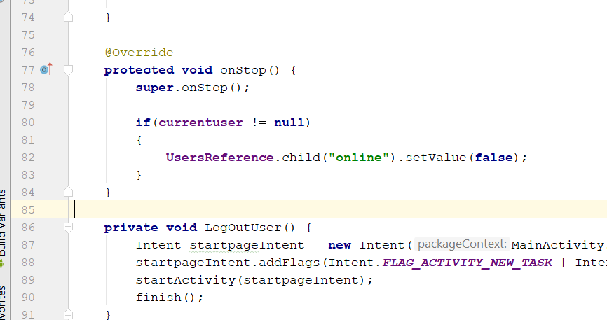
* Change to this
* **super**.onStop();  
    
   **if**(**currentuser** != **null**)  
   {  
   **UsersReference**.child(**"online"**).setValue(ServerValue.***TIMESTAMP***);  
   }  
  }
* 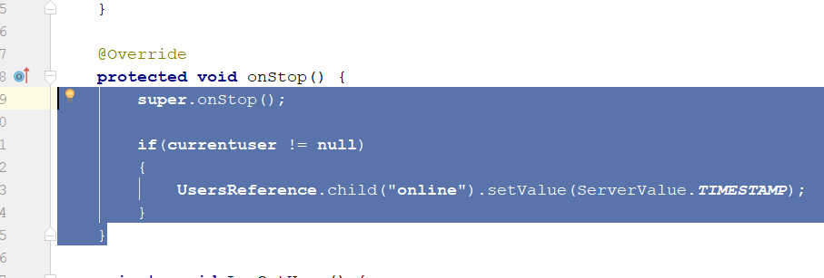
* Now go to myChat_Offline.java
* Go to here
* 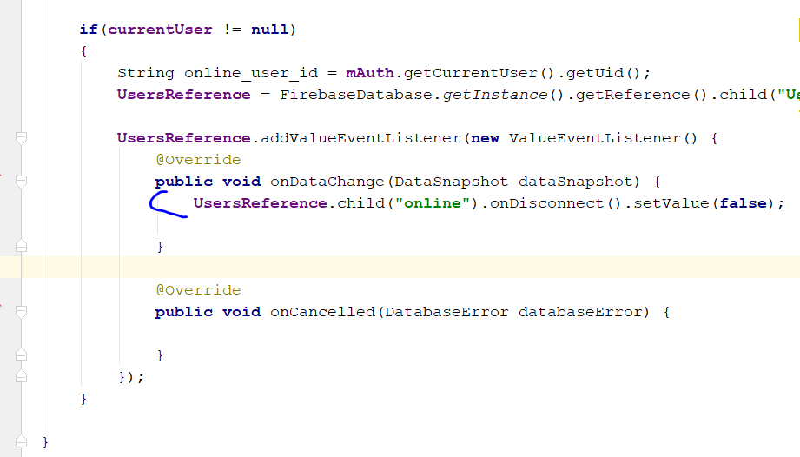
* Change this line to this
* **UsersReference**.child(**"online"**).onDisconnect().setValue(ServerValue.***TIMESTAMP***);
* Now go back to MainActivity.java
* Go to public boolean onOptionsItemSelected(MenuItem item)
* Add this
* 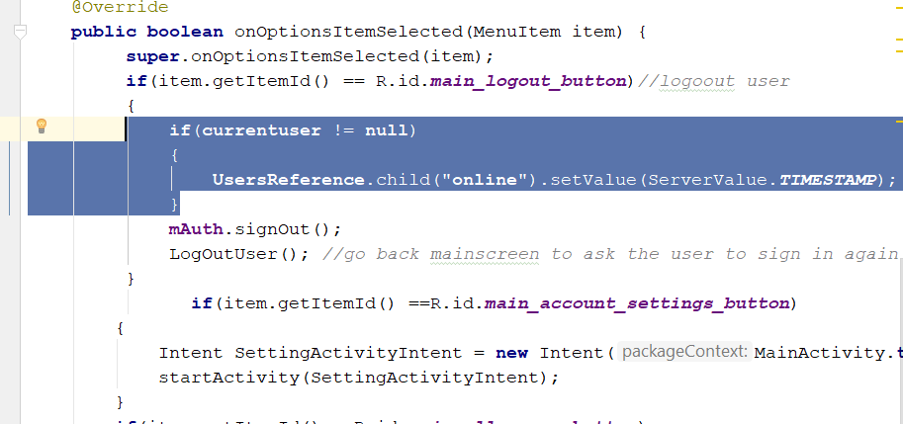
* Now go to the ChatActivity.java
* Declare this
* **private** DatabaseReference **rootRef**;
* rootRef = FirebaseDatabase.*getInstance*().getReference();
* add this
* **rootRef**.child(**"Users"**).child(**messageReceiverId**).addValueEventListener(**new** ValueEventListener() {  
   @Override  
   **public void** onDataChange(DataSnapshot dataSnapshot) {  
   **final** String online = dataSnapshot.child(**"online"**).getValue().toString();  
   **final** String userThumb = dataSnapshot.child(**"user_thumb_image"**).getValue().toString();  
    
   }  
    
   @Override  
   **public void** onCancelled(DatabaseError databaseError) {  
    
   }  
  });
* It should look like this
* 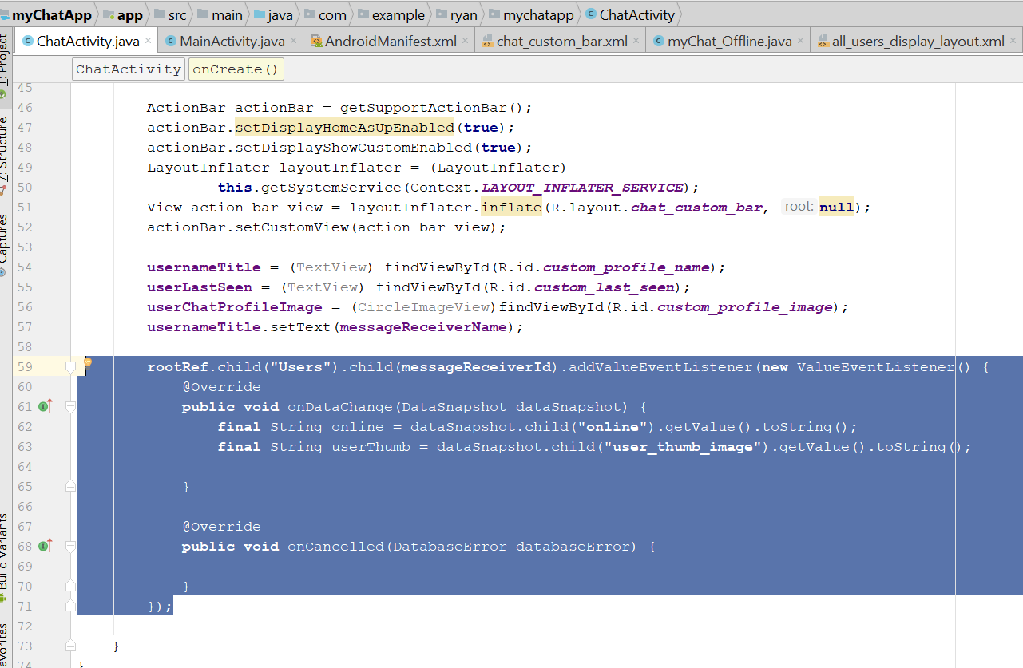
* then go to friendFragment.java
* Copy this code
* 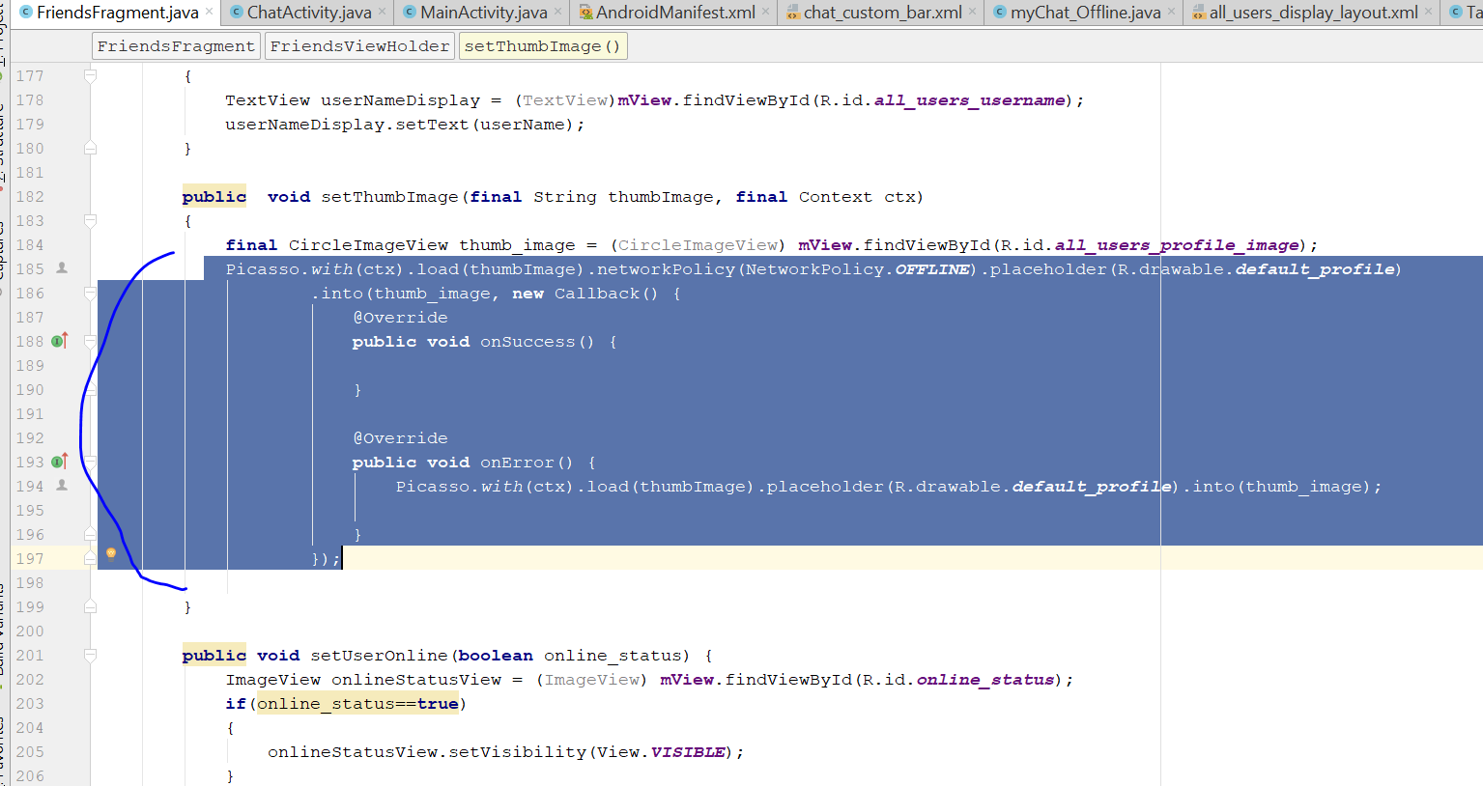
* Go to ChatActivity.java and paste here
* 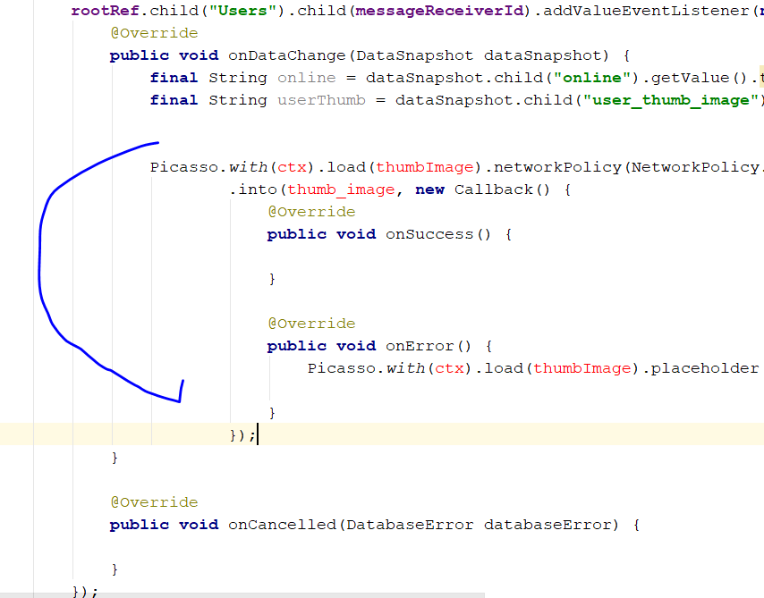
* Change to this
* Picasso.*with*(ChatActivity.**this**).load(userThumb).networkPolicy(NetworkPolicy.***OFFLINE***).placeholder(R.drawable.***default_profile***)  
   .into(**userChatProfileImage**, **new** Callback() {  
   @Override  
   **public void** onSuccess() {  
    
   }  
    
   @Override  
   **public void** onError() {  
   Picasso.*with*(ChatActivity.**this**).load(userThumb).placeholder(R.drawable.***default_profile***).into(**userChatProfileImage**);  
    
   }  
   });
* Go back to FriendsFragment.java
* Go to populateViewHolder
* Change to String
* String online_status = (String)dataSnapshot.child(**"online"**).getValue();
* 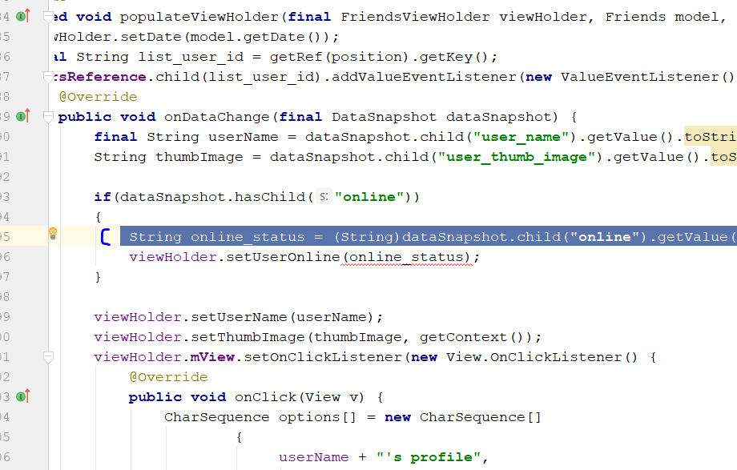
* Change to string
* 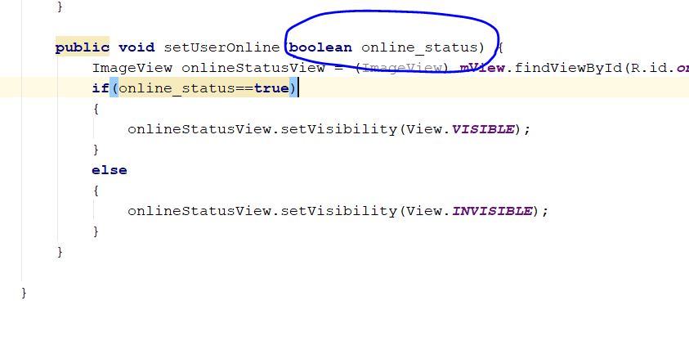
* It will become like this
* **public void** setUserOnline(String online_status) {  
   ImageView onlineStatusView = (ImageView) **mView**.findViewById(R.id.***online_status***);  
   **if**(online_status.equals(**"true"**))  
   {  
   onlineStatusView.setVisibility(View.***VISIBLE***);  
   }  
   **else** {  
   onlineStatusView.setVisibility(View.***INVISIBLE***);  
   }  
  }
* Now proceed to MainActivity.java
* Change this line
* 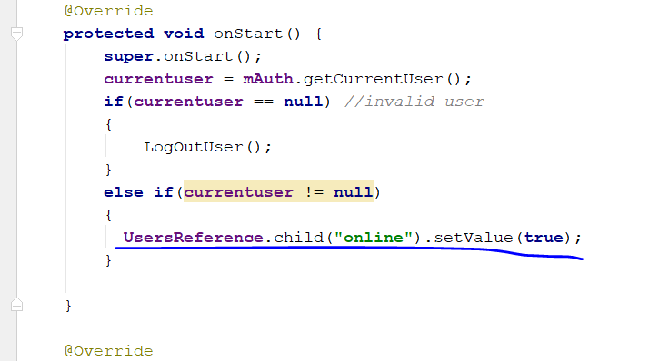
* Change to
* UsersReference.child("online").setValue("true");
* Now go to ChatActvity.java
* Edit to this
* **if**(online.equals(**"true"**))  
  {  
   **userLastSeen**.setText(**"online"**);  
  }  
  **else**{  
   **userLastSeen**.setText(online);  
  }
* 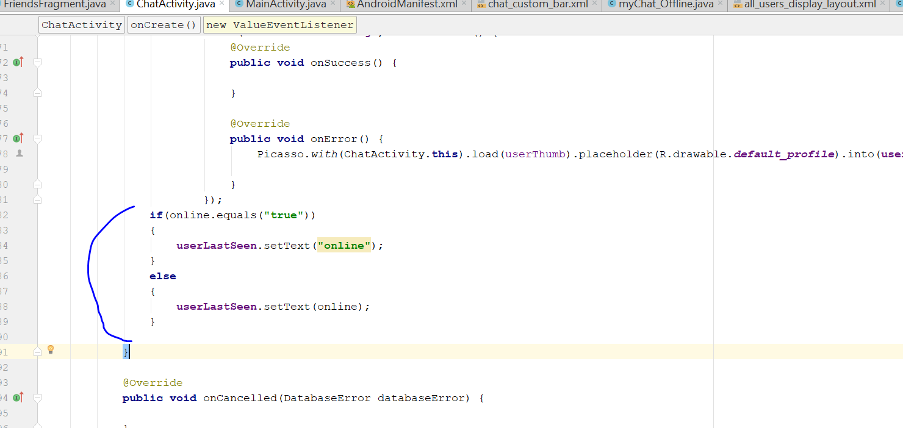
* Now go to friendFragment.java
* 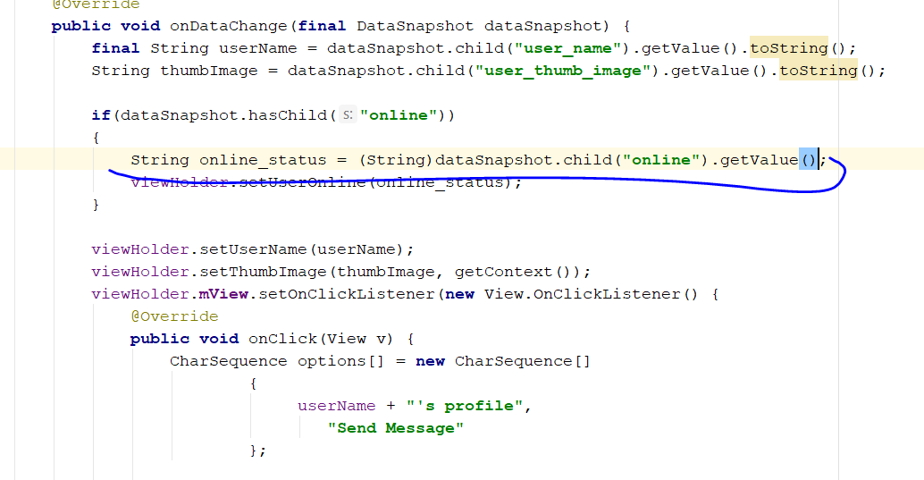
* Change this line to
* String online_status = (String)dataSnapshot.child("online").getValue().toString();
* Now create a new class, name it as LastSeenTime
* 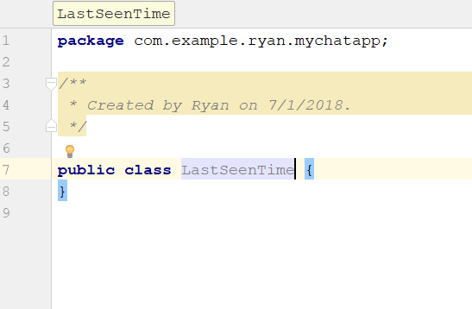
* Go to this URL
* <https://stackoverflow.com/questions/13018550/time-since-ago-library-for-android-java>
* Rmb to extend application
* Copy all the code from the URL and paste it inside the class
* So it now, look like this
* 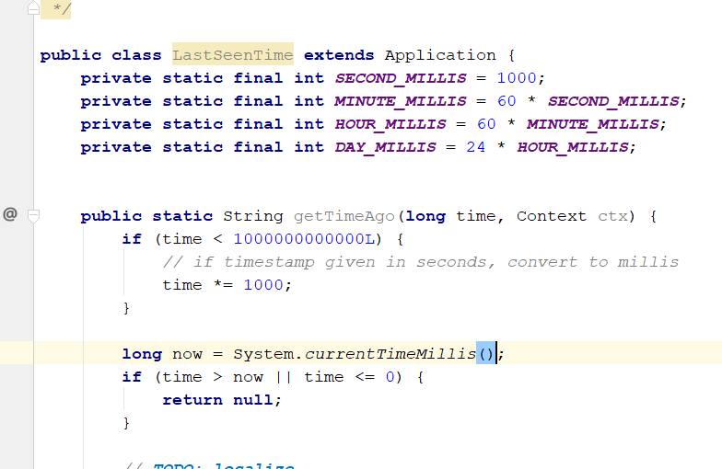
* Change the return of the first line
* **return "Active for a few second"**;
* 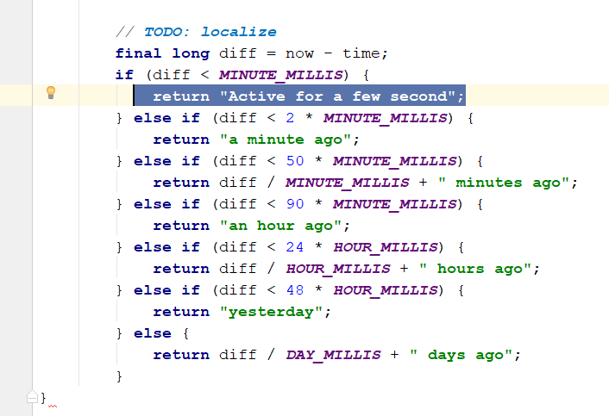
* Now to go to the ChatActivity
* Go to here
* 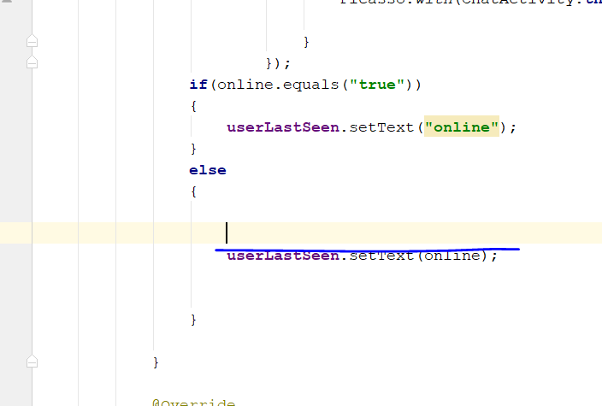
* Add those
* LastSeenTime getTime = **new** LastSeenTime();  
  **long** last_seen = Long.*parseLong*(online);  
  String lastSeenDisplayTime = getTime.*getTimeAgo*(last_seen, getApplicationContext()).toString();  
  **userLastSeen**.setText(lastSeenDisplayTime);
* 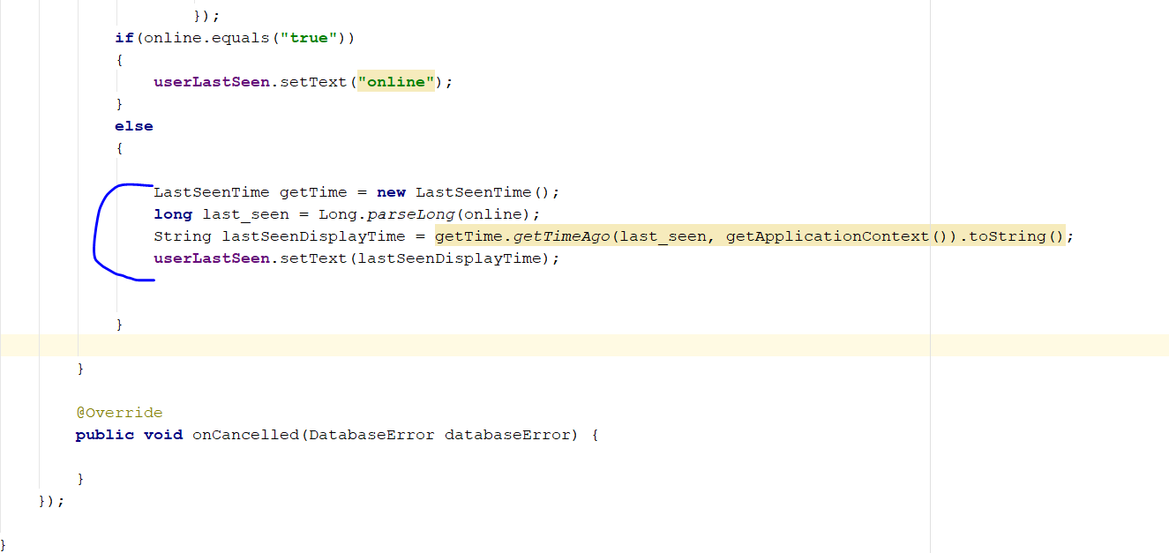
* Now go to FriendsFagment.java
* Copy this
* 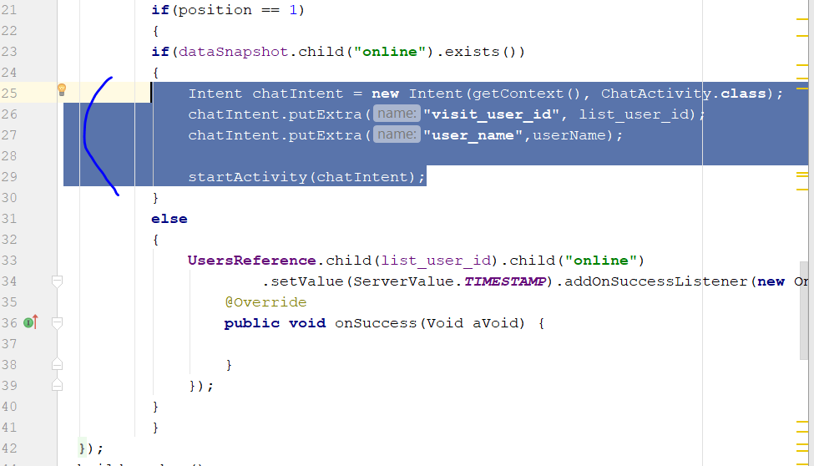
* Paste it in the onSuccess(Void)
* 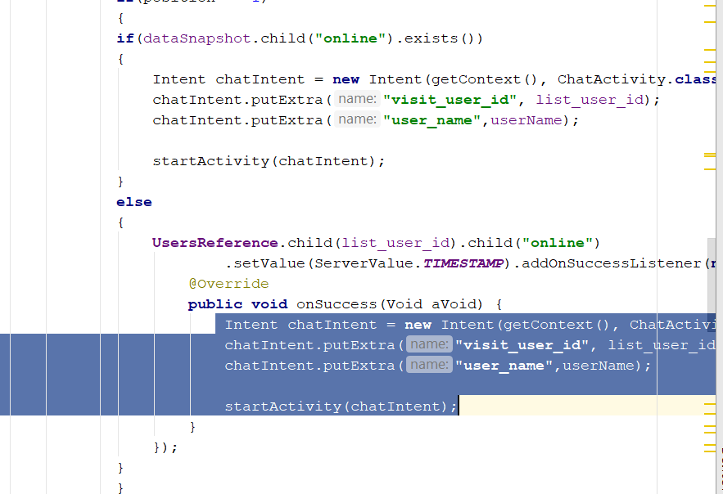
* Clean and rebuild the app
* Rebuild and run, should be able to at least see the online and last active 25 min ago on the chatActivity
* Now go to chatactivity.xml
* Select the send message button
* 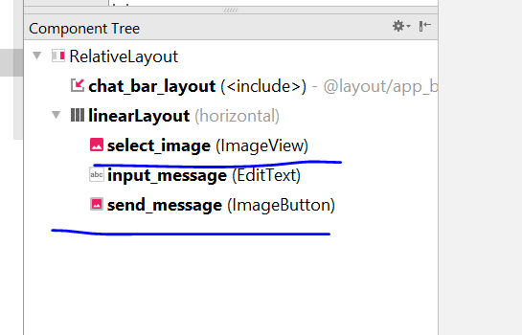
* Change this to image button
* 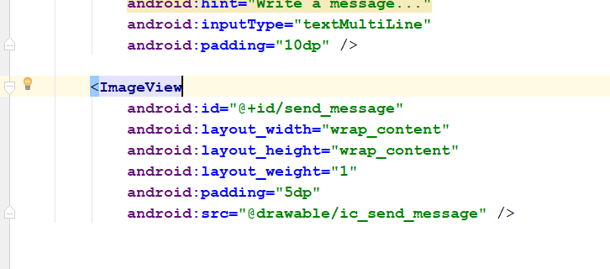
* 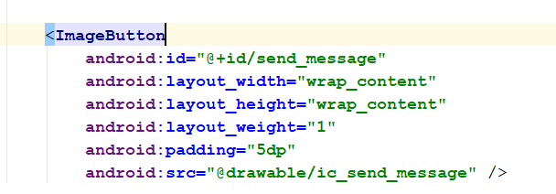
* Go to the ChatActivity.java
* Add this line
* **private** ImageButton **SendMessageButton**;  
  **private** ImageButton **SelectImageButton**;  
  **private** EditText **InputMessageText**;
* 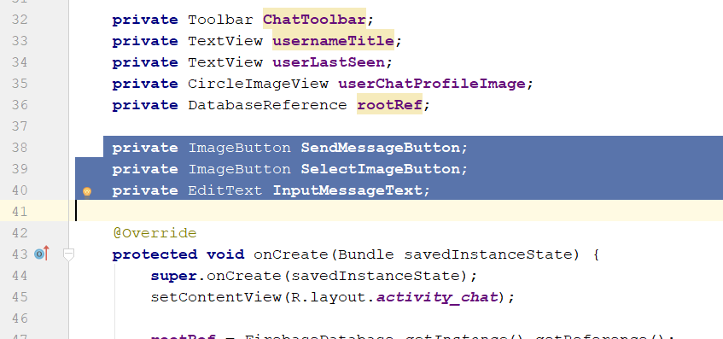
* Then add this line
* **SendMessageButton** = (ImageButton) findViewById(R.id.***send_message***);  
  **SelectImageButton** = (ImageButton) findViewById(R.id.***select_image***);  
  **InputMessageText** = (EditText) findViewById(R.id.***input_message***);
* 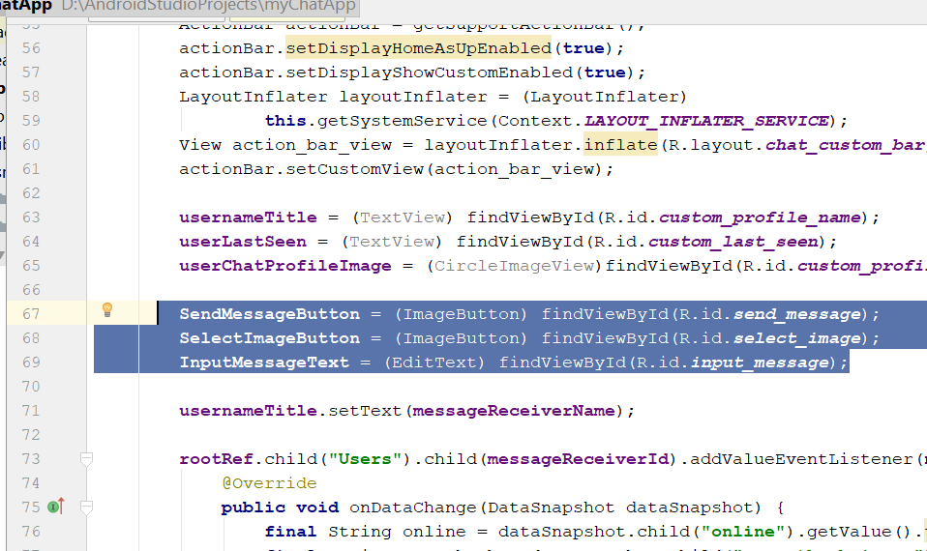
* Now add this line
* **private** FirebaseAuth **mAuth**;  
  **private** String **messageSenderId**;
* then add this
* **mAuth** = FirebaseAuth.*getInstance*();  
  **messageSenderId** = **mAuth**.getCurrentUser().getUid();
* 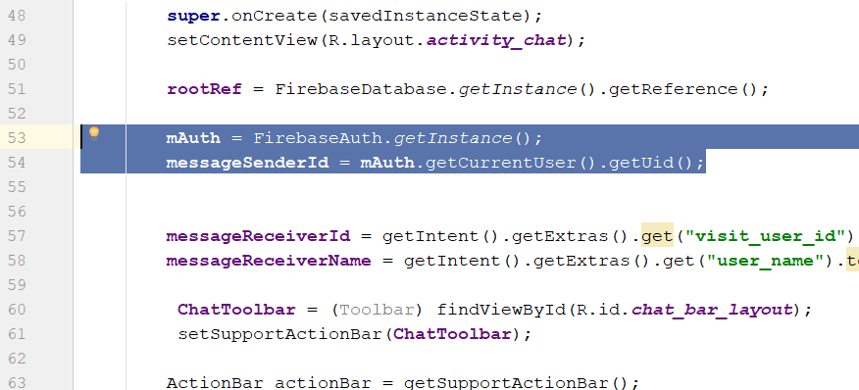
* Add this line
* **SendMessageButton**.setOnClickListener(**new** View.OnClickListener() {  
   @Override  
   **public void** onClick(View v) {  
   SendMessage();  
   }  
   });  
  }  
    
  **private void** SendMessage() {  
   String messageText = **InputMessageText**.getText().toString();  
    
   **if**(TextUtils.*isEmpty*(messageText))  
   {  
   Toast.*makeText*(ChatActivity.**this**, **"Please write the message"**, Toast.***LENGTH_SHORT***).show();  
   }  
   **else** {  
    
   }  
  }
* 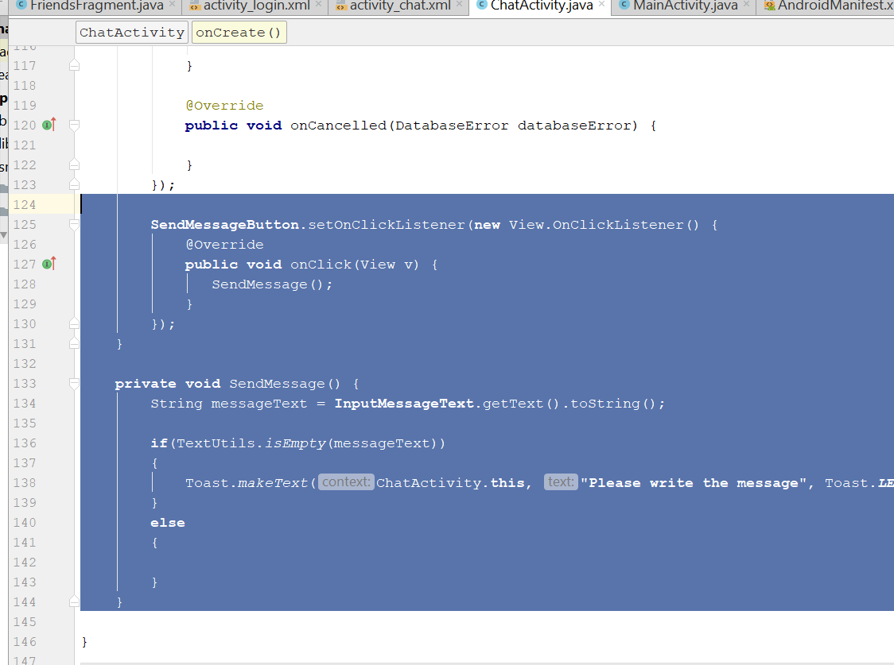
* For sendMessage Method, add all this
* **private void** SendMessage() {  
   String messageText = **InputMessageText**.getText().toString();  
    
   **if**(TextUtils.*isEmpty*(messageText))  
   {  
   Toast.*makeText*(ChatActivity.**this**, **"Please write the message"**, Toast.***LENGTH_SHORT***).show();  
   }  
   **else** {  
   DatabaseReference user_message_key = **rootRef**.child(**"Messages"**).child(**messageSenderId**)  
   .child(**messageReceiverId**).push();  
   String message_push_id = user_message_key.getKey();  
    
   String message_sender_ref = **"Messages/"** + **messageSenderId** + **"/"** + **messageReceiverId**;  
   String message_receiver_ref = **"Messages/"** + **messageReceiverId** + **"/"** + **messageSenderId**;  
    
   Map messageTextBody = **new** HashMap();  
   messageTextBody.put(**"message"**, messageText);  
   messageTextBody.put(**"type"**,**"text"**);  
   messageTextBody.put(**"time"**, ServerValue.***TIMESTAMP***);  
    
   Map messageBodyDetails = **new** HashMap();  
   messageBodyDetails.put(message_sender_ref+**"/"**+ message_push_id,messageTextBody);  
   messageBodyDetails.put(message_receiver_ref+**"/"**+ message_push_id,messageTextBody);  
   **rootRef**.updateChildren(messageBodyDetails, **new** DatabaseReference.CompletionListener() {  
   @Override  
   **public void** onComplete(DatabaseError databaseError, DatabaseReference databaseReference) {  
   **if** (databaseError != **null**)  
   {  
   Log.*d*(**"chat_log"**, databaseError.getMessage().toString());  
   }  
    
   **InputMessageText**.setText(**""**);  
   }  
   });  
   }  
  }
* 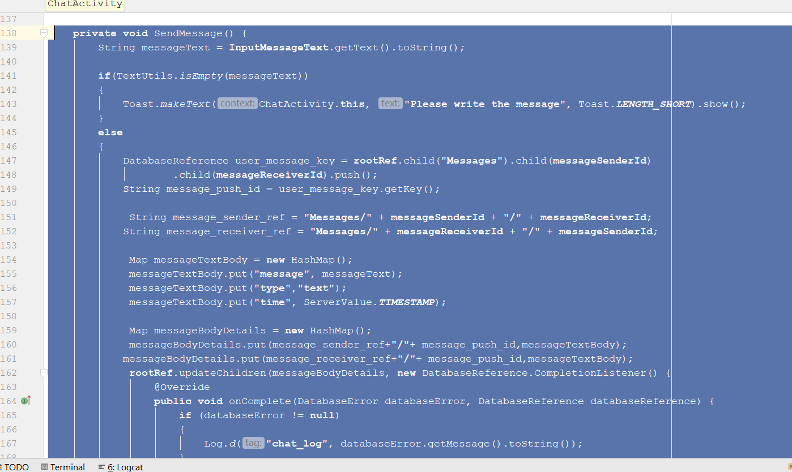
* Rebuild and Run
* Send a message, the message should be in the firebase database
* 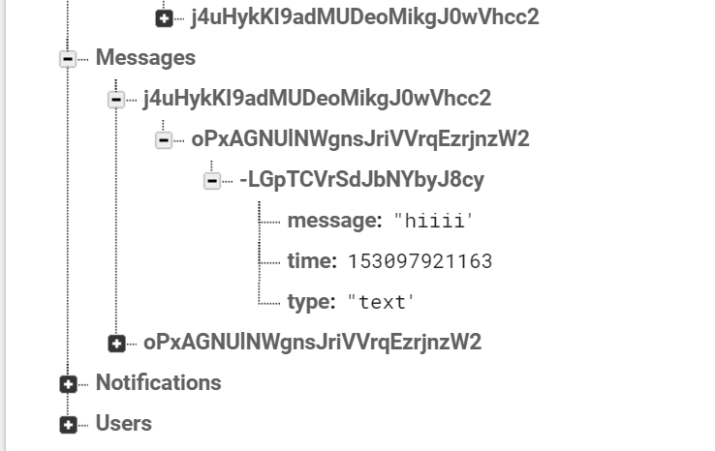

# Step 29: Chat Messages

* Go to activity_chat.xml
* Add the recycle view
* Add this line
* <**android.support.v7.widget.RecyclerView  
   android:id="@+id/messages_list_of_users"  
   android:layout_width="match_parent"  
   android:layout_height="match_parent"**>
* 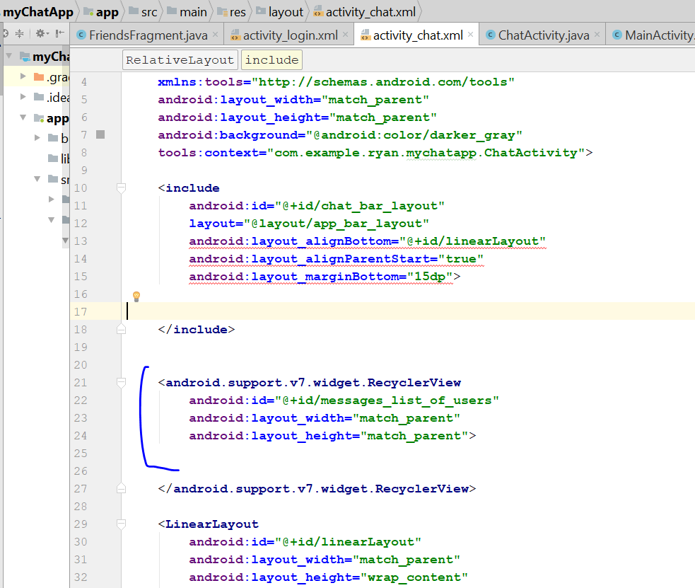
* Now to go ChatActivity.java
* Add this
* **private** RecyclerView **userMessagesList**;
* then add this
* userMessagesList = (RecyclerView) findViewById(R.id.messages_list_of_users);
* now create a new resource file
* slight adjust the RecycleView and shift it below
* 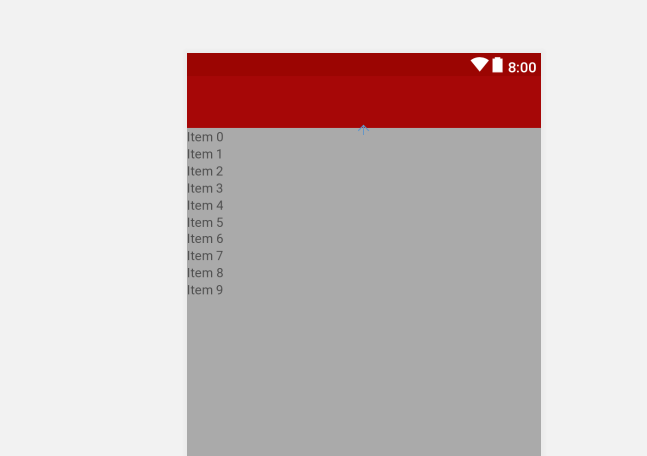
* right click on layout folder, select new layout resource file
* you will see this
* 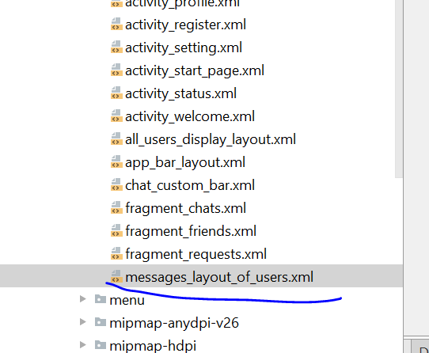
* Change to relative layout
* Add some texttview and circle view
* <**de.hdodenhof.circleimageview.CircleImageView  
   android:layout_width="60dp"  
   android:layout_height="60dp"  
   android:src="@drawable/default_profile"  
   android:id="@+id/circleImageView"** />  
    
  <**TextView  
   android:id="@+id/textView"  
   android:layout_width="wrap_content"  
   android:layout_height="wrap_content"  
   android:layout_alignParentTop="true"  
   android:layout_marginStart="35dp"  
   android:layout_marginTop="19dp"  
   android:layout_toEndOf="@+id/circleImageView"  
   android:text="TextView"** />
* Look like this
* 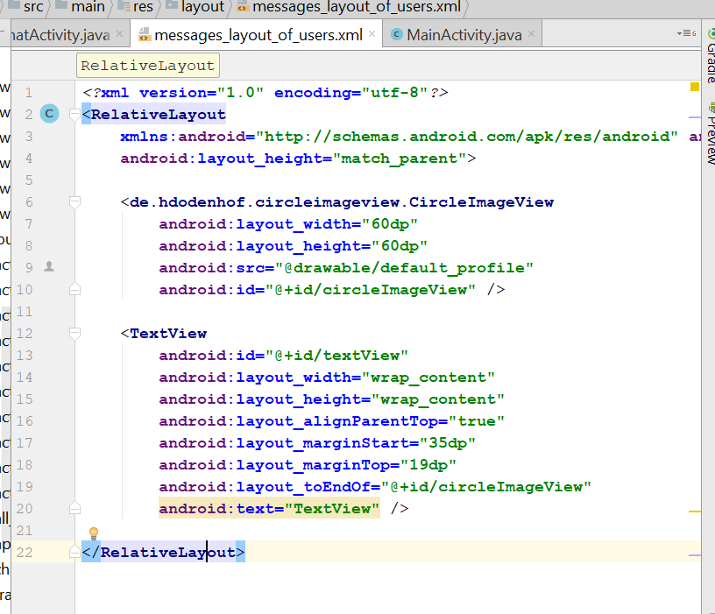
* Change the name of the circleview id to “message_profile_images”
* 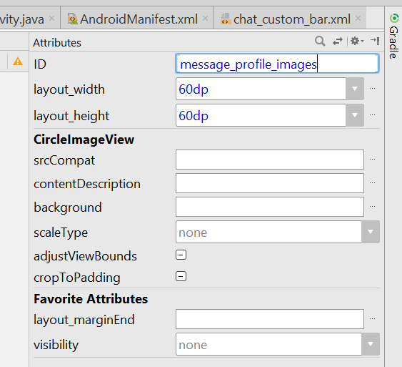
* Now change the textview id to “message_text”
* 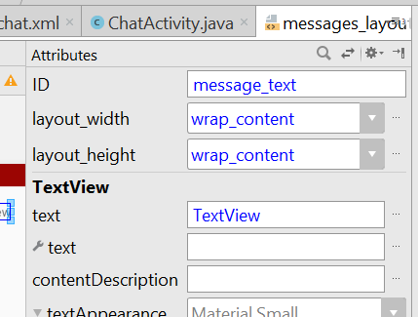
* Now create new drawable Resource file
* Right click drawable folder
* Create new drawable layout, and name it as “message_text_background”
* Change the layout to shape
* *<?***xml version="1.0" encoding="utf-8"***?>*<**shape xmlns:android="http://schemas.android.com/apk/res/android"**>  
    
   <**solid android:color="@color/colorPrimary"**>  
    
   </**solid**>  
   <**corners android:radius="15dp"**></**corners**>  
  </**shape**>
* It should look like this
* Now go to messages_layout_of_user.xml
* Add this line
* android:background="@drawable/message_text_background"
* 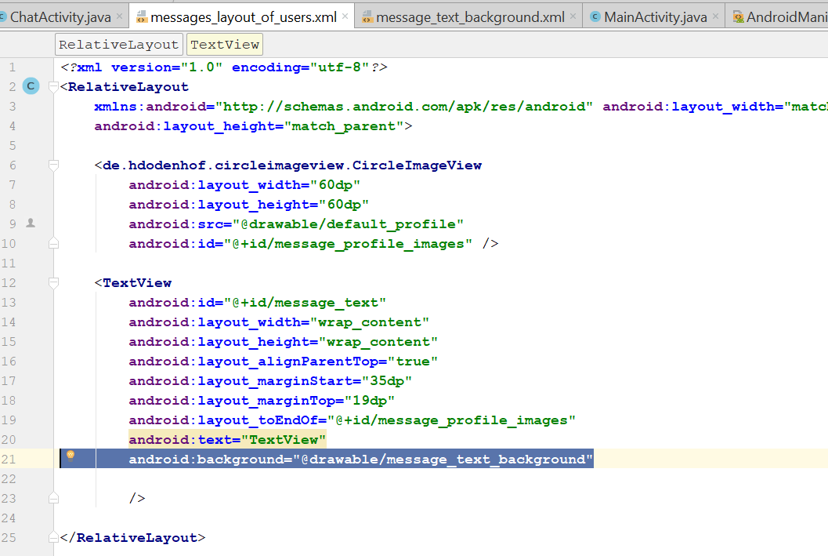
* You will get something like this
* 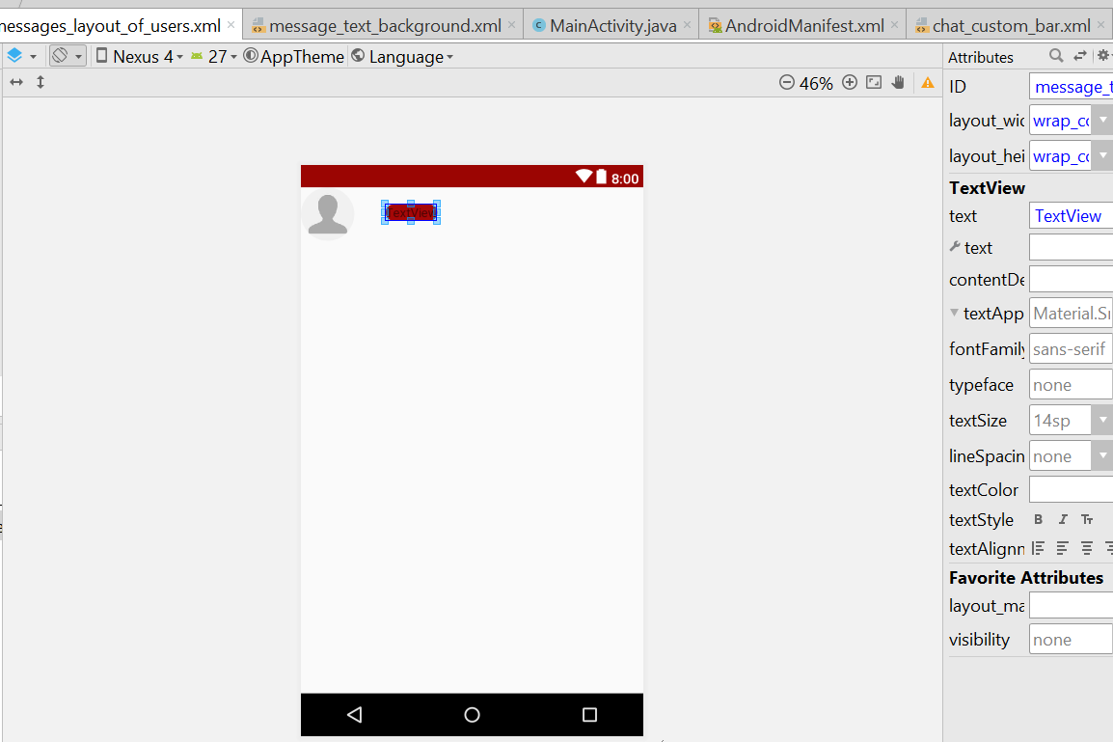
* Change the textcolour of the textview
* 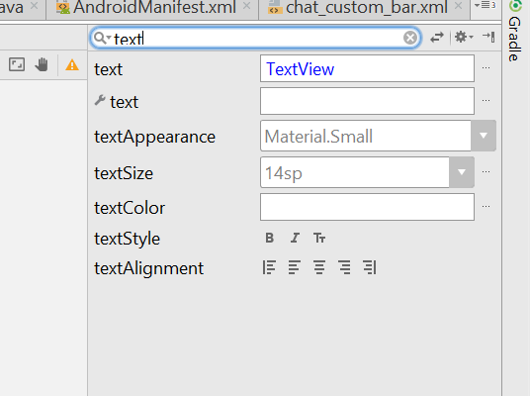
* Change to background light for textColor
* Now it look like this
* 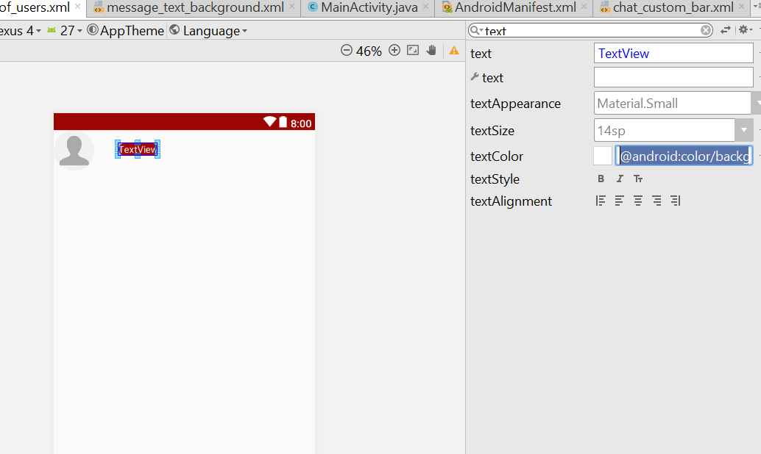
* Change the padding to 20dp and the textstyle to bold
* 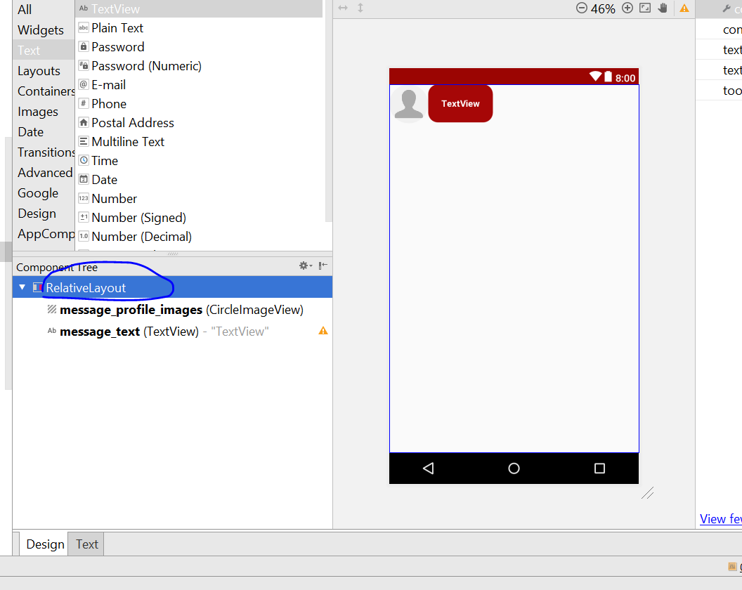
* Click on relative layout
* Padding change to 5dp
* Change the layout height to wrap content
* 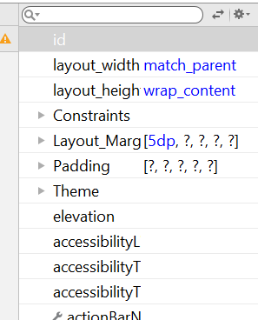
* Now create a new Java class, call “Messages”
* This class look like this
* **package** com.example.ryan.mychatapp;  
    
  */**  
   * Created by Ryan on 7/14/2018.  
   */***public class** Messages {  
   **private** String **message**, **type**;  
   **private long time**;  
   **private boolean seen**;  
   **private** String **from**;  
    
   **public** Messages(String message, String type, **long** time, **boolean** seen, String from) {  
   **this**.**message** = message;  
   **this**.**type** = type;  
   **this**.**time** = time;  
   **this**.**seen** = seen;  
   **this**.**from** = from;  
   }  
    
   **public** String getFrom() {  
   **return from**;  
   }  
    
   **public void** setFrom(String from) {  
   **this**.**from** = from;  
   }  
    
   **public** String getMessage() {  
   **return message**;  
   }  
    
   **public void** setMessage(String message) {  
   **this**.**message** = message;  
   }  
    
   **public** String getType() {  
   **return type**;  
   }  
    
   **public void** setType(String type) {  
   **this**.**type** = type;  
   }  
    
    
    
   **public long** getTime() {  
    
   **return time**;  
   }  
    
   **public void** setTime(**long** time) {  
   **this**.**time** = time;  
   }  
    
   **public boolean** isSeen() {  
   **return seen**;  
   }  
    
   **public void** setSeen(**boolean** seen) {  
   **this**.**seen** = seen;  
   }  
    
   **public** Messages()  
    
   {  
    
   }  
  }
* now create new Java class , call it MessageAdapter
* it should look like this
* **import** android.support.annotation.NonNull;  
  **import** android.support.v7.widget.RecyclerView;  
  **import** android.view.LayoutInflater;  
  **import** android.view.View;  
  **import** android.view.ViewGroup;  
  **import** android.widget.TextView;  
    
  **import** com.example.ryan.mychatapp.Messages;  
  **import** com.example.ryan.mychatapp.R;  
    
  **import** java.util.List;  
    
  **import** de.hdodenhof.circleimageview.CircleImageView;  
    
  */**  
   * Created by Ryan on 7/14/2018.  
   */***public class** MessageAdapter **extends** RecyclerView.Adapter<MessageAdapter.MessageViewHolder> {  
    
   **private** List<Messages> **userMessageList**;  
    
   **public** MessageAdapter(List<Messages> userMessageList)  
   {  
   **this**.**userMessageList** = userMessageList;  
   }  
    
   @NonNull  
   @Override  
   **public** MessageViewHolder onCreateViewHolder(@NonNull ViewGroup parent, **int** viewType) {  
    
   View v = LayoutInflater.*from*(parent.getContext())  
   .inflate(R.layout.***messages_layout_of_users***,parent,**false**);  
   **return new** MessageViewHolder(v);  
   }  
    
   @Override  
   **public void** onBindViewHolder(@NonNull MessageViewHolder holder, **int** position) {  
   Messages messages = **userMessageList**.get(position);

holder.**messageText**.setText(messages.getMessage());

}  
  
 @Override  
 **public int** getItemCount() {  
 **return userMessageList**.size();  
 }  
  
 **public class** MessageViewHolder **extends** RecyclerView.ViewHolder  
 {  
 **public** TextView **messageText**;  
 **public** CircleImageView **userProfileImage**;  
 **public** MessageViewHolder(View view)  
 {  
 **super**(view);  
 **messageText** = (TextView)view.findViewById(R.id.***message_text***);  
 }  
  
 }  
}

* Now go to chatActivity.java
* Add this
* Add this on top
* **private final** List<Messages> **messagesList** = **new** ArrayList<>();  
    
  **private** LinearLayoutManager **linearLayoutManager**;  
  **private** MessageAdapter **messageAdapter**;
* 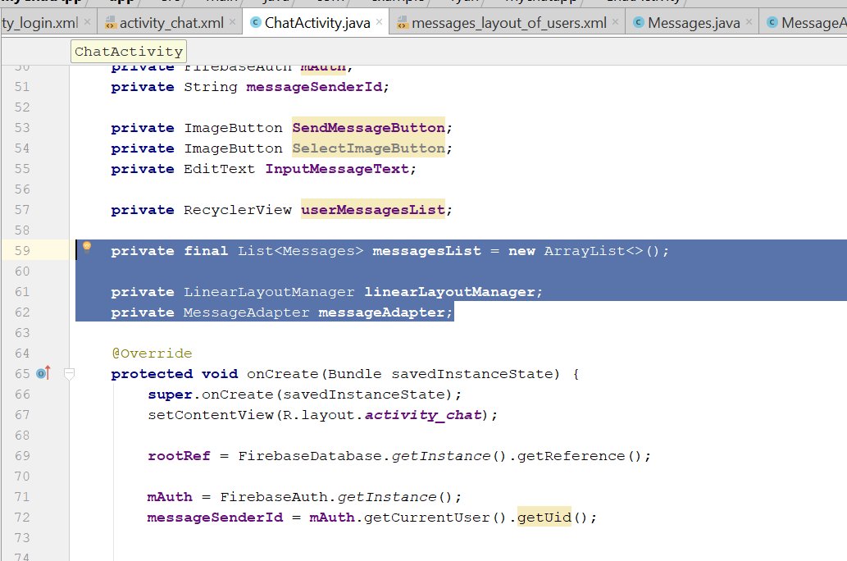
* Then add this below
* **userMessagesList** = (RecyclerView) findViewById(R.id.***messages_list_of_users***);  
    
  **linearLayoutManager** = **new** LinearLayoutManager(**this**);  
    
  **userMessagesList**.setHasFixedSize(**true**);  
  **userMessagesList**.setLayoutManager(**linearLayoutManager**);  
  **userMessagesList**.setAdapter(**messageAdapter**);  
  **usernameTitle**.setText(**messageReceiverName**);  
  FetchMessages();
* 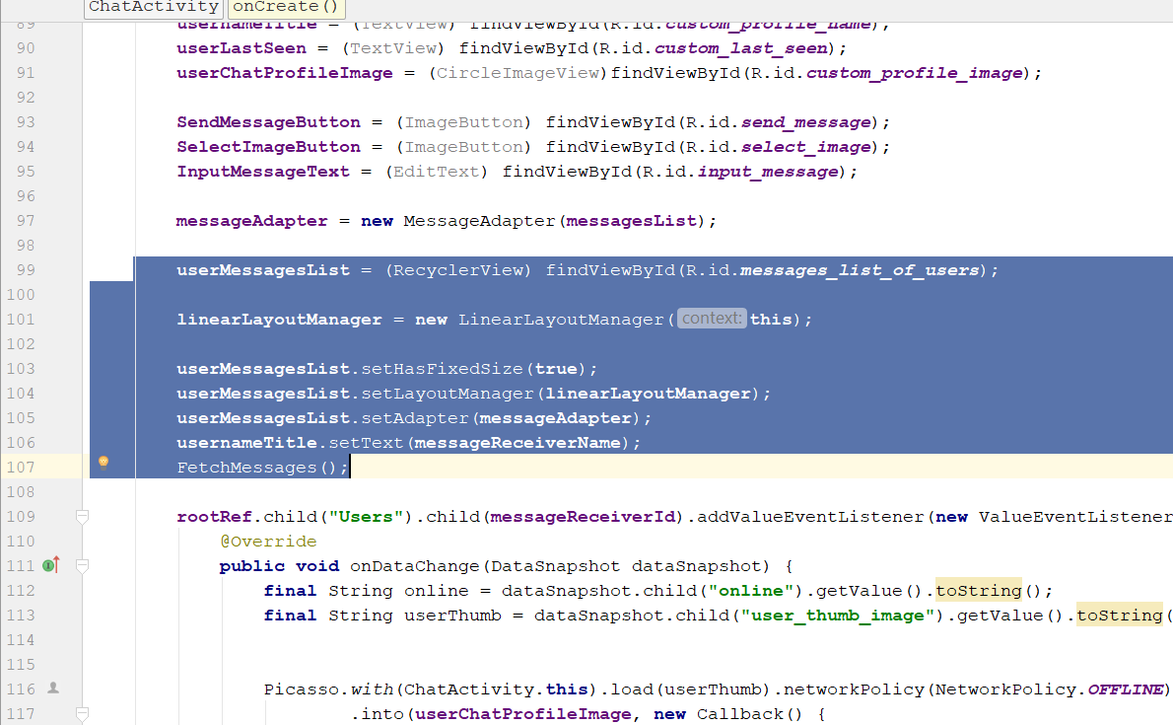
* Then add this
* **private void** FetchMessages() {  
   **rootRef**.child(**"Messages"**).child(**messageSenderId**).child(**messageReceiverId**)  
   .addChildEventListener(**new** ChildEventListener() {  
   @Override  
   **public void** onChildAdded(DataSnapshot dataSnapshot, String s) {  
   Messages messages = dataSnapshot.getValue(Messages.**class**);  
   **messagesList**.add(messages);  
   **messageAdapter**.notifyDataSetChanged();  
   }  
    
   @Override  
   **public void** onChildChanged(DataSnapshot dataSnapshot, String s) {  
    
   }  
    
   @Override  
   **public void** onChildRemoved(DataSnapshot dataSnapshot) {  
    
   }  
    
   @Override  
   **public void** onChildMoved(DataSnapshot dataSnapshot, String s) {  
    
   }  
    
   @Override  
   **public void** onCancelled(DatabaseError databaseError) {  
    
   }  
   });  
  }
* rebuild and run
* you should see your speech bubble
* Now go to messages_layout_of_user.xml
* Change the speech bubble text width to match parent
* 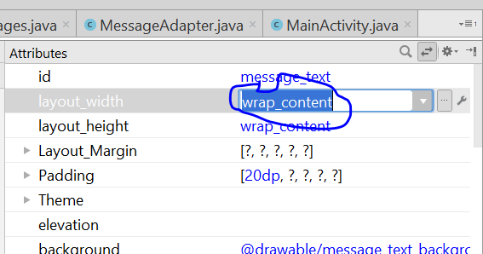
* 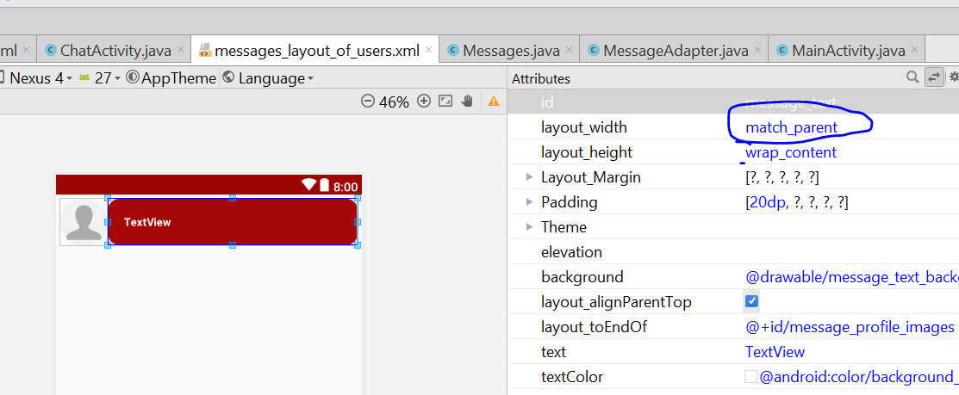
* Now go to messageadapter .java
* Go to public class MessageViewHolder
* Make sure it look like that
* {  
   **public** TextView **messageText**;  
   **public** CircleImageView **userProfileImage**;  
   **public** MessageViewHolder(View view)  
   {  
   **super**(view);  
   **messageText** = (TextView)view.findViewById(R.id.***message_text***);  
    
    
   }  
    
  }
* Now go to drawable folder, right click create a new layout resource file
* Name it as message_text_background_two.xml
* Change the layout to **shape**
* 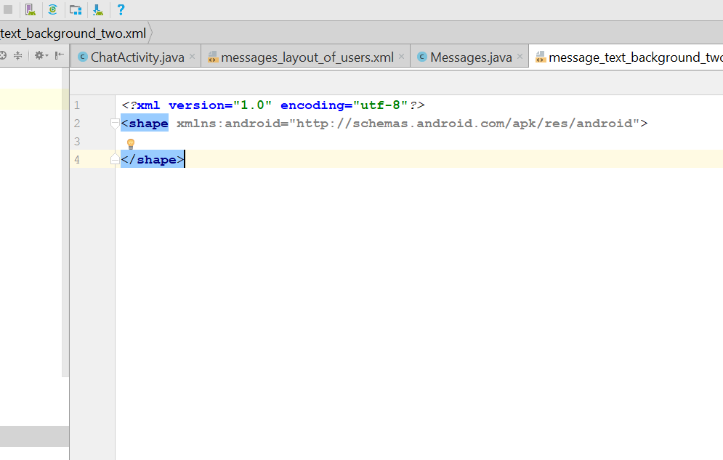
* Now to go color.xml
* You will see this
* 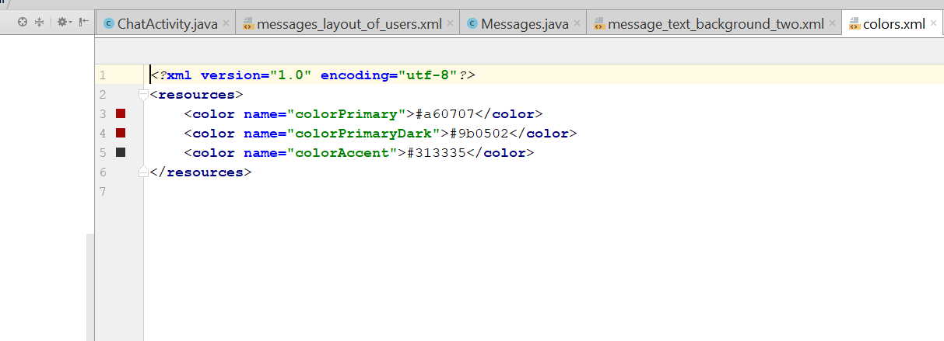
* Add this
* <**color name="colorMessage"**>#4ae864</**color**>
* 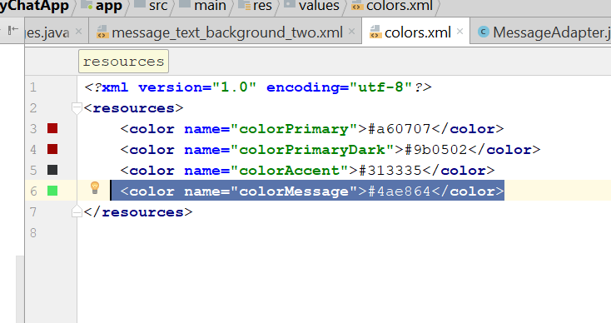
* Back to message_text_background_two.xml
* Add this
* <**solid android:color="@color/colorMessage"**></**solid**>  
  <**corners android:radius="15dp"**></**corners**>
* Now should look like this
* 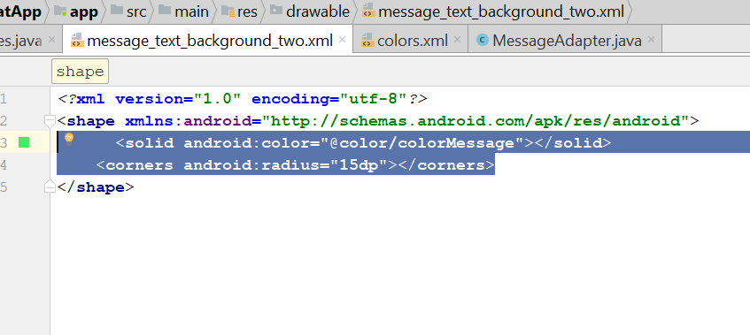
* Now go to MessageAdapter.java, add this
* **private** FirebaseAuth **mAuth**;
* add this line on the OnBindViewHolder()
* **mAuth** = FirebaseAuth.*getInstance*();
* 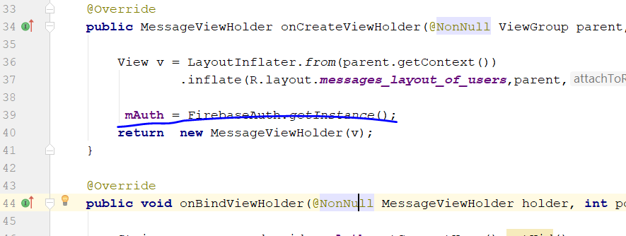
* one bindViewMethod, should look like this
* **public void** onBindViewHolder(@NonNull MessageViewHolder holder, **int** position) {  
    
   String message_sender_id = **mAuth**.getCurrentUser().getUid();  
   Messages messages = **userMessageList**.get(position);  
    
   String fromUserId = messages.getFrom();  
   **if**(fromUserId.equals(message_sender_id))  
   {  
   holder.**messageText**.setBackgroundResource(R.drawable.***message_text_background_two***);  
   holder.**messageText**.setTextColor(Color.***BLACK***);  
   holder.**messageText**.setGravity(Gravity.***RIGHT***);  
   }  
   **else** {  
   holder.**messageText**.setBackgroundResource(R.drawable.***message_text_background***);  
   holder.**messageText**.setTextColor(Color.***WHITE***);  
   holder.**messageText**.setGravity(Gravity.***LEFT***);  
   }  
    
   holder.**messageText**.setText(messages.getMessage());  
  }
* 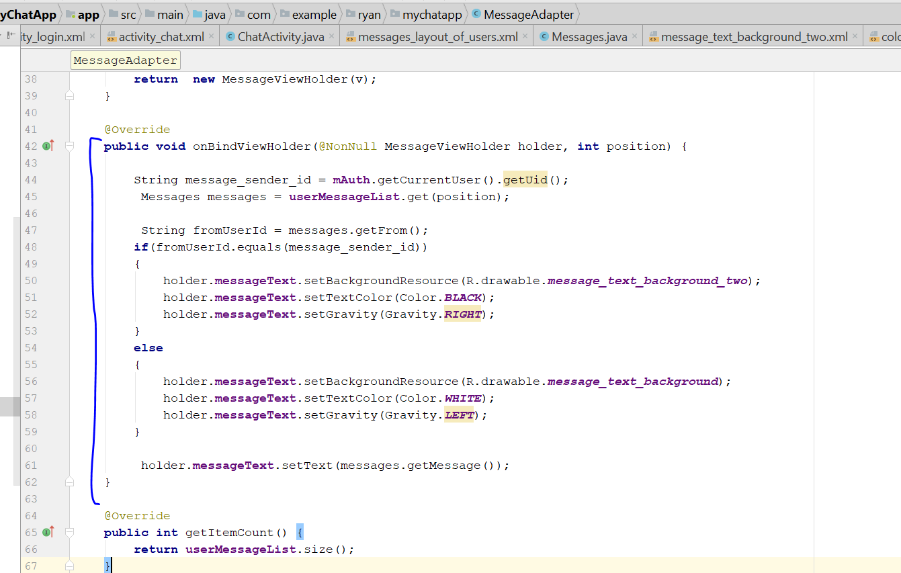
* Go to ChatActivity.java, then go sendMessage()
* Edit to this
* messageTextBody.put(**"message"**, messageText);  
  messageTextBody.put(**"seen"**,**false**);  
  messageTextBody.put(**"type"**,**"text"**);  
  messageTextBody.put(**"time"**, ServerValue.***TIMESTAMP***);  
  messageTextBody.put(**"from"**, **messageSenderId**);
* 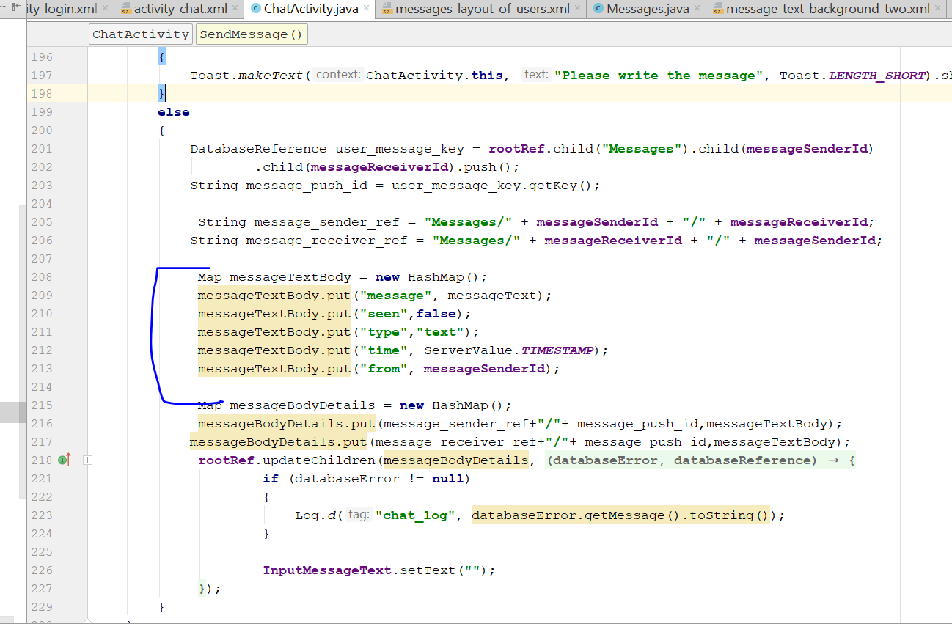
* Rebuild and run
* Now go to fragments_chat.xml
* 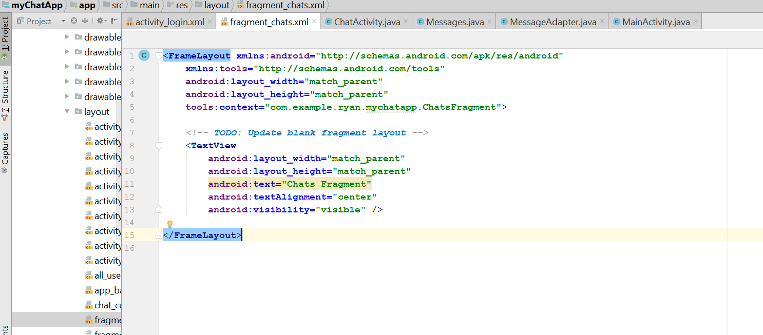
* Remove the de
* 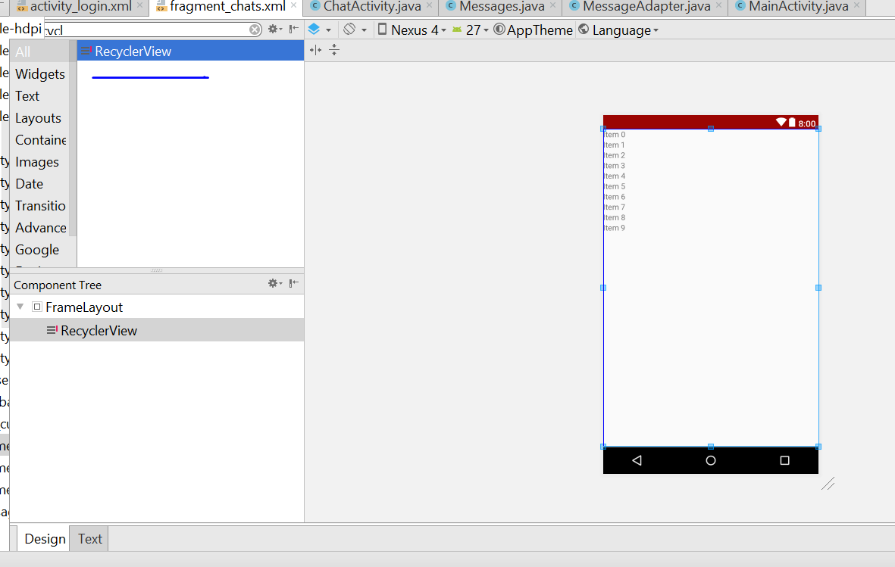
* Then change the layout from frame layout to relative layout
* It will look like this
* 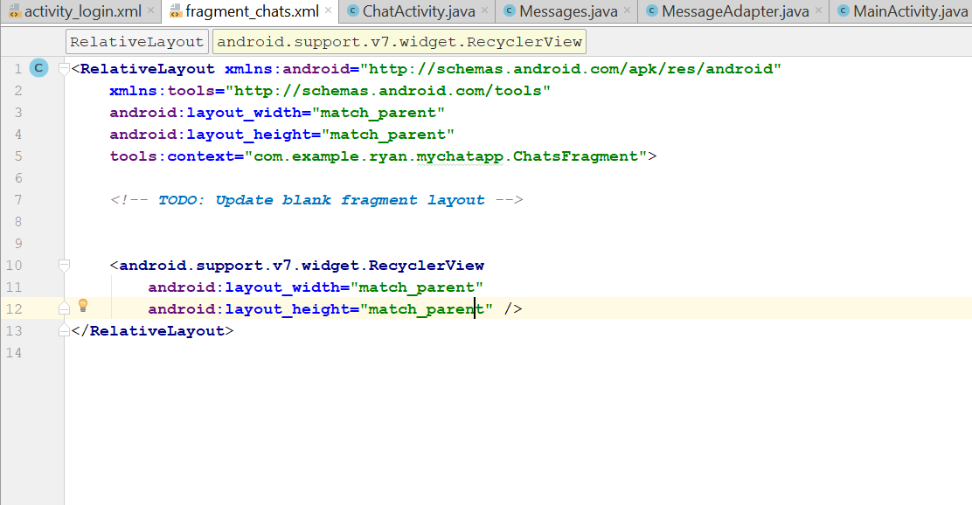
* Name the recycleview id to chats_list
* Create a new Java class, call Chats.java
* It should look like that
* **public class** Chats {  
   **private** String **user_status**;  
   **public** Chats()  
   {  
    
   }  
    
   **public** Chats(String user_status) {  
   **this**.**user_status** = user_status;  
   }  
    
   **public** String getUser_status() {  
   **return user_status**;  
   }  
    
   **public void** setUser_status(String user_status) {  
   **this**.**user_status** = user_status;  
   }  
  }
* Now go to ChatsFragment.java
* Add this
* **private** View **myMainView**;
* **private** RecyclerView **myChatsList**;
* and this
* **myMainView** = inflater.inflate(R.layout.***fragment_chats***,container,**false**);
* in the onCreateView
* Your onCreateMethod should look like this
* **public** View onCreateView(LayoutInflater inflater, ViewGroup container,  
   Bundle savedInstanceState) {  
    
   **myMainView** = inflater.inflate(R.layout.***fragment_chats***,container,**false**);  
   **myChatsList** = (RecyclerView)**myMainView**.findViewById(R.id.***chats_list***);  
    
   **mAuth** = FirebaseAuth.*getInstance*();  
   **online_user_id** = **mAuth**.getCurrentUser().getUid();  
    
   **FriendReference** = FirebaseDatabase.*getInstance*().getReference().child(**"Friends"**).child(**online_user_id**);  
   **UsersReference** = FirebaseDatabase.*getInstance*().getReference().child(**"Users"**);  
   **myChatsList**.setHasFixedSize(**true**);  
   LinearLayoutManager linearLayoutManager = **new** LinearLayoutManager(getContext());  
   linearLayoutManager.setReverseLayout(**true**);  
   linearLayoutManager.setStackFromEnd(**true**);  
    
   **myChatsList**.setLayoutManager(linearLayoutManager);  
    
    
   *// Inflate the layout for this fragment  
   //return inflater.inflate(R.layout.fragment_chats, container, false);* **return myMainView**;  
  }
* 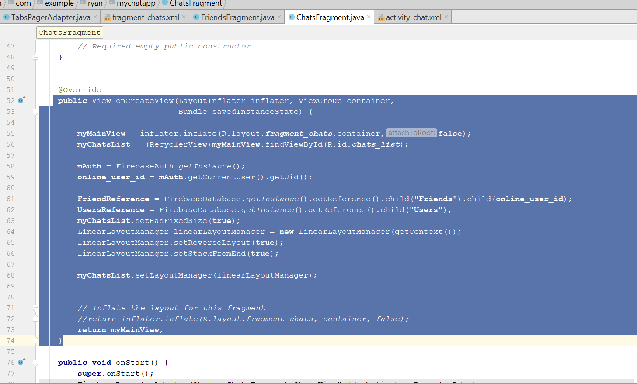
* add this
* **public void** onStart() {  
   **super**.onStart();  
   FirebaseRecyclerAdapter<Chats, ChatsFragment.ChatsViewHolder> firebaseRecyclerAdapter  
   = **new** FirebaseRecyclerAdapter<Chats, ChatsFragment.ChatsViewHolder>(  
   Chats.**class**,  
   R.layout.***all_users_display_layout***,  
   ChatsFragment.ChatsViewHolder.**class**,  
   **FriendReference** ) {  
   @Override  
   **protected void** populateViewHolder(**final** ChatsFragment.ChatsViewHolder viewHolder, Chats model, **int** position) {  
    
   **final** String list_user_id = getRef(position).getKey();  
   **UsersReference**.child(list_user_id).addValueEventListener(**new** ValueEventListener() {  
   @Override  
   **public void** onDataChange(**final** DataSnapshot dataSnapshot) {  
   **final** String userName = dataSnapshot.child(**"user_name"**).getValue().toString();  
   String thumbImage = dataSnapshot.child(**"user_thumb_image"**).getValue().toString();  
   String userStatus = dataSnapshot.child(**"user_status"**).getValue().toString();  
   **if**(dataSnapshot.hasChild(**"online"**))  
   {  
   String online_status = (String)dataSnapshot.child(**"online"**).getValue().toString();  
   viewHolder.setUserOnline(online_status);  
   }  
    
   viewHolder.setUserName(userName);  
   viewHolder.setThumbImage(thumbImage, getContext());  
   viewHolder.setUserStatus(userStatus);  
    
   viewHolder.**mView**.setOnClickListener(**new** View.OnClickListener() {  
   @Override  
   **public void** onClick(View v) {  
   **if**(dataSnapshot.child(**"online"**).exists())  
   {  
   Intent chatIntent = **new** Intent(getContext(), ChatActivity.**class**);  
   chatIntent.putExtra(**"visit_user_id"**, list_user_id);  
   chatIntent.putExtra(**"user_name"**,userName);  
    
   startActivity(chatIntent);  
   }  
   **else** {  
   **UsersReference**.child(list_user_id).child(**"online"**)  
   .setValue(ServerValue.***TIMESTAMP***).addOnSuccessListener(**new** OnSuccessListener<Void>() {  
   @Override  
   **public void** onSuccess(Void aVoid) {  
   Intent chatIntent = **new** Intent(getContext(), ChatActivity.**class**);  
   chatIntent.putExtra(**"visit_user_id"**, list_user_id);  
   chatIntent.putExtra(**"user_name"**,userName);  
    
   startActivity(chatIntent);  
   }  
   });  
   }  
   }  
   });  
    
   }  
    
   @Override  
   **public void** onCancelled(DatabaseError databaseError) {  
    
   }  
   });  
    
    
   }  
   };  
   **myChatsList**.setAdapter(firebaseRecyclerAdapter);  
    
  }  
    
  **public static class** ChatsViewHolder **extends** RecyclerView.ViewHolder  
  {  
   View **mView**;  
   **public** ChatsViewHolder(View itemView) {  
   **super**(itemView);  
   **mView** = itemView;  
    
   }  
   **public void** setUserName(String userName)  
   {  
   TextView userNameDisplay = (TextView)**mView**.findViewById(R.id.***all_users_username***);  
   userNameDisplay.setText(userName);  
   }  
    
   **public void** setThumbImage(**final** String thumbImage, **final** Context ctx)  
   {  
   **final** CircleImageView thumb_image = (CircleImageView) **mView**.findViewById(R.id.***all_users_profile_image***);  
   Picasso.*with*(ctx).load(thumbImage).networkPolicy(NetworkPolicy.***OFFLINE***).placeholder(R.drawable.***default_profile***)  
   .into(thumb_image, **new** Callback() {  
   @Override  
   **public void** onSuccess() {  
    
   }  
    
   @Override  
   **public void** onError() {  
   Picasso.*with*(ctx).load(thumbImage).placeholder(R.drawable.***default_profile***).into(thumb_image);  
    
   }  
   });  
    
   }  
    
   **public void** setUserOnline(String online_status) {  
   ImageView onlineStatusView = (ImageView) **mView**.findViewById(R.id.***online_status***);  
   **if**(online_status.equals(**"true"**))  
   {  
   onlineStatusView.setVisibility(View.***VISIBLE***);  
   }  
   **else** {  
   onlineStatusView.setVisibility(View.***INVISIBLE***);  
   }  
   }  
    
   **public void** setUserStatus(String userStatus) {  
   TextView user_status = (TextView) **mView**.findViewById(R.id.***all_users_userstatus***);  
   user_status.setText(userStatus);  
   }
* rebuild and run
* should see the name on the chat Tab

# Step 30: Request Fragment

* go to requestfragment.java first
* 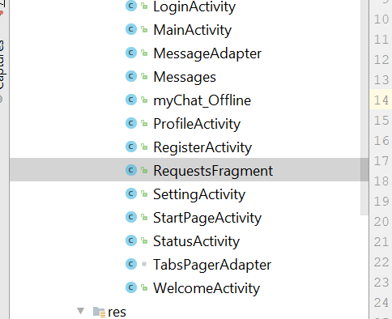
* Go to fragment_request.xml
* Then change to relative layout
* 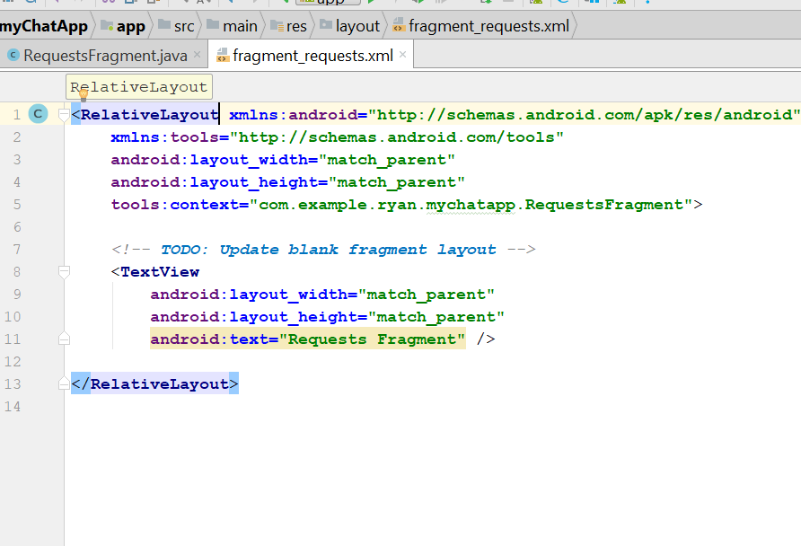
* Now remove the textView
* Add a recyclerView inside
* Name the recyclerView requests_list
* 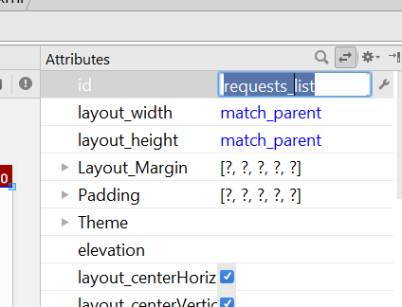
* Now create new layout_resource_files
* 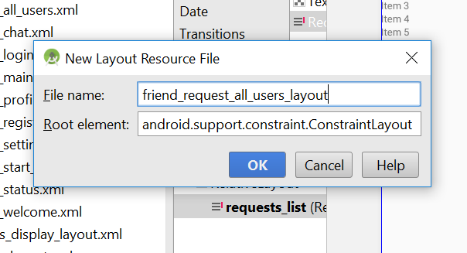
* Name it as “friend_request_all_users_layout”
* In the xml, it should contain the following code, change it to linear layout
* *<?***xml version="1.0" encoding="utf-8"***?>*<**LinearLayout xmlns:android="http://schemas.android.com/apk/res/android"  
   :layout_height="match_parent"  
   android:layout_width="match_parent"  
   android:layout_height="match_parent"  
   android:orientation="vertical"  
   android:padding="10dp"**>  
    
   <**LinearLayout  
   android:layout_width="match_parent"  
   android:layout_height="wrap_content"  
   android:orientation="horizontal"**>  
    
   <**de.hdodenhof.circleimageview.CircleImageView  
   android:layout_width="110dp"  
   android:layout_height="110dp"  
   android:src="@drawable/default_profile"** />  
    
   <**LinearLayout  
   android:layout_width="match_parent"  
   android:layout_height="wrap_content"  
   android:orientation="vertical"**>  
    
   <**TextView  
   android:layout_width="wrap_content"  
   android:layout_height="wrap_content"  
   android:layout_marginLeft="5dp"  
   android:padding="5dp"  
   android:text="display Name"  
   android:textColor="@color/colorPrimary"  
   android:textSize="14sp"  
   android:textStyle="bold"** />  
    
   <**TextView  
   android:layout_width="wrap_content"  
   android:layout_height="wrap_content"  
   android:layout_marginLeft="5dp"  
   android:padding="5dp"  
   android:text="display user status"  
   android:textSize="14sp"** />  
    
   <**LinearLayout  
   android:layout_width="match_parent"  
   android:layout_height="wrap_content"  
   android:orientation="horizontal"**>  
    
   <**Button  
   android:layout_width="90dp"  
   android:layout_height="40dp"  
   android:layout_marginLeft="5dp"  
   android:text="Accept"  
   android:textSize="16sp"** />  
    
   <**Button  
   android:layout_width="90dp"  
   android:layout_height="40dp"  
   android:layout_marginLeft="5dp"  
   android:text="Cancel"  
   android:textSize="16sp"** />  
    
    
   </**LinearLayout**>  
    
    
   </**LinearLayout**>  
    
   </**LinearLayout**>  
  </**LinearLayout**>
* It should look like this
* 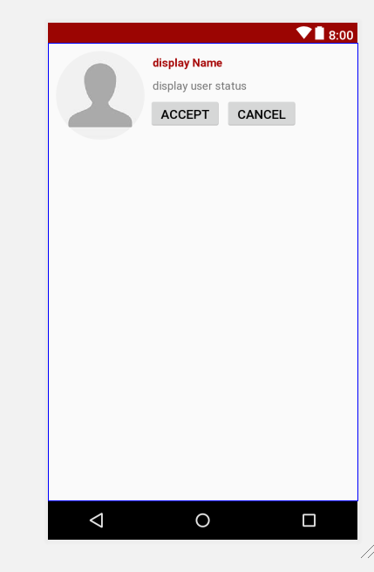
* Now change the colour of the background of the accept button
* The colour will be holo_green_dark
* 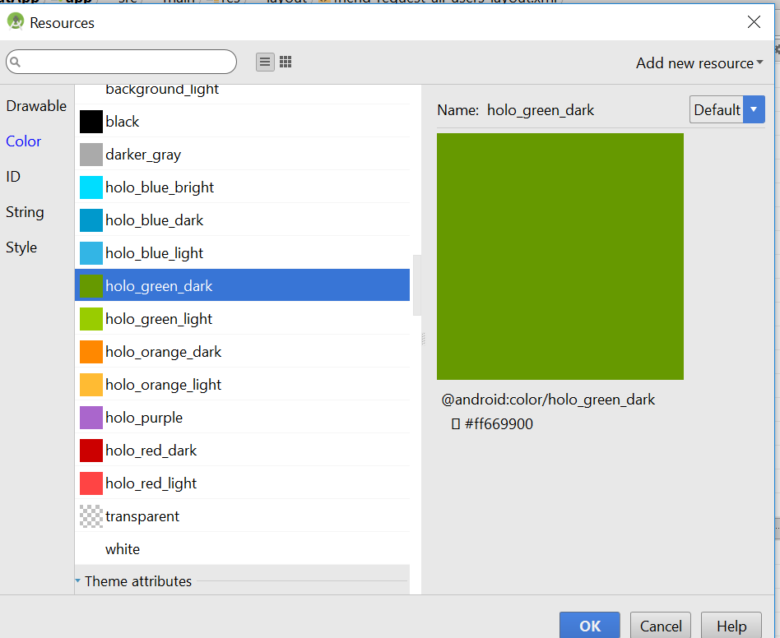
* Cancel button background change to holo_red_dark
* Now change the textcolour to background_light
* Change both buttom text to background light
* Now it should look like this
* 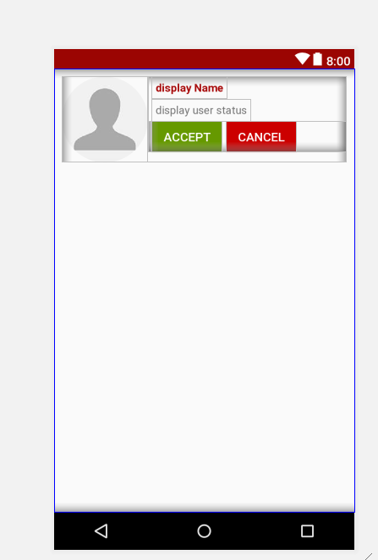
* Change the margin of this layout
* 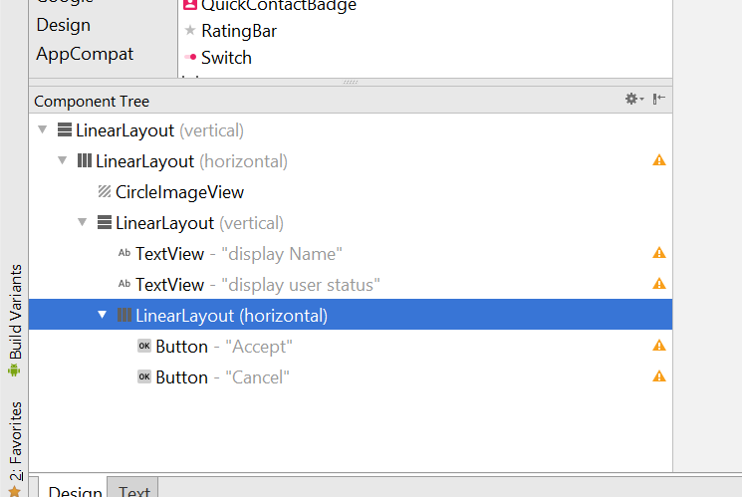
* 7dp to the top
* 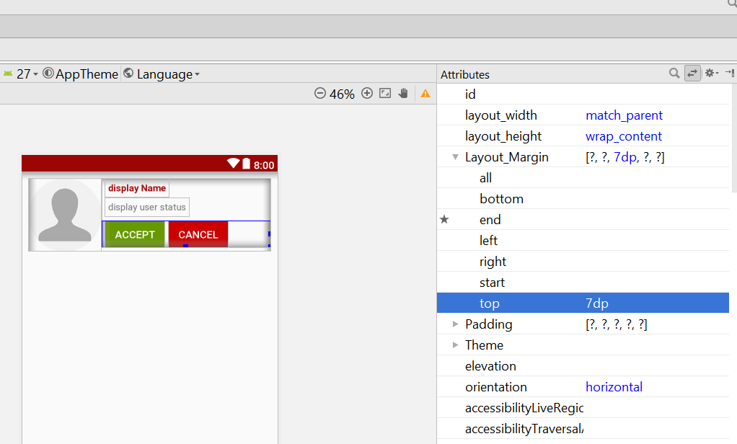
* The id for accept button is request_accept_btn
* The id for cancel buttin is request_decline_btn
* Change the name to this
* 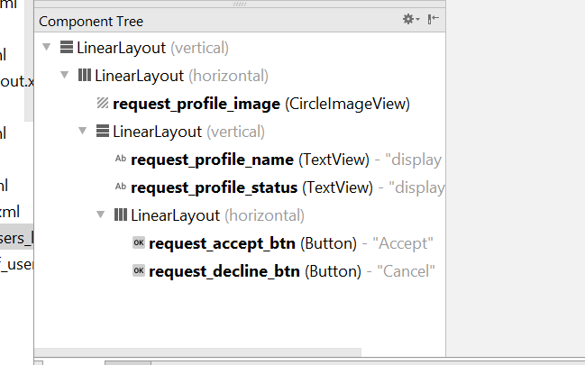
* Request_profile_name for the name
* Request_profile_status for the userstatus
* 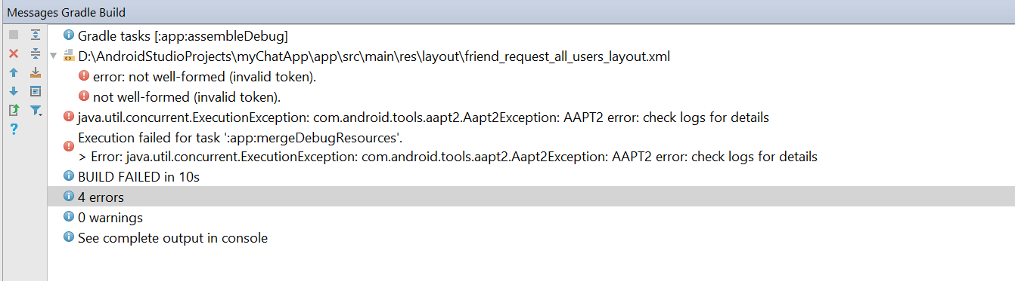
* If there is an error
* Add this line to the gradle
* android.enableAapt2=false
* 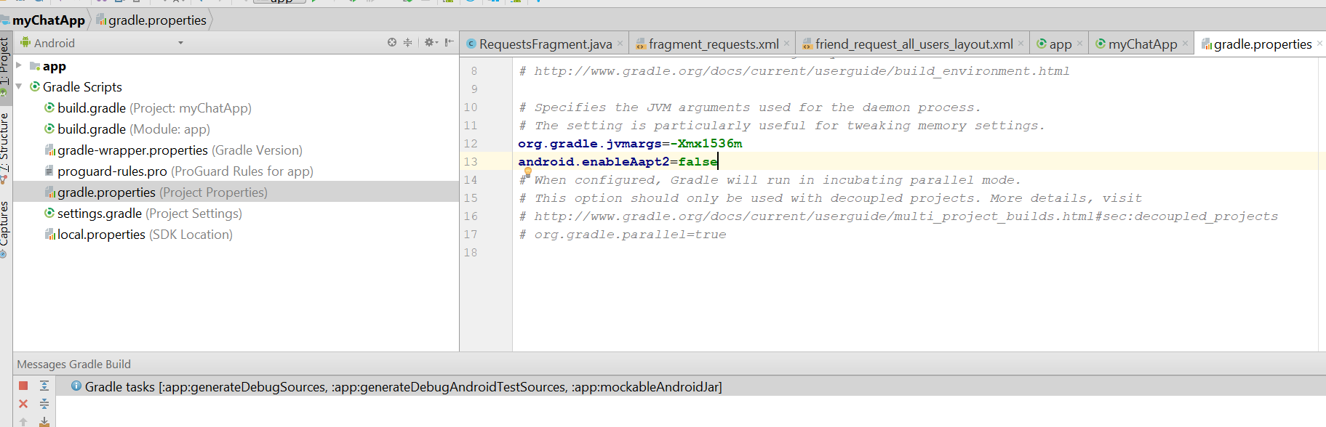
* Now go to requestFragment.java
* Add this line
* **private** RecyclerView **myRequestsList**;  
  **private** View **myMainView**;
* 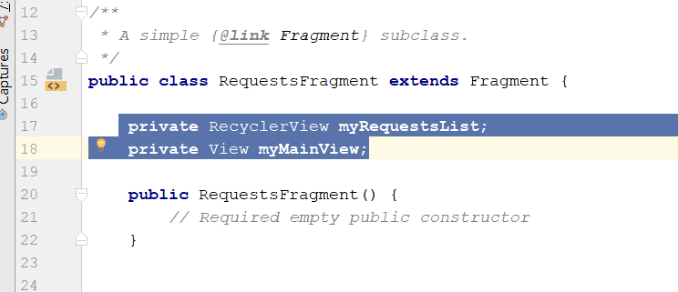
* Edit the onCreateView()
* Add the line below
* **myMainView** = inflater.inflate(R.layout.***fragment_requests***, container, **false**);  
  **myRequestsList** = (RecyclerView)**myMainView**.findViewById(R.id.***requests_list***);  
    
  **myRequestsList**.setHasFixedSize(**true**);  
  LinearLayoutManager linearLayoutManager = **new** LinearLayoutManager(getContext());  
  linearLayoutManager.setReverseLayout(**true**);  
  linearLayoutManager.setStackFromEnd(**true**);  
  **myRequestsList**.setLayoutManager(linearLayoutManager);
* 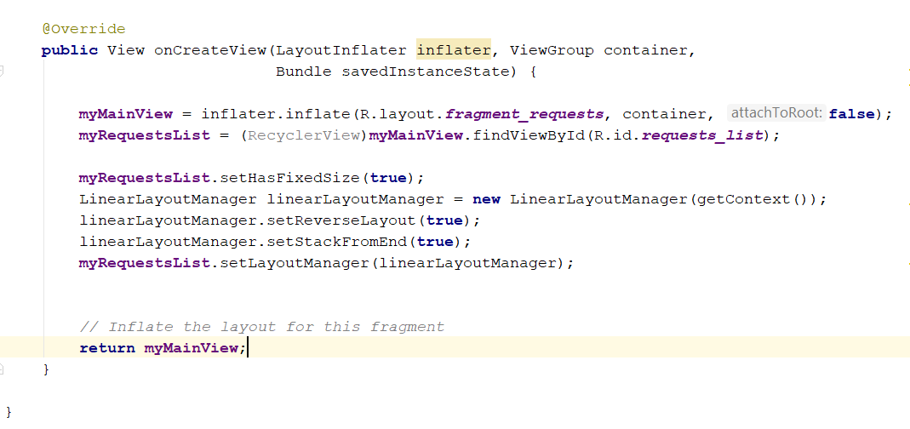
* Now create a new class, call **Requests.java**
* The java should contain the following code
* **package** com.example.ryan.mychatapp;  
    
  */**  
   * Created by Ryan on 7/29/2018.  
   */***public class** Requests {  
    
   **private** String **user_name**, **user_status**, **user_thumb_image**;  
    
   **public** Requests(String user_name, String user_status, String user_thumb_image) {  
   **this**.**user_name** = user_name;  
   **this**.**user_status** = user_status;  
   **this**.**user_thumb_image** = user_thumb_image;  
   }  
    
   **public** Requests()  
   {  
    
   }  
    
   **public** String getUser_name() {  
   **return user_name**;  
   }  
    
   **public void** setUser_name(String user_name) {  
   **this**.**user_name** = user_name;  
   }  
    
   **public** String getUser_status() {  
   **return user_status**;  
   }  
    
   **public void** setUser_status(String user_status) {  
   **this**.**user_status** = user_status;  
   }  
    
   **public** String getUser_thumb_image() {  
   **return user_thumb_image**;  
   }  
    
   **public void** setUser_thumb_image(String user_thumb_image) {  
   **this**.**user_thumb_image** = user_thumb_image;  
   }  
  }
* now go back to the requestFragment.java
* declare this new variable
* **private** DatabaseReference **FriendsRequestReference**;  
   **private** FirebaseAuth **mAuth**;  
  String **online_user_id**;
* 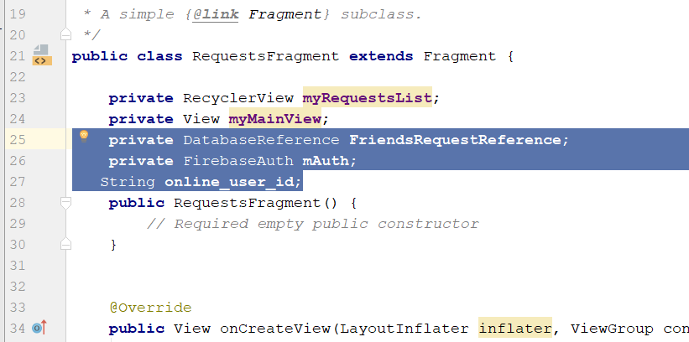
* Then add this line in the onCreate
* **FriendsRequestReference** = FirebaseDatabase.*getInstance*().getReference().child(**"Friend_Requests"**).child(**online_user_id**);
* And add this
* **mAuth** = FirebaseAuth.*getInstance*();  
  **online_user_id** = **mAuth**.getCurrentUser().getUid();
* so the onCreate should look like this
* 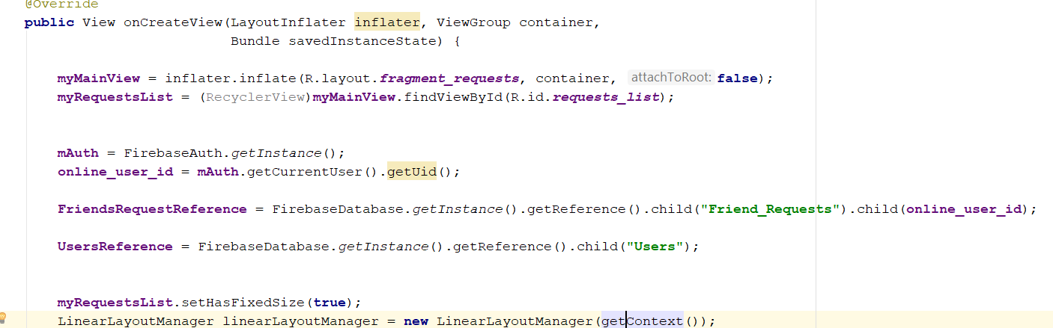
* Now create another database reference
* Now go to RequestFragment.java
* Add this
* **private** DatabaseReference **UsersReference**;
* 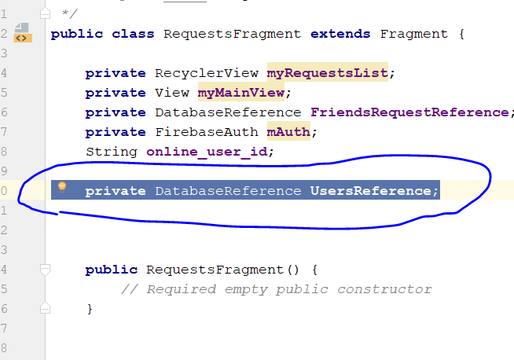
* Then add this
* UsersReference = FirebaseDatabase.*getInstance*().getReference().child(**"Users"**);
* 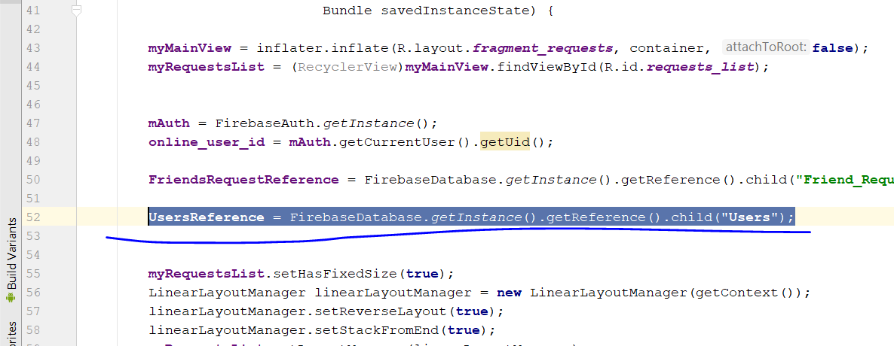
* Copy this three line from chatfragment
* **inal** String userName = dataSnapshot.child(**"user_name"**).getValue().toString();  
  String thumbImage = dataSnapshot.child(**"user_thumb_image"**).getValue().toString();  
  String userStatus = dataSnapshot.child(**"user_status"**).getValue().toString();
* go to requestFragment.java and paste here
* 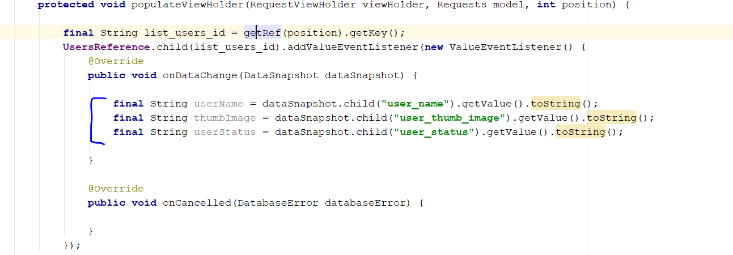
* Add this
* **public void** setUserName(String userName) {  
   TextView userNameDisplay = (TextView) **mView**.findViewById(R.id.***request_profile_name***);  
   userNameDisplay.setText(userName);  
   }
* then add this
* viewHolder.setUserName(userName);
* at this area
* 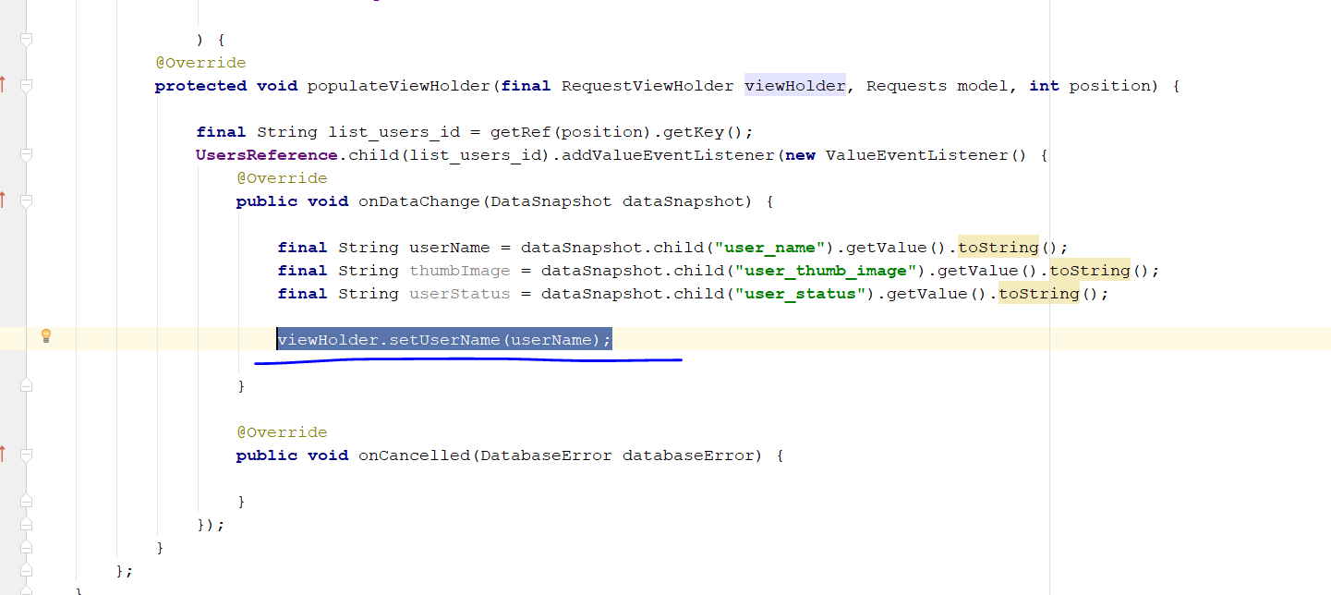
* Add this
* **public void** setThumb_user_image(**final** String thumbImage, **final** Context ctx) {  
    
   **final** CircleImageView thumb_image = (CircleImageView) **mView**.findViewById(R.id.***request_profile_image***);  
   Picasso.*with*(ctx).load(thumbImage).networkPolicy(NetworkPolicy.***OFFLINE***).placeholder(R.drawable.***default_profile***)  
   .into(thumb_image, **new** Callback() {  
   @Override  
   **public void** onSuccess() {  
    
   }  
    
   @Override  
   **public void** onError() {  
   Picasso.*with*(ctx).load(thumbImage).placeholder(R.drawable.***default_profile***).into(thumb_image);  
    
   }  
   });  
    
  }
* then add this
* **public void** setUser_Status(String userStatus) {  
   TextView status = (TextView) **mView**.findViewById(R.id.***request_profile_status***);  
   status.setText(userStatus);  
  }
* in the populate View holder in requestFragment.java, you should see this 3
* 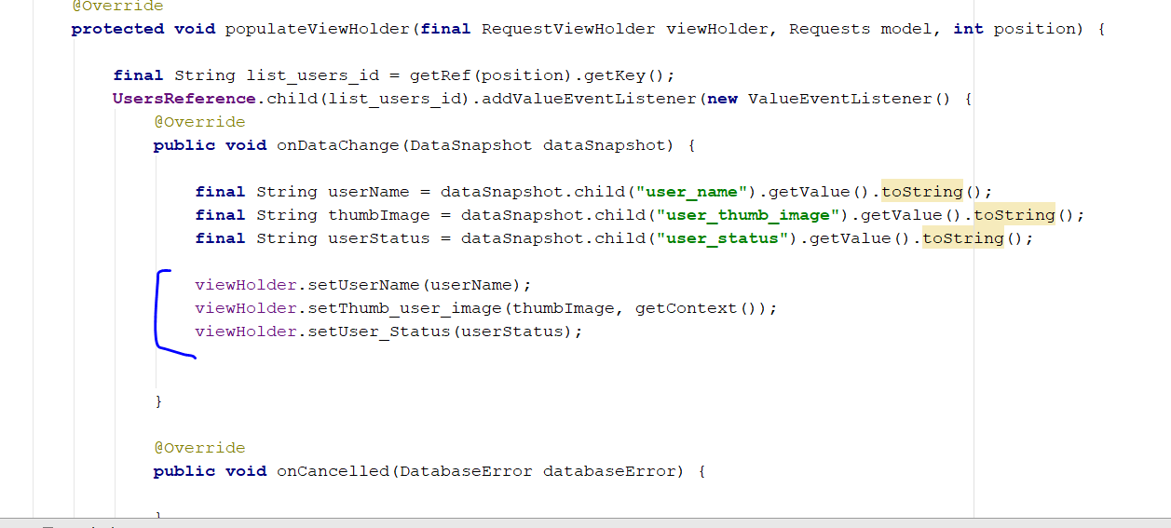
* Down In the same PopulateViewHolder, add this
* Add this
* **myRequestsList**.setAdapter(firebaseRecyclerAdapter);
* 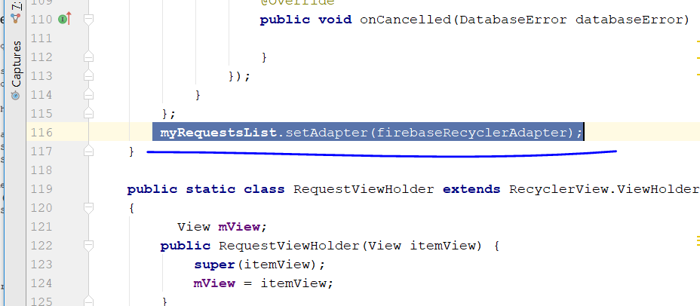
* Now, go to friend_request_all_users_layout.xml
* Select this
* 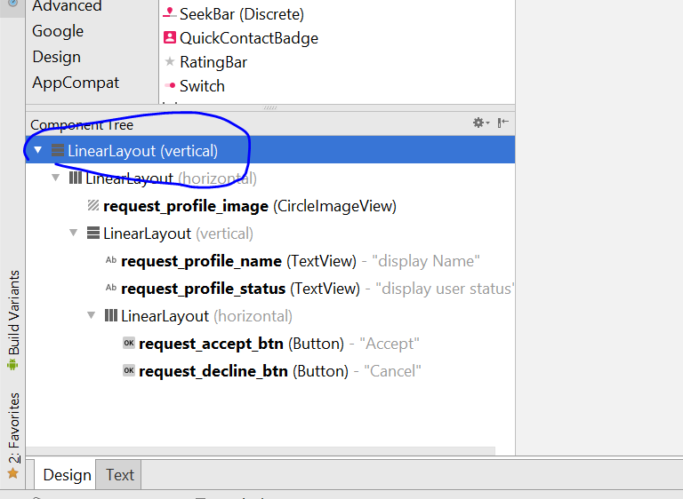
* Change the height to wrap content
* 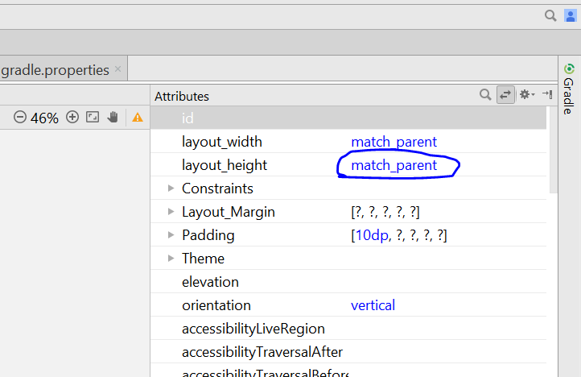
* Rebuild and run. U should see request on the request fragment
* In the RequestFragment.java, add this
* **private** DatabaseReference **FriendsDatabaseRef**;  
  **private** DatabaseReference **FriendsReqDatabaseRef**;
* in the onCreateView
* add this
* **FriendsDatabaseRef** = FirebaseDatabase.*getInstance*().getReference().child(**"Friends"**);  
  **FriendsReqDatabaseRef** = FirebaseDatabase.*getInstance*().getReference().child(**"Friend_Requests"**);

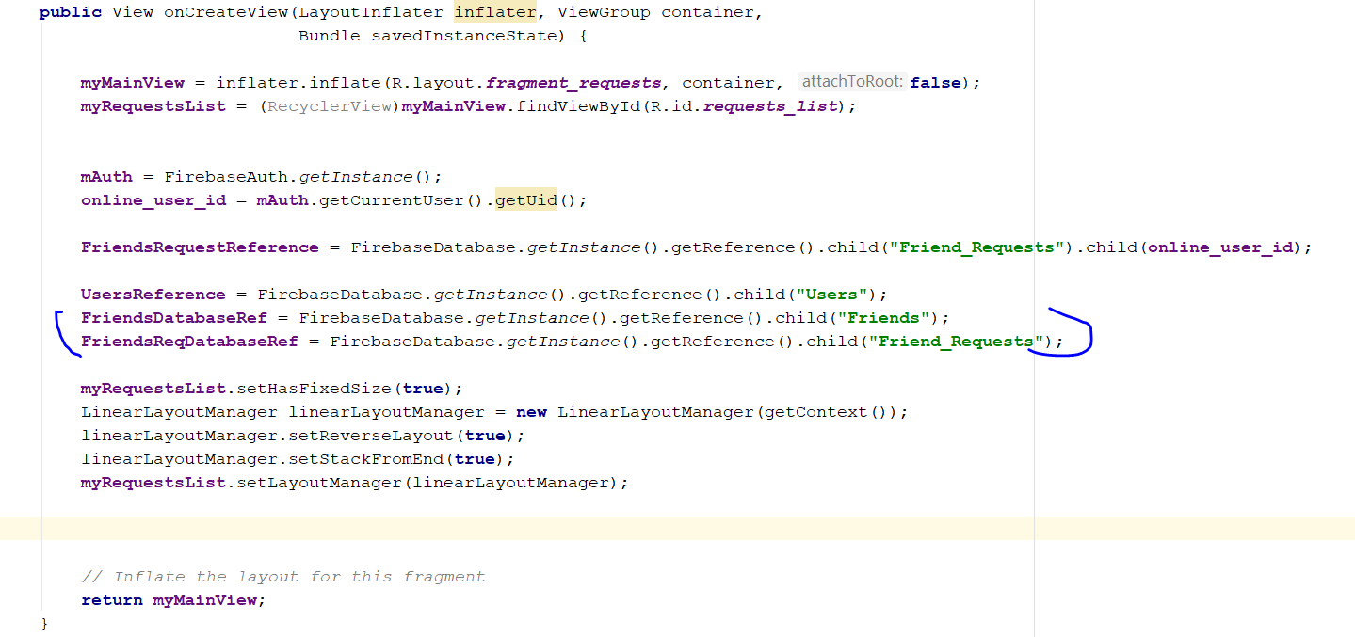

* Change the whole onStart Method to this
* **public void** onStart() {  
   **super**.onStart();  
   FirebaseRecyclerAdapter<Requests,RequestViewHolder> firebaseRecyclerAdapter  
   = **new** FirebaseRecyclerAdapter<Requests, RequestViewHolder>  
   (  
   Requests.**class**,  
   R.layout.***friend_request_all_users_layout***,  
   RequestsFragment.RequestViewHolder.**class**,  
   **FriendsRequestReference** ) {  
   @Override  
   **protected void** populateViewHolder(**final** RequestViewHolder viewHolder, Requests model, **int** position) {  
    
   **final** String list_users_id = getRef(position).getKey();  
    
   DatabaseReference get_type_ref = getRef(position).child(**"request_type"**).getRef();  
   get_type_ref.addValueEventListener(**new** ValueEventListener() {  
   @Override  
   **public void** onDataChange(DataSnapshot dataSnapshot) {  
   **if**(dataSnapshot.exists())  
   {  
   String request_type = dataSnapshot.getValue().toString();  
    
   **if**(request_type.equals(**"received"**))  
   {  
   **UsersReference**.child(list_users_id).addValueEventListener(**new** ValueEventListener() {  
   @Override  
   **public void** onDataChange(DataSnapshot dataSnapshot) {  
    
   **final** String userName = dataSnapshot.child(**"user_name"**).getValue().toString();  
   **final** String thumbImage = dataSnapshot.child(**"user_thumb_image"**).getValue().toString();  
   **final** String userStatus = dataSnapshot.child(**"user_status"**).getValue().toString();  
    
   viewHolder.setUserName(userName);  
   viewHolder.setThumb_user_image(thumbImage, getContext());  
   viewHolder.setUser_Status(userStatus);  
   viewHolder.**mView**.setOnClickListener(**new** View.OnClickListener() {  
   @Override  
   **public void** onClick(View v) {  
   CharSequence options[] = **new** CharSequence[]  
   {  
   **"Accept Friend Request"**,  
   **"Cancel Friend Request"** };  
    
   AlertDialog.Builder builder = **new** AlertDialog.Builder(getContext());  
   builder.setTitle(**"Friend Request Option"**);  
   builder.setItems(options, **new** DialogInterface.OnClickListener() {  
   @RequiresApi(api = Build.VERSION_CODES.***N***)  
   @Override  
   **public void** onClick(DialogInterface dialog, **int** position) {  
    
   **if**(position == 0)  
   {  
   Calendar calFordAte = Calendar.*getInstance*();  
   SimpleDateFormat currentDate = **new** SimpleDateFormat(**"dd-MMMM-yyyy"**);  
   **final** String saveCurrentDate = currentDate.format(calFordAte.getTime());  
    
   **FriendsDatabaseRef**.child(**online_user_id**)  
   .child(list_users_id).child(**"date"**).setValue(saveCurrentDate)  
   .addOnSuccessListener(**new** OnSuccessListener<Void>() {  
   @Override  
   **public void** onSuccess(Void aVoid) {  
   **FriendsDatabaseRef**.child(list_users_id)  
   .child(**online_user_id**)  
   .child(**"date"**)  
   .setValue(saveCurrentDate)  
   .addOnSuccessListener(**new** OnSuccessListener<Void>() {  
   @Override  
   **public void** onSuccess(Void aVoid) {  
   **FriendsReqDatabaseRef**.child(**online_user_id**).child(list_users_id)  
   .removeValue().addOnCompleteListener(**new** OnCompleteListener<Void>() {  
   @Override  
   **public void** onComplete(@NonNull Task<Void> task) {  
   **if**(task.isSuccessful())  
   {  
   **FriendsReqDatabaseRef**.child(list_users_id).child(**online_user_id**)  
   .removeValue().addOnCompleteListener(**new** OnCompleteListener<Void>() {  
   @Override  
   **public void** onComplete(@NonNull Task<Void> task) {  
   **if**(task.isSuccessful())  
   {  
   Toast.*makeText*(getContext(),**"Friend Request Accepted Successfully"**,Toast.***LENGTH_SHORT***).show();  
   }  
   }  
   });  
   }  
   }  
   });  
   }  
   });  
   }  
   });  
   }  
   **if**(position == 1)  
   {  
   **FriendsReqDatabaseRef**.child(**online_user_id**).child(list_users_id)  
   .removeValue().addOnCompleteListener(**new** OnCompleteListener<Void>() {  
   @Override  
   **public void** onComplete(@NonNull Task<Void> task) {  
   **if**(task.isSuccessful())  
   {  
   **FriendsReqDatabaseRef**.child(list_users_id).child(**online_user_id**)  
   .removeValue().addOnCompleteListener(**new** OnCompleteListener<Void>() {  
   @Override  
   **public void** onComplete(@NonNull Task<Void> task) {  
   **if**(task.isSuccessful())  
   {  
   Toast.*makeText*(getContext(),**"Friend Request Cancelled"**,Toast.***LENGTH_SHORT***).show();  
   }  
   }  
   });  
   }  
   }  
   });  
   }  
   }  
   });  
   builder.show();  
   }  
   });  
   }  
    
   @Override  
   **public void** onCancelled(DatabaseError databaseError) {  
    
   }  
   });  
   }  
   **else if**(request_type.equals(**"sent"**))  
   {  
    
   Button req_sent_btn = viewHolder.**mView**.findViewById(R.id.***request_accept_btn***);  
   req_sent_btn.setText(**"Req Sent"**);  
    
   viewHolder.**mView**.findViewById(R.id.***request_decline_btn***).setVisibility(View.***INVISIBLE***);  
    
    
   **UsersReference**.child(list_users_id).addValueEventListener(**new** ValueEventListener() {  
   @Override  
   **public void** onDataChange(DataSnapshot dataSnapshot) {  
    
   **final** String userName = dataSnapshot.child(**"user_name"**).getValue().toString();  
   **final** String thumbImage = dataSnapshot.child(**"user_thumb_image"**).getValue().toString();  
   **final** String userStatus = dataSnapshot.child(**"user_status"**).getValue().toString();  
    
   viewHolder.setUserName(userName);  
   viewHolder.setThumb_user_image(thumbImage, getContext());  
   viewHolder.setUser_Status(userStatus);  
    
   viewHolder.**mView**.setOnClickListener(**new** View.OnClickListener() {  
   @Override  
   **public void** onClick(View v) {  
   CharSequence options[] = **new** CharSequence[]  
   {  
   **"Cancel Friend Request"**,  
    
   };  
    
   AlertDialog.Builder builder = **new** AlertDialog.Builder(getContext());  
   builder.setTitle(**"Friend Requst Sent"**);  
   builder.setItems(options, **new** DialogInterface.OnClickListener() {  
   @RequiresApi(api = Build.VERSION_CODES.***N***)  
   @Override  
   **public void** onClick(DialogInterface dialog, **int** position) {  
    
   **if**(position == 0)  
   {  
   **FriendsReqDatabaseRef**.child(**online_user_id**).child(list_users_id)  
   .removeValue().addOnCompleteListener(**new** OnCompleteListener<Void>() {  
   @Override  
   **public void** onComplete(@NonNull Task<Void> task) {  
   **if**(task.isSuccessful())  
   {  
   **FriendsReqDatabaseRef**.child(list_users_id).child(**online_user_id**)  
   .removeValue().addOnCompleteListener(**new** OnCompleteListener<Void>() {  
   @Override  
   **public void** onComplete(@NonNull Task<Void> task) {  
   **if**(task.isSuccessful())  
   {  
   Toast.*makeText*(getContext(),**"Friend Request Cancelled"**,Toast.***LENGTH_SHORT***).show();  
   }  
   }  
   });  
   }  
   }  
   });  
   }  
   }  
   });  
   builder.show();  
   }  
   });  
    
   }  
    
   @Override  
   **public void** onCancelled(DatabaseError databaseError) {  
    
   }  
   });  
   }  
   }  
   }  
    
   @Override  
   **public void** onCancelled(DatabaseError databaseError) {  
    
   }  
   });  
    
    
    
   }  
   };  
   **myRequestsList**.setAdapter(firebaseRecyclerAdapter);  
  }
* Rebuild and run
* U should see the accept and cancel request image
* 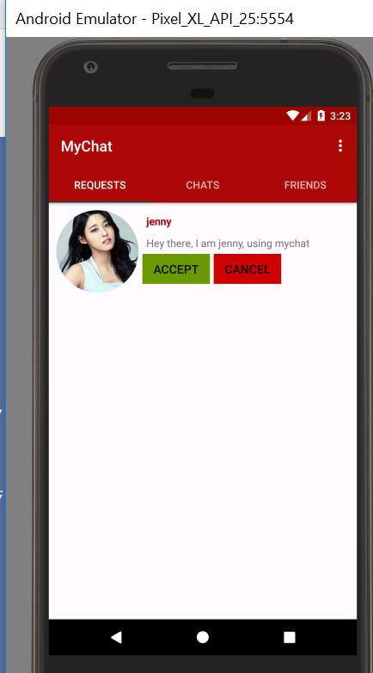
* 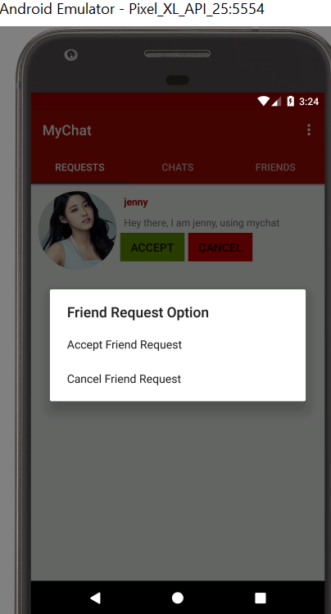

# Step 31: Storing Chat Images to Firebase Storage

* Go to chatactivity.java
* Initalise this variable
* **private static int** *Gallery_Pick* = 1;
* Go to this line
* 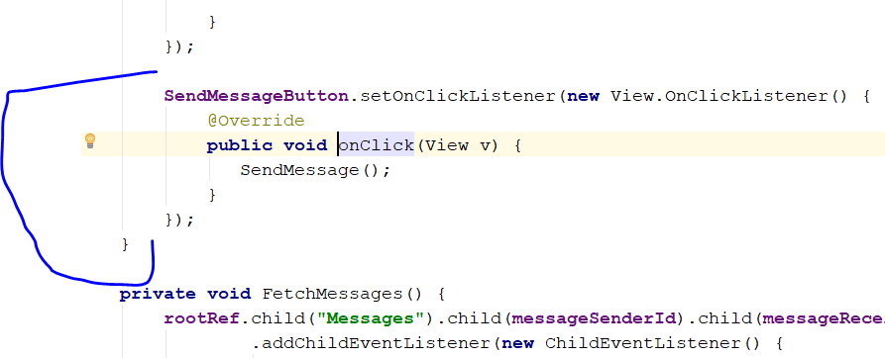
* Then add in this line
* **SelectImageButton**.setOnClickListener(**new** View.OnClickListener() {  
   @Override  
   **public void** onClick(View v) {  
   Intent galleryIntent = **new** Intent();  
   galleryIntent.setAction(Intent.***ACTION_GET_CONTENT***);  
   galleryIntent.setType(**"image/*"**);  
   startActivityForResult(galleryIntent, *Gallery_Pick*);  
   }  
  });
* It will look like this
* 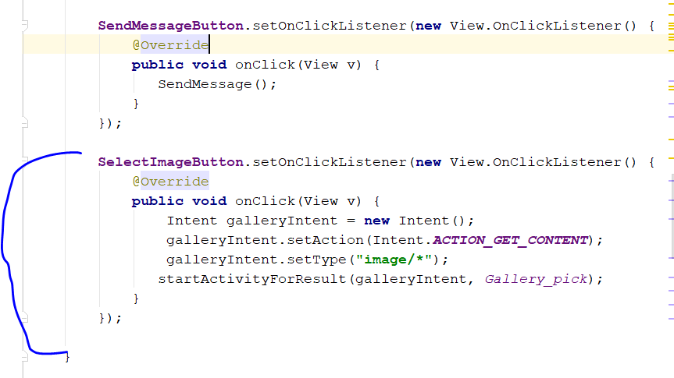
* Add in this line to initialize again
* **private** StorageReference **MessageImageStorageRef**;
* In the onCreate, add this
* **MessageImageStorageRef** = FirebaseStorage.*getInstance*().getReference().child(**"Messages_Pictures"**);
* 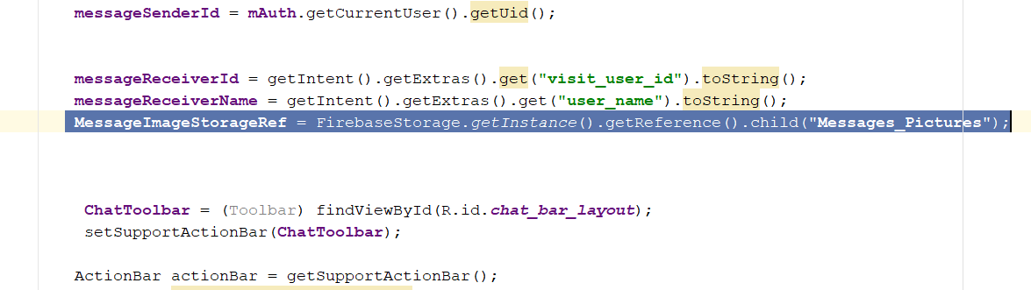
* After the selectImageButton method, add this
* @Override  
  **protected void** onActivityResult(**int** requestCode, **int** resultCode, Intent data) {  
   **super**.onActivityResult(requestCode, resultCode, data);  
   **if**(requestCode == *Gallery_Pick* && resultCode==***RESULT_OK*** && data!=**null**)  
   {  
   Uri ImageUri = data.getData();  
   String message_sender_ref = **"Messages/"** + **messageSenderId** + **"/"** + **messageReceiverId**;  
   String message_receiver_ref = **"Messages/"** + **messageReceiverId** + **"/"** + **messageSenderId**;  
   DatabaseReference user_message_key = **rootRef**.child(**"Messages"**).child(**messageSenderId**)  
   .child(**messageReceiverId**).push();  
   String message_push_id = user_message_key.getKey();  
    
   StorageReference filePath = **MessageImageStorageRef**.child(message_push_id + **".jpg"**);  
   filePath.putFile(ImageUri).addOnCompleteListener(**new** OnCompleteListener<UploadTask.TaskSnapshot>() {  
   @Override  
   **public void** onComplete(@NonNull Task<UploadTask.TaskSnapshot> task) {  
   Toast.*makeText*(ChatActivity.**this**,**"Picture sent successfully. "**,Toast.***LENGTH_SHORT***).show();  
   }  
   });  
   }  
    
  }
* Rebuild and run
* You should see this
* 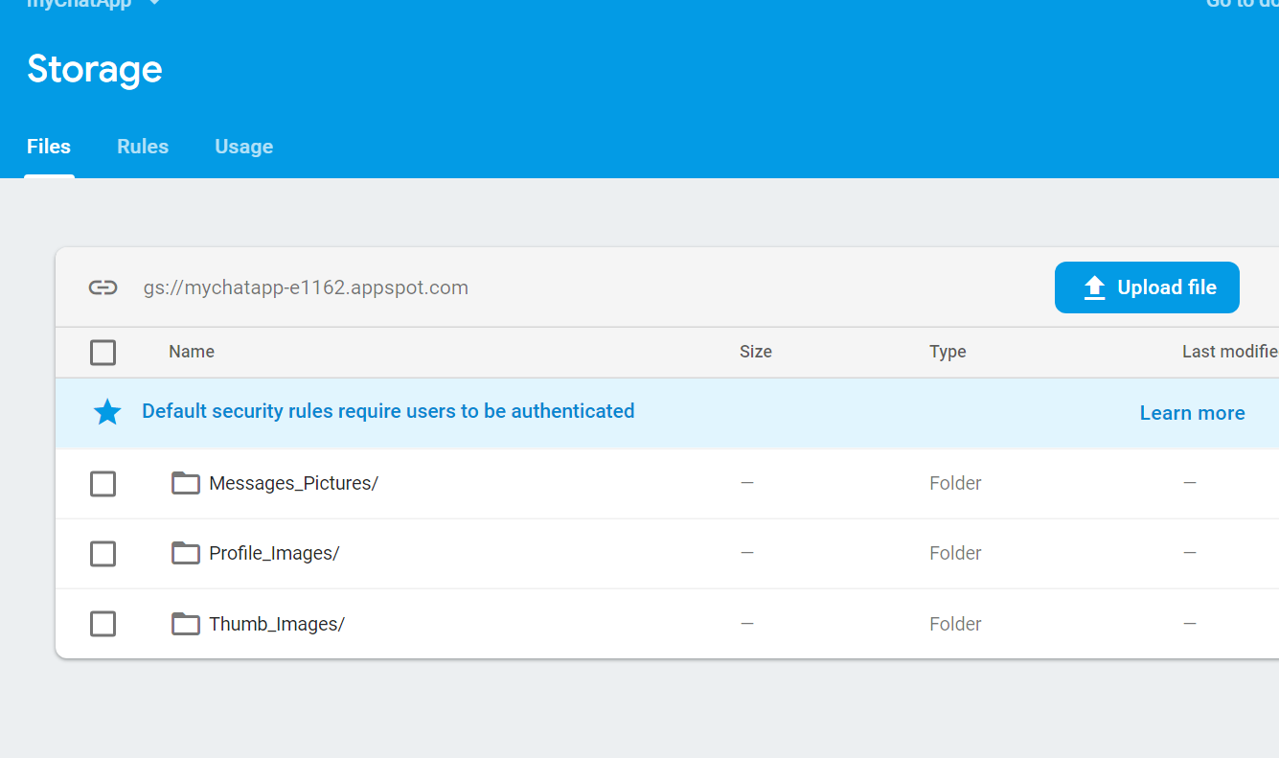
* The folder Message_pictures is created
* Now declare this on top
* **private** ProgressDialog **loadingBar**;
* then add this line In onCreate Method
* **loadingBar** = **new** ProgressDialog(**this**);
* 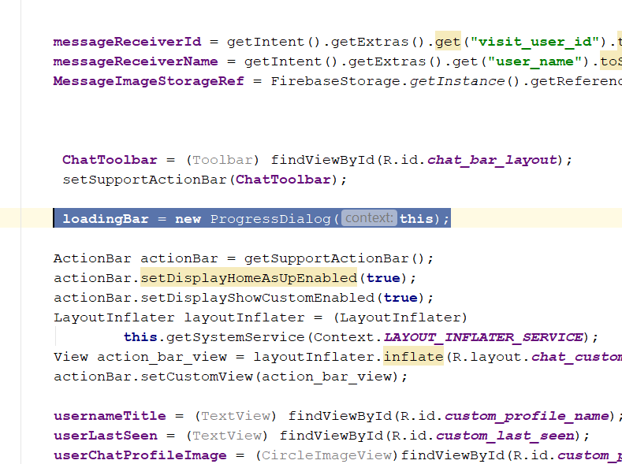

# Step 32: Display Chat Image

* Go to Message_layout_of_user.xml
* You will see something like this
* 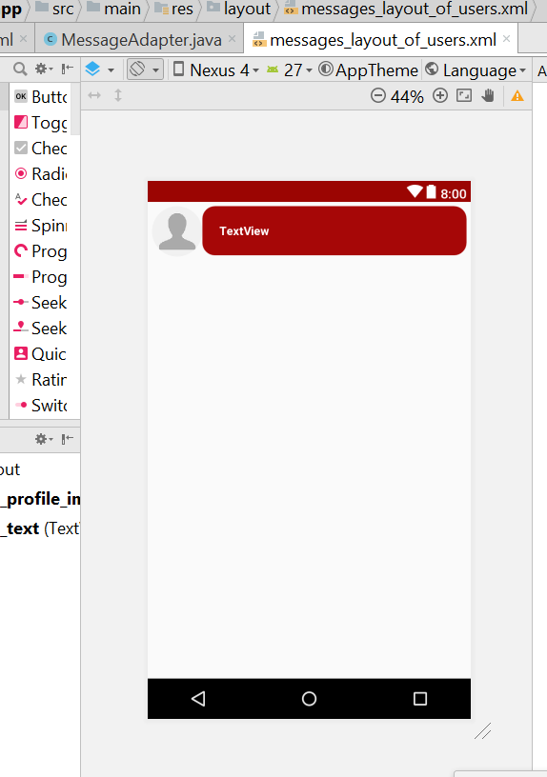
* Remove this line
* 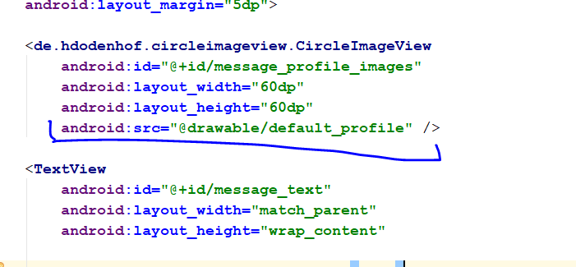
* It become like this
* 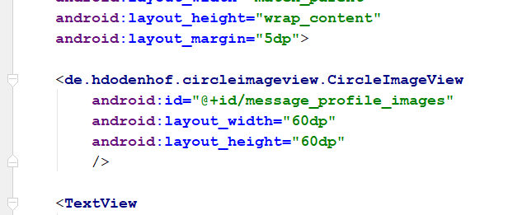
* Then u push it on top
* 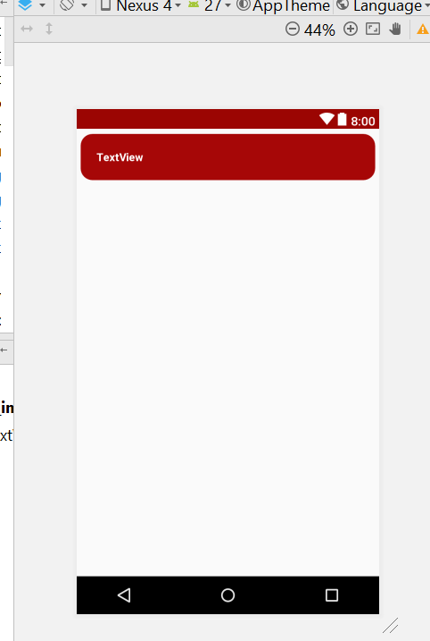
* Now go to MessageAdapter.java
* Go to
* **public class** MessageViewHolder **extends** RecyclerView.ViewHolder
* add this
* **userProfileImage** = (CircleImageView)view.findViewById(R.id.***message_profile_images***);
* 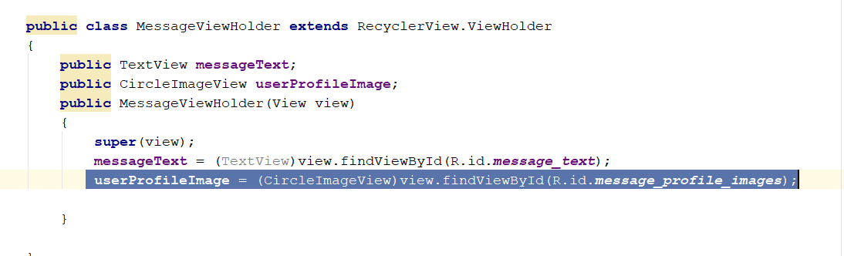
* Now go back to the message_layout_of_user.xml
* Search for imageview, and drag the imageview into the layout
* 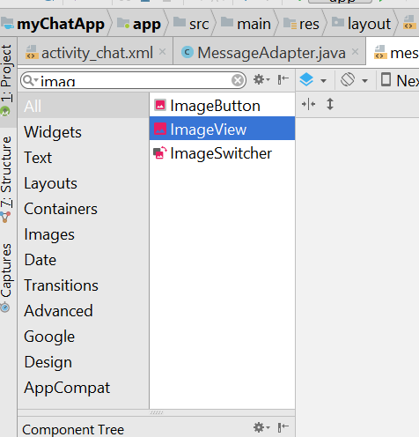
* You will see this
* 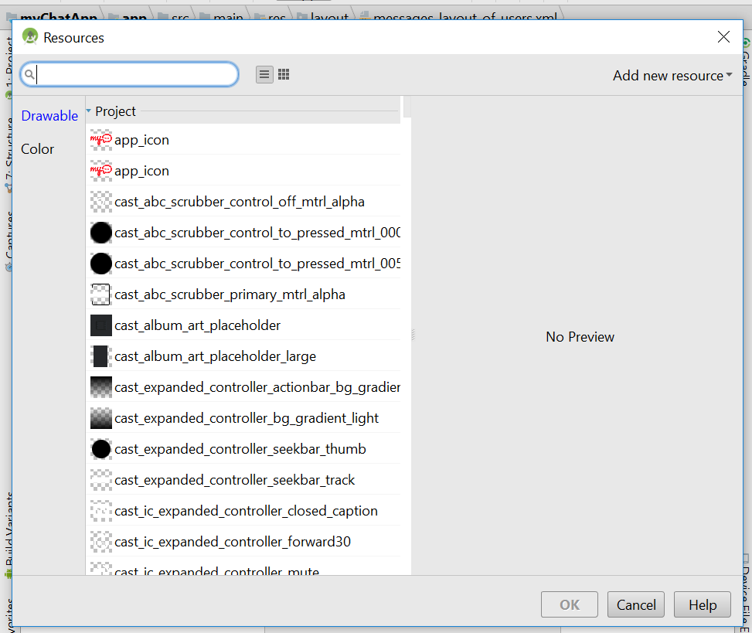
* Select any default image
* I select
* 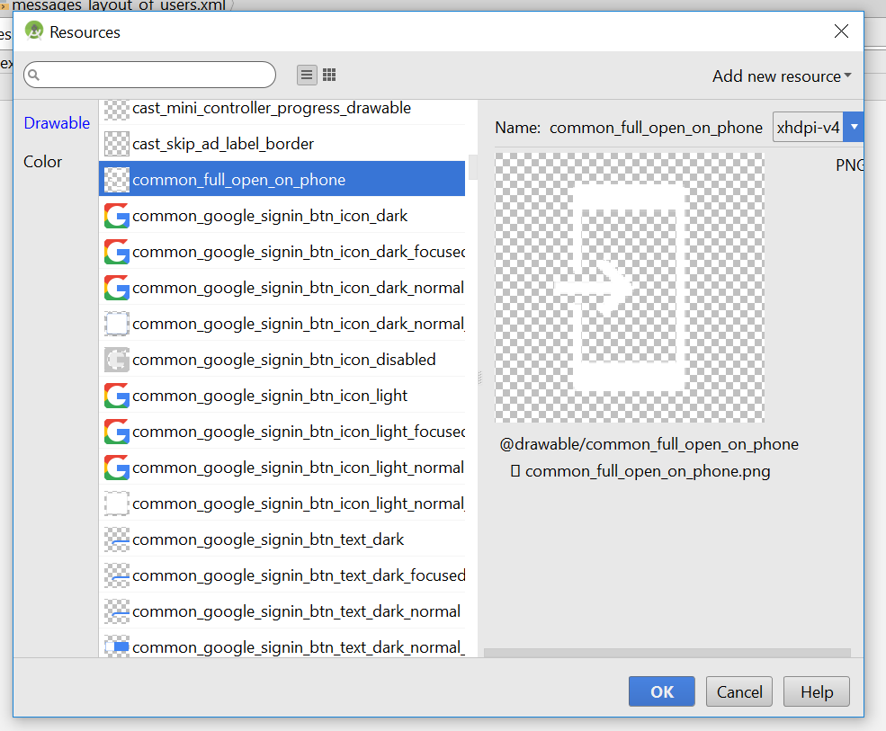
* Move it above here
* 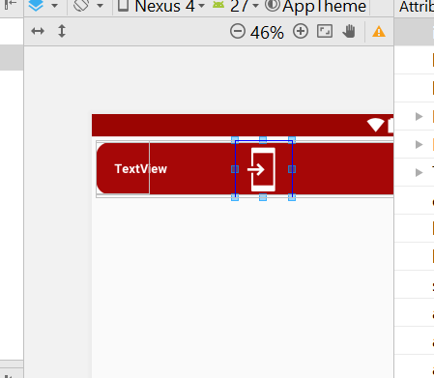
* This will be the property of the imageview, add the new id for it
* 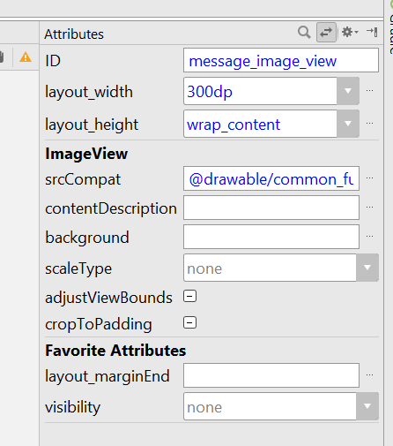
* Then adjust the padding for message_text, TextView
* Change the padding to 15dp
* 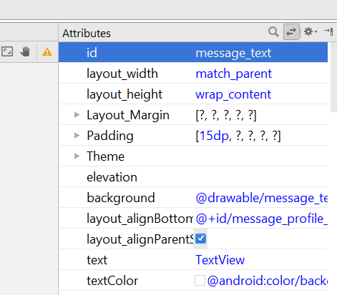
* Now go to MessageAdapter.java > MessageViewHolder
* Change the whole MessageViewholder to this

@Override  
**public** MessageViewHolder onCreateViewHolder(@NonNull ViewGroup parent, **int** viewType) {  
  
 View v = LayoutInflater.*from*(parent.getContext())  
 .inflate(R.layout.***messages_layout_of_users***,parent,**false**);  
  
 **mAuth** = FirebaseAuth.*getInstance*();  
 **return new** MessageViewHolder(v);  
}  
  
@Override  
**public void** onBindViewHolder(@NonNull MessageViewHolder holder, **int** position) {  
  
 String message_sender_id = **mAuth**.getCurrentUser().getUid();  
 Messages messages = **userMessageList**.get(position);  
  
 String fromUserId = messages.getFrom();  
 String fromMessageType = messages.getType();  
 **UsersDatabasereference** = FirebaseDatabase.*getInstance*().getReference().child(**"Users"**).child(fromUserId);  
 **UsersDatabasereference**.addValueEventListener(**new** ValueEventListener() {  
 @Override  
 **public void** onDataChange(DataSnapshot dataSnapshot) {  
 String userName = dataSnapshot.child(**"user_name"**).getValue().toString();  
 String userImage = dataSnapshot.child(**"user_thumb_image"**).getValue().toString();  
  
 }  
  
 @Override  
 **public void** onCancelled(DatabaseError databaseError) {  
  
 }  
 });  
  
 **if**(fromMessageType.equals(**"text"**))  
 {  
 holder.**messagePicture**.setVisibility(View.***INVISIBLE***);  
 **if**(Objects.*equals*(fromUserId, message_sender_id))  
 {  
 holder.**messageText**.setBackgroundResource(R.drawable.***message_text_background_two***);  
 holder.**messageText**.setTextColor(Color.***BLACK***);  
 holder.**messageText**.setGravity(Gravity.***RIGHT***);  
 }  
 **else** {  
 holder.**messageText**.setBackgroundResource(R.drawable.***message_text_background***);  
 holder.**messageText**.setTextColor(Color.***WHITE***);  
 holder.**messageText**.setGravity(Gravity.***LEFT***);  
 }  
 holder.**messageText**.setText(messages.getMessage());  
 }  
 **else** {  
 holder.**messageText**.setVisibility(View.***INVISIBLE***);  
 holder.**messageText**.setPadding(0,0,0,0);  
  
  
 Picasso.*with*(holder.**userProfileImage**.getContext()).load(messages.getMessage())  
 .placeholder(R.drawable.***default_profile***).into(holder.**messagePicture**);  
 }  
  
  
  
  
}

* Declare this variable

**private** DatabaseReference **UsersDatabasereference**;

* Now go to the messages_layout_of_user.xml
* Remove this line
* 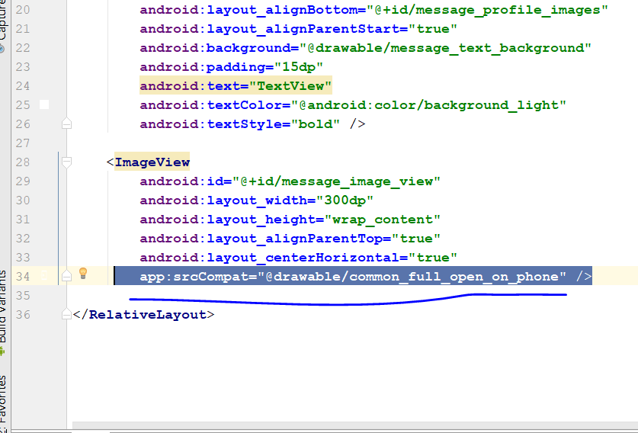
* It become this
* 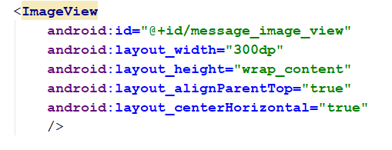
* Now go to Message_Image_view, select Scaletype
* 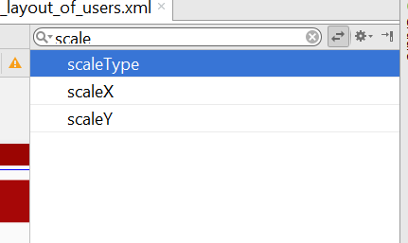
* Select centrecrop
* 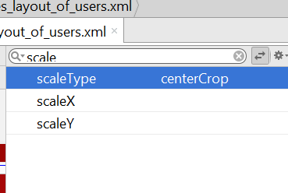
* This is how the XML is like
* Now go to firebase and delete this folders
* 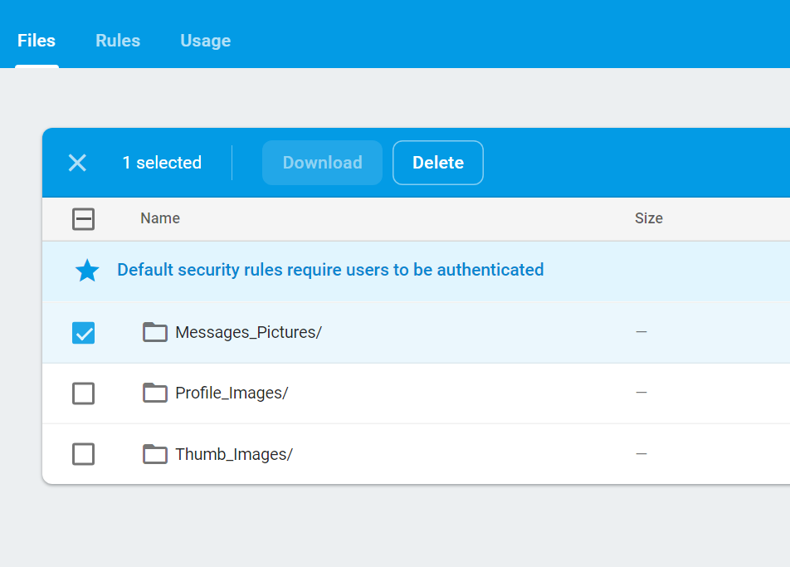
* 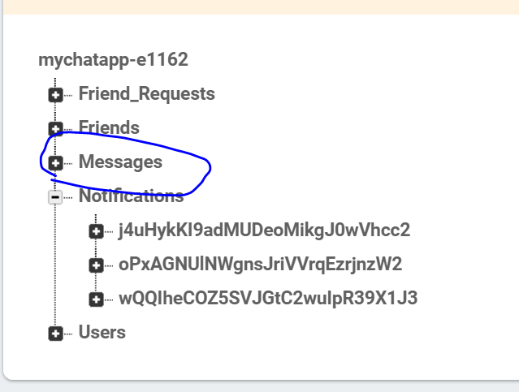
* Rebuild and run, u shld be able to see the picture on the message, when u send message

# Step 33: Chat Messaging Design

* Drag ur Message_Text this way
* 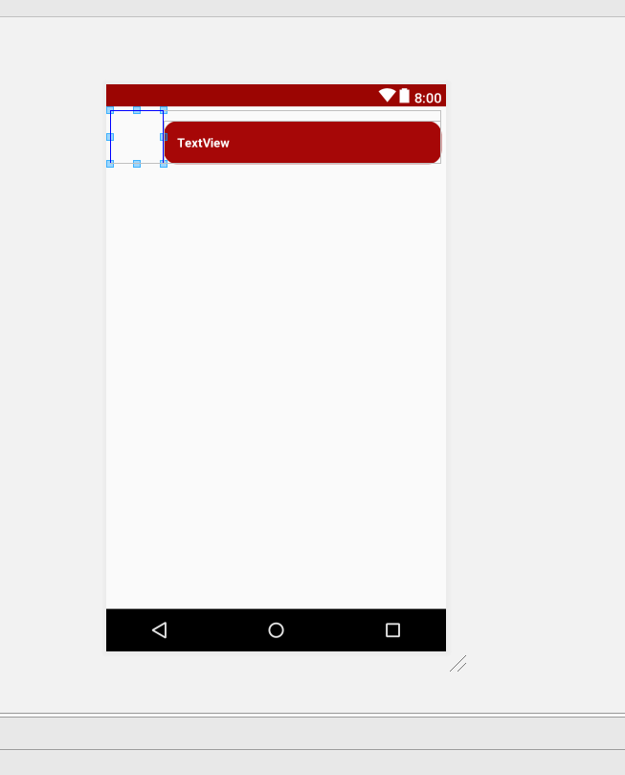
* Add this line
* 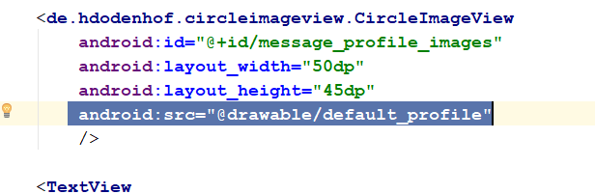
* **android:src="@drawable/default_profile"**
* change the height to 50dp
* 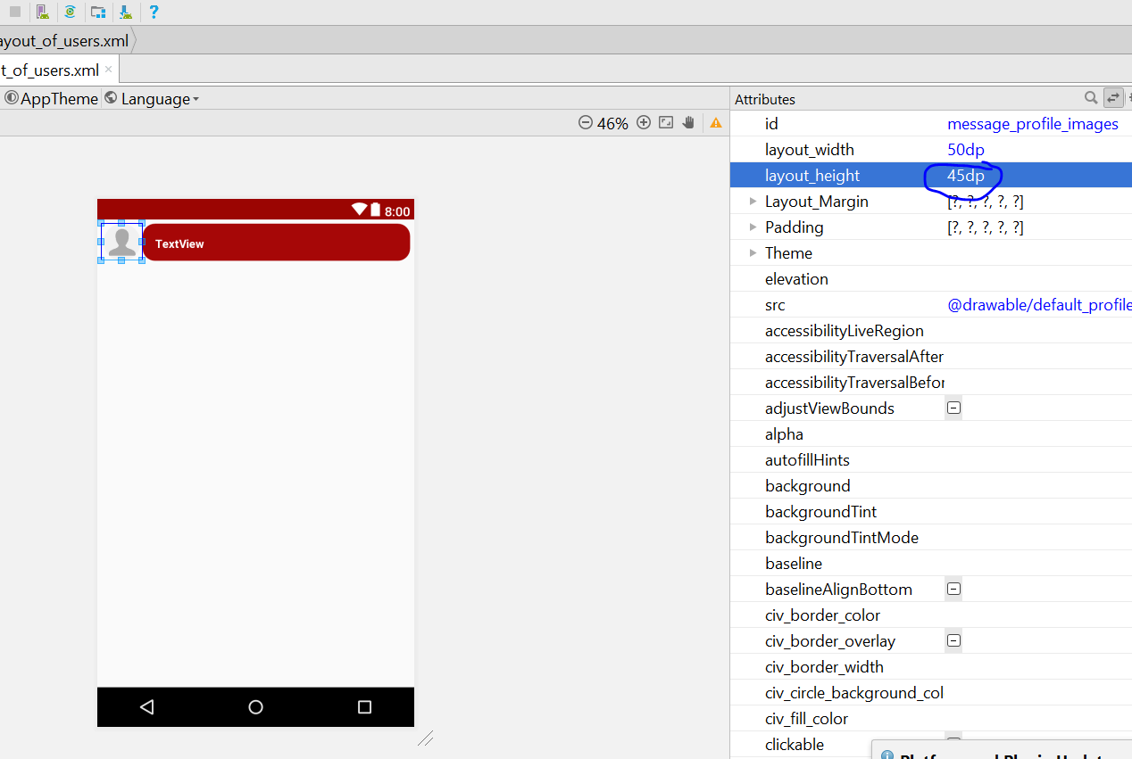
* Change the message_text textview Margin to 2dp
* 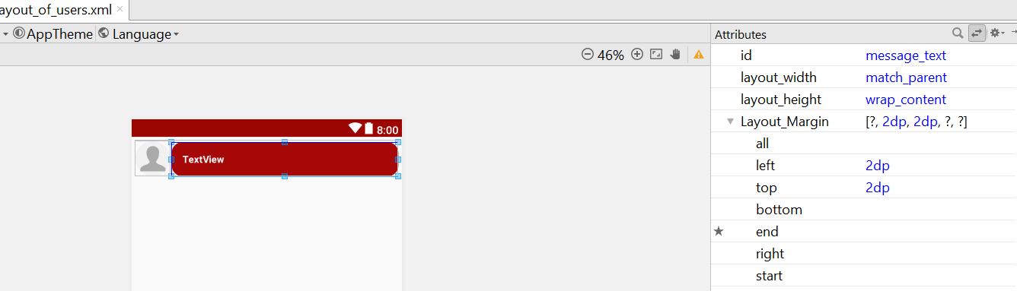
* Change the profile_image margin from top to 1dp
* 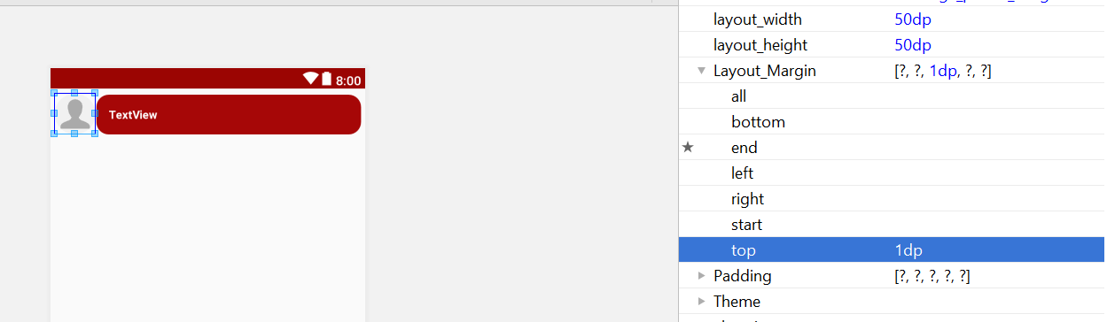
* Add this line in XML
* 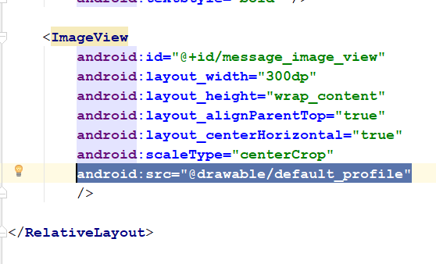
* Change the margin accordingly
* 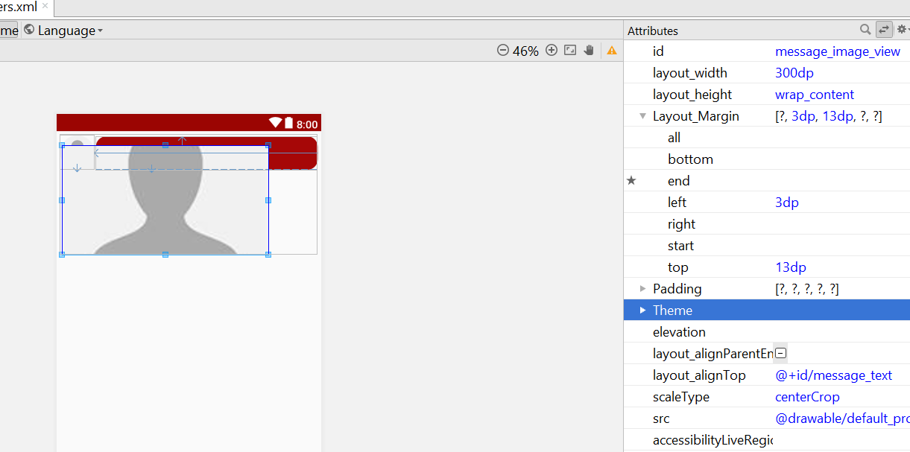
* Or change the XML to this
* 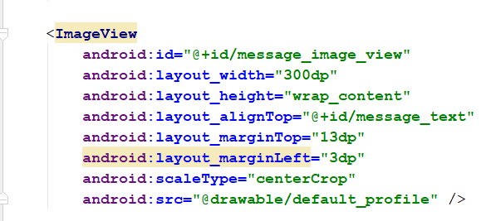
* The whole XML look like this
* *<?***xml version="1.0" encoding="utf-8"***?>*<**RelativeLayout xmlns:android="http://schemas.android.com/apk/res/android"  
   xmlns:app="http://schemas.android.com/apk/res-auto"  
   xmlns:tools="http://schemas.android.com/tools"  
   android:layout_width="match_parent"  
   android:layout_height="wrap_content"  
   android:padding="5dp"**>  
    
   <**de.hdodenhof.circleimageview.CircleImageView  
   android:id="@+id/message_profile_images"  
   android:layout_width="60dp"  
   android:layout_height="60dp"  
   android:src="@drawable/default_profile"** />  
    
   <**TextView  
   android:id="@+id/message_text"  
   android:layout_width="match_parent"  
   android:layout_height="wrap_content"  
   android:layout_alignParentTop="true"  
   android:layout_marginLeft="2dp"  
   android:layout_marginTop="2dp"  
   android:layout_toEndOf="@+id/message_profile_images"  
   android:background="@drawable/message_text_background"  
   android:padding="15dp"  
   android:text="TextView"  
   android:textColor="@android:color/background_light"  
   android:textSize="14sp"  
   android:textStyle="bold"** />  
    
   <**ImageView  
   android:id="@+id/message_image_view"  
   android:layout_width="300dp"  
   android:layout_height="wrap_content"  
   android:layout_alignParentTop="true"  
   android:layout_alignStart="@id/message_text"  
   android:layout_centerHorizontal="true"  
   android:layout_marginLeft="3dp"  
   android:layout_marginTop="13dp"  
   android:scaleType="centerCrop"** />  
    
  </**RelativeLayout**>
* Now go to MessageAdapter.java
* Add this two line here
* Picasso.*with*(holder.**userProfileImage**.getContext()).load(userImage)  
   .placeholder(R.drawable.***default_profile***).into(holder.**userProfileImage**);
* 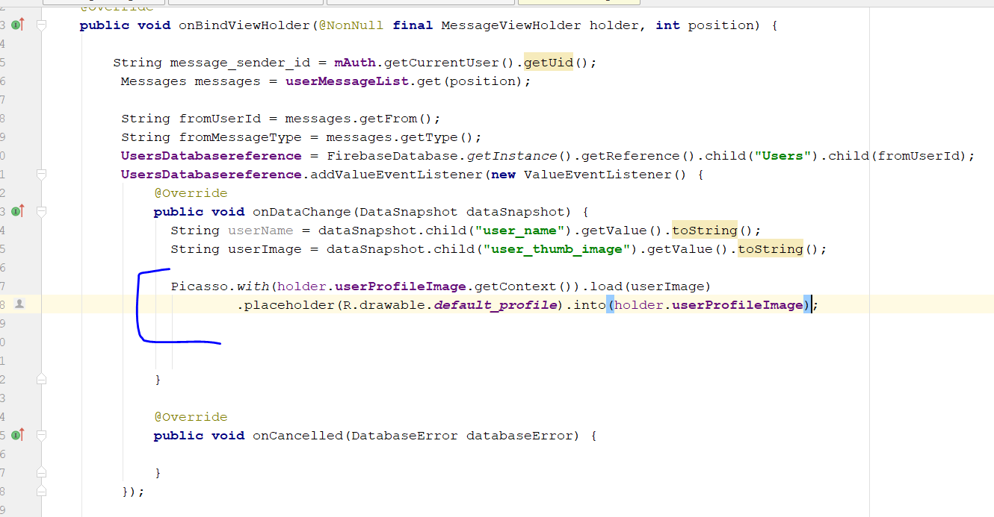
* Rebuild and run
* You should be able to see this
* 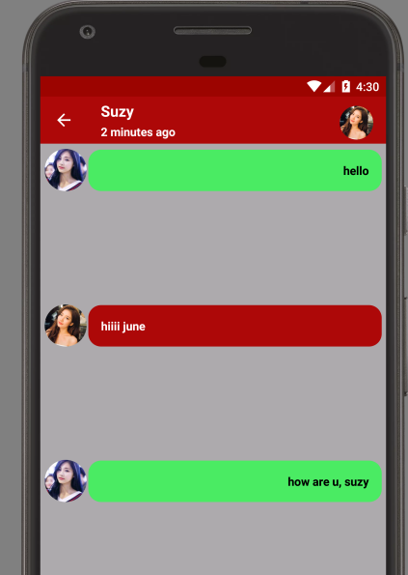

# Step 34: Find Friends

* Go to main_menu.xml
* Then change the second item title to “find friends”
* 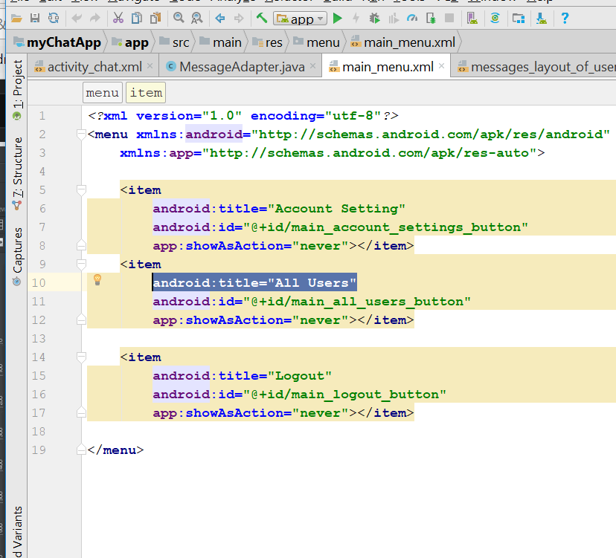
* 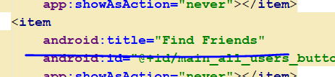
* Now go to all User activity.xml
* Now create a layout for the searchbox
* Right click drawable, select Drawable Resource file
* 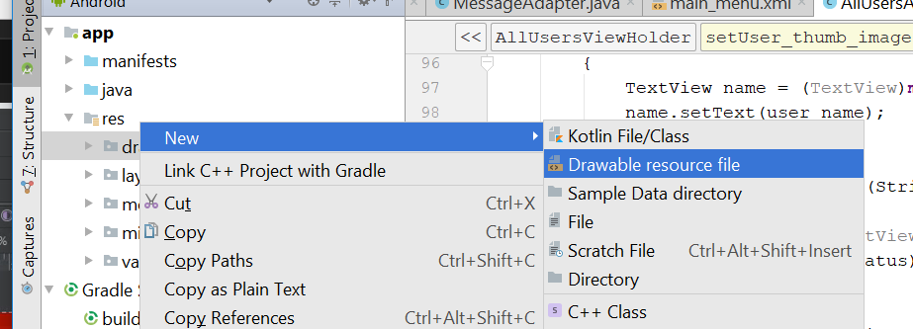
* 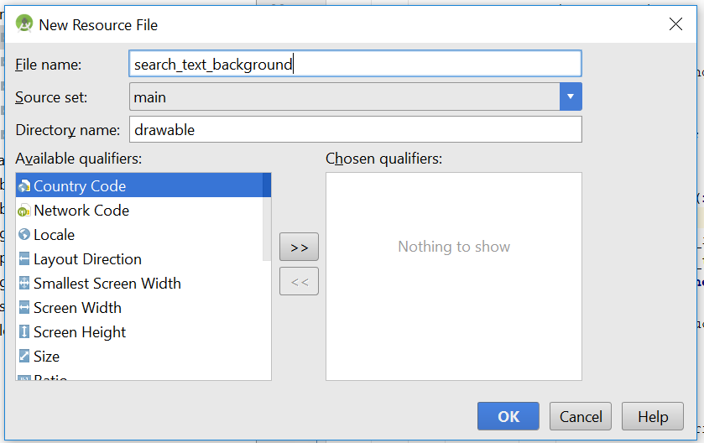
* Change the code in the XML to this
* *<?***xml version="1.0" encoding="utf-8"***?>*<**shape xmlns:android="http://schemas.android.com/apk/res/android"**>  
   <**solid android:color="@color/colorAccent"**></**solid**>  
    
   <**corners android:radius="30dp"**>  
   </**corners**>  
  </**shape**>
* 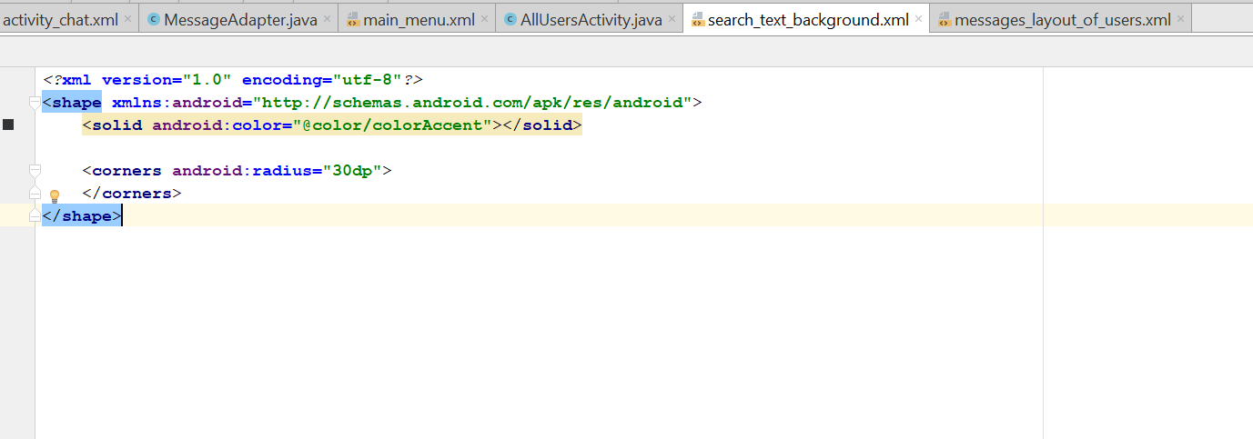
* You will see this
* 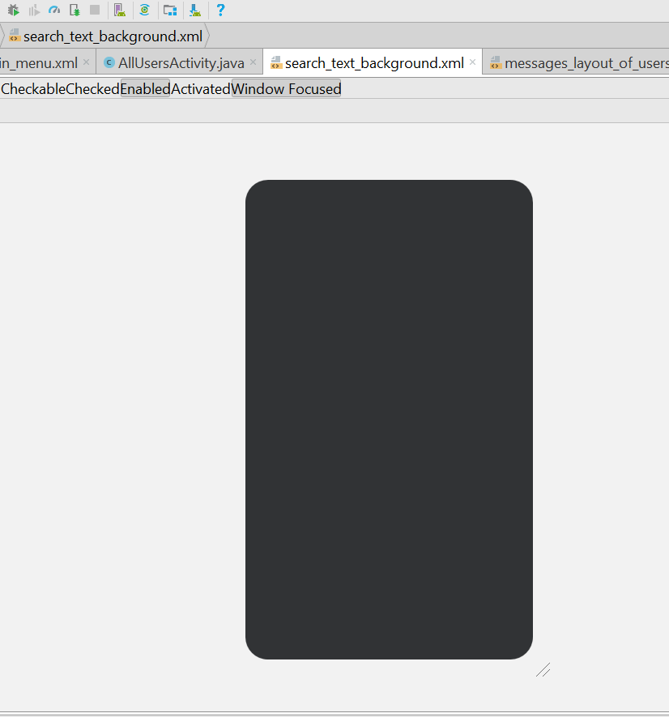
* Now go to activity_all_users.xml
* Change the recycle_view to height 50dp
* 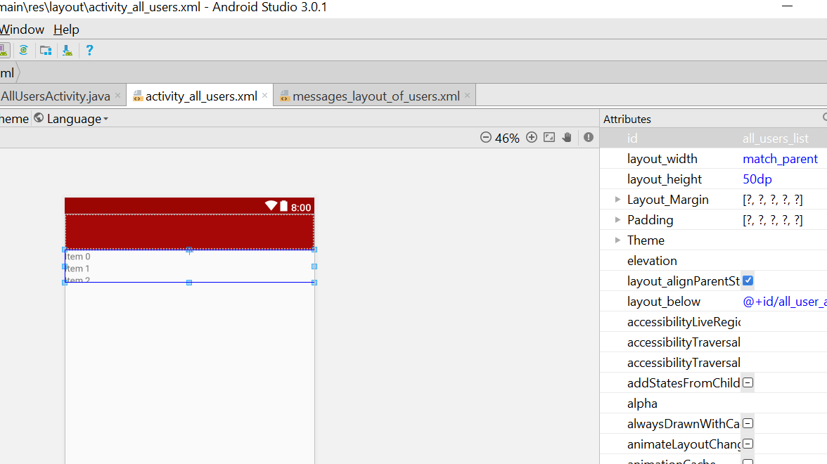
* Pull down and add a new TextView
* Now drag and drop another multiline text onto the layout
* The textView is like that
* <**TextView  
   android:id="@+id/textView"  
   android:layout_width="wrap_content"  
   android:layout_height="wrap_content"  
   android:layout_below="@+id/all_user_app_bar"  
   android:layout_centerHorizontal="true"  
   android:layout_margin="15dp"  
   android:layout_marginTop="25dp"  
   android:text="Search for people and Friends"  
   android:textAlignment="center"  
   android:textSize="18sp"** />  
    
  <**EditText  
   android:id="@+id/editText"  
   android:layout_width="wrap_content"  
   android:layout_height="wrap_content"  
   android:layout_below="@+id/textView"  
   android:layout_centerHorizontal="true"  
   android:layout_marginTop="53dp"  
   android:background="@drawable/search_text_background"  
   android:ems="10"  
   android:inputType="textMultiLine"  
   android:padding="10dp"** />
* Now drag and drop a imageButton
* Download the search icon
* Save it in the folder, name it as search_icon.png
* Change the imagebutton to the search_icon.png, it will prompt you
* So now the whole activity_all_user.xml will look like this
* <**TextView  
   android:id="@+id/textView"  
   android:layout_width="wrap_content"  
   android:layout_height="wrap_content"  
   android:layout_below="@+id/all_user_app_bar"  
   android:layout_centerHorizontal="true"  
   android:layout_margin="15dp"  
   android:layout_marginTop="25dp"  
   android:text="Search for people and Friends"  
   android:textAlignment="center"  
   android:textSize="18sp"** />  
    
  <**EditText  
   android:id="@+id/editText"  
   android:layout_width="wrap_content"  
   android:layout_height="wrap_content"  
   android:layout_alignParentStart="true"  
   android:layout_below="@+id/textView"  
   android:layout_marginStart="41dp"  
   android:layout_marginTop="40dp"  
   android:background="@drawable/search_text_background"  
   android:ems="10"  
   android:inputType="textMultiLine"  
   android:padding="10dp"** />  
    
  <**ImageButton  
   android:id="@+id/imageButton"  
   android:layout_width="wrap_content"  
   android:layout_height="wrap_content"  
   android:layout_alignBottom="@+id/editText"  
   android:layout_marginStart="19dp"  
   android:background="@drawable/search_text_background"  
   android:layout_toEndOf="@+id/editText"  
   app:srcCompat="@drawable/search_icon"** />
* 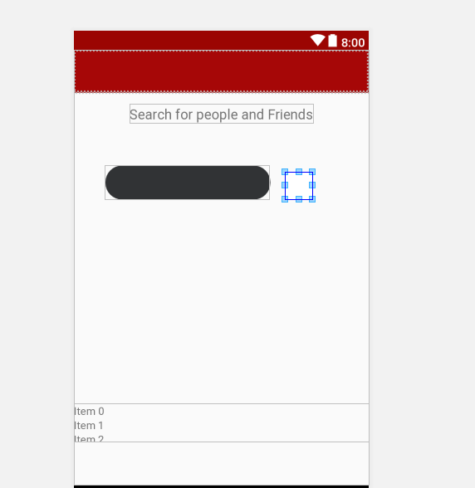
* Change the padding of the button to 15dp
* 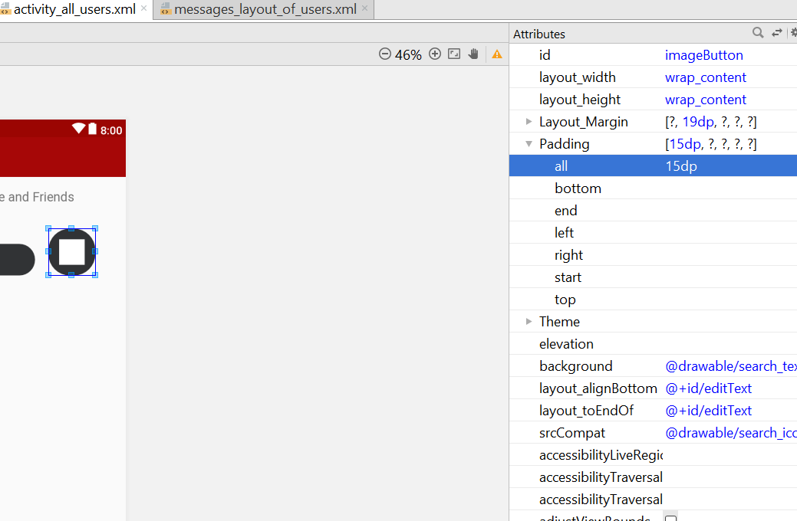
* Padding for edittext is 20dp
* 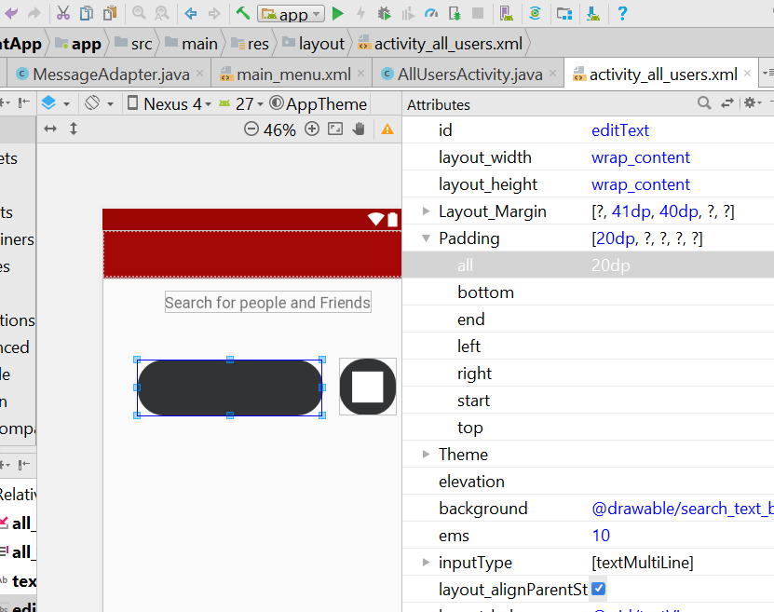
* Width change to 280dp
* 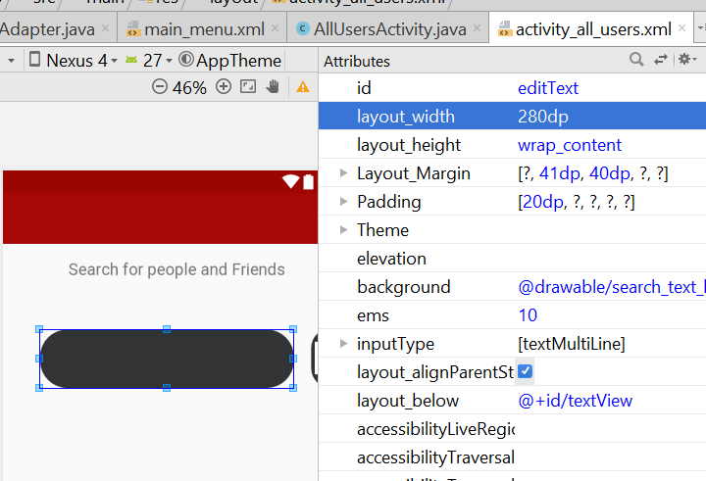
* Temporary, it will look like this
* 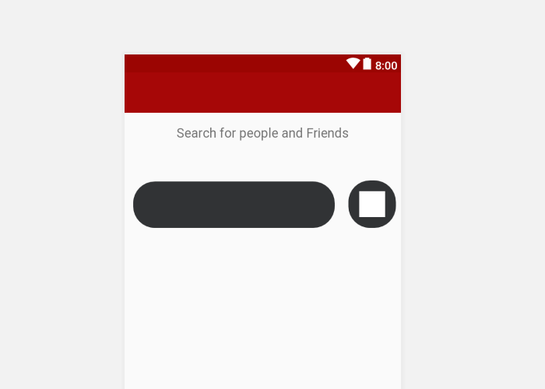
* Change the textcolour to background light
* 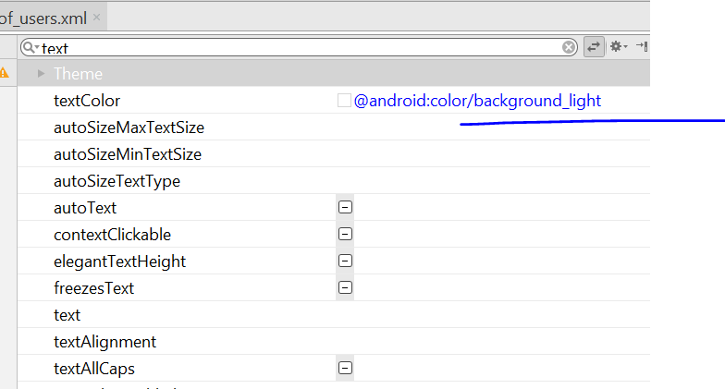
* Change the hint to “search here”
* And the hint text colour to background _light
* 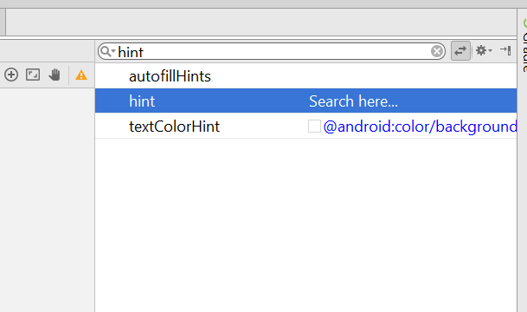
* It will look like this
* 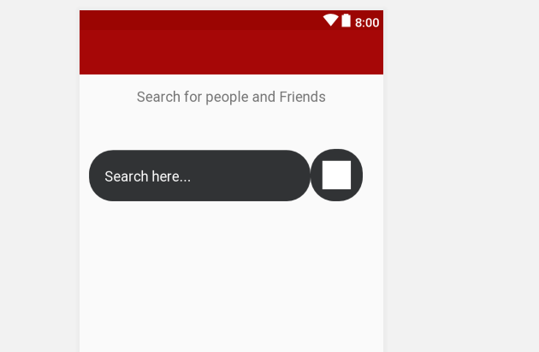
* The id for textbox is “search_input_text”
* The id for the searchbutton is “search_people_button”
* RecycleView layout_height change to match parent
* Layout margin change to 15dp
* It should look like this
* 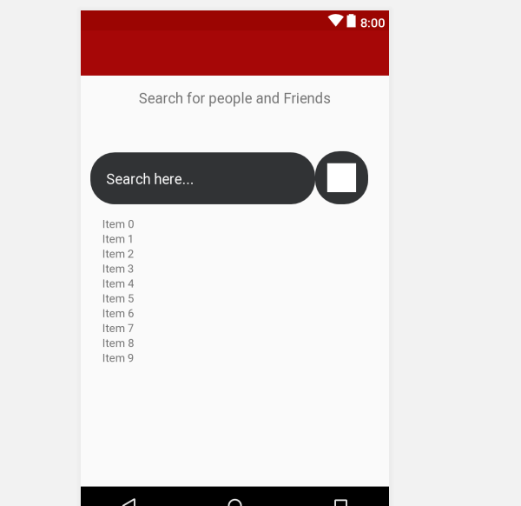
* Now go to AllUsersActivity.java
* Add this
* **private** EditText **SearchInputText**;  
  **private** ImageButton **SearchButton**;
* In the onCreate(), add this two line
* **SearchButton** = (ImageButton) findViewById(R.id.***search_people_button***);  
  **SearchInputText** = (EditText) findViewById(R.id.***search_input_text***);
* And this line
* **SearchButton**.setOnClickListener(**new** View.OnClickListener() {  
   @Override  
   **public void** onClick(View v) {  
    
   String searchUserName = **SearchInputText**.getText().toString();  
   **if**(TextUtils.*isEmpty*(searchUserName))  
   {  
   Toast.*makeText*(AllUsersActivity.**this**,**"Please write a user name to search..."**,Toast.***LENGTH_SHORT***);  
    
   }  
   SearchForPeopleAndFriends(searchUserName);  
   }  
  });
* 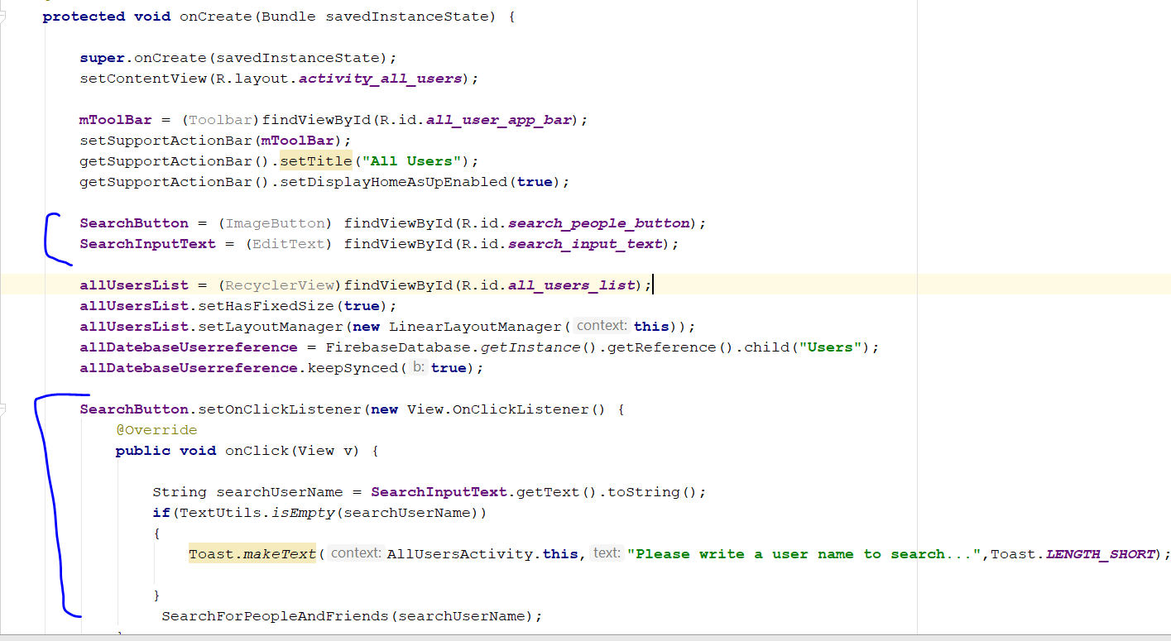
* Change this method
* 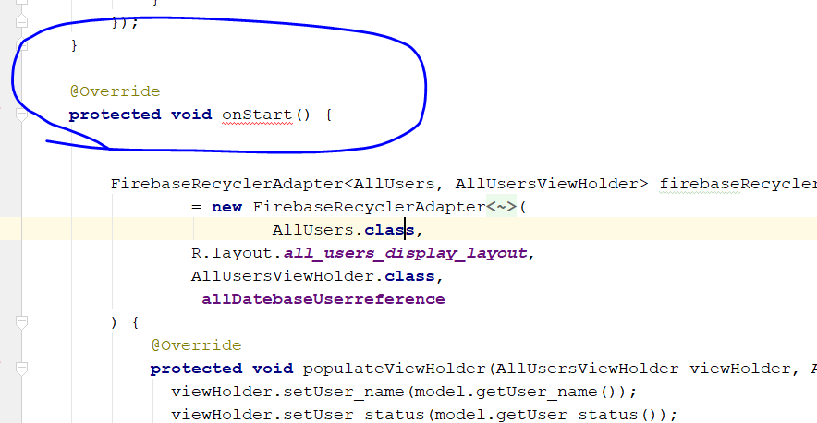
* Change the name and remove the onStart()
* The entire method change to this
* **private void** SearchForPeopleAndFriends(String searchUserName) {  
    
   *//searching purpose* Toast.*makeText*(**this**, **"Searching..."**, Toast.***LENGTH_SHORT***).show();  
   Query searchPeopleAndFriends = **allDatebaseUserreference**.orderByChild(**"user_name"**)  
   .startAt(searchUserName).endAt(searchUserName + **"\uf8ff"**);  
    
    
   FirebaseRecyclerAdapter<AllUsers, AllUsersViewHolder> firebaseRecyclerAdapter  
   = **new** FirebaseRecyclerAdapter<AllUsers, AllUsersViewHolder>(  
   AllUsers.**class**,  
   R.layout.***all_users_display_layout***,  
   AllUsersViewHolder.**class**,  
   searchPeopleAndFriends  
   ) {  
   @Override  
   **protected void** populateViewHolder(AllUsersViewHolder viewHolder, AllUsers model, **final int** position) {  
   viewHolder.setUser_name(model.getUser_name());  
   viewHolder.setUser_status(model.getUser_status());  
   viewHolder.setUser_thumb_image(getApplicationContext(),model.getUser_thumb_image());  
    
   viewHolder.**mView**.setOnClickListener(**new** View.OnClickListener() {  
   @Override  
   **public void** onClick(View v) {  
   String visit_user_id = getRef(position).getKey();  
   Intent profileIntent = **new** Intent(AllUsersActivity.**this**,ProfileActivity.**class**);  
   profileIntent.putExtra(**"visit_user_id"**,visit_user_id);  
   startActivity(profileIntent);  
    
   }  
   });  
    
   }  
   };  
    
   **allUsersList**.setAdapter(firebaseRecyclerAdapter);  
  }

# Bug Solving

## Hug gap between chat bubble

* Change message_layout_of_user.xml
* *<?***xml version="1.0" encoding="utf-8"***?>*<**RelativeLayout xmlns:android="http://schemas.android.com/apk/res/android"  
   xmlns:app="http://schemas.android.com/apk/res-auto"  
   xmlns:tools="http://schemas.android.com/tools"  
   android:layout_width="match_parent"  
   android:layout_height="wrap_content"  
   android:padding="5dp"**>  
    
   <**de.hdodenhof.circleimageview.CircleImageView  
   android:id="@+id/message_profile_images"  
   android:layout_width="60dp"  
   android:layout_height="60dp"  
   android:src="@drawable/default_profile"** />  
    
   <**TextView  
   android:id="@+id/message_text"  
   android:layout_width="wrap_content"  
   android:layout_height="wrap_content"  
   android:layout_alignBottom="@+id/message_profile_images"  
   android:layout_marginStart="17dp"  
   android:layout_toEndOf="@+id/message_profile_images"  
   android:background="@drawable/message_text_background"  
   android:padding="20dp"  
   android:text="TextView"  
   android:textColor="@android:color/background_light"  
   android:textSize="14sp"  
   android:textStyle="bold"** />  
    
   <**ImageView  
   android:id="@+id/message_image_view"  
   android:layout_width="300dp"  
   android:layout_height="30dp"  
   android:scaleType="centerCrop"  
   android:src="@drawable/default_profile"** />  
    
  </**RelativeLayout**>

## Accept/ Cancel Button not working

* I add this
* **acceptBtn** = (Button)viewHolder.**mView**.findViewById(R.id.***request_accept_btn***);  
  **declineBtn** = (Button)viewHolder.**mView**.findViewById(R.id.***request_decline_btn***);
* **cceptBtn**.setOnClickListener(**new** View.OnClickListener() {  
   @RequiresApi(api = Build.VERSION_CODES.***N***)  
   @Override  
   **public void** onClick(View v) {  
   Calendar calFordAte = Calendar.*getInstance*();  
   SimpleDateFormat currentDate = **new** SimpleDateFormat(**"dd-MMMM-yyyy"**);  
   **final** String saveCurrentDate = currentDate.format(calFordAte.getTime());  
    
   **FriendsDatabaseRef**.child(**online_user_id**)  
   .child(list_users_id).child(**"date"**).setValue(saveCurrentDate)  
   .addOnSuccessListener(**new** OnSuccessListener<Void>() {  
   @Override  
   **public void** onSuccess(Void aVoid) {  
   **FriendsDatabaseRef**.child(list_users_id)  
   .child(**online_user_id**)  
   .child(**"date"**)  
   .setValue(saveCurrentDate)  
   .addOnSuccessListener(**new** OnSuccessListener<Void>() {  
   @Override  
   **public void** onSuccess(Void aVoid) {  
   **FriendsReqDatabaseRef**.child(**online_user_id**).child(list_users_id)  
   .removeValue().addOnCompleteListener(**new** OnCompleteListener<Void>() {  
   @Override  
   **public void** onComplete(@NonNull Task<Void> task) {  
   **if**(task.isSuccessful())  
   {  
   **FriendsReqDatabaseRef**.child(list_users_id).child(**online_user_id**)  
   .removeValue().addOnCompleteListener(**new** OnCompleteListener<Void>() {  
   @Override  
   **public void** onComplete(@NonNull Task<Void> task) {  
   **if**(task.isSuccessful())  
   {  
   Toast.*makeText*(getContext(),**"Friend Request Accepted Successfully"**,Toast.***LENGTH_SHORT***).show();  
   }  
   }  
   });  
   }  
   }  
   });  
   }  
   });  
   }  
   });  
   }  
  });  
  **declineBtn**.setOnClickListener(**new** View.OnClickListener() {  
   @Override  
   **public void** onClick(View v) {  
   **FriendsReqDatabaseRef**.child(**online_user_id**).child(list_users_id)  
   .removeValue().addOnCompleteListener(**new** OnCompleteListener<Void>() {  
   @Override  
   **public void** onComplete(@NonNull Task<Void> task) {  
   **if**(task.isSuccessful())  
   {  
   **FriendsReqDatabaseRef**.child(list_users_id).child(**online_user_id**)  
   .removeValue().addOnCompleteListener(**new** OnCompleteListener<Void>() {  
   @Override  
   **public void** onComplete(@NonNull Task<Void> task) {  
   **if**(task.isSuccessful())  
   {  
   Toast.*makeText*(getContext(),**"Friend Request Cancelled"**,Toast.***LENGTH_SHORT***).show();  
   }  
   }  
   });  
   }  
   }  
   });  
   }  
  });
* add it here, on the public void onChanged
* 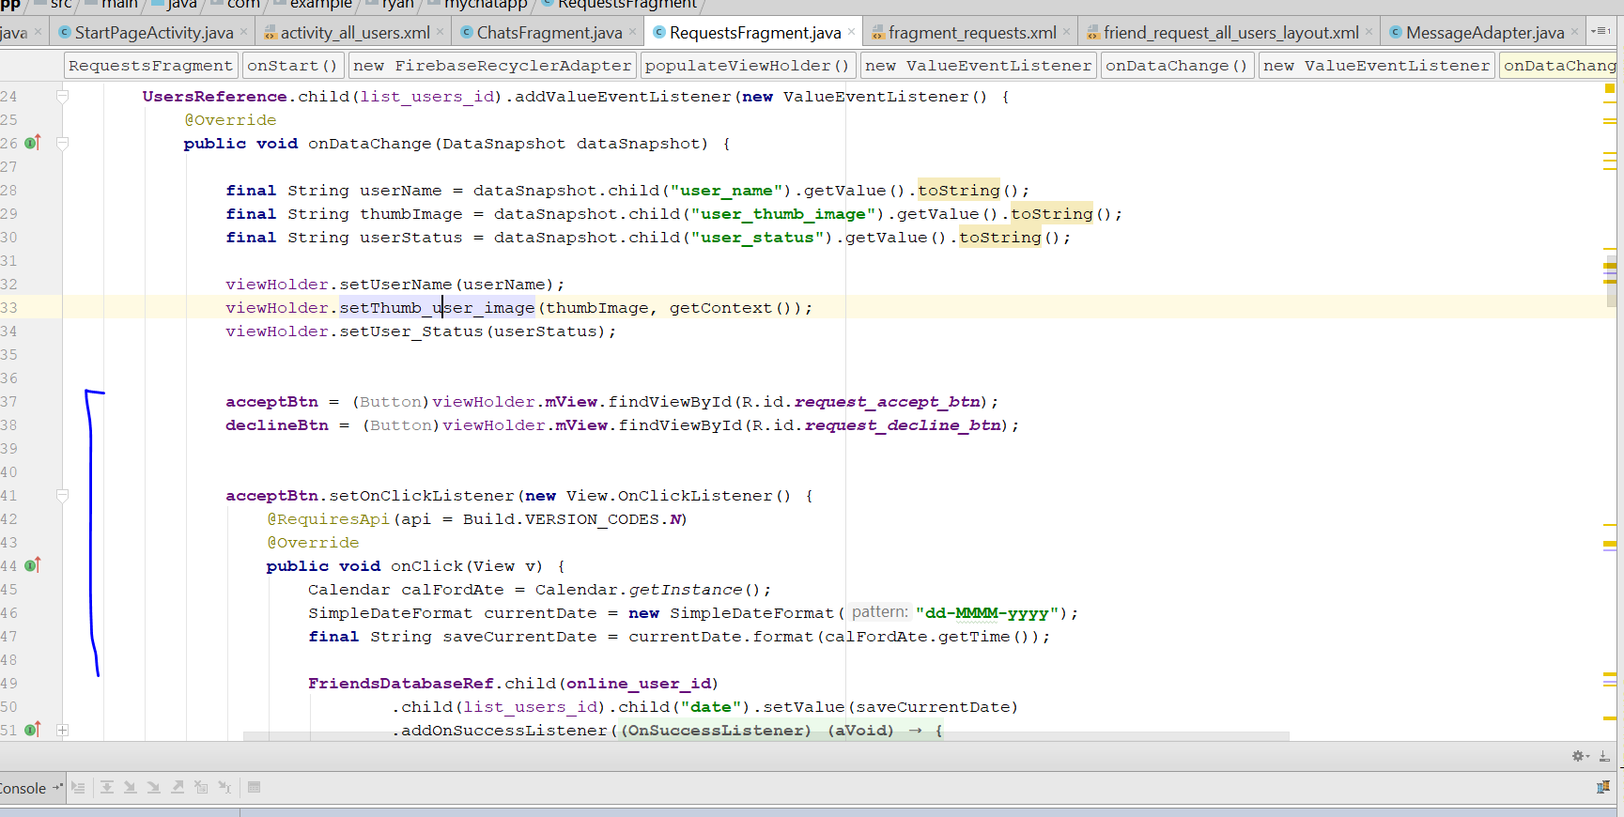

## The right alignment of speech bubble is opposite

* Settled
* Go to MessageAdapter.java and change to this
* 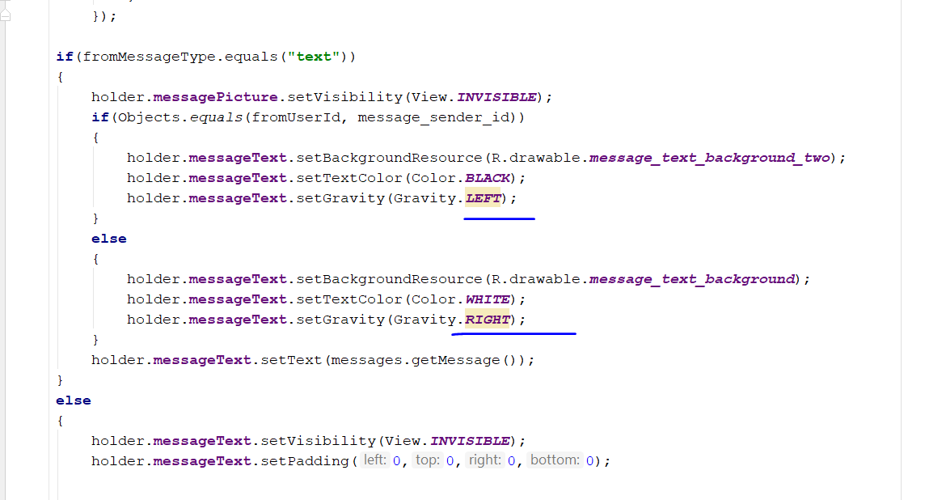

## Noification wrong name

Test Case

|  |  |  |  |  |
| --- | --- | --- | --- | --- |
| App running in background | Send | Received | Popup appear in | Pop up message |
| Yes | Jenny | June | june | Jenny send u a req |
| Yes | June | Jenny | Jenny | June send u a req |
| No | Jenny | June | june | Jenny send u a req |
| No | June | Jenny | jenny | June send u a req |
|  |  |  |  |  |
|  |  |  |  |  |

## New user, accept Friend request will crash

* Old phone crash, new phone okay, dk why

## Unable to scroll to the end, chat fragment

* Go to Activity_chat, change to this
* 